湖北省随州市2017年中考英语真题试题
本试卷分听力和笔试两部分。满分120分，考试时间120分钟
第一部分 听力
一、听力测试（共三节，满分25分）
第一节（共5小题，每小题1分，满分5分）
听下面五段小对话和对话后的问题，从每小题A、B、C三个选项中选出最佳选项。每段对话仅读一遍。
1. A. English. B. Biology. C. Geography.21世纪教育网版权所有
2. A. At a fruit shop. B. At a bank. C. At a library.
3. A. Two. B. Three. C. Four.
4. A. Green. B. White. C. Black.
5. A. On foot. B. By bike. C. By car.
第二节（共15小题，每小题1分，满分15分）
听下面三段长对话和一段独白，每段长对话或独白后有几个小题，从每小题A、B、C三个选项中选出最佳选项。每段对话或独白读两遍。21
听下面一段对话，回答第6-8小题。
6. When does the man take exercise?
A. In the morning. B. In the afternoon. C. In the evening.
7. What will the woman do tomorrow?
A. She will have a party. B. She will have a meeting. C. She will have a driving test.
8. Where will they meet on Saturday?
A. At the school gate. B. At the park gate. C. At the garden gate.
听下面一段对话，回答第9-11小题。
9. Why does Xiao Ming get up so early every morning?
A. Because he wants to do some exercise.
B. Because he wants to read English.
C. Because he wants to remember and recite something.
10. Who gets up as early as Xiao Ming every morning?
A. His father. B. His mother. C. Nobody.
11. How does Xiao Ming spend his spare time?
A. By playing football. B. By watching TV. C. He has no spare time at all.
听下面一段对话，回答第12-15小题。
12. Why does Mike want to hold a party?
A. He bought a new car. B. He found a new job. C. He moved to a new house.
13. When will the party be held?
A. On Saturday afternoon. B. On Saturday evening. C. On Sunday evening.
14. Who will go to the party with Mary?
A. Her husband. B. Her daughter. C. Her brother.【出处：21教育名师】
15. What does Mike forget to tell Mary?
A. The time of the party. B. The name of the restaurant. C. His new address.
听下面一段独白，回答第16-20小题。
16. The writer is ______ years older than his sister.
A. three B. five C. six
17. Why did the writer go out with his sister on his back?
A. Because his sister wanted to sleep.
B. Because his sister wanted to play outside.
C. Because his sister cried for their mother.
18. The stranger sent the writer and his sister to their mother’s workplace ______.
A. by bus B. by taxi C. by car【来源：21cnj*y.co*m】
19. From the passage, we know the writer’s family was ______.
A. rich B. poor C. big
20. The writer mainly tells us ______.
A. people are more important than things.
B. many strangers are very friendly
C. people shouldn’t leave a little girl at home alone.2·1·c·n·j·y
第三节（共5小题，每小题1分，满分5分）
听短文填写表格，每空一词。短文读两遍。
Superstar Sports Centre
Outdoors | There’s a basketball field and two football fields.  There’s a huge 21 .
Indoors | You can 22 on the rice. You can play table tennis.  You can enjoy 23 .
Free Tickets | Children under 24 years old can get free tickets.
Opening Hours | It opens every day 25 Monday evening.
第二部分 笔试
二、单项选择（本题共15分，每小题1分）
从每小题A、B、C、D四个选项中，选出一个可以填入空白处的最佳选项。
26. Lang Lang is ______ famous pianist. He plays ______ piano very well.21·cn·jy·com
A. a, the B. the, the C. the, / D. a, /21世纪教育网21-cn-jy.com
【答案】A
【解析】
试题分析：句意：郎朗是一位著名的钢琴家。他钢琴弹得很好。a用于辅音前，乐器前面不加the。故选A
考点：考查冠词的用法。
27. Thanks for inviting ______ to your food festival. We really enjoyed ourselves.
A. we B. they C. them D. us【版权所有：21教育】21·世纪*教育网
【答案】D
【解析】
试题分析：句意：邀请我们参加你们的美食节的感谢。我们玩得很开心。A. we主格形式，我们 ；B. they 他们，主格； C. them他们，宾格形式；D. us我们，宾格形式。根据inviting动词后要用宾格。
考点：考查代词的用法。
28. –Why don’t you buy the sweater?
--It’s too ____, and I don’t have enough money to buy it. 21教育名师原创作品
A. nice B. expensive C. popular D. cheap
【答案】B
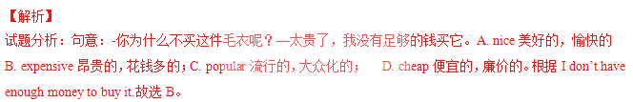考点：考查形容词辨析。
29. –Who lives together with your grandmother?
--______. She lives alone. I often go to see her.
A. Nobody B. Somebody C. Anybody D. Everybody
【答案】A
【解析】
试题分析：句意：-谁和你奶奶住在一起？—没有人，她独自生活。我经常去看她。A. Nobody没有人 ； B. Somebody某人； C. Anybody任何人，无论谁；D. Everybody每人，人人。根据She lives alone.故选A。
考点：考查代词的用法。
30. –Have you seen the movie Baby Plan?
--Of course. I think it’s ______ movie I have even seen.
A. funny B. funnier C. the most funny D. the funniest
【答案】D
【解析】
试题：分析句意：你看过电影《婴儿计划》吗？——当然。我认为这是我看过的最有趣的电影。A. funny有趣的，好笑的，滑稽的； B. funnier滑稽的( funny的比较级 )；C. the most funny 这种形式不正确； D. the funniest滑稽的( funny)的最高级 。根据I have even seen，故选D。
考点：考查形容词的最高级的用法。
31. –Do you know the student _____ David and Jack?
--Yeah. It’s Jim.
A. Among B. in C. between D. around
【答案】C
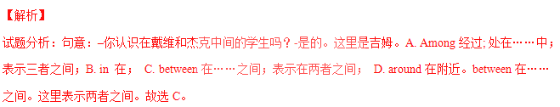考点：考查介词的用法。
32.The teacher asked the students to ______ a story about a trip to the moon.
A. give up B. turn up C. cut up D. make up
【答案】D
【解析】
试题分析：句意：老师要求学生一个编一个去月球旅行的故事。A. give up放弃； B. turn up出现； C. cut up切碎；D. make up组成， 编造；根据句意故选D。
考点：考查动词短语辨析。
33. –Is the mobile phone new or old?
--______. I bought it only two days ago.
A. It’s old B. It’s new C. Yes, it is D. No, it isn’t
【答案】B
【解析】
试题分析：句意：–这部手机是新的还是旧的？—是新的，我仅仅在前两天前买的。因为上句是选择疑问句，所以不能用yes或no来回答。故排除AB；根据I bought it only two days ago.故选B。
考点：考查选择疑问句的答语。
34. ______ important it is for kids to imagine freely!www-2-1-cnjy-com【版权所有：21教育】
A. What B. How C. How an D. What an
【答案】B
【解析】
试题分析：句意：孩子们自由地想象是多么的重要！What+a(an)+(形容词)+单数可数名词+主语+谓语! How+形容词(副词)+主语+谓语!故选B。
考点：考查感叹句的用法。
35. –Did you watch the football match on TV last night?
--I wanted to, but my father ____ his favorite TV program. 【来源：21·世纪·教育·网】
A. watched B. watches C. was watching D. had watched
【答案】C
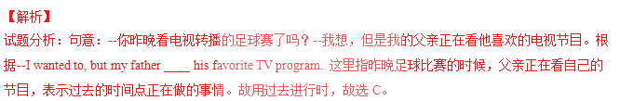
考点：考查过去进行时。
36. –Could you tell me ____?
--Look! He is playing volleyball over there.
A. what is Tom doing B. how Tom did it
C. where Tom is D. why Tom is doing it
【答案】C
【解析】
试题分析：句意：–你能告诉我汤姆在哪里吗？—看！他在那边打排球。根据He is playing volleyball over there.问的是地点，故选C.
考点：考查宾语从句。
37. –Your bedroom is so clean.
--Of course. It ____ every day
A. cleans B. cleaned C. is cleaned D. was cleaned
【答案】C
【解析】
试题分析：句意：--你的卧室真干净。—当然，它每天都被打扫。根据every day句子应该用一般现在时，句子的主语it与谓语动词clean之间是被动关系，故选C。
考点：考查被动语态。
38. –Why are you so worried?
-I’ve lost the watch ______ my dad bought me on my birthday.
A. what B. who C. whose D. which
【答案】D
【解析】
试题分析：句意：-你为什么这么担心？我丢了爸爸给我买了我的生日礼物我的手表。这里是定语从句，先行词是watch手表，是物，所以关系词用which，故选D。
考点：考查定语从句。
39. –What ______ if they ____ to the meeting late?
--Sorry, I don’t know.
A. will happen; go B. happened; go C. happens; will go D. will happen; will go
【答案】A
【解析】
试题分析：句意：-如果他们开会迟到会怎么样？—对不起，我不知道。If引导的在条件状语从句不能用将来时，而用一般现在时来代替，遵循主将从现的原则。故选A。
考点：考查动词时态。
40. –What do you think of talk shows?
--______. I watch them every week.
A. I can’t stand them B. I love them21世纪21世纪教育网有
C. I don’t think so D. I agree with you21*cnjy*com
【答案】B
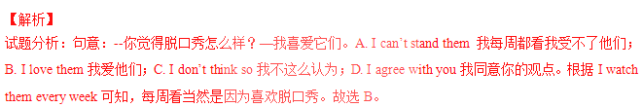
考点：考查交际用语。
三、完形填空（本题共15分，每小题1分）
阅读下面短文，从每小题所给的四个选项中，选出一个最佳选项。
Mulin is a small boy from Hubei. He is a(n) 41 boy. His parents divorced（离婚）when he was two years old. He lived with his 42 and grandmother. 43 the age of 5, his father died of heart disease. He had to live with his grandmother. Unfortunately, there was 44 wrong with his grandmother’s head. He 45 his grandmother well. At the same time, he got 46 grades at school. When he was ten, he took his grandmother to see a 47 in Wuhan with some people’s help. They lived in Wuhan for a month. He had 48 time to go out because he had to look after his grandmother.21cnjy.com
He called 49 a “Sunshine Boy”. He 50 happy every day. But when the reporter asked him 51 he was really so happy. He said he wasn’t. He didn’t want to show his unhappiness to his grandmother. He told the 52 that when he was unhappy, he wrote the unhappy things on the paper with which he folded a model 53 . When the plane flew away, he felt relaxed.
When the reporter asked him if he felt sorry to 54 so many lessons because of going to Wuhan, he said the lessons he missed could be learned later, but if his grandmother missed the best time to cure（治疗）, there would be nothing to get the chance 55 .
What a good boy! We should learn from him.
41. A. lucky B. unlucky C. polite D. impolitewww-2-1-cnjy-com
42. A. mother B. father C. sister D. brother
43. A. At B. In C. For D. To
44. A. something B. anything C. nothing D. everything
45. A. looked at B. looked up C. looked for D. looked after
46. A. good B. bad C. big D. small
47. A. film B. program C. doctor D. friend
48. A. few B. much C. many D. little
49. A. he B. himself C. she D. herself
50. A. smelt B. tasted C. looked D. felt
51. A. that B. if C. where D. why
52. A. writer B. reader C. teacher D. reporter
53. A. bike B. train C. plane D. ship
54. A. get B. catch C. miss D. forget
55. A. back B. up C. off D. down
【答案】
41.B
42.B
43.A
44.A
45.D
46.A
47.C
48.D
49.B
50.C
51.B
52.D
53.C
54.C
55.A
【解析】
试题分析：这篇短文主要讲了一个男孩为了让他的祖母，表现的非常阳光，我们应该向这个男孩学习。
41.考查形容词及语境的理解。 A. lucky运气好的 ； B. unlucky不幸运的； C. polite有礼貌的 ； D. impolite不礼貌的。句意：他是一个不幸的男孩。根据His parents divorced（离婚）when he was two years old.故选B。
42.考查名词及语境的理解。A. mother母亲； B. father父亲；C. sister姐妹； D. brother兄弟。句意：他和他的爸爸，奶奶一起居住。根据his father died of heart disease. He had to live with his grandmother.故选B。
43.考查介词及语境的理解。A. At 在…时间（具体时间） B. In 在上午，下午，某年等。C. For 表示一段时间；D. To到…时。句意：在他5岁时，他父亲死于心脏病。根据 the age of 5,在5岁的时候。At the age of 5，故选A。
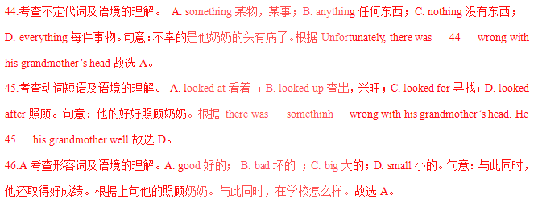47.考查名词及语境的理解。 A. film电影； B. program程序; 节目； C. doctor医生； D. friend朋友。句意：在他10岁时，在人们的帮助下，他带在武汉看医生。根据When he was ten, he took his grandmother to see a 47 in Wuhan with some people’s help.故选C。
48.考查不定代词及语境的理解。 A. few很少; 很少的；后跟可数名词的复数形式。B. much许多的；后跟不可数名词。C. many许多的 ；后跟可数名词的复数形式。 D. little小的，少的；后跟不可数名词。句意：因为他的照顾奶奶，他很少有时间出去。根据句意故选D。
49.考查代词及语境的理解。A. he他； B. himself 他自己； C. she 她；D. herself她自己。句意：他称自己是阳光男孩。根据He called 49 a “Sunshine Boy，主语和宾语是同一个人，故用反身代词，因为是男他，故选B。
50.考查系动词及语境的理解。 A. smelt闻起来； B. tasted 尝起来； C. looked看起来；D. felt感觉。句意：他每天看起来很高兴。根据上句He called 49 a “Sunshine Boy”. 他称自己是阳光男孩。 故选C。
51.考查宾语从句的连词及语境的理解。A. that 在宾语从句中无词意； B. if 是否； C. where 哪儿； D. why为什么。句意：但当记者问他是否真的那么快乐。根据 宾语从句he was really so happy. 故选B。
52.考查名词及语境的理解。 A. writer作家； B. reader读者； C. teacher教师； D. reporter记者。句意：他告诉记者当他不高兴时，他把不高兴的事情写在纸上。根据上句But when the reporter asked him 故选D。
53.考查名词及语境的理解。A. bike自行车；B. train火车； C. plane 飞机；D. ship船。句意：他折成模型飞机。根据下文When the plane flew away, he felt relaxed.故选C。
54.考查动词及语境的理解。A. get得到； B. catch赶上; 接住；C. miss错过; ; 思念;；D. forget忘掉；句意：当记者问他是否感到遗憾由于去武汉错过了许多课。根据下文he said the lessons he missed could be learned later,故选C。
55.考查副词及语境的理解。A. back 返回；B. up向上；C. off 离开；D. down 向下。句意：但是，如果他的祖母错过了治愈的最好时机，那就没有机会再回来了。根据 这句话的意思故选A。
考点：人物故事类短文阅读。
四、阅读理解（本题共30分，每小题2分）
A）阅读下列短文，从每小题所给的四个选项中，选出一个最佳选项。
A
Art Training Course
Do you want to get $75~$200 each hour? You will get good jobs if you spend only a week on our course about ads, TV programs, films and fashion.
Website: 21世纪教育网awardmakeupschool.com
Telephone number: 310-364-0665
Teaching English Overseas
A 4-week language course is offered monthly in Prague. It’s helpful for you to get good jobs around the world.
Cost: $1300 per month
Website: 21世纪教育网teflworldwideprague.com
Looking for a Roommate
I’m Mary. I have a house with three bedrooms. There are many things in it, like a TV, a washing machine and a fridge. You only need to pay $200 for it each month. And it includes the cost of surfing the Internet. There are two rules for you to obey: You mustn’t make lots of noise in the house and you must keep the house clean.
E-mail: 21世纪教育网room.to.rent@hotmail.com

56. If Jim wants to take the language course for two months, he’ll have to pay ______.
A. $ 75 B. $200 C. $1300 D. $2600
57. Mary’s house provides the following things EXCEPT ________.21cnjy.com21教育名师原创作品
A. a computer B. a TV C. a fridge D. a washing machine
58. Which of the following is TRUE according to the passage?
A. The cost of the art training course is $75 each hour.
B. People should pay $1300 for the language course each week.
C. If you often surf the Internet, you’d better not rent Mary’s house.
D. People who want to live in Mary’s house should pay $1200 half a year.
【答案】
56.D
57.A
58.D
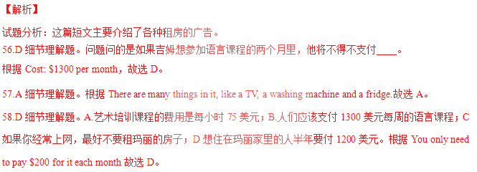
考点：考查广告类阅读。
B
When I was a little child, my mom liked to make meals for my father and me. She often made good food for us after work.
One evening, my mom placed a plate of eggs, sausage and burned biscuits in front of my dad and me. I saw the burned biscuits, and I refused to eat them. I looked up at my father. He picked up one of the burned biscuits and smiled at my mom. He asked me how my day at school was as usual. I don’t remember what I told him that night, but I do remember watching him put butter on the biscuits and eat all of them!
When I got up from the table, I heard my mom say sorry to my dad for burning the biscuits. And I would never forget what he said, “Baby, I love burned biscuits.”
Later, I asked him if he really liked the burned biscuits. He wrapped me in his arms and said, “Your mom works very hard today and she’s really tired. Besides, burned biscuits never hurt anyone!”
You know, life is full of imperfect things and imperfect people. What I’ve learned over the years is learning to accept others’ faults. That is one of the most important keys to creating a healthy and lasting relationship.
59. What did the writer’s dad do with the burned biscuits?
A. He refused to eat them. B. He threw them away.
C. He ate all of them. D. He asked the writer to eat all of them.
60. Which of the following is TRUE according to the passage?
A. My mom didn’t know the biscuits were burned. B. My mom said sorry for the burned biscuits.
C. I put butter on the biscuits. D. I ate all of the burned biscuits happily.
61. What does the writer want to tell us?
A. To learn to make good biscuits. B. To make friends with parents.
C. To accept someone’s mistakes. D. To create a good relationship with parents.
【答案】
59.C
60.B
61.C
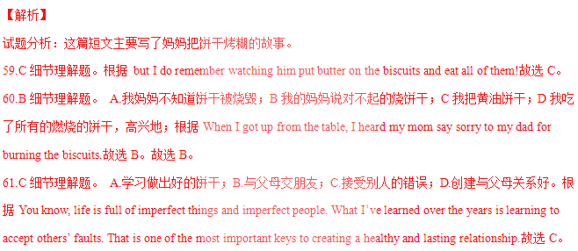
考点：考查人物故事阅读。
C.
Are you a TV lover? Can you imagine living without TV? Well, you could give it a try.
A group of Americans from TV-Turnoff Network（网络）have an idea. From April 19 to 25, they are asking children all over the world to turn off their TVs for one week. They hope children will find more interesting things to do. Maybe they can read some books, or learn to swim, or paint a picture. Since 1995, about 24 million people in America have taken part in TV-Turnoff Week.
TV-Turnoff Network says watching TV too much can bring children big problems with school, health and family. They want kids to watch a lot less TV. What do you think?
Bad for your studies
American scientists did a study of 1,300 children. They watched the children for four years. They say that if children watch lots of TV, they don’t do well in school.
Bad for your health
Studies show that when children watch lots of TV, they eat more unhealthy food. More children are getting overweight. Overweight children become will ill more easily. Watching too much TV is also bad for their eyes.
Bad for family life
About 40% of American families watch TV at dinner time. That means that they don’t talk very much when they eat together.
Also, too many violent（暴力的）things
An American study says that before a child turns 18 years old, that child will see 200,000 violent things on TV. Some kids become violent in real life.
If you want to learn more about this unusual week, you can go to this Website: 21世纪教育网tvturnoff.org.
62. When is TV-Turnoff Week?
A. From April 19 to 25. B. Any week in April. C. The first week in April. D. It doesn’t tell us.
63. What do children do during that week?
A. They watch TV much less. B. They go to this website, 21世纪教育网tvturnoff.org.
C. They read some books, or learn to swim, or paint a picture. D. Both A and C.
64. The passage tells people if children watch too much TV, they may ______.
①be overweight ②know more about the world ③be weak in study ④become violent in real life
A. ①②③ B. ①③④ C. ①②④ D. ①②③④
65. Which of the following sentences is NOT true according to the passage?
A. Millions of people have taken part in TV-Turnoff Week since 1995.
B. The Website www.tvturnoff.org. can tell you more about TV-Turnoff Week.
C. Children in America aren’t allowed to see violent things on TV until they are 18.
D. About three fifths of American families don’t watch TV whey they have dinner.
【答案】
62.A
63.C
64.B
65.C
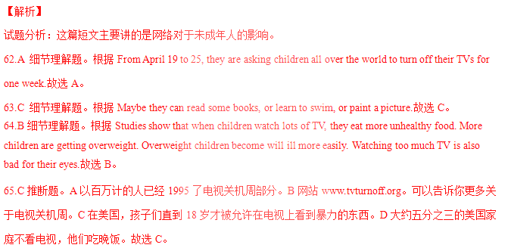
考点：考查社会类短文阅读。
B）阅读下面短文，按要求完成任务。
D
It was a very foggy day in London. ⑤The fog was so thick that it was impossible to see more than a foot.2·1·c·n·j·y
Buses, cars and taxis were not able to run and were standing by the side of the road. People were trying to find the way but lost ①______ way in the fog.
Mr. Smith had a very important meeting at the Houses of Parliament（国会大厦）and had to get there on time but no one could take him.
He tried to walk there but found he was lost. Suddenly he knocked into a stranger. The stranger asked if he could help him.
Mr. Smith said he wanted to get to the Houses of Parliament. The stranger told him that he could take him there.21教育网
Mr. Smith thanked him and they started to walk there. The fog was getting thicker every minute but the stranger had no difficulty in finding the way.
He went along one street, turned down another, crossed a ③/skweə/______ and at last after about half an hour’s walk, they ②______ at the Houses of Parliament.
Mr. Smith couldn’t ④/ˌʌndəˈstænd/______ how the stranger found his way. “It is wonderful,” he said. “⑥你是怎样在这样的雾里找到路的？”21*cnjy*com
“It is no trouble at all to me,”said the stranger. “I’m blind.”
66. 在文中的①处和②处分别填入一个合适的词，使短文通顺连贯。
①_________________ ② _________________
67. 根据音标提示，在文中的③处和④处分别填入一个合适的单词。
③__________________ ④_________________
68. 将⑤句译成汉语。
_________________________________________________________________________________
69. 将⑥句译成英语。
__________________________________________________________________________________
70. How long did it take Mr. Smith and the blind man to walk to the Houses of Parliament?
【答案】
66.① their / the ② arrived
67.③ square ④ understand
68.雾是那么的大，以至于一英尺之外就看不清了。
69.How did you find the way in the fog?
70.About half an hour
【解析】
试题分析：这篇短文讲述的是在一个大雾天，Smith先生要去开一个很重要的会。在这样的天气里，人们很容易迷路。幸运的是，Smith先生得到了一个陌生人的帮助。这个人在茫茫大雾中没有费什么力气就找到了Smith先生要去的地方，帮助他的人原来是一个盲人。【出处：21教育名师】【来源：21·世纪·教育·网】
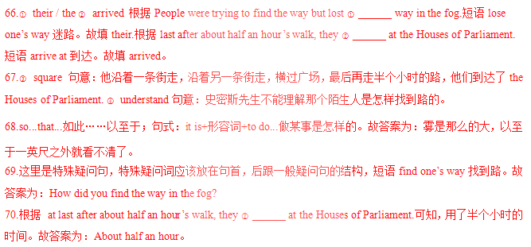
考点：考查故事类阅读。
五、完成句子（本题共10分，每小题2分）
根据所给汉语提示完成句子，每空一词。
71.钱学森是中国人民的骄傲。
Qian Xuesen is the ______ of the _______ people.
72.这部电影取材于一部科幻小说。
This movie is ________ _______ a science fiction story.21·cn·jy·com
73.茶叶主要产自于中国的南方。
Tea ______ are produced mainly in the ______ part of China.www.21-cn-jy.com
74.京剧起源于1790年之后，它有着200多年的历史。
Beijing Opera came into ______ after 1760 and has a ______ of over 200 years.
75.在你作重要决定之前，一定要仔细考虑。
Think it over before ______ an important _______.
【答案】
71.pride; Chinese
72.based; on
73.leaves; southern
74.being; history
75.making; decision
【解析】
试题分析：
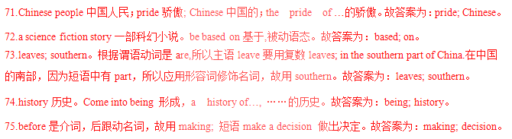
考点：考查完成句子。
六、短文填空（本题共10分，每小题1分）
从方框中选择适当的单词，并用其适当的形式完成短文，每词只能用一次，每空一词。
down anther fast use pronounce
easy one if be improve

Are you facing problems in learning English? If so, the following two days will help you to learn it more 76 and with more fun!2-1-c-n-j-y
“I download English songs from the Internet. It has really 77 my listening. What’s more, I am happier when I study this way,” said one junior student. Listening to your favorite English songs 78 actually an effective way. Before you listen, you can read 79 and find out what they song is about. While listening, pick some useful words or phrases. A dictionary may also be helpful 80 necessary.
Watching a movie is 81 good and interesting way. “It is wonderful to watch movies, and it can help your English a lot!” said a junior three student. “You can also imitate the 82 of the actors.” So choose your favorite movie before watching. Then have paper and a pen ready as you may want to write 83 useful words or phrases. In this way, you can increase the number of words and know the dialogues better.
Enjoy 84 the two ways, and you are sure to learn 85 and do better!
【答案】
76.easily
76.improved
78.is
79.first
80.if
81.another
82.pronunciation
83.down
84.using
85.faster
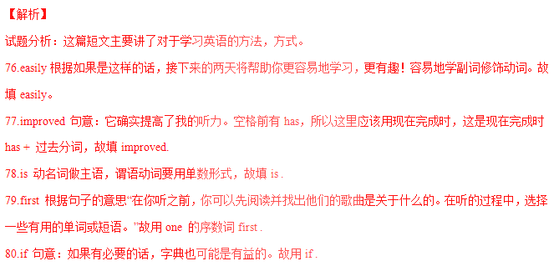81.another another是又一，再一，泛指。Watching a movie 又是学习英语的一种方式。故填another .
82.pronunciation 句意：你也可以模仿演员的发音”。冠词the后用名词。故用pronounce的名词pronunciation 。2
83.down 根据固定短语write down 写下，记下。故填down .
84.using 根据enjoy doing ,故用use的动名词形式using .
85.faster 根据and do better,故and 前也用比较级。故填faster 。
考点：短文填空。
七、书面表达（本题共15分）
上周你班召开了一次“告别陋习，走向文明”的主题班会，会上老师让你们谈谈身边同学的变化。请你根据表格里的内容写一篇有关王明同学的文章。
过去的表现 | 现在的表现
经常和同学打架 | 与同学相处融洽
花很多时间玩电脑游戏 | 积极参加各项活动
经常吃垃圾食品 | 健康的生活习惯
在课堂上吃东西、睡觉 | 认真听讲，按时完成作业
考试不及格 | 各门学科学得很好
注意：1.文章必须包括所有内容要点，可适当发挥，使短文的意思连贯，语句通顺；
2.词数：80词左右：（文章的开头已给出，不计入总词数）
3.文中不得出现真实的人名、校名及地名。
Wang Ming is my classmate. He has made great progress this term. In the past _________________________2-1-c-n-j-y

One possible version:
Wang Ming is my classmate. He has made great progress this term. In the past, he always fought with others. He used to spend time playing computer games. And he often ate junk food. In class, he either ate or slept. He could never pass any exam.
But now, he has changed a lot. He can get on well with the other students. He takes an active part in all kinds of activities. He has healthy living habits. He always listens to the teachers carefully in class and finishes his homework on time. And he does well in all subjects. We all like him now.
王明是我的同学。这学期他进步很大。过去，他总是和别人打架。他过去常花时间玩电脑游戏。他经常吃垃圾食品。上课时，他要么吃东西，要么睡觉。他决不能通过任何考试。
但现在，他变了很多。他能和其他同学相处得很好。他积极参加各种活动。他有健康的生活习惯。他上课时总是认真听老师讲课，按时完成作业。而且他各科成绩都很好。我们现在都很喜欢他。
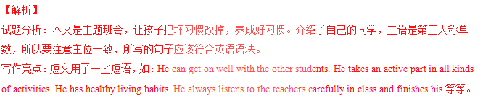
考点：材料作文。

