四川省达州市201 7年高中阶段学校招生统一考试
英 语
本试卷分为第I卷和第Ⅱ卷两部分，共12页。考试时间120分钟，满分120分。
温馨提示：
1．答题前，考生务必将自己的姓名、座位号、考号用0.5毫米黑色签字笔填写在答题
卡上。监考老师统一将条形码贴在答题卡规定的位置后，考生须认真核对，确认无误。
2．选择题必须使用2B铅笔，在答题卡相应位置规范填涂。如需改动，用橡皮擦擦干
净后，再选涂其他答案标号；非选择题用0.5毫米黑色签字笔作答，作答必须写在答题卡的
对应框内，超出答题区书写的答案无效；在草稿纸、试题卷上作答无效。
3．考试结束后，将试卷及答题卡一并交回。
第I卷（选择题共85分）
第一部分 听力（共两节 满分20分）
第一节（本题共5小题，每小题1分，计5分）
听下面五段对话，每段对话后有一个小题，从题中所给的A、B、C三幅图片中选出最
佳选项，并将答题卡上对应题号的答案标号涂黑。听完每段对话后，你将有5秒钟的时间来
回答有关小题和阅读下一小题。每段对话读两遍。
1. Which invention does the man think is the most important?21·世纪*教育网
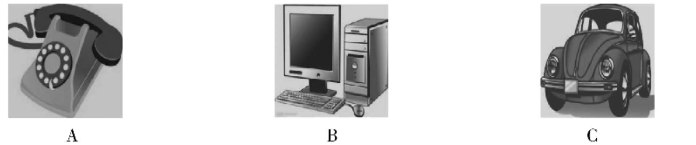
2. What festival are they talking about?
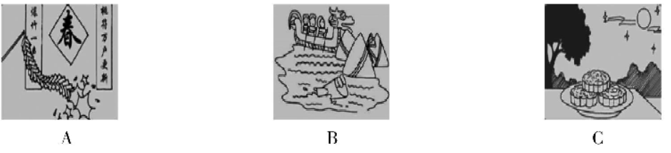
3. What did Mary use to look like?
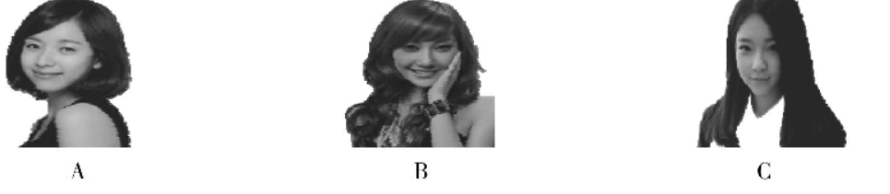
4. How do people in China greet others when they meet for the first time?
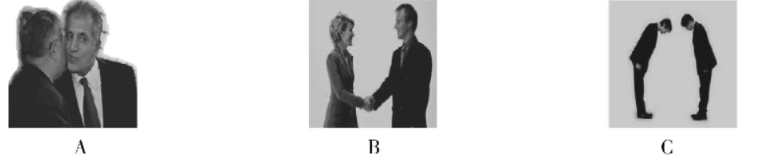
5. Where did Lily go on vacation?
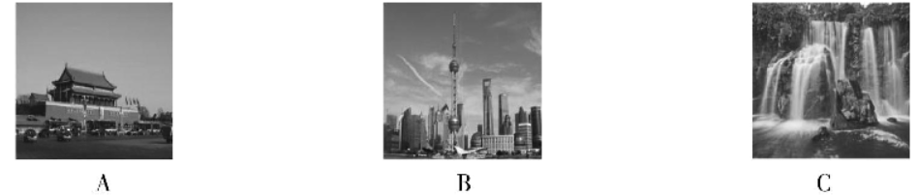
第二节（本题共15小题，每小题1分，计15分）
听下面四段对话和一段独白，每段对话或独白后有几个小题，从题中所给的A、B、C三个选项中选出最佳选项，并将答题卡上对应题号的答案标号涂黑。听每段对话或独白前，你将有5秒钟的时间阅读各小题；听完后，各小题将给出5秒钟的作答时间。每段对话或独白读三遍。
听第6段材料，回答6 -7题。
6. What does John want to be when he grows up?
A. A runner. B. A musician. C. An astronaut.
7. What does he do every day to be stronger?
A. He studies hard. B. He plays sports. C. He has more healthy food.
听第 7段材料,回答 8 -10题。
8. Who does the boy want to buy a gift for?
A. His father. B. His grandfather. C. His mother.
9. Why doesn't the boy buy the black shirt?
A. Because he doesn't like the color.
B. Because the shirt is on sale.
C. Because he has no enough money.
10. How much will the boy pay for the gift at last?
听第 8段材料,回答 11 -13题。
11. How was Alice's holiday in the country?
A. Terrible. B. Very awful. C. Wonderful .
12. How was the weather there?
A. Sunny. B. Rainy. C. Cloudy.
13. What did they think of the people there?
A. Interesting. B. Friendly. C. Very unfriendly.
听第 9段材料,回答 14 - 16题。
14. Why can't the woman find the way?
A. Because Dazhou has changed a lot.
B. Because she is too old to remember the way.
C. Because she has never been to Dazhou before.
15. Why doesn't her daughter come to meet her?
A. Because she is too busy.
B. Because she doesn't know her mother came.
C. Because she is ill in hospital.
16. Where does her daughter work?
A. At the train station. B. In a Children's Hospital. C. In a school.
听下面一段独白,回答 17 - 20题。
17. How long did the speaker volunteer at the local store?21·cn·jy·com
A. For a week. B. For a month. C. For one year.
18. What did the young lady want to buy for her son?【来源：21cnj*y.co*m】
A. A toy. B. A bag. C. A check.
19. What happened to the young lady?
A. She lost her money somewhere. B. She left her wallet at home.
C. A thief took her wallet away.
20. Who helped the young lady finally?
A. The speaker's mother. B. The lady's son. C. The speaker.
第二部分 基础知识运用（共两节 满分30分）
第一节 单项选择（本题共15小题，每小题1分，计15分）
从每小题所给的A、 B、 C、D四个选项中选出可以填入空白处的最佳答案。
21. —Do you like____movie Dan,gal?
—Yes. It's____educational movie.I like it very much.
A. the；an B.a；an C.a；the D.the；a
22. — Could you please offer me some____ in my research?
—Yes, sure.
A. idea B.message C.suggestion D.advice
23. —What about these two coats, madam?
— of them fits me. Could you show me one?21世纪教育网
A. Either； other B. Neither； another C.Neither； else D.Either； another
24.____of the land in that town____covered with trees and grass.
A. Two fifth； is B.Two fifth； are C.Two fifths； is D.Two fifths； are
25. —Is it____cheaper and____enjoyable to travel by train than by plane?
—Yes,I think so.
A. very； very more B.even；a little
C.more； much more D.much； far more
26. —____fine weather it is!
—Yes. Look! many people are walking around the park.
A. What；So B.How；So C.How; Such D.What a; So
27. —What's the matter,Jack?
—I down while I____on the ice. I got hurt badly.
A. was falling, skated B.fell, was skating
C.fell, skated D.was falling, was skating
28. —Hi, Tina! What are you going to do for the coming summer holiday?
—I am going to cooking because I like eating delicious food.21世纪教育网
A. take down B.take up C.pick up D.clean up2-1-c-n-j-y
29. —May we leave the classroom now?
— No, you . You to leave until the bell rings.
A. needn't; aren't allowed B. may not; are allowed
C. mustn't; aren't allowed D. can't; are allowed
30. —Do you prefer basketball with me?
—No, I'd rather at home and watch TV.
A. play; stay B. to play; to stay C. play; to stay D. to play; stay
31. —Does your mother have a hobby?
— No, you call going shopping a hobby.
A. unless B. because C. although D. if
32. —Where's your brother?21世纪教育网
—Oh, He the library and .
A. has been to; so Lucy is B. has gone to; so Lucy has2·1·c·n·j·y
C. has gone to; so has Lucy D. has been in; so has Lucy
33. — kind of tea would you like?
—I love tea has a fruity taste.
A. Which;what B. What; which C. Whose; that D. What; who
34. —Excuse me, how long will it take me to get to the post office?
—Well, it depends on .
A. how you will get there B. when you will get there
C. where you will get D. how will you get there
35. —We failed in the dancing competition.
— . Better times are waiting for you.
A. Good luck B. Best wishes C. Great idea D. Cheer up
第二节 完形填空（本题共15小题，每小题1分，计15分）
阅读下面的短文，掌握其大意，然后从短文后各题所给的A、 B、C、D四个选项中选
出可以填人相应空白处的最佳答案。
A
What is real happiness? Different people have different ideas about it.Some people like money better than 36 in the world in the past. They think if they are rich, they have happiness; nowadays some think if they are 37 ,they have happiness; others think if they help people in trouble, they have happiness.
In fact, everyone in the world needs happiness. Everyone wants to own happiness. Many
people always 38 happiness. Many people live in happiness, but they don't realize it. So you must have your own answers to happiness. You can find happiness 39 .For example, working is happiness; playing is happiness; reading is happiness.... happiness lies in what you do 40 you find and enjoy it.
36. A. nothing else B. anything else C. else nothing D. else anything
37. A. in good health B. in public C. in need D. in danger
38. A. look after B. look out C. look down D. look for
39. A. somewhere B. everywhere C. nowhere D. anywhere
40. A. as well as B. as soon as C. as long as D. as far as
B
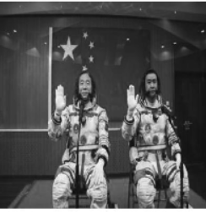
On Oct. 16, 2016, Chinese astronauts of the Shenzhou-ll mission(任务), Jing Haipeng and Chen Dong, met the press（新闻发布会）Sunday ahead of Monday's launch.21教育网
Sitting under a national flag, the astronauts 41 in good spirits and answered several questions.
“ 42 the job is challenging, risky and dangerous, there is nothing more I would rather
do,” Jing Haipeng, 50, who is commander of this mission, told reporters. It will be Jing's 43 spaceflight following his Shenzhou-7 mission in September 2008 and Shenzhou-9 m/ssion in March 2012.
On Monday, China successfully launched (发射) manned spacecraft Shenzhou-ll carrying the two astronauts who will remain in space for 33 days. The spacecraft was sent up at the Jiuquan Satellite Launch Center in 44 China's Gobi desert at 7: 30 a. m. Beijing time Monday with a Long March-2F Yll carrier rocket. The spacecraft has entered its designated orbit (轨道). The launch 45 a success by Zhang Youxia, about 19 minutes after the blast-off (发射).
Three weeks before the task, the family members of Jing Haipeng and ChenDong still knew nothing. Chen Dong has been a (an) 46 for many years before joining the space team. He and his wife now have a pair of five-year-old twin sons. One-month mission is not the longest time that Chen 47 away from home. When he was a pilot , he once did not come back home for half a year during a mission.
Cheng Dong described the experience as “no seeing, no 48 .” But with the help of Virtual Reality (虚拟现实) (VR) technology, astronauts will meet their family during free time. “If I see them (family members) , it will be different somehow,”Chen said.
For Jing, he looks very calm. In his first space mission on Shenzhou VII, his wife was so nervous 49 she almost did not sleep during those three days. Now that it is his third , his wife has 50 it.
41. A. met B. came C. appeared D. stood
42. A. Until B. Although C. Because D. But
43. A. first B. second C. third D. fourth
44. A. northwest B. southwest C. northeast D. southeast
45. A. was told B. was announced C. was spoken D. was said
46. A. astronaut B. engineer C. pilot D. scientist
47. A. has stayed B. left C. has left D. stayed
48. A. listening B. watching C. noticing D. missing
49. A. one B. it C. this D. that
50. A. got used to B. used to C. been used for D. been used by
第三部分 阅读理解（共两节 满分30分）
第一节阅读下面的短文，根据短文内容，从每题所给的A. B. C.D四个选项中选出最佳答案。（本题共11小题，每小题2分，计22分）
A
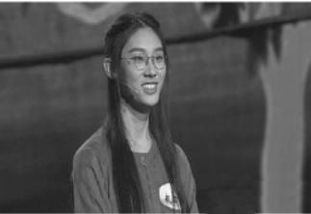
For thousands of years, poetry has been the favorite type of literature （文学）for many in China. Chinese literature is one of the major parts of China's ancient traditions, and Chinese poetry is just like the best prize in this famous culture's literary treasure house.
There were many famous poets from different periods of time in Chinese history, and thousands of their poems are still read and appreciated (欣赏) today.
To remind people of those classic Chinese poems and to promote (推广) cultural heritage (遗产) , CCTV has produced a TV show - Chinese Poetry Competition. The final of the hit show's second season was shown on Feb. 7, 2017.
Wu Yishu, 16, who studies at the High School Affiliated to Fudan University in Shanghai,
came out on top. In an earlier program, Wu wowed (赢得喝彩) the audience when performing in a section entitled “Feihualing”.
“I really admire her knowledge of poems,” said Huang Zijin, 16, a senior 2 student from
Ningbo High School . “What's more, she always appears so calm throughout the show, which is
very unusual for her age.” As the old saying goes: “One who is filled with knowledge always
behaves with elegance (优雅).”
“Learning poems isn't about winning or losing. The power of poetry lies in shaping one's view of life and developing one's inner world,” said Li Bo, an expert guest at the Chinese Poetry
Competition's second season. Li Dingguang told China. org. cn. “It's important to help students truly appreciate the artistry and fun of poetry.”21世纪教育网版权所有
51. What is like the best prize in this famous culture's literary treasure house?
A. Chinese poetry. B. Chinese literature.
C. China's ancient traditions. D. China's ancient culture.
52. Who won the first prize in the Chinese Poetry Competition?
A. Li Dingguang. B. Li Bo. C. Huang Zijin. D. Wu Yishu.
53. According to the article, which of the following is FALSE ?
A. Thousands of famous poets' poems are still read and appreciated today.
B. Wu Yishu appeared so calm throughout the show.
C. It's unimportant to help students truly appreciate the artistry and fun of poetry.
D. Li Bo said, “Learning poems isn't about winning or losing.”
54. Which is the best title of the passage?
A. Enjoying Beautiful Literature
B. Enjoying Beautiful Poetry
C. Joining English Speaking Competition
D. Holding Chinese Literature Competition
B
Fu Yuanhui is an Olympic swimmer from the Chinese city of Hangzhou. She competed in the l00-meter backstroke event in Rio de Janeiro. She finished third in her semi-final swim on August 7. Shortly after the semi-finals, She became a trending topic on Chinese social media and she became famous quickly around the world. It was not her swimming, however, that made her famous. It was some of the words she made afterward.
A Chinese reporter spoke with her after the semi-finals. The reporter told her that she swam the race in under 59 seconds. This seemed to shock her. “58. 95?” she said with excitement. “I was really fast!” She told the reporter that she used “mystical powers” in her swim.
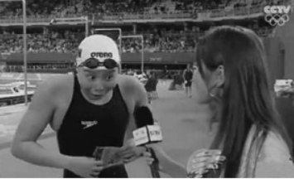
Her shock, joy and honesty won her many friends in China and around the world. People began making GIFs of her excited facial expressions. Those images spread quickly.
One American wrote, “Fu Yuanhui from China is the loveliest person on the planet.” Even the Huffington Post website called her, the “most lovable swimmer at the Rio Olympics.”
Fu's fame only grew on August 9, when she competed in the l00-meter backstroke finals. She beat her semi-final time. She swam the race in 58. 76 seconds. It was fast enough to earn (嬴得) her a share of the bronze medal. She tied for third place with Kylie Masse of Canada.
Her words after the race won her even more followers in China and around the world. At first, the swimmer said she does not think she won a medal. She said she is still pleased with her time because she beat the Asian record. A reporter told her that she was just 0.01 seconds behind the silver medal winner. She said she couldn't reach second place because “her arms are too short.”
Her reaction (反应) and personality have made her one of China's - and the world's – favorite Olympians. The New York Times newspaper wrote Thursday of the swimmer, “Rather than mere happiness at her performances, Ms. Fu, 20, exhibits something closer to pure (纯粹的) joy, bouncing around and making lively faces.”
55. What made Fu Yuanhui famous in China and around the world ?
A. Her bronze medal. B. Her funny words and swimming.
C. Her different lively faces. D. Some of her words and expressions.
56. The underlined words “mystical powers” mean in Chinese.
A.洪荒之力 B.洪荒之利 C.不可思议 D.神秘的力量
57. From the passage, what can we know about Fu Yuanhui ?
A. She is a very brave and honest girl.
B. She is true to reporters as well as to herself.
C. She is a swimmer who is good at making a speech.www.21-cn-jy.com
D. She is not so strict with herself in the Olympic competition.
58. What does the story mainly tell us in the passage?
A. Fu Yuanhui had more followers in China and around the world.
B. Fu Yuanhui was the most lovable swimmer at the Rio Olympics.
C. Fu Yuanhui showed the world how to express pure happiness.
D. Fu Yuanhui beat the Asian record in the l00-meter backstroke finals.
C
The roundtable of the Belt and Road Forum for Intemational Cooperation (合作) was held on May14, 2017 in Beijing. President Xi Jinping made a theme speech at the Opening Ceremony.
Distinguished guests from over 100 countries attended this important forum on the Belt and Road Initiative.
Over 2,000 years ago, our ancestors opened the transcontinental (横贯大陆的) passage connecting Asia, Europe and Africa, known today as the Silk Road. They also created sea routes connecting the East with the West, namely, the maritime (海洋) Silk Road. These ancient silk routes opened windows of friendly engagement among nations.
In China's Han Dynasty around 140 B. C. , Zhang Qian left Chang'an. He made a journey to the Western regions and opened an overland route connecting the East and the West. Centuries later, in the years of Tang, Song and Yuan Dynasties, such silk routes, both over land and at sea, great adventurers, including Du Huan of China, Marco Polo of Italy, left their footprints along these ancient routes. In the early 15th century, Zheng He, the famous Chinese navigator (航海家) in the Ming Dynasty, made seven voyages to the Western Seas, a great achievement which still is remembered today. Generation after generation, the silk routes travelers have built a bridge for peace and East-West cooperation.
The Belt and Road Initiative is rooted c檀根) in the ancient Silk Road. It focuses on the
Asian, European and African continents, but is also open to all other countries. All countries, from
either Asia, Europe, Africa or the Americas, can be international cooperation partners of the Belt
and Road Initiative.21世纪教育网
Today, China is trying to build the Silk Road Economic Belt and the 21st Century Maritime Silk Road. The Belt and Road can create chances in challenges and changes. "Peaches and plums do not speak, but they are so attractive that a path is formed below the trees. " Four years on, over 100 countries and international organizations have supported and got involved in this initiative. We are sure the dream of the Belt and Road is coming true.
59. According to this passage, can we infer which of the following is TRUE?
A. The Belt and Road Initiative focuses on the Asian, European and American continents.
B. Zhang Qian left Chang'an and created sea routes connecting the East with the West.
C. The roundtable of the Belt and Road Forum was held successfully in Beijing.
D. Marco Polo of Italy left his footprints along these ancient routes in the Song Dynasty.
60. Put the sentences in the right order according to the passage.
①These ancient silk routes opened windows of friendly engagement among nations.
②The silk routes travelers have built a bridge for peace and East-West cooperation.
③President Xi Jinping made a theme speech at the Opening Ceremony.
④The Belt and Road can create chances in challenges and changes.
⑤The Belt and Road Initiative is rooted in the ancient Silk Road.
A. ③②④①⑤ B. ②①④⑤③ C. ②③①④⑤ D. ③①②⑤④
61. What's the meaning of the underlined sentence in the last paragraph?
A.使者相望于道，商旅不绝于途。 B.桃李不言，下自成蹊。
C.不积跬步，无以至千里。 D.伟业非一日之功。
第二节 根据短文内容,从下面方框中选择适当的选项补全短文。(本题共 4小题,每小题2分,计 8分)
A young man went to visit a wise man who lived deep in the mountain. He wanted to ask for wisdom of life.
“Excuse me! 62 Is it the day we were born or the day we die? Is it the day we fall in love or the day we are successful?” the young man asked.
“None. The most important day in our lives is today. ” the wise man replied calmly.
“Why?” the young man was very surprised. “ 63 ”
“No. Nothing has happened today.”
“So is it because of my visit?”
“Even if nobody visited me today, today is still very important, because today is the only
wealth we have. No matter how important yesterday is, it has gone by; 64 No matter how
ordinary and boring today is, it is in our hands.”
The young man still wanted to ask something, but the wise man stopped him and said, “When we are talking about the importance of today, we have wasted a lot of it. That is to say, part of ‘today’ has passed.”
Having understood this, the young man nodded and then went down the mountain.
65 Therefore, what we should do now is to forget yesterday and tomorrow and catch hold of today !
A. Is it because there is some unusual event taking place today?
B. Actually today is the only wealth and chance we have.
C. No matter how wonderful tomorrow may be, it hasn't come.
D. Could you tell me what is the most important day in our lives?
第四部分 口语应用（共5小题，每小题1分，满分5分）
从下面的方框中选择适当的选项补全对话。（有两项是多余的）
W: Good evening, Ted! Tell our listeners what you do, please.www-2-1-cnjy-com
M: Good eveningl I help collect rubbish along the Zhou River with other members in our volunteer team.21*cnjy*com
W: That's great! 66.
M: As you see, the Zhou River is our mother river. It provides us with clear water. 67.
W: I agree with you. 68.
M: Um... 10 girls and 15 boys.
W: When do you do this work?
M: We live near the river. 69. and when we see the rubbish, we collect it.
W: 70.
M: Yeah, I think so.
A. In cities, pollution is mainly from factories.
B. How many members do you have in the team?
C. It's good for your health and the environment, isn't it?
D. How did you come up with the idea?
E. What about rubbish pollution?
F. We don't want it to be polluted.
G. After dinner every evening, we take a long walk along the side of the river

第Ⅱ卷（非选择题共35分）
第五部分 任务型阅读（共5小题，每小题1分，满分5分）
根据短文后所给的任务，完成71 - 75小题。
How do you decide if someone is smart? One way is to find A the person's intelligence quotient（智商），or IQ.【版权所有：21教育】
A 12-year-old girl recently took an IQ test. People found that her IQ is higher than Albert
Einstein's and Stephen Hawking's! Rajgauri Pawar, an Indian girl studying in England, scored 162 in the famous Mensa（门萨）IQ test, reported the Independent. Mensa, founded in England in 1946, is the largest and oldest high IQ society in the world. To become a Mensa member, you must have an IQ that falls in the top 2 percent of the population that take the tests. Hawking got a score of 160. Although Einstein never took the test,①Hawking's, his, said, as, would, same, experts, score, the, be.21*cnjy*com
However, what does having a high IQ mean? Will those with a high IQ definitely become the next Einstein or Hawking?21教育名师原创作品
Not necessarily. Most IQ tests, including the Mensa one, test one's ability in math, language
and memory. However, these tests don't test abilities B knowing how to make things work, according to Richard Nisbett,a professor of psychology at the University of Michigan, US. It doesn't test your creativity or curiosity, either. Also,a lot of things can affect one's IQ score, including poverty, nutrition【营养）,stress and how familiar you are with the tests.
Lisa Van Gemert,a Mensa expert, said that good habits, perseverance and a strong work ethic are just as important as intelligence. ② “If you don't develop those other qualities, you can waste a smart IQ,” she said.
任务一：请分别在文中A、B两处的横线上填人适当的单词。
71. (A)_______ ; (B) __________
任务二：请将文中①处后面斜体单词连成句子。
72.____
任务三：请将文中②处划线句子翻译成汉语。
73.____
任务四：请回答问题：What can also influence one's IQ score?
74.____
任务五：请给短文拟一个适当的题目。（10词以内）
75. _______________________
第六部分 词汇运用（共10小题，每小题1分，满分10分）
用方框中所给单词的适当形式填空，使短文完整、通顺。每词限用一次。
run she use thank compare foot healthy important will burn
Being a fit and healthy person is very important for lots of people today. In fact, some people like running and exercising so much that they love keeping track of it.
76. to fitness apps and gadgets (小机械) , people can measure (/Amij量) every step they take, what they eat and every calorie they burn. They might wear a special watch on their
wrist, shoes on their 77. or use different apps on their phone to measure their
movements. 78. , once they have done that they post it on social media. All of their
friends can see where they 79. . what activities they've done or what they had for lunch.
Sounds familiar?
Doctor Daniel Kraft from the United States makes gadgets for people like this. He told the
Digital Health Summit that these people 80. become the norm(帝态) in the future.
And I think he's right. I can see the world of 81. and fitness changing around me every day.
One of my friends, named Anna Palmer, is always 82. the latest fitness gadgets. Her favorite is an app called Argus. She uses it on her phone to measure her steps, heart rate and amount of calories she has 83. . She always posts these things, and pictures of 84. exercising, on social media. “It's nice to know exactly how much exercise you have
done, rather than guess,” she said. “That way I can keep pushing myself to improve.”
Also, my friends in China use WeChat 85. how many steps they've taken each day. They are very competitive about this!
第七部分 完成句子（共两节 满分10分）
第一节句型转换（本题共5小题，每小题1分，计5分）
按要求完成下面各句。每空一词。
86. The little girl put her things on the floor．（改为一般疑问句）
______the little girl____her things on the floor?
87. This warning sign tells us not to pick flowers.（保持句意基本不变）
This warning sign says,“____ ____flowers!”
88. The waiter took away the plates after we finished eating． （改为被动语态）
The plates____ _____away by the waiter after we finished eating.
89. Mr. Black decided to send his son to China．（改为同义句）
Mr. Black____the____to send his son to China.
90. Whose schoolbag is on the desk? Father asked.（合并为含有宾语从句的复合句）
Father asked _____ schoolbag____on the desk.
第二节汉译英（本题共5小题，每小题1分，计5分）
根据所给的中文意思完成句子，每空一词。
91.请认真对待老师所说的话。
Please____what the teacher said____.
92．他们已经决定成立一个帮助留守儿童的团体。
They have decided to____ _____a group to help the stay-at-home children.
93.莲花湖公园被认为是达州最美的公园之一。
LianHua Lake Park is____ ______one of the most beautiful parks in DaZhou.
94．如果我们都齐心协力，我们就会完成这项任务。
If all of us____ ______,we're going to finish the task.21cnjy.com
95．孩子们高兴地在那儿互相扔雪球。
The children are happily____snowballs____each other over there.
第八部分 书面表达（10分）
96．某班英语课上，就“争当中华好少年”进行小组交流活动，请你根据活动记录情况，以
“How to be a good student?”为题，写一篇英语短文。
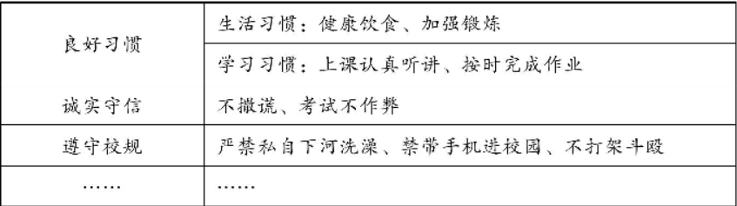
要求：1．全文字数90词左右。文章开头已给出，不计入单词总数。
2．条理清楚，书写T整，句式规范，标点符号和大小写使用正确。
3．内容必须包含表格中的提示信息，并适当发挥；文中不能m现真实的人名、
地名。
How to be a good student?
It's very important to be a good student. As teenagers, how to be a good student?
In my opinion，______________________________________________________________
______________________________________________________________________________________________________________________________________________________________________________________

达州市2017年高中阶段学校招生统一考试参考答案
英语参考答案与评分意见
I卷（共85分）
1—5ACBBC 6- 10 CBACA 11 - 15 CABAB 16 - 20 CBABC
21 - 25 ADBCD 26 - 30 ABBCD 31 - 35 ACBAD 36 -40 BADBC
41 - 45 CBCAB 46 -50 CADDA 51 - 55 ADCBD 56 - 60 ABCCD
61 - 65 BDACB 66—70 DFBGC
（其中1-50小题，每小题1分，共50分。51-65小题，每小题2分，共30分。66 -70小题，每小题1分，共5分。）
Ⅱ卷（共35分）
第五部分任务型阅读（共5小题，每小题1分，满分5分。注意：每小题按具体要求给分）
71．(A) out(B) like（单词正确，每空0.5分。）
72. experts said his score would be the same as Hawking's./experts said Hawking's score would be
the same as his.（单词顺序错误不给分。）
73.如果你不发展其它品质，你就会浪费（你的）聪明才智。（表述的内容符合文章大意可酌
情给分。）
74. Poverty, nutrition, stress and how familiar you are with the tests。（答对给1分。）
75. Will/Can a person with a high IQ succeed/be successful?（表述的内容符合文章大意可酌情
给分。）
第六部分 词汇运用（共10小题，每小题1分，满分10分。注意：只要有大小写、单词拼写、语
法等错误，均不给分）
76. Thanks 77. feet 78. Importantly 79. have run 80. would
81. health 82. using 83. burnt /burned 84. herself 85. to compare
第七部分 完成句子（共两节，满分10分。注意：只要有大小写、单词拼写等错误，均不给分）
第一节句型转换（本题共5小题，每空0.5分，每小题1分，计5分）
86. Did, put 87. Don't pick/No picking 88. were taken 89. made decision 90. whose,was
第二节汉译英（本题共5小题，每空0.5分，每小题1分，计5分）
91. take, seriously 92. set up 93. regarded as 94. pull together 95. throwing, at
第八部分书面衷达（10分）
96. One possible version:
How to be a good student?
It's very important to be a good student. As teenagers, How to be a good student?
In my opinion, first, we should develop good habits of living and learning. We should eat
healthy food and exercise more. Also, we have to listen to the teachers carefully and finish
homework on time. Second, we should be honest and keep our promises. We can't tell lies and
cheat in the exams. Next, we must obey the school rules. We mustn't swim alone in the river
without perrmssion. We can't bring mobile phones to the school and fight with others.
What't more, it's necessary to be polite and helpful. We should be always ready to help people
in need.

达州市2017年高中阶段学校招生统一考试
英语听力材料
第一节（本题共5小题，每小题1分，计5分）
听下面五段对话，每段对话后有一个小题，从题中所给的A.B\C三幅图片中选出最佳选项，并将答题卡上对应题号的答案标号涂黑。听完每段对话后，你将有5秒钟的时间来回答有关小题和阅读下一小题。每段对话读两遍。
1. W:I think the computer is the most important invention.
M: For me, the telephone is the most important one. Because I can chat with my friends at
any time I want.
2. M: What a great party for Mid-Autumn Festival!
W:I think so. I like the great performance and delicious mooncakes.
3. M: Mary, is that you? Wow, you have changed a lot!
W: Hey, Alan. Yeah,I used to have long curly hair, but now I have short hair.
4. W: You know,1 will go to China next month, Jack?
M: Oh, really?I think you are supposed to shake hands when you meet people for the first time.
5. M: Hello, Lily, where did you go on vacation last year?
W:1 went to Guizhou.l visited the famous Huangguoshu Waterfall.
笫二节（本题共15小题，每小题1分，计15分）
听下面四段对话和一段独白，每段对话或独白后有几个小题，从题中所给的A\B\C三个选项中选出最佳选项，并将答题卡上对应题号的答案标号涂黑。听每段对话或独白前，你将有5秒钟的时间阅读各小题；听完后，各小题将给卅5秒钟的作答时间。每段对话或独白读三遍。
听第6段材料，回答6 -7题。21世纪教育网
W: What do you want to be when you grow up, John?
M:1 want to be an astronaut, Mum.
W: It's great. Why do you want to be an astronaut?
M: Because I think it must be interesting to watch the earth from space. My hero is Jing Haipeng.
W: You have to be strong and healthy if you want to be an astronaut.
M: You're right, Mum. So I do sports every day to be stronger and I also know I need to study hard to make my dream come true.【来源：21·世纪·教育·网】
昕第7段材料，回答8 -10题。
W: May I help you?
M: Yeah. Father's Day is coming. I'm looking for a gift for my father.
W: We have a lot of gifts here. How about this black shirt?
M: How much is it?
W: It's only$25.
M: That's too expensive for me.
W: How much money do you want to spend?
M:$16. That's all I have.
W: How about this tie?
M: It looks nice, but I don't like the color.
W: What about this blue and black one?
M: That's OK. How much is it?
W: It's $ 18. But it's on sale now. It is only $ 15.
M: Oh, thanks. I'll take it.
听第 8段材料 ,回答 11 - 13题。
M:Morning, Alice. How was your holiday in the country?
W:Wonderful! We had a great time. And some friends went with us.
M:Where did you stay? In a hotel?
W:No, we stayed in farmers' houses. We cooked all our meals ourselves and ate outside
M:Sounds wonderful. Was the weather good?
W:The sun shone nearly every day and it didn't rain.【出处：21教育名师】
M:Did you like the people there?
W:Yes, they were friendly. We met some farmers and had tea in their houses.
M:When did you come back? Last night?
W:No, we came back this morning.
昕第 9段材料,回答 14 - 16题。
M: What can I do for you, madam?
W: Yes, please. I've been to see my daughter, but I can't find the way
M: You've been to Dazhou before?
W: Yes. Several years ago I did. But Dazhou has changed a lot.
M: That's true. So your daughter should come to meet you at the train station.
W: I didn't tell her about it. I think she is busy and I don't want to trouble her.
M: Where does she work, do you know? Do you have her address?
W: I only know she works in a school and beside it is a Children's Hospital.
M: Great. I know where it is. Come on with me. I can help you find it.
W: Thanks a lot.
昕下面-段独白,回答17 -20题。
Last year I volunteered as a clerk at a local store. I worked there for a month. I felt very happybecause I could do something to help our local people.
One day, a young mother with a baby came to the store. The baby was only one year old. Theyoung mother was looking for some toys for her son. She was happy about a toy she was looking at.But after she went through her bag for a while, she said that she had left her wallet at home.
I suggested she went home quickly and came back for the toy, but she said she lived far fromhere. Looking at her disappointed face, I felt sorry for her and I took out my wallet and paid for hertoy. She was so surprised that someone offered to do that and then she took down my name and address.
My mother thought the young lady wouldn't give back the money. But two days later, after I
received a check from the woman. She was very surprised!

