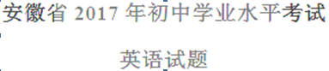
第一部分 听力（共五大题，满分30分）
I. 关键词语选择（共5小题；每小题1分，满分5分）
你将听到五个句子。请在每小题所给的A、B、C三个选项中选出一个你所听到的单词或短语。每个句子读两遍。2-1-c-n-j-y
1. A. milk B. drink C. chalk
2. A. risk B. mix C. fix
3. A. road B. boat C. coat
4. A. loud B. proud C. round
5. A. copy down B. turn down C. bring down
II. 短对话理解（共10小题；每小题1分，满分10分）
你将听到十段对话，每段对话后有一个小题。请在每小题所给的A、B、C三个选项中选出一个最佳选项。每段对话读两遍。
6. What does Lucy want to buy for her mum?
A.  B.  C. 
7. What animal does the woman like?
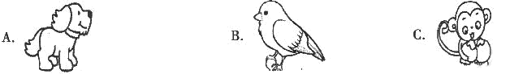
8. What are the speakers talk about?
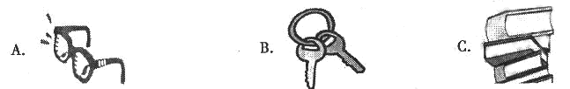
9. What is the woman’s favorite fruit?
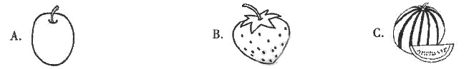
10. What will the speaker’s grandparents do this Sunday?【出处：21教育名师】21教育网
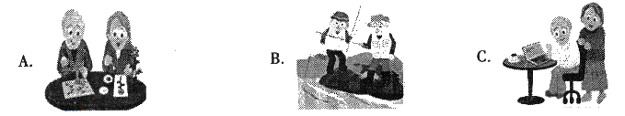
11. What could the woman like to drink?
A. Coffee. B. Juice. C. Water.21·cn·jy·com
12. Why does the man feel nervous?
A. Because he isn’t good at dancing.
B. Because he doesn’t know most of the guests.
C. Because the woman won’t introduce him to others.
- How will the man probably go to Washington Square?
A. By car. B. By bus. C. On foot.
14. What does the woman want to do?
A. Stay with Alan. B. Send Alan to school. C. Find Alan a teacher.
15. Where did the woman study English?
A. In London. B. In Beijing. C. In New York.
III. 长对话理解（共5小题；每小题1分，满分5分）
你将听到两段对话，每段对话后有几个小题。请在每小题所给的A、B、C三个选项中选出一个最佳选项。每段对话读两遍。
听下面一段对话，回答第16 至17小题。
16. What is wrong with the woman?
A. She has a headache. B. She has a fever. C. She has a cough.
17. What’s the relationship between the two speakers?
A. Classmates. B. Doctor and patient. C. Father and daughter.
听下面一段对话，回答第18至20小题。
18. Who will spend the weekend with the man?
A. His parents. B. His friends. C. His teachers.
19. Where will the man go camping?
A. By a lake B. On a hill C. Near a river.
20. What does the woman ask the man to be careful of?
A. Weather. B. Traffic. C. Fire.
IV. 短文理解（共5小题；每小题1分，满分5分）
你将听到一篇短文，短文后有五个问题。请根据短文内容，在每小题所给的A、B、C三个选项中选出一个最佳选项。短文读两遍。
21. How old are the speaker’s parents?
A. Under 60. B. About 65. C. Over 70.
22. What happened at the speaker’s home village?
A. A big rainstorm. B. An earthquake. C. A car accident.
23. How long will the speaker stay at home?
A. For three days. B. For five days. C. For a week.
24. What can the speaker do to help?
A. Do some repair work. B. Call the police. C. Buy a new house.
25. What is the listening text?
A. A public speech. B. A phone message. C. A news report.21·cn·jy·com
V. 信息转换（共5小题；每小题1分，满分5分）
你将听到一篇短文。请根据短文内容，写出下面表格中所缺的单词，每空仅填一词。短文读两遍。
A School Day
Who | The students of Class Eight, Grade 26
When | Last 27
What | ●Some students acted as 28 to help the visitors.  ●The speaker told the visitors about the 29 of the school.  ●Other students put on a 30 for the visitors.

第二部分 英语知识运用（共两大题，满分45分）
VI. 单项填空（共15小题；每小题1分，满分15分）
从每小题所给的A、B、C、D四个选项中选出一个可以填入空白处的最佳选项。
31. ---I’m afraid I can’t do well in the game.
---_____. It’s just for fun.
A. Sounds good B. What a pity C. Thank you D. Take it easy
【答案】D
【解析】
试题分析：句意：--恐怕我在比赛中不能很好地发挥。--放松。那只是为了娱乐。A. Sounds good听起来很好； B. What a pity多么的遗憾； C. Thank you谢谢您； D. Take it easy放松，不紧张。根据后文It’s just for fun.故选D。【来源：21cnj*y.co*m】21cnjy.com
考点：考查情景交际。
32. ---Is this iPad yours?
---Yes. My parents bought _____ for my language learning.21cnjy.com21*cnjy*com
A. one B. it C. other D. another
【答案】B
【解析】
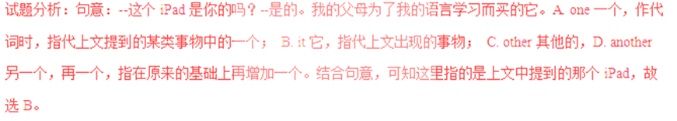考点：考查代词的用法。
33. The New Silk Road will offer a good _____ for more nations to communicate.
A. chance B. habit C. question D. price
【答案】A
【解析】
试题分析：句意：新丝绸之路将为更多的国家交流提供一个好机会。A. chance 机会； B. habit 习惯；C. question 问题，疑问；D. price价格。新丝绸之路是为更多的国家提供交流的机会，故选A。【版权所有：21教育】
考点：考查名词辨析的用法。
34. I am surprised at the new look of my hometown, for it _____ a lot over the years.
A. changed B. changes C. will change D. has changed
【答案】D
【解析】
试题分析：句意：对我的家乡的新面貌我感到吃惊，因为这几年它变化很大。A. changed 改变，过去式； B. changes第三人称单数形式； C. will change 一般将来时；D. has changed现在完成时。over the years.指最近几年即从过去到现在的几年，所以用现在完成时，故选D。2-1-c-n-j-y
考点：考查动词的时态的用法。
35. ---What do you think of the movie?
---Great! I have never seen a _____ one.
A. good B. bad C. better D. worse
【答案】C
【解析】
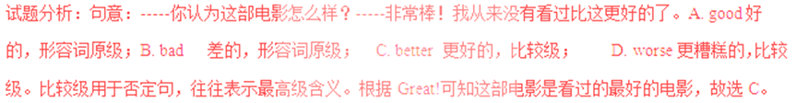考点：考查形容词比较级的用法。
36. Hold your dream, _____ you might regret some day.
A. and B. or C. but D. so
【答案】B
【解析】
试题分析：句意：抓住你的梦想，否则你有一天会后悔。A. and 并且，表示并列关系；B. or 用于连接两个并列的句子,表示"否则,要不然"的意思。 C. but但是，表示转折关系； D. so所以，表示结果。根据句意，故选B。
考点：考查连词的用法。
37. It is necessary for schools to _____ the need of all the students’ development.
A. cut B. hide C. refuse D. satisfy
【答案】D
【解析】
试题分析：句意：对于学校来说满足所有学生发展的需求是必要的。A. cut砍，切，割；B. hide 藏；C. refuse 拒绝；D. satisfy满足。结合句意，故选D。21教育名师原创作品
考点：考查动词辨析的用法。
38. To my pleasure, my family is always _____ me whatever I decide to do.
A. above B. behind C. from D. through
【答案】B
【解析】
试题分析：句意：令我愉快的是，无论我决定做什么，我的家庭总是支持我。A. above 在……上面；B. behind在……后面； C. from 从……； D. through通过。be behind sb 对某人支持或者赞同。结合句意，故选B。
考点：考查介词的用法。
39. ---Mum, I’ve signed for the box. What’s in it?
---I’m not sure. It _____ be a present from your uncle.21教育网
A. need B. must C. may D. will
【答案】C
【解析】
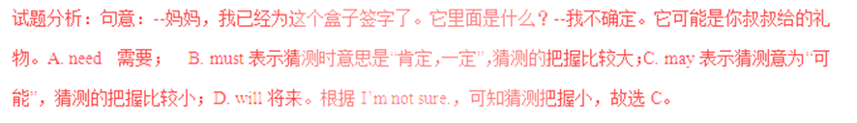考点：考查情态动词的用法。
40. My deskmate is really _____. She likes to attend different activities after school.
A. active B. quiet C. lazy D. honest
【答案】A
【解析】
试题分析：句意：我的同桌真地很积极。她喜欢参加课外的不同活动。A. active积极的，活泼的；B. quiet安静的；C. lazy 懒惰的； D. honest诚实的。根据她参加不同的课外活动，可知她是积极的，故选A。【版权所有：21教育】
考点：考查形容词的用法。
41. ---Do you know _____ Ann goes to work every day?
---Usually by underground.
A. why B. how C. when D. whether
【答案】B
【解析】
试题分析：句意：--你知道安每天怎样去上班吗？--通常乘坐地铁。A. why为什么，提问原因； B. how怎样，提问方式；C. when 何时，提问时间；D. whether是否。根据回答Usually by underground可知提问交通方式，故选B。
考点：考查疑问词的用法。
42. Mr. Green _____ to sing an English song at the party and he sang well.
A. was invited B. invited C. is invited D. invites
【答案】A
【解析】
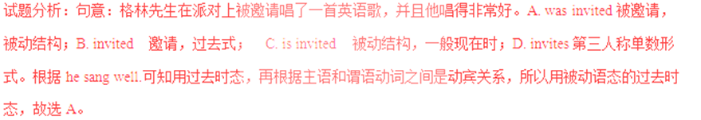考点：考查被动语态的用法。
43. There are many beautiful places to visit in Anhui, _____ Mount Huang in autumn.
A. simply B. finally C. luckily D. especially
【答案】D
【解析】
试题分析：句意：在安徽有许多美丽的地方可以参观，尤其是秋天的黄山。A. simply简单地；仅仅； B. finally最后；C. luckily幸运地；D. especially尤其是。根据句意，故选D。
考点：考查副词的用法。
44. Our geography teacher told us to _____ more information about our city and share it next week.
A. find out B. keep away C. turn off D. use up
【答案】A
【解析】
试题分析：句意：我们的地理老师告诉我们找出关于我们市的更多的信息，以便下周分享。A. find out 找出，查出；B. keep away 远离，离开；C. turn off 关闭； D. use up用光。结合句意，故选A。
考点：考查动词短语的用法。
45. ---May I do some sports after finishing my homework?
---_____. It is good for your health.
A. I hope not B. Sorry, you can’t C. Of course D. Yes, I’d love to
【答案】C
【解析】
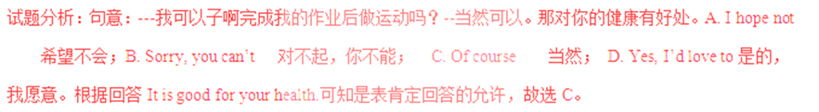考点：考查情景交际。
VII. 完形填空（共20小题；每小题1.5分，满分30分）
阅读下列短文，从每小题所给的A、B、C、D四个选项中选出一个最佳选项。
A
Henry Bond was about seven years old when his father died. His mother found it 46 to support the large family. However, she tried her best to do so. Also, she 47 Henry, the eldest son, to school. 21*cnjy*com
At one time, Henry needed a grammar book for his study. His family was so 48 that his mother could not afford one.
One morning, Henry found that a deep snow had fallen, and the 49 wind was blowing. “Ah,” he said, “it is an ill wind that blows nobody good.” With these words, he ran to the house of a neighbor, and offered his 50 to move away the snow around it. The offer was accepted. When he finished the work, he received his 51 . Then he went to another place for the 52 purpose, and then to anther, 53 he had earned (挣得) enough to buy a grammar book.
From that time, Henry was 54 the first in all his classes. He knew no such word as “ 55 ”, and he succeeded in all he tried to do. Having the will, he always found the way.
46.A. easy B. fun C. difficult D. possible
47. A. returned B. sent C. followed D. lent
48. A. large B. small C. rich D. poor
49. A. cold B. warm C. cool D. hot
50. A. service B. choice C. money D. interest
51. A. book B. pay C. letter D. study
52. A. last B. strange C. same D. boring
53. A. if B. because C. since D. until
54. A. always B. never C. already D. seldom
55. A. help B. fall C. try D. give
【答案】
46.C
47.B
48.D
49.A
50.A
51.B
52.C
53.D
54.A
55.B
【解析】
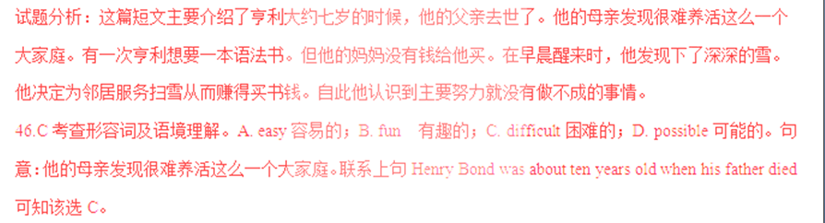47.B考查动词及语境理解。A. returned 返回，归还；B. sent送，寄；C. followed 跟随； D. lent借给。根据上文However, she tried her best to do so可知她送亨利最大的儿子去上学。故选B。www-2-1-cnjy-com
48.D A. large巨大的；B. small小的； C. rich富有的； D. poor贫穷的。他的家庭是那么的贫穷以至于她的妈妈负担不起一本语法书。根据上下文可知他家贫穷，结合句意，故选D。
49.A考查形容词及语境理解。A. cold冷的；B. warm温暖的；C. cool凉爽的； D. hot热的。根据上文Henry found that a deep snow had fallen可知在刮着寒冷的风，故选A。
50.A考查名词及语境理解。 A. service服务；B. choice选择；C. money 钱； D. interest兴趣。根据后文可知他跑到邻居家，为邻居提供清扫房子周围雪的服务，故选A。
51.B考查名词及语境理解。A. book预定，书；B. pay付款； C. letter 信；D. study学习。当他完成这项工作，他受到了他的报酬。根据他买到了语法书，可知他受到了报酬，故选B。
52.C考查形容词及语境的理解。A. last最后；B. strange 奇怪的；C. same 相同的； D. boring无聊的。然后他为了相同的目的去了另一个地方。根据后文可知他为了赚钱而去了另一个地方，赚钱买语法书是他的目的，故选C。21·世纪*教育网
53.D考查连词及语境的理解。A. if如果；B. because因为；C. since 自从； D. until直到。他为了赚钱而去了另一个地方，然后在一个地方，直到他挣得足够买语法书的钱。结合句意，故选D。
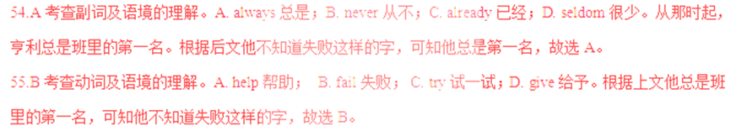考点：人物介绍类短文。
B
Bike-sharing is a new choice for short journeys in cities. It is good to the 56 development of the big cities.【来源：21cnj*y.co*m】
A 57 by a company found that shared bikes started the nation’s 58 for bikes again. Now more and more Chinese people are 59 bikes instead of cars to make short journeys in cities.
An engineer of that company says that since the 60 of shared bikes, people have made fewer trips by car. The love for shared bikes is not only among 61 people, who were born in the 1980s and 1990s, but also among people over sixty.
At weekends, the number of the riders in Shenzhen reaches the 62 of all cities. On weekdays, the number of people who use shared bikes to travel to work is 63 in Shanghai.
It is said that bike-sharing will help 64 the cities’ environment. It not only helps solve the traffic problems, but also will help to make more use of 65 in cities. Take Beijing as an example if more people choose shared bikes, an area of five Bird’s Nest stadiums (体育场)will be saved.
56. A. slow B. healthy C. harmful D. sudden
57. A. rule B. plan C. report D. suggestion
58. A. search B. worry C. preparation D. love21世纪21世纪教育网有
59. A. choosing B. pushing C. repairing D. locking
60. A. end B. start C. control D. fall
61. A. strong B. weak C. old D. young
62. A. top B. side C. corner D. line
63. A. coming over B. putting off C. going up D. giving away
64. A. discover B. separate C. experience D. improve
65. A. air B. time C. space D. money
【答案】
56.B
57.C
58.D
59.A
60.B
61.D
62.A
63.C
64.D
65.C
【解析】
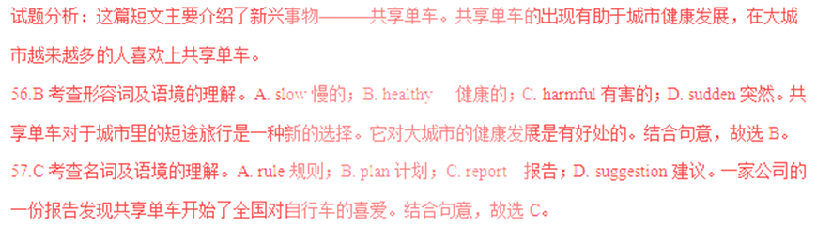58.D考查名词及语境的理解。A. search 搜查，探究；B. worry 担心； C. preparation 准备；D. love爱。根据下文可知共享单车开始了全国对自行车的爱。故选D。
59.A考查动词及语境的理解。A. choosing选择；B. pushing 推；C. repairing修理；D. locking锁。越来越多的中国人正在选择自行车而不是汽车在城市进行短途旅行。结合句意，故选A。
60.B考查动词及语境的理解。A. end结束； B. start 开始；C. control 控制； D. fall落下。那家公司的工程师说，自从共享单车开始，人们更少开车进行旅行了。结合句意及上文，故选B。21·世纪*教育网21世纪教育网版权所有
61.D考查形容词及语境的理解。A. strong强壮的；B. weak 虚弱的； C. old老的，旧的；D. young年轻的。对共享单车的喜爱不仅仅是在八九十年代出生的年轻人中，也出现在六十多岁的老人中。根据下文but also among people over sixty.故选D。
62.A考查名词及语境的理解。A. top 顶部； B. side 边；C. corner 角落； D. line线；周末在深圳骑自行车的人数达到了所有城市之首。根据比较级范围，可知处于首位，故选A。
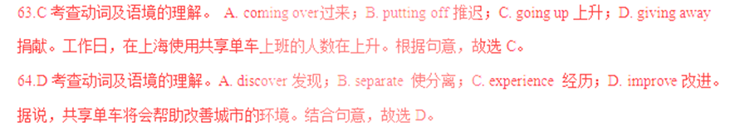65.C考查名词及语境的理解。A. air 空气； B. time时间； C. space 太空，空间；D. money钱。它不仅能帮助解决交通问题而且也能帮助更好的利用城市空间。根据后文的例子，可知是更好利用城市空间，故选C。www-2-1-cnjy-com
考点：社会现象类短文。
第三部分 阅读理解（共两大题，满分45分）
VIII. 补全对话（共5小题；每小题1分，满分5分）
根据对话内容，从方框内的选项中选出能填入空白处的最佳选项，其中有两个为多余选项。
Li Lei: hey, Bruce. I’m going home this weekend.
Bruce: 66
Li Lei: To celebrate the Mid-Autumn Festival.
Bruce: 67
Li Lei: It is an important time for family.
Bruce: 68
Li Lei: We’ll have dinner together, watch the moon and eat mooncakes.
Bruce: Mooncakes? Are they delicious?
Li Lei: Yes. 69 We can celebrate it together.
Bruce: 70 Thank you!
Li Lei: You are welcome.
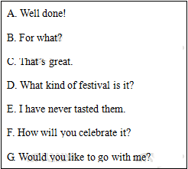
【答案】
66.B
67.D
68.F
69.G
70.C
【解析】
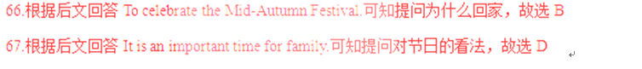
68.根据后文回答怎么过节，可知提问怎么庆祝，故选F
69.根据We can celebrate it together.可知提出邀请，故选G
70.根据后文的感谢，可知接受了邀请，故选C.
考点：情景交际。
IX. 阅读理解（共20小题；每小题2分，满分40分）
阅读下列短文，从每小题所给的A、B、C、D四个选项中选出一个最佳选项。
A
Once upon a time there was no tea at all in England. People there used to drink a light beer(啤酒). No coffee or milk but large glasses of beer stood on the breakfast table!
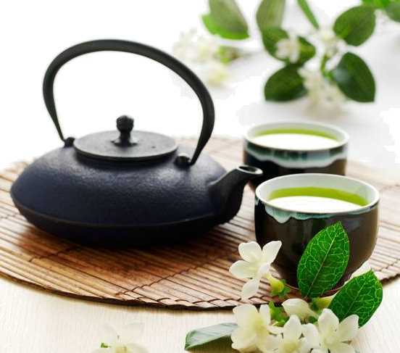
When tea was first brought to England, an old couple got some as a special treat. But they did not know how I t should be used. They cooked the leaves in hot water, and spread them on a piece of bacon(熏肉) which they were going to have for dinner. They ate the leaves, and threw the tea away! However, tea is becoming as popular as coffee and milk in England today.
Tea is the leaf of a plant which grows widely in China, Japan and some other countries. Tea famers usually grow many tea plants on a large piece of land. When the tea leaves are ready to be picked, it is the busiest time for tea farmers in a year. They pull off on the leaves and dry them. In their spare time, they pick out the best leaves and get them ready for market. In china, whenever a visitor comes into a house, he is served with a cup of tea.21世纪教育网21-cn-jy.com
71. What was served for breakfast in England long ago?2·1·c·n·j·y
A. Beer. B. Tea. C. Coffee. D. Milk.
72. How did the old couple deal with the tea leaves?
A. They sold them. B. They ate them.
C. They burnt them. D. They threw them away.
73. Tea farmers are the busiest in a year when they _____.
A. serve visitors at home B. sell tea in the market
C. pick and dry tea leaves D. look for a piece of land
74. In which part of a magazine can read the text?
A. Nature. B. Culture. C. Environment. D. Technology.
【答案】
71.A
72.B
73.C
74.B
【解析】
试题分析：这篇短文主要介绍了英国人的饮茶历史及茶的产地及种植。
71.A 细节理解题。根据短文第一段No coffee or milk but large glasses of beer stood on the breakfast table!可知很久以前，在英国人们早餐桌上只有大杯的啤酒。故选A 。
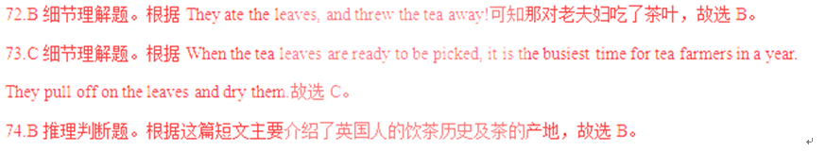
考点：文化历史类短文阅读。
B
Still remember the following poems? Memories return every time I read or hear them.
①  Hush now, my little one.  Hush now, my sunshine.  Hush now, piece of my heart.  Go to sleep, my little one.  Go to sleep, my love.  Go to sleep, piece of my heart.  Sleep, my little one,  While I sing to you.  Sleep, my little one,  Who is already asleep. | ②  My mama feeds me,  And washes my fur.  The first thing I see every morning is her.  The last thing I kiss every night is her face.  My mama is the very best one,  And sings like a bird,  And knows how I feel.  When I don’t say a word,  My mama is warm. | ③  I can set the table.  I can sweep the floor.  I can wash my clothes  And count to forty-four.  I can wash dishes.  And clean my bedroom.  There is so much I can do.  Now ask you.
Notes: 1. hush v. 安静 2. fur n. 皮毛 3. sweep v. 打扫
75. The first poem is sung to _____.
A. babies B. mothers C. relatives D. friends
76. In the second poem, the last thing “I” will kiss at night is _____.www.21-cn-jy.com
A. the fur B. mum’s face C. a bird D. mum’s bed
77. What do you think of “I” in the third poem?
A. Helpful. B. Lucky. C. Crazy. D. Shy.
78. What are the three poems mainly about?
A. Food and health. B. Hobbies and sports.
C. Family and love. D. Animals and humans.
【答案】
75.A
76.B
77.A
78.C
【解析】
试题分析：这篇短文主要介绍了三首诗歌：第一首诗歌是妈妈的摇篮歌，第二首描述的是孩子对妈妈的依恋及爱，第三首描述孩子长大了能帮助做家务了。【来源：21·世纪·教育·网】
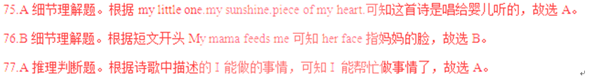
78.C归纳理解题。根据第一首诗歌是妈妈摇篮歌，第二首描述的是孩子对妈妈的依恋，第三首描述孩子长大了能帮助做家务了，可知这三首诗歌主要是关于家庭和爱的，故选C。
考点：诗歌类短文阅读。
C
Dear Sunday Globe,
I am writing to tell you about your article Smartphones Make Life Easier in last Sunday’s newspaper. You did an excellent job explaining the good points of smartphones, but you didn’t talk about their bad points at all. So, I hope you’ll let me give your readers some advice on smartphone etiquette (礼仪). 【来源：21·世纪·教育·网】
The first point I’d like to address is loudness. When you talk on your smartphone in public, please don’t shout. In fact, the microphones in smartphones are very sensitive (灵敏的). So, you can be heard even if you speak quietly.
Another point is about personal space. I don’t think it is polite to make calls in small spaces full of people. This makes others uncomfortable and forces them to listen to your personal business. What’s worse, it stops many face-to-face conversations from ever beginning.
Lastly, doing two things at the same time is dangerous. For example, making calls while driving is a bad habit. Pay attention to the road! Similarly, when staying with your friends, turn off your smartphone and enjoy their company.
Yours truly,
Amber Jala
79. Amber Jala wrote the letter to ________ .
A. find a good job B. provide advice
C. make her life easier D. buy a smartphone
80. What does the underlined word “address” in Paragraph 2 probably mean?
A. 致函 B. 称呼 C. 陈述 D. 选址
81. According to Paragraph 3, what makes people around you uncomfortable?
A. Discussing face-to-face. B. Speaking quietly on your phone.
C. Minding your own business. D. Calling in small spaces full of people.
82. What can we learn from the last paragraph?
A. It is dangerous to drive on the road.
B. It is easy to start a company with others.
C. It is bad to turn off our phones while driving.
D. It is important to use our smartphones properly.
【答案】
79.B
80.C
81.D
82.D
【解析】
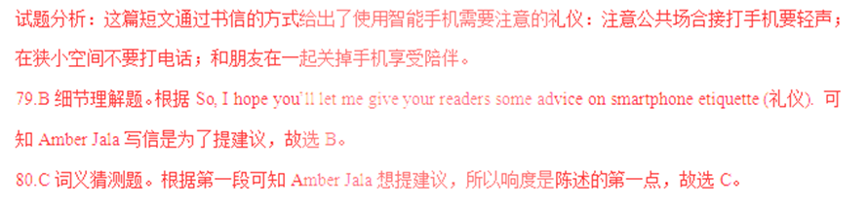81.D细节理解题。根据第三段I don’t think it is polite to make calls in small spaces full of people.及 This makes others uncomfortable and forces them to listen to your personal business.可知this指代上文中to make calls in small spaces full of people这件事，故选D。
82.D归纳理解题。根据最后一段主要介绍了边开车边打电话时危险的，和朋友在一起要关闭手机享受陪伴，对比选项可知作者想告诉我们合适的使用手机时重要的，故选D。
考点：书信类短文阅读。
D
Kaitlin Riffel’s dream to end poverty(贫困) started when she was visiting her father, who worked for the homeless.
“I never realized there were people in the world who didn’t have a home or food before,” said Kaitlin, who is now sixteen. “I knew there was something I had to do about that.”
At age eight, she started raising money to build a playground. "It took me two years," Kaitlin said. "We started small. We wanted to do something to make a difference.”
In 2014, When Kaitlin was thirteen, she visited Central America, and saw people going hungry and families living in houses made of cardboard. That year, we set Kids on a Mission, which has helped hundreds of people there.
“The rooms were smaller than my bedroom, but there would be eight people living in each one," Kaitlin said. “We also got to see the dirty rivers that those people were drinking out of.”
Providing clean drinking water, food and clothes for people living in poverty is now an important task for Kids on a Mission. “This young lady is changing the hearts of people, and also changing the world," said the headmaster of Kaitlin's school.
83. The job of Kaitlin's father was to__________
A. sell foods B. build playgrounds
C. visit schools D. help homeless people
84. When did Kaitlin set Kids on a Mission?
A. In 2009. B. In 2011. C. In 2014. D. In 2017.
85. What was people's life like in Central America according to Kaitlin?
A. They lived in strong houses. B. Their drinking water was dirty.
C. Their bedrooms were very big. D. They had enough food and clothes.
86. What can we infer from the headmaster's words?
A. Kaitlin is always ready to give and help. B. Kaitlin has many chances to travel around.
C. Kaitlin often changes schools for her study. D. Kaitlin has a serious problem with her heart.
87. What might be the best title for the text?
A. School life in America B. Gift from a headmaster
C. Father’s duty in the family D. Girl's dream to end poverty
【答案】
83.D
84.C
85.B
86.A
87.D
【解析】
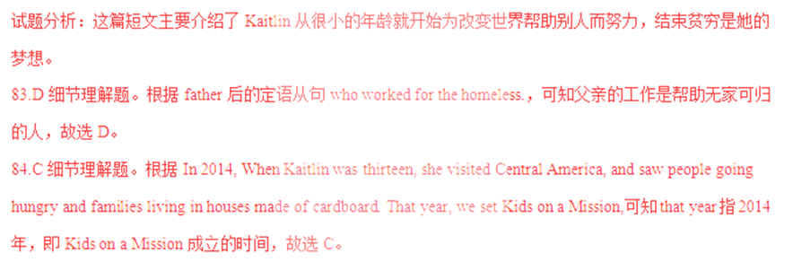85.B是非判断题。根据she visited Central America, and saw people going hungry and families living in houses made of cardboard.可知ADC项错误，根据“We also got to see the dirty rivers that those people were drinking out of.”可知B正确，故选B。
86.A推理判断题。根据“This young lady is changing the hearts of people, and also changing the world," said the headmaster of Kaitlin's school.校长说“这位年轻的女士正在改变人们的心灵，也改变了世界，”及上文对Kaitlin帮助人们的表现，可知Kaitlin总是准备给予帮助他人，故选A。
87.D标题归纳题。根据短文主要介绍了Kaitlin从很小的年龄就开始为改变世界帮助别人而努力，结束贫穷是她的梦想，故选D。
考点：人物介绍类短文阅读。
阅读下面短文，并用英语回答问题（请注意每小题后面的词数要求）。
E
There was once an old and deep well. People got water by dropping a bucket(木桶) tied to a rope. The rope passed over a wheel just above the well. On the other side of the rope was another bucket.
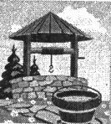
A strong pull brought one bucket to the top while the other down to the water. They always passed each other on the way up and down, but never had time to speak.
At last, the rope became worn. So a new rope had to be put in its place. While this was being done, the two buckets were left standing together near the well.
“What a boring life we have!” said one bucket to the other. “I am quite tired of it. No matter how full we come up, we are always sent down empty.”
But the other bucket laughed and said, “What a funny way you have of looking at things! Don’t you see that whenever we are sent down empty, we always come up full?’
Boys and girls sometimes talk like these two buckets. You may hear one of them say, “Just as we are having a good game, we are made to stop and go to work again.” “Yes,” the other will reply, “but as soon as work is over, we always get to go out and have fun again.”
There are two ways of looking at things. If you want to be happy, look at the bright side.
88. What were the buckets tied to? （不超过10个词）
____________________________________________
89. Where did the two buckets talk with each other?（不超过10个词）21*cnjy*com
____________________________________________
90. What does the story tell us?（不超过15个词）
【答案】
88.A rope. / They were tied to a rope
89.Near the well. / They talked with each other near the well.【出处：21教育名师】
90.If we want to be happy, we should look at the bright side of things.
【解析】
试题分析：这篇短文主要介绍了水井里的两只木桶对同一件事的消极和积极态度。作者想告诉我们事物总是有两面性的，如果我们想快乐我们就要看到事物积极的一面。
88.根据There was once an old and deep well. People got water by dropping a bucket(木桶) tied to a rope. 可知木桶被栓到绳上。故填A rope. / They were tied to a rope
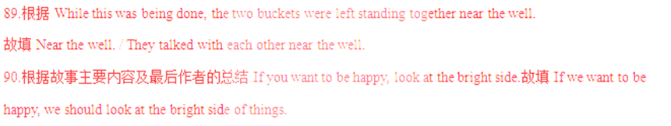考点：故事类短文阅读。

第四部分 写（共两大题，满分30分）
X. 单词拼写（共5小题；每小题1分，满分5分）
根据首字母及汉语提示，完成下列单词的拼写，使句意明确，语言通顺。
91. For a w (明智的) man, a mistake is a lesson.21*cnjy*com
92. My father’s T-shirt has completely lost its s (形状).
93. Look! The boys are k (踢) the ball around in the yard.
94. An old man began to collect rubbish along the river b (岸) years ago.
95. Please follow the rules. Don’t t (触碰) the photos in the museum.
【答案】
91.wise
92.shape
93.kicking
94.bank(s)
95.touch
【解析】
试题分析：
91.对于明智的人来说，错误就是教训。形容词修饰名词，结合句意，故填wise
92.我父亲的T恤衫完全走形了。根据句意，故填shape
93.看！那些男孩正在院子里到处踢球。be doing 构成现在进行时，故填kicking
94.数年前一个老人开始沿着河岸收集垃圾。结合句意，故填bank(s)
95.请遵守这些规则。不要碰触博物馆里的照片。否定祈使句的构成是don’t +动词原形+其他，结合句意，故填touch. 2·1·c·n·j·y
考点：词语运用。
XI. 书面表达（共1小题；满分25分）
假如你是李华，你们学校将举行“弘扬中华传统文化——戏曲进校园”展演活动，你打算邀请你的美国朋友Mike参加。请你根据以下提示用英文给他写一封电子邮件。
1. 时间：7月1日下午2点；
2. 地点：学校操场；
3. 内容：文化展览、节目表演等。
提示词：戏曲opera n. 表演performance n.
注意：1. 词数80～100；
2. 可适当增加细节，以使行文连贯；
3. 信中不能出现与本人相关的信息；
4. 开头和结尾已为你写好，不计入总词数。
Dear Mike,
I know you are interested in Chinese traditional culture. __________________________________________
_____________________________________________________________________________________________________________________________________________________________________________________________________________________________________________________________________________________________________________________________________________________________________
Yours,
Li Hua
【答案】
One possible version:
Dear Mike,
I know you are interested in Chinese traditional culture.
Now, I have a piece of good news to share with you. There is an activity about Chinese traditional operas at 2:00 p.m. on July 1. It will be held on the playground in our school and all t he teachers and students will attend. On that day, a culture show and many wonderful opera performances will be put on. It's a chance for you to learn more about Chinese traditional culture. Come and join us! I think we'll have a great time.
I'm looking forward to your early reply.
Yours,
Li Hua
【解析】
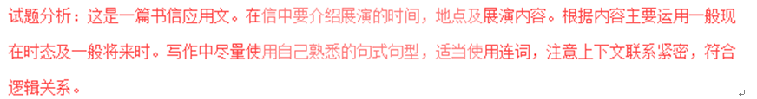
写作亮点：这篇短文内容涵盖了题目要求的所有要点，表达准确，意思连贯，符合逻辑。文章脉络清晰，自然流畅，首先通过分享好消息来引出展演及展演时间，进而介绍展演地点及展演内容最后提出邀请。同时文章还使用了一些常用的句式和短语，这为文章增色不少。在学习中注意积累，掌握一些常用句式及短语，写作时就可以适当引用，使文章的表达更有逻辑性，更富有条理。21教育名师原创作品
考点：书信类作文。

