宜宾市20 1 7年高中阶段学校招生考试
英语试卷
（考试时间：120分钟；全卷满分：120分）
注意事项：1．答题前，务必将自己的姓名、座位号、准考证号填写在答题卡指定的位置，
并将答题卡背面座位号对应号涂黑。
2．第1卷、第II卷的答案务必答在答题卡上。若答在试卷上，将被视为无效。
第1卷每小题选出答案后，用2B铅笔把答题卡上对应题目的答案标号涂黑。
如需改动，用橡皮擦干净后，再选涂其他答案标号。
第I卷 选择题（共三部分，满分85分）
第一部分 听力（共三节，满分20分）
第一节听对话选图（共5小题，每小题1分，满分5分）
听下面五段对话，从题中所给的A、B、C三幅图片中选出与对话意思相符的图片。每
段对话听两遍。
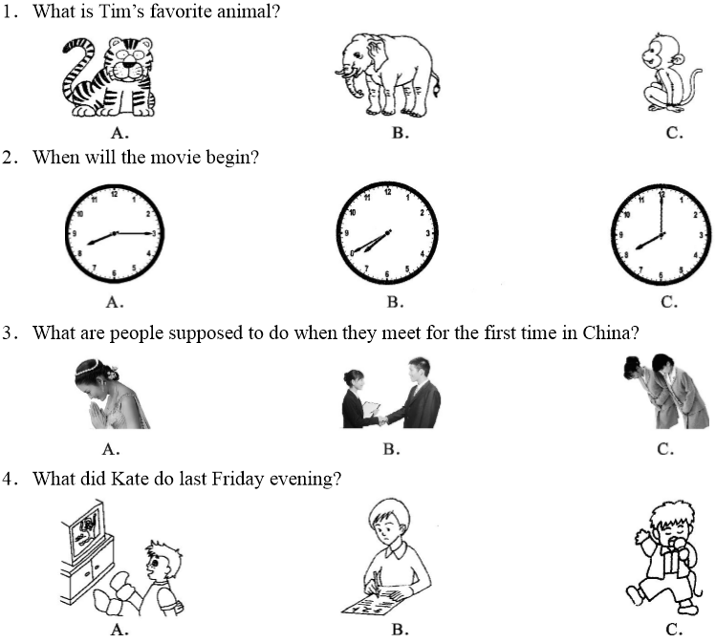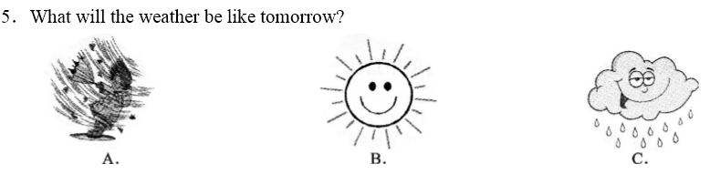
第二节对话理解（共10小题，每小题1分，满分10分）
听下面七段对话，从题中所给的A、B、C三个选项中选出最佳选项。每段对话听两遍。
听第一段对话，完成第6小题。
6. Which subject is difficult for the girl?
A. Chinese. B. Math. C. English.
听第二段对话，完成第7小题。
7. When was Fu Yuanhui born?
A. On January 2nd, 1996.
B. On February 7th, 1995.
C. On January 7th, 1996.
听第三段对话，完成第8小题。
8. Why does the boy study so hard?
A. To get good grades.
B. To enter a good university.
C. To travel to good places.
听第四段对话，完成第9小题。
9. What is the girl going to be when she grows up?2·1·c·n·j·y
A.Amovie star. B.A swimming star C. A pop singer. 【版权所有：21教育】
听第五段对话，完成第10至第11小题。
10. Where did Frank spend his holiday?
A. In the city. B. In the country. C. In the factory.
11. What did they do there?
A. They helped with getting in tomatoes.
B. They helped with getting in potatoes.
C. They helped with planting potatoes.
昕第六段对话，完成第12至第13小题。
12. How many times has Dick been to the East Park?
A. Once. B. Twice. C. Three times
13. How does Dick like the East Park?
A. Notinteresting. B. Too old. C. Not very big
听第七段对话，完成第14至第15小题。
14. Who is the shortest of the three boys?
A. Tom. B. Bill. C. Rick.
15. What does Tom like playing better?
A. Basketball. B. Volleyball C. Soccer
第三节听短文，选择正确信息填表（共5分，每小题1分）
根据所听内容和表格中的提示词，从下列各题所给的A、B、C三个选项中选择最佳选
项。短文听三遍。

An Experience of Watching a Movie
Time | Last weeked
Event | I went to cinema to watch journey to the west with 16 .
Result | Some of the people there made me feel very 17 .
Causes | - A few guys were 18 loudly or even shouting.  - Some people threw away plastic bags, 19 and other rubbish.
Advice | All of us are supposed to obey the rules 20 .
16. A. my friends B. my parents C. my classmates
17. A. surprised B. excited C. unhappy
18. A. singing B. laughing C. talking
19. A. paper B. bottles C. snacks
20. A. at school B. in public C. at home
笫二部分语言知识运用（共二节，满分25分）
第一节单项选择（共10小题，每小题1分，满分10分）
从下列各题所给的A、B、C三个选项中，选出可以填入空白处的最佳选项。
21. Li Qiang is_____ honest boy. He wants to be_____useful person when he grows up
A. a, an B. an,a C．a：a
22. —Is this your book?
—No. It's not . It's .
A. my; his B. mine; hers C. me; him
23. Who is better______playing basketball, you or your brother?
A. at B. in C. on21·世纪*教育网
24. There ______a basketball match in our school this afternoon.
A. will have B. will be C. is going to have
25. —Would you please tell me_______?
—In Yibin.
A. where do you live B.where you live C. you live where
26. It is ______for him to get to school on time, because it is raining ______.
A. hard; hardly B.hardly; hard C. hard; hard
27. Two months ____ a long time. We can visit our grandparents during the vacation.
A. am B. is C. are
28. I don't know when he back. Please tell me when he back.
A. comes, comes B. comes, will come C. will come, comes
29. The child is crying. Please do something to make him_____. 【来源：21cnj*y.co*m】
A. stop to cry B. stop crying C. to stop crying
30. —I have difficulty working out the problem by myself. Could you help me?
—_____________.
A. It's my pleasure B. With pleasure C. No,l couldn't
第二节完形填空（共10小题，每小题1.5分，满分15分）
阅读下面短文，从下列各题所给的A、B、C三个选项中，选出可以填入空白处的最佳
选项。
The Spring Festival is one of the most important festivals in China. During the Festival,
Chinese people have many activities. They paste up Spring Festival couplets(舂联) , greeting the
New Year and saying 31 to the old year. On the first day of the Spring Festival, people 32 , wearing new clothes. Nowadays, children get 33 pockets from their parents and their relatives by web chat. It is a good time for people to visit relatives and friends. More importantly, the Spring Festival is celebrated not only in China but also in 34 parts of the world. 21cnjy.com
The Spring Festival was 35 in the UK from 1980. Every new year, people also get together and have lots of activities. They sing songs, dance 36 music, share photos with friends or watch 37 in the cinema. Additionally, the Spring Festival has become a key time
for Chinese living in the US. They 38 in a large evening party to welcome the traditional
new year. The Chinese New Year will be welcomed with three weeks of celebrations across Australia. Thousands ofpeople come to Sydney's Chinatown. They enjoy fireworks(鞔炮) and lion
dances. The family dinner on New Year's Eve is an important tradition for Chinese 39 they were born in Singapore or moved there from China. They usually hold it at 40 because having it in a restaurant takes away the meaning of the tradition.【出处：21教育名师】
31. A. yes B. goodbye C. no
32. A. hang up B. hang back C. hang out
33. A. green B. golden C. red
34. A. other B. others C. another
35. A. congratulated B. celebrated C. happened
36. A. on B. in C. to
37. A. TV B. matches C. movies
38. A. put B. join C. live
39. A. if B. weather C. whether
40. A. home B. outdoors C. restaurant

第三部分阅读理解（共二节，满分40分）
第一节阅读选择（共16小题，每小题2分，满分32分）
阅读下面四篇材料，从每题所给的A、B、C、D四个选项中，选出最佳选项。
A
Summer vacation is coming. Most of students want to have a good trip this summer. Here is
some information about trips for you
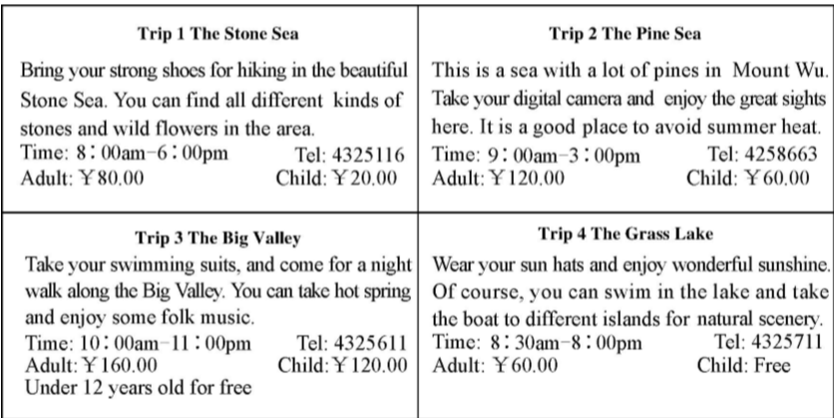

41. You should call if you want to take hot spring. 21教育网
A. 4325116 B. 4258663 C. 4325611 D. 4325711
42. If you want to go to the Pine Sea, you can't enter_______.
A. at 10 :00 am B. at 6 :00 pm C. at 11 :00am D. at 2 :00 pm
43. If a couple with a 5-year-old child go to the Big Valley, they need to pay ______ for the trip.
A.Y160.00 B.￥280.00 C.￥440.00 D.￥320.00
44. You can go to ______ for hiking.
A. the Stone Sea B. the Pine Sea C. the Big Valley D. the Grass Lake
B
An old man went to live with his son, his daughter-in-law, and a four-year-old grandson. The
old man's hands trembled, his eyesight was very poor, and he couldn't walk steadily(平稳地). The
family ate together nightly at the dinner table. But the elderly grandfather's shaky hands and
failing sight made eating rather difficult. Rice often dropped on the floor.
The son and the daughter-in-law became angry with the old man, so they put a small table in
the corner. There, the grandfather ate alone, while the rest of the family enjoyed dinner at the table
Since the grandfather had broken a dish or two, his food was served in a wooden bowl.
The four-year-old son watched it all in silence. One evening before supper, the father noticed
his son playing with a piece of wood on the floor. He asked the child sweetly, “What are you
making?” The boy answered, “Oh, I am making a little bowl for you and mama to eat your food
from when I grow up.” The four-year-old son smiled and went back to work. The words struck the
parents so that they were in silence. Then tears started to stream down their cheeks(脍颊). Though
no word was spoken, both knew what must be done. That evening the husband took grandfather's
hand and gently led him back to the family table.
45. Why was the old man's food served in a wooden bowl?
A. Because the wooden bowl was light enough
B. Because the old man had broken a few bowls
C. Because there was only a wooden bowlleft
D. Because the son and the daughter-in-law became angry with the old man
46. The word “struck” in Paragraph 3 refers to______.
A. annoyed B. worried C. scared D. shocked
47. Why did the husband lead the old man back to the family table?
A. Because he realized his mistakes
B. Because the old man didn't drop rice on the floor any more
C. Because the old man was served m a wooden bowl
D. Because a gentleman led him back to the family table
48. What's the best title ofthe passage?
A. An old man and his son
C. A wooden bowl
B. A couple and their son
D. A dinner table
C
Nowadays more and more people like to travel, especially when vacations come. A great
number of people rush out of their homes or companies to travelling spots. They either drive or21世纪教育网
take a bus, a train, a ship and so on. Some even ride bikes.21教育名师原创作品
However, there is another way of travelling—poorism. People have a tour in the poorest areas
of the world. Some people may take one-day poorest tour, and some even pay to stay in very poor
neighborhoods to experience the lowest living standards in the world. Poorism tours take place
around the world, and not just in the third world countries. You can, for instance, tour New York
neighborhoods in the Bronx, in the Bund of Shanghai. Such tours can take people into the heart of
poor areas within large and in some rich cities. These tours may awaken people to pay more attention to long-standing poverty, or the effects of war.www.21-cn-jy.com
Some suggest that tours in the poor areas can raise social care. And the money from the tour
can be donated to help the people there.
49. like to travel when vacations come.
A. Few people B. Poor people C. Lots of people D. Rich people
50. What's the meaning ofthe underlined word“poorism”in the second paragraph?
A. 贫困 B.穷人 C。穷游 D.可怜的人
51. Some people have poorism tours_______.
A. to show how rich they are B. to experience the poor life
C. to enjoy the beautiful scenes D. to see poor people
52. Poorism tours can make people____________.
A. care for the poverty more B. know about the countryside
C. go to big cities D. go into the heart of rich cities
D
Many people thought a computer wasn't supposed to be able to beat a top master at the
ancient Chinese game, Weiqi, for at least another 10 years. But AlphaGo, an artificially intelligent
system(人工智能系统) designed by Google, made it. It easily beat Lee Sedol last year, one of the
best players in the world. It challenged the world's top players to show how much progress it had
made over the past few years.
In the late of May, 2017, AlphaGo appeared in China and played against 19-year-old Ke Jie in Wuzhen, China. He is No. 1 player now in the world. However, the result wasn't out of people's
expectation. He lost the matches. Though Ke Jie tried his best and he once saw the victory just a
step away, he lost his best chance when he became excited.
At the press conference(新闻发布会) after the match, Ke Jie was interviewed by the reporters
He said he had realized how powerful AlphaGo was, and it was getting perfect. When a Chinese
reporter asked him in English, the reporter spoke so fast that the interpreter(口译员 ) couldn't
catch him. Ke Jie got kind of angry and told him that it was unnecessary for two Chinese to speak
English. The reporter apologized to him and offered to ask him for a coffee.
The cat and mouse game is over, but the challenge between man and robots will still go on.
53. Which was the most probable date when Ke Jie played against AlphaGo?
A. May 5. B. May 23. C. May 18. D. May Day
54. Why did Ke Jie get angry at the press conference?21·cn·jy·com
A. Because he lost the game.
B. Because the reporter couldn't catch the interpreter.
C. Because the reporter asked him in English.
D. Because the reporter wasn't able to speak Chinese well.
55. According to the passage, which of the following statements is True?
A. People thought a computer could beat humans many years ago.
B. Ke Jie was expected to lose the matches.
C. Ke Jie asked the reporter for a coffee.
D. AlphaGo had great trouble winning the game last year.
56. AlphaGo is______________.
A. Ke Jie B. Lee Sedol
C. a Weiqimatch D. an artificially intelligent system
笫二节还原句子（共4小题，每小题2分，满分8分）
阅读下面短文，把A、B、C、D四个句子填入文中空缺处，使短文内容完整、正确。
Dear Xiao Fang，
How time flies! It is two years since you moved to America for your study. (57) _____________
How happy we are! During your staying in America, little companions(小伙伴们 ) kept complaining,“There is no one to play with.” Huang Lei talked about the little woods where we
often played together. (58) ______Each time I saw your empty house next door, I held back tears. How much I have missed the days when we played in the woods behind our houses, where we dug up some worms, chasing the birds. I still remember we slipped down along the stream, feeling the spray(浪花) on our faces.
After reading your letter, Huang Lei and I came up with an idea. How about our families spending a week's vacation together this summer? (59)_________ It is located between the downtown of Chunxi and Wulin Town where we used to have fun. July will be the best month for
us, so we must enjoy freedom and joy for a long time. (60) _________
I can't wait to look forward to the time when we meet again
Yours
Xiao Mei

A. What about the Spring Lake?
B. Talk with Huang Lei about it as soon as possible.
C. These days, we have known that you will come back.
D. As for me, it was honor to have such a close friend like you.

注意：请把所有答案填涂到答题卡相应的位置，请不要错位、越界答题。

第II卷 非选择题（满分35分）
第四部分读写综合（共三节，满分35分）
第一节综合填空（共10小题，每小题1分，满分10分）
阅读下面短文，根据音标、单词、首字母和语境提示，在每个空格内填入一个适当的单
词，要求意义准确、拼写正确。
One cold and dark midnight, a young little girl, called Nannan, woke up to pass water (撒尿 )
She by 61 _____(her) got up and down her bed, walked to the bedroom door and opened it. She
looked outside and walked 62.b____ quickly, for it was so dark in the hall that she feared. Her
mother said, “Don't be 63_____/a'freid/, honey. Take courage!” “What's courage?” she asked, 64.
______ (run) to her mother's bed. “Courage is the brave breath.” her mother answered.
The girl held out her little hands, saying, “Mum, blow some of your breath of courage to me.”
After her mother blew out two 65.______ (mouthful) of breath into her cold hands, the little girl
clenched her fists(握拳) 66. ______(nervous), worried that the “breath of courage” would run
67._____.Then with her fists clenched, she walked out of the bedroom 68. _____/təˈwɔ:dz/ the
bathroom without fear.
Her mother said to herself, “It will be nice 69.i_____someone can blow some kind of ‘breath’ to me. Then I can hold it in my hands whenever I feel terrified or lost.”
70._____ fact, mostly, what we are terrified of is nothing but the fear in our mind. Who we
should defeat(战胜) is nobody but ourselves.
笫二节 完成句子（共5小题，每小题2分，每空1分，满分10分）
根据中文意思完成英语句子，每空一词。
71.我们一直忙于准备今天的考试。
We are ____preparing for______ exam all the time.
72.直到中考结束，李雷他轻松下来。
Li lei _____relax himself _____the entrance to high school exam ends.
73.在中国只有一个孩子的夫妇被允许再生一个孩子。
A couple ______have only one child are allowed to have _____ second baby in China.
74.现在越来越多的人选择了共享单车去上班而不是开车去。
Bike sharing _____ _____ instead of driving to work by more and more people now.
75.“一带一路”是东西方之间交流合作的象征。
The Belt and Road is the symbol ofcommunication and cooperation the East______ the West.www-2-1-cnjy-com
第三节 书面表达（满分15分）21世纪教育网
目前很多学生整天都忙于学习，成绩却不理想。请根据表格内容，结合自身实际，写一
篇关于“怎样提高学习效率”的短文。
学习方法 | 1.listen to the teacher  2.take notes21世纪教育网  3.review in time  4.correct mistakes  ...
体育锻炼 | 1.exercise  ….
其它方面 | 1.make good use of time  2.ask sb. For help  ….

要求：1．短文应条理清楚，行文连贯，段落分明，90词左右。（开头结尾己给出，不计入
总字数）
2．短文中不能出现真实的姓名、学校、地名等信息。
3．短文应包括全部信息，可围绕主题适当发挥。
How to improve our study effectively
A great number of students can't finish their tasks, which leads to bad results and makes them
less interested in their study. How can we solve the problem? Here are some suggestions. _________
_________________________________________________________________________________________________________________________________________________________________________________________________________________________________________________________________________________________________________________________________________________________________________________________________________
If you follow the advice that I have mentioned above, you will be successful.

宜宾市20 1 7年高中阶段学校招生考试
英语试题参考答案及评分细则
第I卷（选择题共85分）
第一部分：听力测试（共三节，满分20分）
第一节听选图片（5分） 1-5 ABBBA
第二节对话理解（10分） 6-10 CCBCB 11-15 BBABC
第三节短文理解（5分） 16-20 ACCAB
第二部分：语言知识运用（共二节，满分25分）
第一节单项选择（10分） 21-25 BBABB 26-30 CBCBB
第二节完型填空（15分） 31-35 BCCAB 36-40 CCBCA
第三部分：阅读理解（共二节，满分40分）
第一节阅读理解（32分）
(A) 41-44 CBDA (B) 45 -48 BDAC
(C) 49-52 CCBA (D) 53-56 BCBD
第二节还原句子（8分）
57-60 CDAB
第II卷（非选择题
第四部分：读写综合（共三节，
第一节综合填空（10分）
61．herself 62. back 63. afraid 64. running 65. mouthfuls
66. nervously 67. away 68. towards 69. if 70. In

第二节完成句子（10分）
71. busy; today's 72. didn't; until 73.who/that;a 74.is;chosen 75. between; and
笫三节书面表达（15分）
（范文一）
How to improve our study effectively
A great number of students can't finish their tasks, which leads to bad results and makes them less interested in their study. How can we solve the problem? Here are some suggestions.
First, we are supposed to have good study methods, such as previewing the lessons before
class, listening to the teacher carefully in class, taking notes in time, reviewing in time, doing homework on time, correcting mistakes at any time.
Then, it's helpful for study to have good health. So we should spend at least an hour (in)
exercising our body every day.
Besides, we'd better make good use of time. Don't put off what we can do today till
tomorrow. We should ask the teacher or classmates for help if we have some questions.
If you follow the advice that I have mentioned above, you will be successful.

How to improve our study effectively
A great number of students can't finish their tasks, which leads to bad results and makes them
less interested in their study. How can we solve the problem? Here are some suggestions.
First and foremost, we should listen carefully and pay attention to what teachers said in class, which is good for saving much time that should be spent on other subjects. Of course, it is necessary to take notes in class to help us understand lessons better and review what we have learnt in time. Besides, there is no doubt that we should correct our mistakes that we made during practice.
Perhaps more importantly, Not only can taking exercise build up our strong body, but also let
our brain have enough time to rest, thus improving our study effectively.
Last but not least, we'd better make good use of time. Don't put off what we can do today tilltomorrow. We should ask the teacher or classmates for help if we have some questions.
If you follow the advice that I have mentioned above, you will be successful.
(评分说明】
评分原则
1．本题总分15分，按5个档次评分。
2．评分时，先根据文章的内容和语言初步确定其所属档次，然后以该档次的要求来衡
量、确定或调整档次，最后给分。网阅时，也可以按要点打分。
3．词数少于70或多于110的，从总分中减去1分。
4．评分时应注意的主要内容为：内容要点，应用词汇和话法结构的数量和准确性及上
下文的连贯性。
5．拼写与标点符号是语言准确性的一个方面。评分时，应视其对交际的影响程度予以
考虑。英、美拼写及词汇用法均可接受。
6．如书写较差影响交际，将其分数降低一个档次。
二、内容要点（七个要点，每个要点2分（内容1分，表达1分），书写1分。）
1．上课认真听讲； 2．认真做笔记；
3．及时复习； 4．随时纠正错误；
5．锻炼身体； 6．充分利用时间；
7．不懂多问。

宜宾市20 1 7年高中阶段学校招生考试
英语听力材料
第一节听对话选图（共5小题，每小题1分，满分5分）
听下面五段对话，从题中所给的A. B.C三幅图片中选出与对话意思相符的图片。每
段对话听两遍。
Number 1
W: Tim, what is your favorite animal?
M:I like tigers best.
Number 2
W: Hurry up, John. The movie will begin soon.
M: Don't worry. The movie will begin at twenty to eight.2-1-c-n-j-y
Number 3
M: What are people supposed to do when they meet for the first time in China?
W: They are supposed to shake hands.
Number 4
M: What did you do last Friday evening, Kate?
W:I did my homework last Friday evening.
Number 5
W: What a sunny day it iS!
M: So it is.But the radio says it will be windy tomorrow.21世纪教育网版权所有
第二节对话理解（共10个题，每小题1分，满分10分）
听下面七段对话，从题中所给的A, B,C三个选项中选出最佳选项。每段对话听两遍。
听第一段对话，完成第6小题。
M: You have so many subjects. What do you think of them?【来源：21·世纪·教育·网】
W: Most ofmy classmates find Chinese or math difficult, but English is difficult for me.
听第二段对话，完成第7小题。
M: Lucy, do you like the Chinese swimmer Fu Yuanhui?21*cnjy*com
W: Yeah, she is an active and humorous girl. But I don't know when she was born.
M: She was born on January 7th, 1996.
听第三段对话，完成第8小题。
W: May I ask you some questions, Ken?
M: Sure.
W: Why do you study so hard?
M: Because I want to enter a good university in the future. And I want to get a good job.
听第四段对话，完成第9小题。

W: Jim, what are you doing now?21世纪教育网
M; I'm writing a composition about my future.21世纪教育网21*cnjy*com
W: Oh, what are you going to be when you grow up?
M: I'm going to be a swimming star like Sun Yang. What about you?
W: I want to be a pop singer. You know, I like pop music best.

听第五段对话,完成第 10至第 11个题。
W: Good morning, Frank. Did you enjoy your holiday in the country?
M: Yes, I did. I had a good time with some friends there.
W: Where did you stay?
M: We lived in a big house ofa farmer in the country.
W: Was the weather fine?
M: Yes, it was fine and it didn't rain at all.
W: What did you do there?
M: We helped the farmers with getting in potatoes. Here are some photos ofus on the farm
听第六段对话,完成第 12至第 13个题。
W: Dick, have you ever been to the East Park?
M: Yes,I have been there twice. What about you, Tina?
W: No, never. Will you go there with me this Sunday?
M: Oh, there is nothing interesting in that park. We can go to the West Park.I hear there are a lot
ofwonderful things in it.
W: Sounds good.
听第七段对话，完成第14至第15小题。
W: Bill, who is the tallest ofyou three?
M: Rick is taller than me. But Tom is taller than us two.
W: Then Tom must be good at playing basketball.
M: No, he likes playing soccer better.
第三节听短文，选择正确信息填表（共5分，每小题1分）
根据所听内容和表格中的提示词，从下列各题所给的A. B.C三个选项中选择最佳选
项。短文听三遍。
Last weekend, after finishing my homework,1 wanted to relax myself, s0 1 went to the
cinema to watch Journey to the West with my friends.I hoped to enjoy ourselves there. However,
some of the people there made me feel very unhappy.
When we arrived there, the movie had been on for ten minutes. We found our seats quickly
and sat down. What's worse,a few guys were talking loudly or even shouting when they saw some
exciting pictures. Also, some people threw away plastic bags, paper and other rubbish on the floor.
It made the floor very dirty.
As we know, the cinema is a public place where we can have a nice time. All of us are
supposed to obey the rules in public. Only in this way can we make public places more
comfortable.

