1.在锐角三角形ABC中，AB上的高CE与AC上的高BD相交于点H，以DE为直径的圆分别交AB、AC于F、G两点，FG与AH相交于点K，已知BC＝25，BD=20，BE＝7，求AK的长。
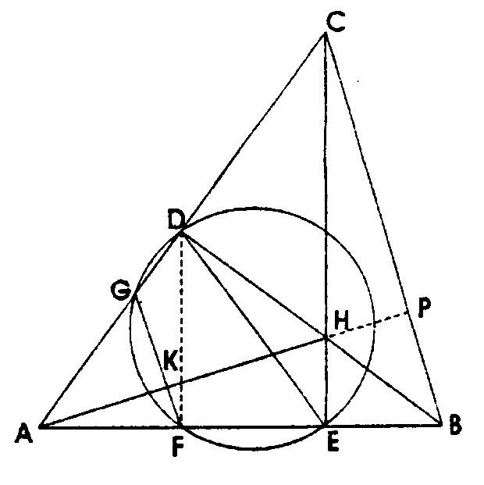

2过圆外一点P作圆的两条切线和一条割线，切点为A、B。所作割线交圆于C、D两点，C在PD之间，要统CD上取一点Q，使∠DAQ=∠PBC，求证：∠DBQ=∠PAC．
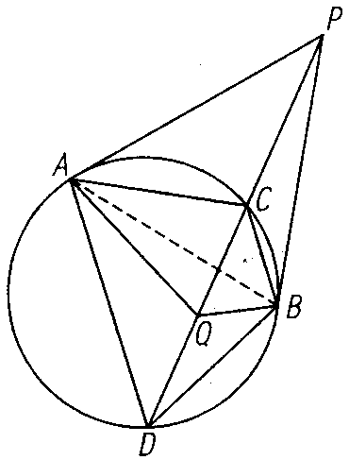

3.$\text{如图，在}Δ\text{ABC}\text{中，}∠A＝\text{60}°，\text{AB}>\text{AC}\text{，点}O\text{是外心。}$$\text{两条高}\text{BE}、\text{CF}\text{交于}H\text{点，点}M、$$N\text{分别在线段}\text{BH}、\text{HF}\text{上，且满足}\text{BM}=\text{CN}\text{，求}\frac{\text{MH}+\text{NH}}{\text{OH}}\text{的值。}$
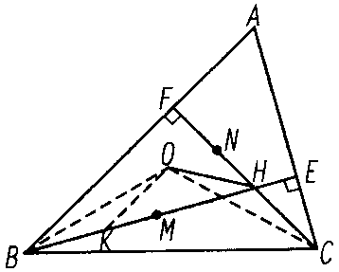

4.$\text{如图，}Δ\text{ABC}\text{中，}O\text{为外心，三条高}\text{AD}、\text{BE}、$
$$\text{CF}\text{交于点}H\text{，直线}\text{ED}和\text{AB}\text{交于点}M，$$
$$\text{FD}和\text{AC}\text{交于点}N\text{。求证：}(1)\text{OB}⊥\text{DF},\text{OC}⊥\text{DE}; (2)\text{OH}⊥\text{MN};$$
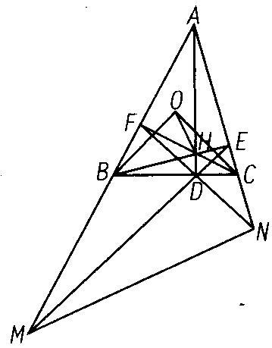
$$\begin{aligned}5\text{.}\text{如图},\text{在锐角}Δ\text{ABC}的\text{BC}\text{边上有两点}E、F\text{，满足}∠\text{BAE}\text{=∠}\text{CAF}\text{，作}\text{FM}⊥\text{AB},\text{FN}⊥\text{AC} \\ (M、N\text{是垂足})\text{，延长}\text{AE}交Δ\text{ABC}\text{的外接圆于}D\text{点，证明四边形}\text{AMDN}与Δ\text{ABC}\text{的面积相等；}\end{aligned}$$
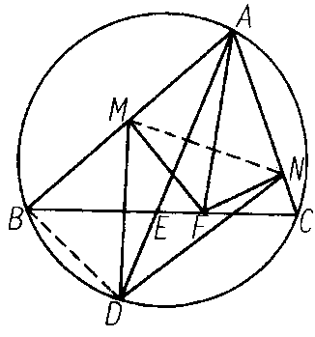

$$\begin{aligned}6\text{.}\text{如图，在四边形}\text{ABCD}\text{中，对角线}\text{AC}\text{平分}∠\text{BAD}\text{，在}\text{CD}\text{上取一点}E，\text{BE}与\text{AC}\text{相交于}F， \\ \text{延长}\text{DF}交\text{BC}于G\text{，求证：}∠\text{GAC}\text{=∠}\text{EAC}\end{aligned}$$
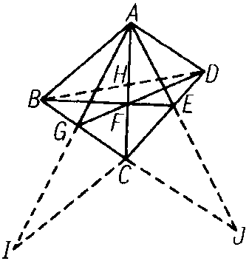

$$\begin{aligned}7\text{.}\text{如图，已知两个半径不相等的圆}O_{1}\text{和圆}O_{2}\text{相交于}M、N\text{两点，且圆}O_{1}\text{、圆}O_{2}\text{分别与圆}O \\ \text{内切于}S、T \text{两点，求证：}\text{OM}⊥\text{MN}\text{的充分必要条件是}S、N、T \text{三点共线；}\end{aligned}$$
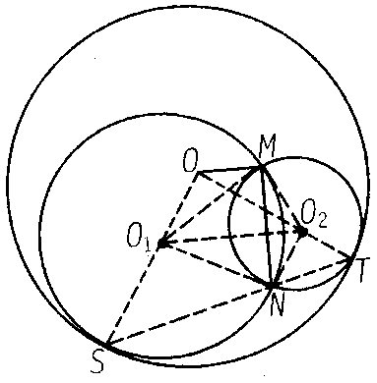

参考答案
1.
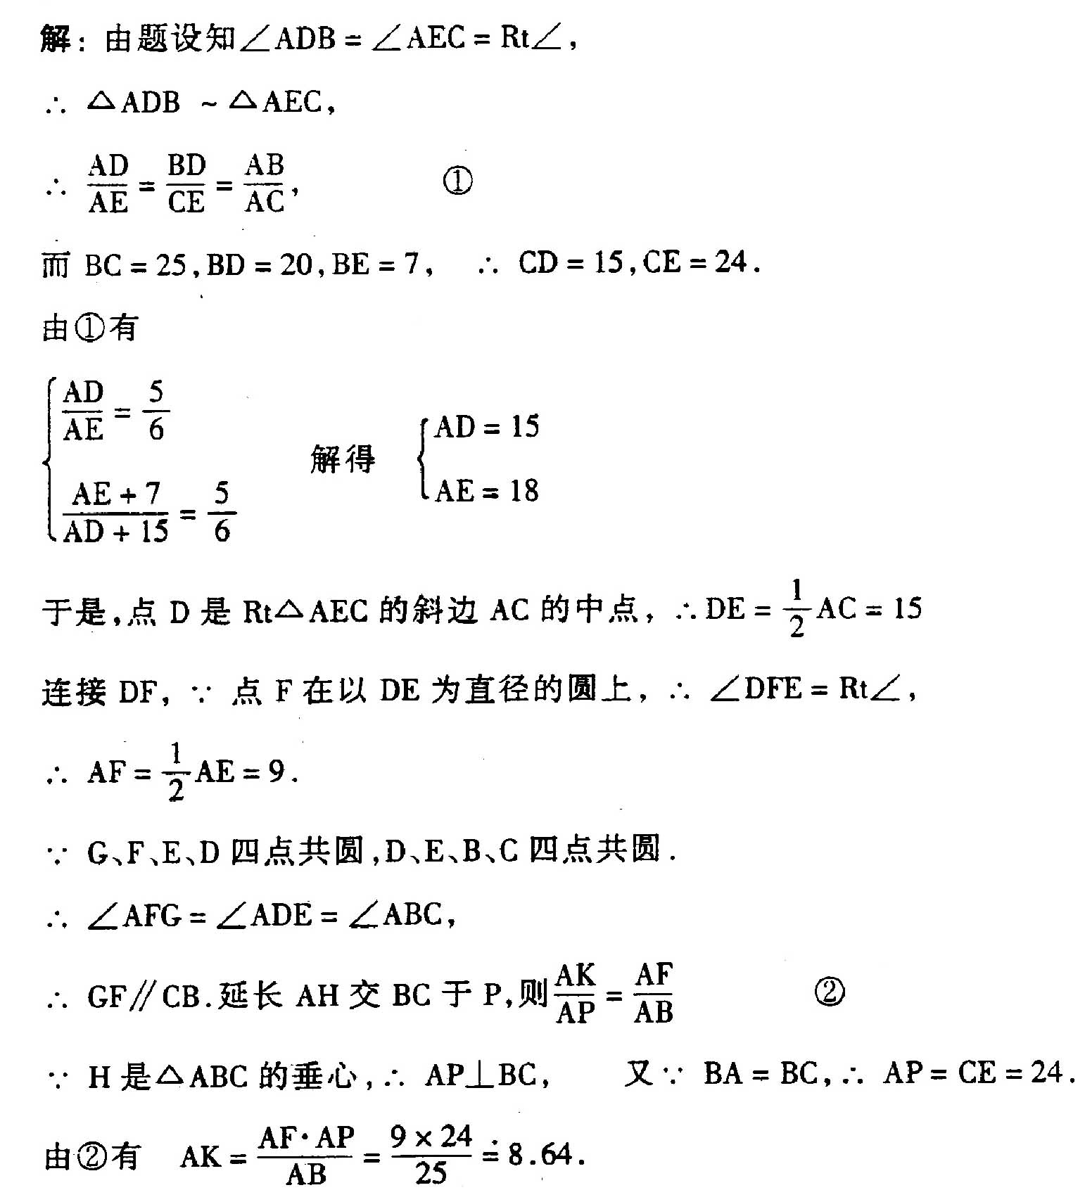
2.
$$\begin{aligned}\text{证：如图：连结}\text{AB}\text{，在}Δ\text{ADQ}与Δ\text{ABC}\text{中，} \\ ∠\text{ADQ}\text{=∠}\text{ABC}, ∠\text{DAQ}\text{=∠}\text{PBC}\text{=∠}\text{CAB} \\ ∴Δ\text{ADQ}≃Δ\text{ABC} \\ \text{从而有}\frac{\text{BC}}{\text{AB}}=\frac{\text{DQ}}{\text{AD}}⇒\text{BC}⋅\text{AD}=\text{AB}⋅\text{DQ} \\ \text{又由切割线关系可知：}Δ\text{PCA}≃Δ\text{PAD} \\ ∴\frac{\text{PC}}{\text{PA}}=\frac{\text{AC}}{\text{AD}} \\ \text{同理：由}Δ\text{PCB}≃Δ\text{PBD}\text{得：}\frac{\text{PC}}{\text{PB}}=\frac{\text{BC}}{\text{BD}}\end{aligned}$$
$$\begin{aligned} 又∵\text{PA}=\text{PB} \\ ∴\frac{\text{AC}}{\text{AD}}=\frac{\text{BC}}{\text{BD}}⇒\text{AC}⋅\text{BD}=\text{BC}⋅\text{AD}=\text{AB}⋅\text{DQ} \\ 又∵\text{关于圆内接四边形}\text{ABCD}\text{的托勒密定理有：} \\ \text{AC}⋅\text{BD}+\text{BC}⋅\text{AD}=\text{AB}⋅\text{CD} \\ \text{于是：}\text{AB}⋅\text{CD}=2\text{AB}⋅\text{DQ}⇒\text{DQ}=\frac{1}{2}\text{CD}⇒\text{CQ}=\text{DQ} \\ 在Δ\text{CBQ}与Δ\text{ABD}\text{中：}\frac{\text{AD}}{\text{AB}}＝\frac{\text{DQ}}{\text{BC}}＝\frac{\text{CQ}}{\text{BC}}, ∠\text{BCQ}\text{=∠}\text{BAD} \\ ∴Δ\text{CBQ}≃Δ\text{ABD} \\ \text{∴∠}\text{CBQ}\text{=∠}\text{ABD} \\ \text{∴∠}\text{DBQ}\text{=∠}\text{ABC}\text{=∠}\text{PAC}\end{aligned}$$
3.
$$\begin{aligned}\text{解：如图在}\text{BE}\text{上取}\text{BK}=\text{CH}\text{，连结}\text{OB}、\text{OC}、\text{OK} \\ \text{由三角形的外心的性质可知：}∠\text{BOC}=2⋅∠A=\text{120}° \\ \text{由三角形的垂心的性质可知：}∠\text{BHC}=\text{180}°−∠A=\text{120}° \\ \text{∴∠}\text{BOC}\text{=∠}\text{BHC} \\ ∴B、C、H、O\text{四点共圆。} \\ \text{∴∠}\text{OBH}\text{=∠}\text{OCH} \\ 又∵\text{OB}=\text{OC}, \text{BK}=\text{CH} \\ ∴Δ\text{BOK}≃Δ\text{COH} \\ ∵∠\text{BOK}\text{=∠}\text{COH}, \text{OK}=\text{OH} \\ \text{∴∠}\text{KOH}\text{=∠}\text{BOC}=\text{120}°, ∠\text{OKH}\text{=∠}\text{OHK}=\text{30}° \\ \text{观察}Δ\text{OKH}\text{有：}\frac{\text{KH}}{\text{sin}\text{120}°}=\frac{\text{OH}}{\text{sin}\text{30}°} \\ 则\text{KH}=\sqrt{3}⋅\text{OH} \\ 又∵\text{BM}=\text{CN}, \text{BK}=\text{CH} \\ ∴\text{KM}=\text{NH} \\ ∴\text{MH}+\text{NH}=\text{MH}+\text{KM}=\text{KH}=\sqrt{3}⋅\text{OH} \\ 故\frac{\text{MH}+\text{NH}}{\text{OH}}=\sqrt{3}\end{aligned}$$
4.
$$\begin{aligned}\text{证：}(1)∵A、C、D、F\text{四点共圆；} \\ \text{∴∠}\text{BDF}\text{=∠}\text{BAC} \\ 又∵∠\text{OBC}=\frac{1}{2}(\text{180}°−∠\text{BOC})=\text{90}°−∠\text{BAC} \\ ∴\text{OB}⊥\text{DF}\end{aligned}$$
$$\begin{aligned} \text{同理}\text{OC}⊥\text{DE} \\ (2)∵\text{CF}⊥\text{MA} \\ ∴{\text{MC}}^{2}−{\text{MH}}^{2}={\text{AC}}^{2}−{\text{AH}}^{2} ⋯ \\ ∵\text{BE}⊥\text{NA} \\ ∴{\text{NB}}^{2}−{\text{NH}}^{2}={\text{AB}}^{2}−{\text{AH}}^{2} ⋯ \\ ∵\text{DA}⊥\text{BC} \\ ∴{\text{BD}}^{2}−{\text{CD}}^{2}={\text{BA}}^{2}−{\text{AC}}^{2} ⋯ \\ ∵\text{OB}⊥\text{DF} \\ ∴{\text{BN}}^{2}−{\text{BD}}^{2}={\text{ON}}^{2}−{\text{OD}}^{2} ⋯ \\ ∵\text{OC}⊥\text{DE} \\ ∴{\text{CM}}^{2}−{\text{CD}}^{2}={\text{OM}}^{2}−{\text{OD}}^{2} ⋯ \\ 由 − + + − ,\text{得：} \\ {\text{NH}}^{2}−{\text{MH}}^{2}={\text{ON}}^{2}−{\text{OM}}^{2} \\ {\text{MO}}^{2}−{\text{MH}}^{2}={\text{NO}}^{2}−{\text{NH}}^{2} \\ ∴\text{OH}⊥\text{MN} \end{aligned}$$
5．
$$\begin{aligned}\text{证明：如图，连结}\text{MN}、\text{BD} \\ ∵\text{FM}⊥\text{AB}，\text{FN}⊥\text{AC} \\ ∴A、M、F、N\text{四点共圆} \\ \text{∴∠}\text{AMN}\text{=∠}\text{AFN} \\ \text{∴∠}\text{AMN}\text{+∠}\text{BAE}\text{=∠}\text{AFN}\text{+∠}\text{CAF}=\text{90}° \\ \text{即：}\text{MN}⊥\text{AD} \\ ∴S_{\text{AMDN}}=\frac{1}{2}\text{AD}⋅\text{MN} \\ ∵∠\text{CAF}\text{=∠}\text{DAB}, ∠\text{ACF}\text{=∠}\text{ADB}\end{aligned}$$
$$\begin{aligned} ∴Δ\text{AFC}≃Δ\text{ABD}⇒\frac{\text{AF}}{\text{AB}}=\frac{\text{AC}}{\text{AD}}⇒\text{AB}⋅\text{AC}=\text{AD}⋅\text{AF} \\ 又∵\text{AF}\text{是过}A、M、F、N\text{四点的圆的直径} \\ ∴\frac{\text{MN}}{\text{sin}∠\text{BAC}}=\text{AF}⇒\text{AF}\text{sin}∠\text{ABC}=\text{MN}\end{aligned}$$
$$\begin{aligned} ∴S_{Δ\text{ABC}}=\frac{1}{2}\text{AB}⋅\text{AC}⋅\text{sin}∠\text{BAC} \\ =\frac{1}{2}\text{AD}⋅\text{AF}⋅\text{sin}∠\text{BAC} \\ =\frac{1}{2}\text{AD}⋅\text{MN} \\ =S_{\text{AMDN}} \\ ∴S_{Δ\text{ABC}}=S_{\text{AMDN}}\end{aligned}$$

6．
$$\begin{aligned}\text{证明：如图，连结}\text{BD}交\text{AC}于H\text{，对}Δ\text{BCD}\text{用塞瓦定理，有：} \\ \frac{\text{CG}}{\text{GB}}⋅\frac{\text{BH}}{\text{HD}}⋅\frac{\text{DE}}{\text{BC}}=1 \\ \text{因为}\text{AH}是∠\text{BAD}\text{的平分线，由角平分线定理，可得} \\ \frac{\text{BH}}{\text{HD}}=\frac{\text{AB}}{\text{AD}} \\ \text{故：}\frac{\text{CG}}{\text{GB}}⋅\frac{\text{AB}}{\text{AD}}⋅\frac{\text{DE}}{\text{EC}}=1 \\ \text{过点}C作\text{AB}\text{的平行线交}\text{AG}\text{的延长线于}I\text{，过点}C作\text{AD} \\ \text{的平行线交}\text{AE}\text{的延长线于}J \\ \text{则：}\frac{\text{CG}}{\text{GB}}=\frac{\text{CI}}{\text{AB}},\frac{\text{DE}}{\text{EC}}=\frac{\text{AD}}{\text{CJ}} \\ ∴\frac{\text{CI}}{\text{AB}}⋅\frac{\text{AB}}{\text{AD}}⋅\frac{\text{AD}}{\text{CJ}}=1 \\ \text{从而}: \text{CI}=\text{CJ} \\ 又∵\text{CI}\text{//}\text{AB},\text{CJ}\text{//}\text{AD} \\ \text{∴∠}\text{ACI}=π−∠\text{BAC}=π−∠\text{DAC}\text{=∠}\text{ACJ} \\ ∴ Δ\text{ACI}≃Δ\text{ACJ} \\ \text{∴∠}\text{IAC}\text{=∠}\text{JAC} \\ \text{∴∠}\text{GAC}\text{=∠}\text{EAC}\end{aligned}$$

7．
$$\begin{aligned}\text{证明：如图，设圆}O_{1}\text{，圆}O_{2}\text{，圆}O\text{的半径分别为}r_{1}、r_{2}、r， \\ \text{由条件可知}O、O_{1}、S \text{三点共线，}O、O_{2}、T \text{三点共线，} \\ 且\text{OS}=\text{OT}=r,\text{连结}\text{OS}、\text{OT}、\text{SN}、\text{NT}、O_{1}N、O_{2}M、 \\ O_{2}N,O_{1}O_{2}\end{aligned}$$
$$\begin{aligned} (\text{充分性})设S、N、T\text{三点共线，则}∠S＝∠T， \\ 又∵{ΔO}_{1}\text{SN}{与ΔO}_{2}\text{NT}\text{均为等腰三角形，} \\ \text{∴∠}S\text{=∠}O_{1}\text{NS},∠T\text{=∠}O_{2}\text{NT} \\ \text{∴∠}S\text{=∠}O_{2}\text{NT},∠T\text{=∠}O_{1}\text{NS} \\ ∴O_{2}N\text{//}\text{OS},O_{1}N\text{//}\text{OT} \\ ∴\text{四边形}{\text{OO}}_{1}{\text{NO}}_{2}\text{为平行四边形} \\ ∴{\text{OO}}_{1}=O_{2}N=r_{2}={\text{MO}}_{2}, {\text{OO}}_{2}=O_{1}N=r_{1}={\text{MO}}_{1} \\ ∴{ΔO}_{1}\text{MO}≃{ΔO}_{2}\text{OM} \\ ∴S_{{ΔO}_{1}\text{MO}}=S_{{ΔO}_{2}\text{OM}} \\ ∴O_{1}O_{2}\text{//}\text{OM} \\ 又∵O_{1}O_{2}\text{MN} \\ ∴\text{OM}⊥\text{MN} \\ (\text{必要性})若\text{OM}⊥\text{MN},O_{1}O_{2}\text{MN},{有O}_{1}O_{2}\text{//}\text{OM} \\ ∴S_{{ΔO}_{1}\text{MO}}=S_{{ΔO}_{2}\text{OM}} \\ 设\text{OM}＝a \\ \text{由于}O_{1}M=r_{1},O_{1}O=r−r_{1},O_{2}O=r−r_{2},O_{2}M=r_{2} \\ \text{可知}{ΔO}_{1}\text{MO}{与ΔO}_{2}\text{OM}\text{的周长都等于}a+r, \\ 记p=\frac{a+r}{2}, \text{由三角形面积的海伦公式，有：} \\ S_{{ΔO}_{1}\text{MO}}=\sqrt{p(p−r_{1})(p−r+r_{1})(p−a)} \\ =\sqrt{p(p−r_{2})(p−r+r_{2})(p−a)}=S_{{ΔO}_{2}\text{MO}} \\ \text{化简可得：}(r_{1}−r_{2})(r−r_{1}−r_{2})=0 \\ \text{又已知}r_{1}r_{2}，∴有r=r_{1}+r_{2} \\ \end{aligned}$$
$$\begin{aligned} {故O}_{1}O=r−r_{1}=r_{2}=O_{2}N, \\ O_{2}O=r−r_{2}=r_{1}=O_{1}N, \\ ∴{\text{OO}}_{1}{\text{NO}}_{2}\text{为平行四边形} \\ ∠O_{2}\text{NS}\text{+∠}S=\text{180}\text{°=∠}O_{1}\text{NT}\text{+∠}T \\ 又∵{ΔO}_{1}\text{SN}{与ΔO}_{2}\text{NT}\text{均为等腰三角形} \\ \text{∴∠}T\text{=∠}O_{2}\text{NT}, ∠S\text{=∠}O_{1}\text{NS} \\ \text{∴∠}O_{1}{\text{NO}}_{2}+2∠S\text{=∠}O_{2}\text{NS}\text{+∠}S\end{aligned}$$
$$\begin{aligned} \text{=∠}O_{1}\text{NT}\text{+∠}T \\ \text{=∠}O_{1}{\text{NO}}_{2}+2∠T \\ \text{∴∠}S\text{=∠}T \\ ∴ ∠O_{1}\text{NS}\text{=∠}O_{2}\text{NT} \\ \text{∴∠}O_{1}\text{NS}\text{+∠}O_{1}{\text{NO}}_{2}\text{+∠}O_{2}\text{NT} \\ \text{=∠}{\text{SNO}}_{2}\text{+∠}S=\text{180}° \\ ∴S、N、T\text{三点共线}\end{aligned}$$

答案：

