
北京师大附中2016-2017学年下学期初中七年级期末考试英语试卷

第Ⅰ卷 听力部分(30分)
一、听对话或独白，选择最佳答案，每段对话你将听两遍。(共15分，每小题1.5分)
听一段对话，回答下面第1至2题
1. What's in Carl's hand?
A. A dictionary. B. A book. C. A magazine.
2. What does Carl think of it?
A. Useful. B. Cheap. C. Interesting.

听一段对话，回答下面第3至4题
3. Who is Tom's role model(榜样)?
A. His favourite teacher. B. A basketball player. C. His grandfather.
4. What does Tom's role model do every day?
A. He runs for an hour.
B. He writes stories on the Internet.
C. He helps others with Computer problems.

听一段对话，回答下面第5至7题
5. How many people will go to the park?
A. 2. B. 3. C. 4.
6. How do they plan to go to the park?
A. By bus. B. By bike. C. By car.
7. When are they going to see a film?
A. On Saturday afternoon.
B. On Sunday evening.
C. On Saturday evening.

听一段对话，回答下面第8至10题
8. What is twenty dollars each in Fashion Clothes Store?
A. Sweaters B. Socks. C. Dresses.
9. What colour are the women's dresses?
A. White, black and blue.
B. White, blue and yellow.
C. Purple, blue and white.
10. How much are two pairs of socks?
A. Four dollars. B. Eight dollars. C. Twelve dollars

二、听对话、问题和选项，选择最佳答案，每段对话你将听两遍。(共10分，每小题2分)
11-15，以下共有五段对话，每段对话有一个问题。在听的过程中可在下方空白处记录你需要的信息。
11. _______________________
12. _______________________
13. _______________________
14. _______________________
15. _______________________

三、听独白，记录关键信息。本段独白你将听两遍。(共5分，每小题1分)
Lost ＆ Found
What | A dog
Features | Fat  Looking like a rabbit  Two long 16 and a small mouth  17 eyes  18 legs  A 19 nose  Clean and quiet
Phone number | 584- 20

基础知识部分(60分)
四、单项选择。阅读下面四篇短文，选择最佳答案。(共5分，每小题0.5分。)
(1)
Blues and jazz started in the south of America, and 21 (A. became/B. becomes) popular in the last century. People played the blues with the guitar, and sometimes with a piano. The musician play blues and jazz to express his feelings. Usually he 22 (A. feel/B.feels) sad.
(2)
Rob is talking to Sam about shoes. Rob has a lot of shoes in his closet. He has a pair of sneakers and a pair of slippers at work, too. Rom enjoys 23 (A. exercising/B. to exercise) at lunch. He can 24 (A. walk/B. walks) and jog in his sneakers. He wears slippers inside his office. They are very comfortable, and they fit well.
(3)
Mark Twain had his first success in 1865. He wrote many successful stories. 25 (A. His/B. Her) works became more and more popular, and soon he became a rich man. 26 (A. So/B. But) in his later life, he lost a lot of money and became very sad. He died in New York 27 (A. on/B. in) April 21st, 1910.
(4)
Hello, I'm Mike. Today is Sunday. My mother and I went shopping. We bought some apples, oranges and bananas. Bananas are my favourite fruit. My 28 (A. parents/B. parents') favourite fruit is apples. These oranges 29 (A. is/B. are) for orange juice. We bought tomatoes, potatoes and carrots, too. We eat vegetables every day. What's that? It's a hamburger. Hamburgers are my sister's favourite food. 30 (A. What/B. Who) is behind the hamburger? It's milk.

五、阅读理解。阅读下面四篇文章，选择最佳答案。(共30分，每小题2分。)
A

Welcome to the Natural History Museum at Tiring
Discover the amazing animals here. It is home to the world-class research and collections.
Opening times:
The Museum is open every day except December 24--26.
Monday to Saturday 10:00--17:00
Sunday 14:00--17:00
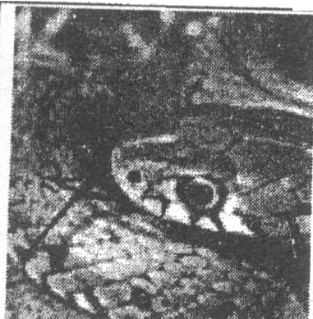 | Snake Sock Puppets(木偶)  October 26, 2010 10:15--12:15, 14:00--15:00 Interested in different kinds of snakes? Try making and decorating a snake sock puppet of your own. Ticket price ￡1.50
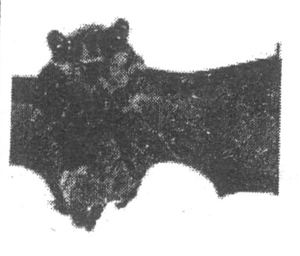 | Go Batty  October 27,2010 10:15--12:15, 14:00--15:00  Drop in and check out the bats on show in Gallery 6 and make your own bat out of paper to fly home with  you.  Ticket price ￡1.50
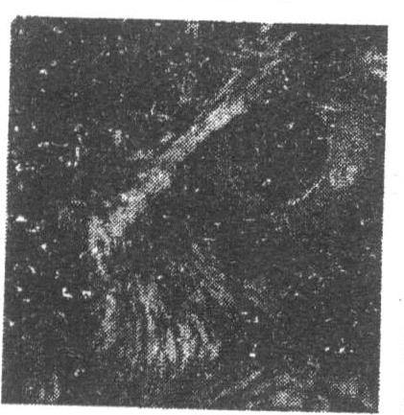 | Animals After School  November 11,2010 15:45--16:30  December 9,2010 15:45--16:30  Looking for after-school activities? Get the most out of your Museum--find out about some amazing animals and make something to take home.  Ticket price ￡1.50
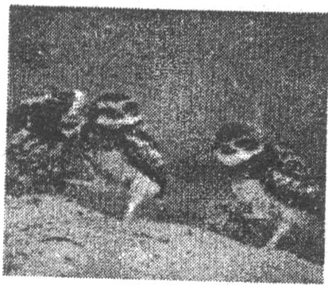 | Wildlife Photographer Exhibition  November 26,2010 to January 9,2011  This wonderful photographic exhibition returns with many kinds of pictures from around the world.  Free exhibition
31. The museum is closed on _______.
A. October 26 B. November 11
C. December 9 D. December 25
32. At Animals After School, children can
A. decorate a snake sock puppet B. make their bats out of paper
C. make something to take home D. take photos of many birds
33. Which exhibition Or activity is free?
A. Snake Sock Puppets B. Go Batty
C. Animals after School D. Wildlife Photographer Exhibition
34. If you are interested in snakes, you can ______.
A. check them out on show in Gallery 6
B. try making and decorating one sock puppet
C. get them out of your Museum
D. enjoy their pictures from around the world

B
Long ago, there lived in Greece a learned man. He was so well-known for his good knowledge of almost everything that lots of people from all over the country came to learn from him. The great man taught his students heart and soul and answered their questions with great patience.
One day a student asked him, "My dear teacher, didn't you say you have many more questions about things than we do? But I think we students have far more than you."
With a smile on his face, the teacher drew two circles, one was as large as a big cake, the other was small. Then he said, "Of course, I've learned much more. But it's wrong to think that a teacher has fewer questions than his students. Now, look at these two circles. The inside of the bigger one is my knowledge of things, and the inside of the smaller one is yours. Out of the circles is what is still unknown to us. Since mine is larger, I have the larger line to draw the bigger circle. That means I have more opportunities to face what is still unknown. And that's why I myself have more questions than you do. The more you learn, the more questions you have. You will never leam enough, you know."
35. Why did many people learn from the learned man?
A. Because he was well-known.
B. Because he had good knowledge of almost everything.
C. Because he lived in Greece.
D. Because he was patient to his students.
36. The student didn't agree that
A. The teacher had as many questions as a learned man.
B. The teacher had as many questions as the students.
C. The teacher has fewer questions than the students
D. The teacher had more questions than the students.
37. The learned man drew two circles to show
A. he was good at drawing
B. his knowledge had nothing to do with the circle.
C. why he had more questions than the students
D. how he could get more knowledge
38. From the passage we can learn that ______
A. the more knowledge we have, the more questions we may get
B. every one of us should try to be a learned man
C. a teacher should have many questions
D. it's never too old to leam

C
When I was a little girl, there was always one dream that I wanted to make true: to travel around the world! I spent a lot of time reading books all about other countries and imagining what they might be like.
I was lucky enough to be able to go to a lot of the countries I had dreamed about, but the one place that I always wanted to go to but never had a chance to visit was South America. So, as soon as I finished university, I knew I had to make plans to go there. I would do whatever I could to finally be able to achieve this life goal.
I knew it would be difficult, because at the time I started making my plans to go, I couldn't speak a word of Spanish(西班牙语), and I only had enough money to book my flight there! However, after six months of preparation--a lot of planning, hard work and a try to learn Spanish, I was ready and found myself on a flight to Uruguay with my best friend.
When we first arrived, I couldn't believe I had finally made it there, somewhere I had imagined many times. I have to say, it wasn't at all like I imagined--it was even better!
We went to many different countries in South America and I loved them all, but one of my favorites was Chile. Chile is amazing because it has so many different landscapes(风景)——which isn't surprising when you think about how long the country is! We went down to a place called Pucon. It was very cold there, and we were completely unprepared for that. When we planned our trip, we thought the weather would always be hot, but we were wrong! After buying some warm jumpers, we were ready to explore. The best thing about Pucon was the huge volcano(火山). It was smoking the whole time we were there. You could even climb the volcano if you were brave enough!
It was absolutely a wonderful experience that I can't forget it in the rest of my life!
39. What was the writer's dream when she was little?
A. Travel to Spain
B. Have a global trip
C. Visit South America
D. Read books around the world
40. What preparation was NOT the writer do for the trip to South America?
A. Learning Language
B. Booking plane tickets
C. Finding a friend in Uruguay
D. Earning enough money
41. Which is true about the writer's trip?
A. Chile is always hot with different sceneries.
B. The writer and the friend bought warm clothes.
C. The writer smoked when climbing the volcano.
D. Uruguay wasn't as good as the writer imagined at all.
42. Where can you most likely to read this passage?
A. a newspaper
B. a travel magazine
C. a guide book
D. a geography book

D
Books vs. e-books: Choose the best way to read
When you are going to read, you may be faced with a tough decision: e-books or the traditional kind? Each one has its advantages and disadvantages, and the best choice depends on a number of factors(因素).
Different people may have different preferences in reading. For example, an e-reader, like Kindle, can carry a whole library wherever you go, which is great for travelers or people who always want a choice of different readings. However, some people do love the look, smell, and feel of the classical book held in the hand.
Here's a look at some of the science to think over before you decide to buy a Kindle, or some new hardcovers.
Young, unwilling readers prefer e-readers
A 2014 study found that out of 143 10th grade students, most liked e-readers. Boys and those who did not care much for reading also shared a strong preference for e-readers. Some scientists said that an e-reader has more similarities with electronic devices(设备) that young people use all the time, like smartphones or iPads. That is maybe one of the reasons that teenagers like an e-book more than a paper one.
Reading on paper may improve memory
Some small studies found that reading on paper instead of an electronic screen is better for memory. When you read on paper you can sense with your fingers on pages. You can see the progress when pages on the left are growing, and on the right are reducing. Perhaps this somehow helps the reader with memorizing what they read.
Paper helps readers with sleep problems and poor eyesight
High levels of screen brightness from an electronic device can cause eye problems, especially when reading e-books at night, Also, artificial(人造的) light from e-readers may interfere with users' ability to sleep, leading to health problems and tiredness the following day.
Love for books
Many book-lovers still prefer the traditional option and value the feeling of a regular paper book. Paper books are usually very well designed. They look and smell good, and they carry with them a more human touch. As a result, some readers prefer reading on paper, because traditional books give them a sense of ownership, instead of just using something.
43. What can we learn from Paragraph 2?
A. E-books are the best choice.
B. E-readers are convenient.
C. Classical books are popular.
D. Paper books look beautiful.
44. What does the underlined part "interfere with" in paragraph 6 mean?
A. show B. hold C. hurt D. help
45. What is the writer's purpose of writing this passage?
A. To tell people not to use traditional books.
B. To introduce e-books as a new technology.
C. To advise young people to buy paper books.
D. To help people choose the best way to read.

第Ⅱ卷 笔试部分
六、选词填空。阅读下面两篇短文，从方框给出的词中选择相应最佳答案。（共5分，每小题0.5分）

saying way stars popular make time
called hand TV Internet heart headed
Are you still doing the V for victory sign? It's out. The latest popular 46 gesture(姿势) is putting both of your hands together to make a heart shape. It is
47 "hand heart".
Many young pop 48 in the United States have done the move in recent photo. "The 'hand heart' gesture means something between 'I love you' and 'thank you'," said Taylor Swift, the country singer. "You can send a sweet, simple message without 49 a word." Swift often does it at her concerts. And she is believed to be the first to 50 it popular.
Last month, Justin Bieber and his superstar friends did the "hand heart" and put the photos online. They did it to help out three kids whose parents were killed in a car accident.
"It used to take much 51 for body languages to move. But now, it moves faster because we have smartphones and the 52 .
In the Republic of Korea, the "hand heart" has been 53 for a long time, but in a different 54 . People there put their hands above their heads and make a bigger 55 shape with their arms. It means, "I love you."

七、阅读短文回答问题。（共10分，每小题2分）
International Friendship Day is a day for celebrating friendship and it is very popular in western countries. The day has been celebrated in some western countries for many years and in 2011, the General Assembly of the United Nations stated 30 July as official International Friendship Day.
On a Friendship Day, people of all ages do different things to make this day special for their friends. Some people give a surprise party to their very dear friends, and others go out to talk to each other. Those who live far away from each other and can't make to meet personally on Friendship Day prefer to send flowers and greeting cards online. There are different kinds of gifts in these days on Friendship Day. Some are expensive, like a watch, a mobile phone or a music player. But some people think feelings are more important than gifts. If you want to give your friends a special Friendship Day, you should pay attention to what your friends like most. Prepare in such a way and they will feel you are the special one in their life.
56. What is Friendship Day?
57. When is International Friendship Day?
58. How do people give Friendship Day greetings if they live far away from each other?
59. Which is more important, feelings or gifts?
60. According to this passage, how can you give your friend a best gift?

八、写作（10分）
进入师大附中，学校和年级组织了很多有意义的活动，例如运动会、跳蚤市场、联欢会、外出参观、学科展示活动等等。而你最喜欢哪一项活动呢，为什么？你在活动中做了什么？你希望学校将来还能举办什么活动？
提示词语：enjoy, interesting, take part in, be good for
提示问题：
What's your favorite activity at school and why?
What did you do in this activity?
What other activities do you hope our school can hold in the future?
There are a lot of activities in our school, such as the flea market, school trips, English dubbing show and so on.___________________________________________
【参考答案】
一、听对话，选择答案。
1. B 2. C 3. B 4. C 5. B
6. B 7. C 8. A 9. A 10. B

二、听对话和问题。选择答案。
11.A 12. C 13. C 14. C 15. A

三、听对话，记录关键信息。
16. ears 17. red 18. short
19. small 20.9923

四、单项选择。阅读下面四篇短文，选择最佳答案。(共5分，每小题0.5分。)
21. A 22. B 23. A 24. A 25. A
26. B 27. A 28. B 29. B 30. A

五、阅读短文，选择最佳选项。
31. D 32. C 33. D 34. B 35. B
36. D 37. C 38. A 39. B 40. C
41. B 42. B 43.B 44. C 45. D

六、选词填空
46. hand 47. called 48. stars 49. saying 50. make
51. time 52. Internet 53. popular 54. way 55. heart

七、阅读短文回答问题
56. It is a day for celebrating friendship.
57.30 July.
58. They send flowers and greeting cards online.
59. Feelings.
60. We should pay attention to what my friends like most.

听力原文：
一、听对话，根据对话的内容，从下面各题所给的A、B、C三个选项中选择最佳选项。每
段对话你将听两遍。(共20分，每小题2分)
对话1
W: Carl, what's this in your hand?
M: It's a story book.
W: Do you like it?
M: Yes, it's interesting.
W: Did you buy it yourself?.
M: No. My father bought it for me as a New Year gift.
对话2
W: Hi, Tom. This is my role model, Yao Ming. I think he is really cool. Who is your role model?
M: My role model is my grandpa.
W: Really? I thought your role model was a famous person.
M: No. I prefer to choose a person in my life as my role model.
W: Your grandpa must have taught you a lot.
M: Yes. Although he is in his seventies, he is willing to learn new things. He spent a lot of time learning how to use a computer and read on the Internet. Sometimes I even ask him to help me with my computer problems.
W: I thought you should help him.
M: Most people do. And my grandpa runs for an hour every day. He keeps doing this for 2 years. Can you keep doing it for such a long time?
W: Well, I may give up.
M: So this is why my grandpa is my role model.
对话3
M: What are you going to do at the weekend, Mary?
W: I'm going to have a picnic with Betty. Would you like to join us?
M: That's a good idea. Where are you going?
W: Chaoyang Park. It's near our school. We can ride a bike there.
M: Sounds great, it must be lots of fun. Oh, one more thing. There will be a new film at the weekend.
W: Why not see it after we get back from the park?
M: You mean this Saturday evening?
W: Yes. Seeing a wonderful film after a picnic will be very interesting, won't it?
对话4
Welcome to our Fashion Clothes Store. Today is our first day to sell clothes. We have sweaters at a very good price. They are only 20 dollars each! Do you need bags for sports? We have nice bags for only 15 dollars! For women, we have dresses in white, black and blue for only 21 dollars! For boys, you can buy socks for only 4 dollars each pair! Anybody can afford our prices! Come and see for yourself!

二、听对话和问题记录有关信息。（共10分，每小题2分）
对话6：
M: What are you doing, Gina?
W: I'm running.
M: I can see you run every day. Why?
W: I run for the city sports game.
M: Are you on the city running team?
W: Yes, I am.
M: Congratulations.
W: Thanks.
M: When is the sports game?
W: Next Friday, August 2nd.
Question: When is the game?
A. On August 2. B. On August 22. C. On September 25th
对话 8:
W: Listen! The telephone is ringing. Who's it from?
M: From David.
W: Who is David?
M: He's my new friend. He say she wants to call me today.
W: Is he a student, too?
M: Yes, he is studying in a middle school near here.
Question: What is David?
A. A policeman. B. A cook. C. A student.
对话9：
W: Hi, Jack!
M: Hi, Kate!
W: Is your mother working in a bank?
M: No, she works in a library.
W: Does your father live in a library, too?
M: No, he works in a zoo. He is a zoo keeper.
W: That's an interesting job. Let's go to the zoo this afternoon.
M: Sorry, the zoo isn't open on Saturday.
W: Then let's go to the library to read books.
Question: What day is it today?
A. Monday. B. Thursday. C. Saturday.
对话10:
W: Hello, Ken. Which club do you want to join this term?
M: I want to join the Music Club, Sonia.
W: Great, can you sing and dance?
M: No, but I'm good at playing the piano. How about you?
W: I'd like to join the Chinese Club.
M: The Chinese Club? Are you good at Chinese?
W: No, but I love it.
Question: What club does the woman want to join?
A. The Dance Club. B. The Music Club. C. The Chinese Club.
对话11：
M: May I help you?
W: Yes, I'd like to know something about the tour in London. How long does the tour take?
M: About seven hours. Where are you staying?
W: At the Hyde Park Hotel.
M: Let's see. The bus stops there at 9:30. You should be back by 5:30 in the afternoon.
W: How much should I pay if I go with my husband and daughter?
M: It's 15 pounds for each person.
W: Thanks very much.
Question: How much should the woman pay for the tour?
A. 45 pounds. B. 15 pounds. C. 35 pounds.

三、听独白，记录关键信息。本段对话你将听两遍（共10分，每小题2分）
Hello, everyone! Here's a photo of a white dog. He's lost. I think he's an expensive dog. So I
want to find the owner. Is the dog yours?
Look! He is fat. And he looks like a rabbit. He has two long ears and a small mouth. His eyes are red. He has short legs. His nose is very small. He is very clean and very quiet. If the dog is yours, please call us at 584-9923.

