**One**

**Part l Listening（第一部分听力）**

**I. Listening Comprehension (听力理解) (共30分)**

**A. Listen and choose the right picture (根据你听到的内容，选出相应的图片) (共6分)**

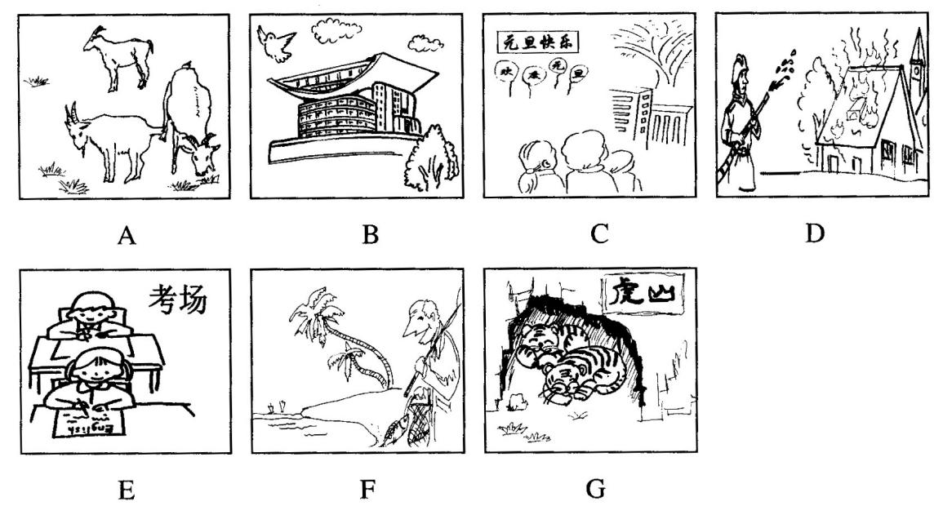

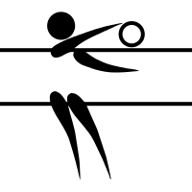

1.\_\_\_\_\_\_\_\_ 2.\_\_\_\_\_\_\_\_ 3.\_\_\_\_\_\_\_\_ 4.\_\_\_\_\_\_\_\_ 5.\_\_\_\_\_\_\_\_ 6.\_\_\_\_\_\_\_\_

**H**

**H**

**B. Listen and choose the best answer (根据你听到的对话和问题，选出最恰当的答案) (共8分)**

7. A) 6:50. B) 7:00. C) 7:10. D) 7:50.

8. A) In Mary’s desk. B) On Mary’s desk C) In Tom’s desk. D) On Tom’s desk.

9. A) $35. B) $55. C) $80. D) $90.

10. A) A dancer. B) A singer. C) An engineer. D) A postman.

11. A) A bus. B) A bicycle. C) A taxi. D)An underground.

12. A) Husband and wife. B) Teacher and student.

C) Mother and son. D) Doctor and patient.

13. A) To eat out with the boy. B) To work on the computer.

C) To go dancing for a change. D) To go to bed early.

14. A) Jane’s new friends are too shy. B) Jane doesn’t like the new school.

C) Jane has got two new friends. D) Jane has no new friends there.

**C. Listen to the passage and tell whether the following statements are true or false (判断下列句子是否符合你听到的短文内容，符合的用“T”表示，不符合的用“F”表示) (共6分)**

15. When packing, the more things you take, the more freedom you will have.

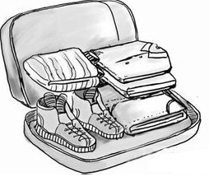16. Even when traveling with kids, one hair dryer is enough for a family.

17. When traveling, we must take different shoes according to different places.

18. If you go to Australia in December, you have to take thick clothes.

19. The writer thinks we should consider four questions when packing.

20. This passage is mainly about how to travel to more places in less time.

**D. Listen to the passage and complete the following sentences (听短文，完成下列内容。每空格限填一词) (共10分)**

21. Mr. Smith lived in a small village with all around it.

22. Ann spent passing all exams in the college and found a job in a hospital.

23. When Mr. Smith his daughter, he was happy and ready to set out.

24.As soon as Mr. Smith got off, Ann ran up to him and found that her father .

25. Ann wondered why her father didn’t exchange seats with the person him.

**Two**

**Part l Listening（第一部分听力）**

**I. Listening Comprehension (听力理解) (共30分)**

**A. Listen and choose the right picture (根据你听到的内容，选出相应的图片)：(6分)**

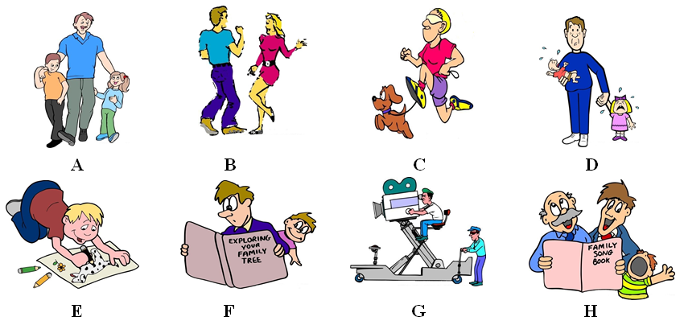

1. \_\_\_\_\_\_ 2. \_\_\_\_\_\_ 3. \_\_\_\_\_\_ 4. \_\_\_\_\_\_ 5. \_\_\_\_\_\_ 6. \_\_\_\_\_\_

**B. Listen to the dialogue and choose the best answer to the question you hear (根据你听到的对话和问题，选出最恰当的答案)：(8分)**

7. A) Jim. B) Jenny. C) Lily. D) Linda.

8. A) A TV play. B) The TV news. C) Their past. D) Their hometown.

9. A) By asking for them from a friend. B) By lining up in front of the ticket office.

C) By booking them on the phone. D) By buying them from someone else.

10. A) He had lost Mr. Smith’s dictionary.

B) He had forgotten to bring Mr. Smith’s dictionary.

C) He had forgotten to give Mr. Smith the dictionary.

D) He had forgotten to tell Mr. Smith to bring the dictionary.

11. A) In a bookshop. B) In a library. C) In a hospital. D) In a store.

12. A) Eight hours. B) Six hours. C) Three hours. D) One hour.

13. A) After one o’clock. B) Before twelve o’clock.

C) Before one o’clock. D) At a quarter past twelve.

14. A) Mother and teacher. B) Mother and son.

C) Father and teacher. D) Teacher and student.

**C. Listen to the dialogue and tell whether the following statements are true or false (判断下列句子是否符合你听到的对话内容, 符合的用“T”表示，不符合的用“F”表示)：(6分)**

15. John Slack went to Royal Hotel to book a room.

16. He needed a single room for the 15th of October.

17. He wanted to enjoy the beautiful lake view in the room.

18. He must pay $840 for his stay in the hotel with breakfast.

19. He can check in at 12:30 pm when he arrives at the hotel.

20. This dialogue is mainly about how to book a hotel room.

**D. Listen to the passage and complete the following sentences (听短文，完成下列内容，每空格限填一词)：(共10分)**

21. Let me tell you \_\_\_\_\_\_\_\_ \_\_\_\_\_\_\_\_ stories of great animal parents.

22. After the heavy rain, a dog swam to an island \_\_\_\_\_\_\_\_ \_\_\_\_\_\_\_\_ day.

23. The mother dog swam to the island every day to feed \_\_\_\_\_\_\_\_ \_\_\_\_\_\_\_\_.

24. *Chimpanzees*(猩猩) also cared for those that \_\_\_\_\_\_\_\_ \_\_\_\_\_\_\_\_ or got lost.

25. The brave parents rushed down to the road and took the \_\_\_\_\_\_\_\_ \_\_\_\_\_\_\_\_ away.

**Three**

**I．Listening Comprehension (听力理解) (共30分)**

**A. Listen and choose the right picture (根据你听到的内容，选出相应的图片) (6分)**

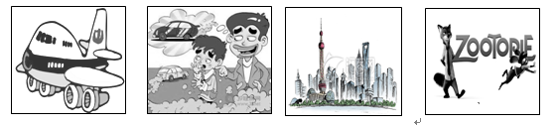

　A B C D

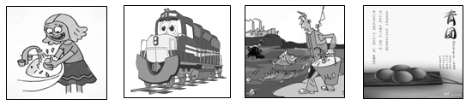

E F G H

1.\_\_\_\_\_\_\_\_ 2.\_\_\_\_\_\_\_\_ 3. \_\_\_\_\_\_\_\_ 4. \_\_\_\_\_\_\_\_ 5. \_\_\_\_\_\_\_\_ 6.\_\_\_\_\_\_\_\_

**B．Listen to the dial学科网(www.zxxk.com)--教育资源门户，提供试卷、教案、课件、论文、素材及各类教学资源下载，还有大量而丰富的教学相关资讯！ogue and choose the best answer to the question you hear (根据你听到的对话和问题，选出最恰当的答案) (8分)**

7. A) Jerry. B) Jessica. C) John. D) Jane.

8. A) Coffee. B) Coke. C) Tea学科网(www.zxxk.com)--教育资源门户，提供试卷、教案、课件、论文、素材及各类教学资源下载，还有大量而丰富的教学相关资讯！. D) Juice.

9. A) A bus station. B) A train station. C) An airport. D) A supermarket.

10. A) 500 yuan. B) 1000 yuan. C) 1800 yuan. D) 900 yuan.

11. A) Teacher and student. B) Mother and son.

C) Wife and husband. D) Waitress and customer.

12. A) A newspaper. B) A travel guide. C) A map. D) A book.

13. A) He has had a bad cold. B) He has had a headache.

C) He didn’t put on his coat. D) He didn’t close the windows.

14. A) She will go by bus. B) She will go on foot.

C) She will go by car. D) She will go by bike.

**C. Listen to the passage and tell whether the following statements are true or false (判断下**

**列句子是否符合你听到的短文内容，符合的用“T”表示，不符合的用“F”表示) (6分)**

15. This is a brief introduction of an exciting physics project.

16. The bridge that the students are going to see was built in 1832.

17. A famous engineer built the bridge and also paid for it.

18. Two dollars is enough for students to get into the Bridge Museum.

19. Students need no food or drink, but a camera for the trip.

20. May 9 is the date that the students will have the trip to the bridge.

**D．Listen to the passage and complete the following sentences. (听短文，完成下列内容。每空格限填一词) (10分)**

21. The teachers tried different ways to get the bird, but \_\_\_\_\_\_\_\_ \_\_\_\_\_\_\_\_.

22. Lisa \_\_\_\_\_\_\_\_ \_\_\_\_\_\_\_\_ call her student Mary for help.

23. Mary couldn’t catch the bird until it was sitting on \_\_\_\_\_\_\_\_ \_\_\_\_\_\_\_\_.

24. The town locates \_\_\_\_\_\_\_\_ \_\_\_\_\_\_\_\_ away from Mary’s home.

25. Mary \_\_\_\_\_\_\_\_ \_\_\_\_\_\_\_\_ that the bird wants to find its owner.

**Four**

**I. Listening Comprehension (听力理解)**

**A. Listen and choose the right picture.（根据你听到的句子，选出相应的图片。）（6分）**

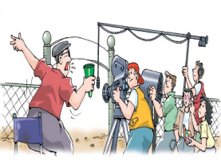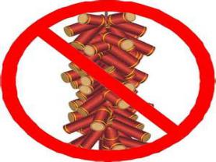

**A B C D**

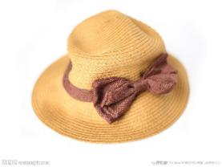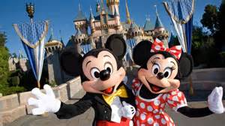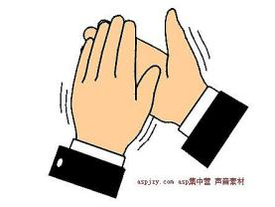

**E F G H**

1. 2. 3. 4. 5. 6.

**B. Listen to the dialogue and choose the best answer to the question you hear. （根据你听到的对话和问句，选出最恰当的答案。）（8分）**

7. A) At 8:00. B) At 8:15. C) At 8:25. D) At 8:50.

8. A) 2 days. B) 3 days. C) 4 days. D) 5 days.

9. A) Play basketball. B) Play baseball. C) Go to school. D) Visit her grandma.

10. A) On the seaside. B) In the zoo. C) On the road .D) In the neighbourhood.

11. A) Too long. B) Quite boring.

C) Helpful but boring. D) Helpful and interesting.

12. A) Because she was late. B) Because she was in the library.

C) Because she didn’t finish her work. D) Because she forgot the work.

13. A) Politics. B) Book review. C) Basic news. D) Disaster information.

14. A) To look it up in a dictionary. B) To ask others for help.

C) To guess it by herself. D) To remember it.

**C. Listen to the passage and tell whether the following statements are true or false.（判断下列句子是否符合你所听到的短文内容，符合的用“T”表示, 不符合的用“F”表示。）（6分）**

15. Hospital dogs are often with people who are in hospital or in homes.

16. People train many different types of dogs as hospital dogs.

17. If the dogs work very well with children, they can work as hospital dogs.

18. Elsie is nearly 90 years old and will stay in the hospital for the rest of her life.

19. When Elsie is taken outside, Trudy can go with her and run around the grass.

20. This passage is mainly about how people train hospital dogs.

**D. Listen to the passage and complete the sentences. (听短文，完成下列内容，每空限填一词。)**

**（10分）**

21. We talked with three teenagers about different customs for \_\_\_\_\_\_\_\_ \_\_\_\_\_\_\_\_.

22. For \_\_\_\_\_\_\_\_ \_\_\_\_\_\_\_\_, Chinese people clean the house and put up red decorations.

23. People always have a \_\_\_\_\_\_\_\_ \_\_\_\_\_\_\_\_, so they have three days to celebrate Australia Day.

24. Jessica and her parents have barbecues in the back yard and friends always \_\_\_\_\_\_\_ \_\_\_\_\_\_\_.

25. Thanksgiving Day is a very important day for families to \_\_\_\_\_\_\_\_ \_\_\_\_\_\_\_\_.

**Five**

**I. Listening Comprehension (听力理解): (共30分)**

**A. Listen and choose the right picture (根据你听到的内容，选出相应的图片): (共6分)**

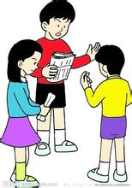 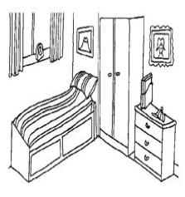  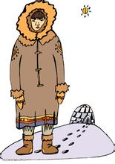

**A B C D**

  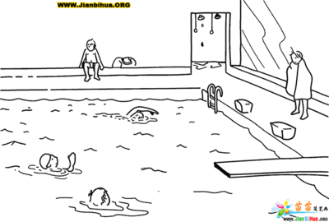 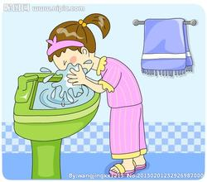

**E F G H**

1. \_\_\_\_\_\_ 2. \_\_\_\_\_\_ 3. \_\_\_\_\_\_ 4. \_\_\_\_\_\_ 5. \_\_\_\_\_\_ 6. \_\_\_\_\_\_

**B. Listen to the dialogue and choose the best answer to the question you hear (根据你听到的对话和问题，选出最恰当的答案): (共8分)**

7. A) Two. B) Three. C) Five. D) Seven.

8. A) In Hong Kong. B) In Tokyo. C) In Beijing. D) In London.

9. A) At 8:30. B) At 9:00. C) At 9:30. D) At 10:00.

10. A) Wife and husband. B) Teacher and student.

C) Boss and secretary. D) *Air hostess*(空姐) and passenger.

11. A) In the kitchen. B) In the bedroom . C) In the living room. D) In the garden.

12. A) Look for dinosaurs. B) Go to the library.

C) Search for information online. D) Borrow some books from the lady.

13. A) Happy. B) Tired. C) Bored. D) Excited.

14. A) The woman used to travel a lot.

B) The woman’s sister likes to collect postcards.

C) Their suitcases may be full of gifts.

D) The man wants a bigger suitcase.

**C. Listen to the passage and tell whether the following statements are true or false (判断下列句子是否符合你听到的内容, 符合的用“A”表示，不符合的用“B”表示): (共6分)**

15. The mother took her son to a concert to praise him for his progress.

16. Their seats were close to the entrance of the concert hall.

17. The boy secretly went up onto the stage and started to play.

18. The pianist was surprised to find how wonderfully the boy played the piano.

19. The pianist and the boy played together and their music attracted the crowd.

20. It tells us a helping hand makes a difference and people are supposed to help each other.

**D. Listen to the passage and complete the following sentences (听短文，完成下列内容。每空格限填一词): (共10分)**

21. When I was 22 years old, I weighed 220 pounds and wore a \_\_\_\_\_\_\_\_ \_\_\_\_\_\_\_\_.

22. My doctor told me that if I didn’t \_\_\_\_\_\_\_\_ \_\_\_\_\_\_\_\_ I would face an early death.

23. I started walking in the biggest park nearby \_\_\_\_\_\_\_\_ \_\_\_\_\_\_\_\_ and began to eat less.

24. In 2006, I decided to use an online diet diary to record my daily \_\_\_\_\_\_\_\_ \_\_\_\_\_\_\_\_ and exercise.

25. In five months, I lost 30 pounds and I was \_\_\_\_\_\_\_\_, \_\_\_\_\_\_\_\_ and healthier than I’d ever been.

**Six**

**I. Listening Comprehension (听力理解) (共30分)**

**A. Listen and choose the right picture (根据你听到的内容，选出相应的图片) (6分)**

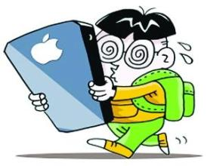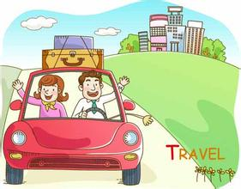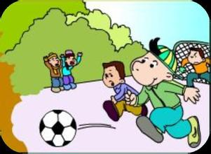



**A B C D**

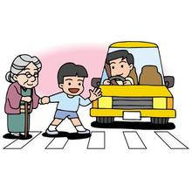

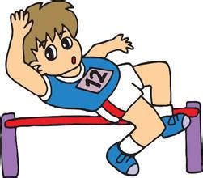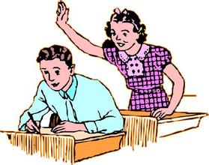

**E F G H**

1. \_\_\_\_\_\_ 2. \_\_\_\_\_\_ 3. \_\_\_\_\_\_ 4. \_\_\_\_\_\_ 5. \_\_\_\_\_\_ 6. \_\_\_\_\_\_

**B. Listen to the dialogue and choose the best answer to the question you hear (根据你听到的对话和问题，选出最恰当的答案) (8分)**

7. A) A watch. B) A book. C) A case. D) A stamp.

8. A) By car. B) By train. C) By plane. D) By bus.

9. A) Sunny. B) Rainy. C) Windy. D) Snowy.

10. A) She doesn’t like parties. B) Her doctor will visit her.

C) She is busy working. D) She is not feeling well.

11. A) At an airport. B) At a supermarket. C) At a hotel. D) At a bank.

12. A) At 7: 00. B) At 8: 00. C) At 9: 00. D) At 10: 00.

13. A) Manager and secretary. B) Shop assistant and customer.

C) Teacher and student. D) Wife and husband.

14. A) They can buy vegetables together. B) They can go out for dinner that day.

C) He has never eaten in that restaurant. D) He disliked the food the woman cooked.

**C. Listen to the passage and tell whether the following statements are true or false (判断下列句子是否符合你听到的内容, 符合的用“T”表示，不符合的用“F”表示) (6分)**

15. An old couple went to their doctor because they were seriously ill.

16. The doctor told them to write things down in order not to forget.

17. The old lady told her husband to get her a bowl of rice after they got home.

18. The old lady told her husband to write something down, but he refused.

19. The husband could remember clearly what to do before he went to the kitchen.

20. From the story we can learn that the old lady was less forgetful than her husband.

**D. Listen to the dialogue and complete the following sentences (听对话，完成下列内容，每空格限填一词) (共10分)**

21. Sherry is going to visit Quebec \_\_\_\_\_\_\_\_ \_\_\_\_\_\_\_\_.

22. The St. Lawrence River \_\_\_\_\_\_\_\_ \_\_\_\_\_\_\_\_ the middle of the city, Montreal.

23. Bob tells Sherry that she’d better practise \_\_\_\_\_\_\_\_ \_\_\_\_\_\_\_\_ before she goes there.

24. Sherry will also visit a friend \_\_\_\_\_\_\_\_ \_\_\_\_\_\_\_\_ who lives in Quebec City.

25. Many old buildings in Quebec City were built in the \_\_\_\_\_\_\_\_ \_\_\_\_\_\_\_\_.

**Seven**

**I. Listening Comprehension (听力理解) (共30分)**

**A. Listen and choose the right picture (根据你听到的内容，选出相应的图片)：(6分)**

** 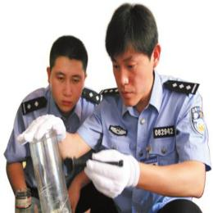 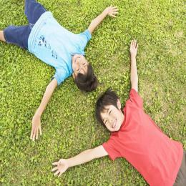 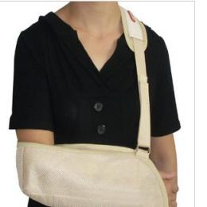**

**A B C D**

**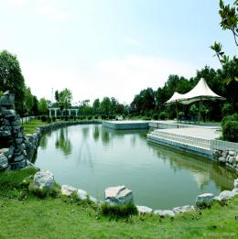   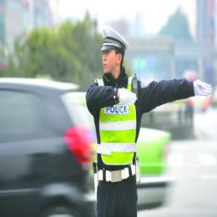**

**E F G H**

1.\_\_\_\_\_\_\_\_ 2.\_\_\_\_\_\_\_\_ 3.\_\_\_\_\_\_\_\_ 4.\_\_\_\_\_\_\_\_ 5.\_\_\_\_\_\_\_\_ 6.\_\_\_\_\_\_\_\_

**B. Listen to the dialogue and choose the best answer to the question you hear (根据你听到的对话和问题，选出最恰当的答案): (8分)**

7. A) England. B) Japan. C) Korea. D) America.

8. A) A cup of coffee. B) A cup of black tea.

C) A cup of coffee with milk and sugar. D) A cup of black tea with milk and sugar.

9. A) Write to each other. B) Make a phone call.

C) Have a video chat. D) Send emails.

10. A) In the shop. B) In the supermarket.

C) On line. D) In the book store.

11. A) Mum and son. B) Hotel clerk and customer.

C) Teacher and student. D) Patient and Doctor.

12. A) $2. B) $3. C)$ 4. D)$6.

13. A) To make Qing Tuan. B) To cook the delicious food.

C) To tell the story. D) To play with her younger niece.

14. A) He can't leave here this evening.

B) He will take the next flight to Hong Kong.

C) He has to hurry to catch the plane.

D) He can take the last flight finally.

**C. Listen to the passage and tell whether the following statements are true or false (判断下列句子是否符合你听到的内容, 符合的用“T”表示，不符合的用“F”表示): (6分)**

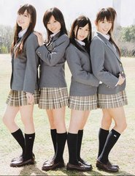15. Japanese girls may still wear school uniforms after they have graduated from school.

16. Japanese girls love school uniforms because of their fashionable design and good quality.

17. The style of Japanese school uniforms for girls is adapted from astronaut suits.

18. Japanese school uniforms are as expensive as those from Chinese schools.

19. It's convenient for Japanese girls to wear school uniforms because they meet the strict school rules.

20. This passage tells us three reasons why Japanese girls love school uniforms.

**D. Listen to the passage and complete the following sentences (听短文，完成下列内容，每空格限填一词): (共10分)**

21. To the rest of the world, Federer is \_\_\_\_\_ \_\_\_\_\_ a greater tennis player.

22. Federer helps \_\_\_\_\_ \_\_\_\_\_ for the poor children in Africa.

23. Last summer Federer went to Africa to celebrate\_\_\_\_\_ \_\_\_\_\_ of the Roger Federer Foundation(罗杰.费德勒基金会）

24. During his stay, Federer spent the day sitting in classes and \_\_\_\_\_ \_\_\_\_\_ young pupils in the school.

25. Federer believes every young child has the right to attend school because \_\_\_\_\_\_ \_\_\_\_\_is very important.

**Eight**

**Part l Listening（第一部分听力）**

**I. Listening Comprehension (听力理解): (共30分)**

**A. Listen and choose the right picture (根据你听到的内容，选出相应的图片) : (6分)**

|  |  |  |  |  |
| --- | --- | --- | --- | --- |
| **photosA** | **bike1B** | **morningC** | http://img5.imgtn.bdimg.com/it/u=1072251012,4097637351&fm=21&gp=0.jpg**D** | |
| http://img0.imgtn.bdimg.com/it/u=1418180099,431945953&fm=15&gp=0.jpg **E** | **http://img1.imgtn.bdimg.com/it/u=366286253,2502867884&fm=21&gp=0.jpgF** | **speechG** | **trafficH** |

1. \_\_\_\_\_\_ 2. \_\_\_\_\_\_ 3. \_\_\_\_\_\_ 4. \_\_\_\_\_\_ 5. \_\_\_\_\_\_ 6. \_\_\_\_\_\_

**B. Listen to the dialogue and choose the best answer to the question you hear (根据你听到的对话和问题，选出最恰当的答案) ：(8分)**

7. A) By plane. B) By bike. C) By car. D) By train.

8. A) Spring. B) Summer. C) Autumn. D) Winter.

9. A) At the airport. B) In a shop. C) At a cinema. D) At a railway station.

10. A) $20. B) $30. C) $50. D) $70.

11. A) Nancy. B) Peter. C) Jack. D) Bill.

12. A) At 7:10. B) At 7:15. C) At 7:25. D) At 7:35.

13. A) Mother’s Day gift. B) Buying a scarf.

C) Cooking a meal. D) A surprise party.

1. A) The hotel wants to change a room for Peter.

B) The hotel will give Peter another room.

C) Peter is complaining about the noise.

D) Peter wants to book a room in the hotel.

**C. Listen to the passage and tell whether the following statements are true or false (判断下列句子是否符合你听到的内容, 符合的用“T”表示，不符合的用“F”表示)：(6分)**

15. In an old Chinese story, a woman became very sad when her only son died.

16. A clever man gave the woman a magic seed to drive out her sadness.

17. There was not any sadness in the beautiful home the woman visited.

18. The woman stayed to *comfort* (安慰) the people in the beautiful house.

19. The woman found many sad stories from the homes of the poor except the rich.

20. In fact, the woman finally got rid of her own sadness by helping others.

**D. Listen to the passage and complete the following sentences (听短文，完成下列内容，每空格限填一词) ：(10分)**

21. In Brazil, young or unmarried people kiss one another twice or even \_\_\_\_\_\_ \_\_\_\_\_\_ a day.

22. Americans kiss family members and usually shake hands when they\_\_\_\_\_\_ \_\_\_\_\_\_ people.

23. In the U.S.A, it’s polite to make \_\_\_\_\_\_ \_\_\_\_\_\_ when you’re talking to someone.

24. It is not very common for Americans to \_\_\_\_\_\_ \_\_\_\_\_\_ into their homes.

25. In the U.S.A., new friends usually call each other by their \_\_\_\_\_\_ \_\_\_\_\_\_.

**Nine**

**I. Listening Comprehension (听力理解) (共30分)**

**A．Listen and choose the right picture（根据你听到的内容，选出相应的图片）（6分）**

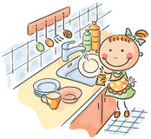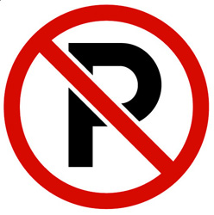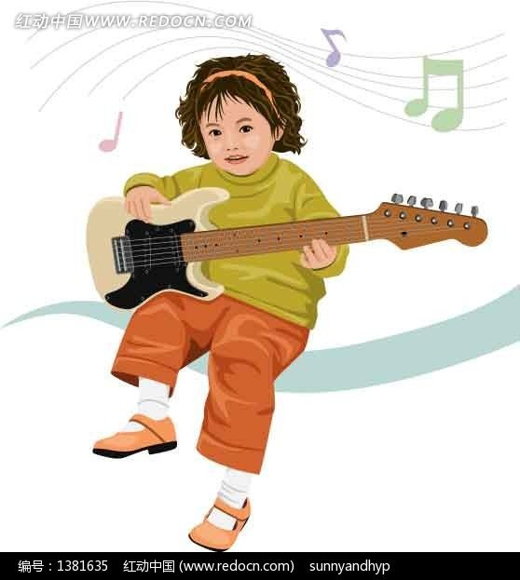

**A B C D**

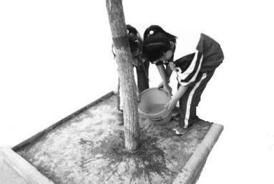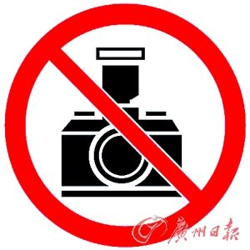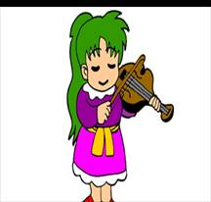

**E F G H**

1. \_\_\_\_\_\_ 2. \_\_\_\_\_\_ 3. \_\_\_\_\_\_ 4. \_\_\_\_\_\_ 5. \_\_\_\_\_\_ 6. \_\_\_\_\_\_

**B. Listen to the dialogue and choose the best answer to the question you hear (根据你听到的对话和问题，选出最恰当的答案) (8分)**

7. A) Sunny. B) Rainy.

C) Windy. D) Foggy.

8. A) Once a day. B) Twice a day.

C) Twice a week. D) Every two days.

9. A) At 9:30 a.m. B) At 10:00 a.m.

C) At 1:00 p.m. D) At 1:30 p.m.

10. A) Mother and son. B) Teacher and student.

C) Father and daughter. D) Doctor and patient.

11. A) Computer courses. B) A fitness program.

C) A trip to Hong Kong. D) Plans for summer holiday.

12. A) In the library. B) In the restaurant.

C) In the cinema. D) In the supermarket.

1. A) Because he visited a company. B) Because he had an interview.

C) Because the woman thought he was cool. D) Because he got a job as sales manager.

14. A) He liked the Australian professor. B) He wanted to have a sleep.

C) He didn’t like the lecture. D) He took many notes of the lecture.

**C. Listen to the passage and tell whether the following statements are true or false (判断下列句子是否符合你听到的短文内容，符合的用“T”表示，不符合的用“F”表示) (6分)**

15. Three students are talking about how to reduce the unnecessary waste in daily life.

16. Wang shen went back to the classroom again because the lights were still on.

17. Wang shen gives us two ideas on how to save electricity in the class.

18. Zhao Xin used to waste a lot of water when she washed her face.

19. Zhao’s mother suggested that we should grow plants with the water we used.

20. Pan finds that many people in his dad’s office make full use of printing paper.

**D. Listen to the passage and complete the following sentences (听短文，完成下列内容。每空格限填一词) (10分)**

**Hans Christian *Andersen* (安徒生)**

21. Hans Christian Andersen, the father of modern fairy tales, was born on \_\_\_\_\_\_\_ \_\_\_\_\_\_, 1805.

22. Hans Christian Andersen had to \_\_\_\_\_\_\_ \_\_\_\_\_\_\_ and started to work in a factory because of his father’s death.

23. When Hans Christian Andersen went back to the classroom, he found his classmates were six \_\_\_\_\_\_\_\_ \_\_\_\_\_\_\_\_ than him.

24. In 1835, Andersen’s \_\_\_\_\_\_\_\_ \_\_\_\_\_\_\_\_ of fairy tales was *published* (出版) successfully.

25. Children can learn many things about \_\_\_\_\_\_\_\_ and \_\_\_\_\_\_\_\_ from his fairy tales.

**Ten**

**I. Listening Comprehension(听力理解)（共30分）**

**A. Listen and choose the right picture.(根据你听到的内容，选出相应的图片)（6分）**

**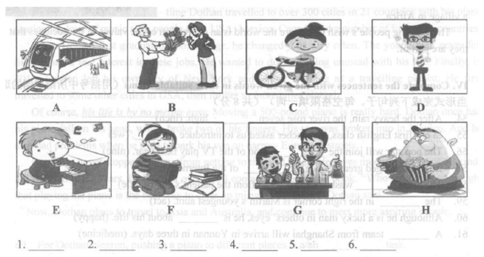**

**B. Listen to the dialogue and choose the best answer to the question you hear.(根据你听到的对话和问题，选出最恰当的答案)（8分）**

7. A) 9:00. 　 B) 9:30.　 C) 10:00. 　 D) 10:30.

8. A) She will see her uncle off. B) She will visit her uncle.

C) She will take a plane. D) She will go to the beach.

9. A) Football. B)学科网(www.zxxk.com)--教育资源门户，提供试卷、教案、课件、论文、素材及各类教学资源下载，还有大量而丰富的教学相关资讯！ Basketball. C) Tennis. D) Table tennis.

10. A) The service. B) The food. C) The price. D) The smell.

11. A) By making phone calls. B) By going out with them.

C) By sending messages. D) By chatting online.

12. A) In a field. B) On a farm. C) On a train. D) At a bus stop.

13.A) She was the writer of the book. B) She believes the man knows Mary well.

C) She thinks books are the best gifts for writers. D) She suggests the man change the gift.

14. A) An earthquake. B) A traffic accident. C) A terrible bus. D) A running race.

**C. Listen to the passage and tell whether the following statements are true or false(判断下列句子是否符合你听到的短文内容，符合的用T表示，不符合的用F表示)**

15. Monty's father trained horses for people on the farms.

16. Monty drew a picture of a horse farm in the composition学科网(www.zxxk.com)--教育资源门户，提供试卷、教案、课件、论文、素材及各类教学资源下载，还有大量而丰富的教学相关资讯！ about his dream.

17. Monty got a low mark for the composition because it was too long.

18.The teacher explained to the class about her opinions of Monty's composition.

19.Monty changed some parts of the composition though he didn't quite agree with her.

20.His teacher's words didn't make him change his mind and he finally realized his dream.

**D. Listen to th学科网(www.zxxk.com)--教育资源门户，提供试卷、教案、课件、论文、素材及各类教学资源下载，还有大量而丰富的教学相关资讯！e passage and complete the following sentences （听短文完成下列内容，每空格限填-词) (共 10分)**

21. Julian, a 17-year-old .,was the only person alive after the accident

22. She had a terrible headache and a bad cut on the arm when she .

23. In the forest, she knew that the most important thing was to find .

24. When the animals attacked her, she with a stick.

25. 学科网(www.zxxk.com)--教育资源门户，提供试卷、教案、课件、论文、素材及各类教学资源下载，还有大量而丰富的教学相关资讯！After ,the police decided to give up searching for people who might be alive.

**Eleven**

**I. Listening comprehension (听力理解) (共30分)**

**A. Listen and choose the right picture (根据你听到的内容，选出相应的图片) (6分)**

|  |  |  |  |
| --- | --- | --- | --- |
|  |  |  |  |
| A | B | C | D |
|  |  |  |  |
| E | F | G | H |

1. 2. 3. 4. 5. 6.

**B. Listen to the dialogue and choose the best answer to the question you hear (根据你听到的对话和问题，选出最恰当的答案) (8分)**

7. A) Apples. B) Pears. C) Peaches. D) Lemons.

8. A) 2. B) 3. C) 4. D) 5.

9. A) Independent. B) Humourous. C) Careless. D) Helpful.

10. A) At 7:10. B) At 7:30. C) At 7:50. D) At 9:30.

11. A) In a hospital. B) In a restaurant. C) At a bank. D) At a cinema.

12.A) Secretary and manager. B) Husband and wife.

C) Student and teacher. D) Patient and doctor.

13. A) Because there was a heavy traffic. B) Because he has been somewhere else.

C) Because he was caught by the police.D) Because he doesn’t like going to school.

14. A) She has got a very bad cold. B) It has been windy for days.

C) The weather is changeable. D) A scarf is needed in winter.

**C. Listen to the dialogue and tell whether the following statements are true or false (判断下列句子是否符合你听到的对话内容, 符合的用“T”表示，不符合的用“F”表示) (6分)**

15. Tony and his mother were talking about the play he had just seen.

16. Though the play lasted for about three hours, Tony still thought it enjoyable.

17. Tony’s mum recited a line from the play, and her son went on reciting.

18. Romeo and Juliet decided to kill themselves when the two families and the servants fought.

19. Connie and Jack couldn’t hear the dialogue at all because their seats were at the back.

20. It was pity that Tony didn’t have time to eat anything before the play.

**D. Listen to the dialogue and complete the following sentences (听对话，完成下列内容。每空格限填一词) (10分)**

21. Cathy’s head started \_\_\_\_\_\_\_\_\_\_ \_\_\_\_\_\_\_\_\_\_ as soon as she arrived.

22. She is excited to be home, but she has already \_\_\_\_\_\_\_\_\_\_ \_\_\_\_\_\_\_\_\_\_.

23. Cathy’s \_\_\_\_\_\_\_\_\_\_ \_\_\_\_\_\_\_\_\_\_ have all been in a small village.

24. It’s like that she \_\_\_\_\_\_\_\_\_\_ \_\_\_\_\_\_\_\_\_\_ what her old life was like.

25. Kathy is not used to American food any more and she keeps \_\_\_\_\_\_\_\_\_\_ \_\_\_\_\_\_\_\_\_\_.

**Twelve**

**I. Listening Comprehension (听力理解) (共30分)**

**A. Listen and choose the right picture (根据你听到的内容，选出相应的图片) ( 6分)**

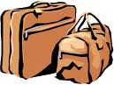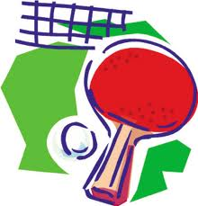

**A B C D**

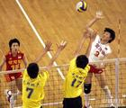

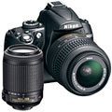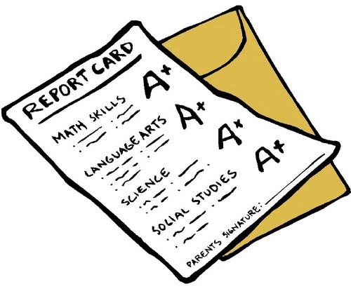

**E F G H**

1. \_\_\_\_\_\_\_\_ 2. \_\_\_\_\_\_\_\_ 3. \_\_\_\_\_\_\_\_ 4. \_\_\_\_\_\_\_\_ 5. \_\_\_\_\_\_\_\_ 6. \_\_\_\_\_\_\_\_

**B. Listen to the dialogue and choose the best answer to the question you hear (根据你所听到的对话和问题，选择最恰当的答案) (8分)**

7. A) On his way home. B) In his car. C) At home. D) In his office.

8. A) Because she was ill. B) Because she was writing her report.

C) Because she was busy. D) Because she didn’t know it.

9. A) Maths and physics. B) English and Chinese.

C) History and maths. D) Physics and history.

10.A) She missed the plane to London. B) She lost her handbag.

C) She missed the train to London. D) She lost a big handbag.

11. A) The woman only. B) Only Anna and Karl.

C) Anna, Karl and the woman. D) Nobody.

12. A) A quarter. B) One-fifth. C) One-fourth. D) Four-fifths.

13. A) Tuesday morning. B) Friday morning. C) Saturday Morning. D) Sunday morning.

14. A) About two weeks. B) About three weeks.

C) About four weeks. D) About five weeks.

**C. Listen to the passage and tell whether the following statements are true or false (判断下列句子是否符合你听到的短文内容, 符合的用“T”表示，不符合的用“F”表示) (6分)**

15. The world championship (锦标赛）was held in Austria in 2007.

16. Michael Phelps won 7 gold medals at Beijing Olympics.

17. Only his tall and wild body makes his dream come true.

18. He succeeded because he put his mind into swimming.

19. Phelps trains every day except on Christmas Day.

20. From Phelps’ experiences, we know that nothing is impossible.

**D. Listen to the passage and fill in the blanks (听短文填空，完成下列句子。每空格限填一词) (10分)**

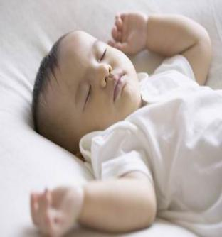21.Sleep is important for things to \_\_\_\_\_\_\_ \_\_\_\_\_\_\_\_ into the brain.

22.If you are trying to remember a \_\_\_\_\_\_\_\_\_ \_\_\_\_\_\_\_\_\_ within

30 minutes, a good night’s sleep is necessary.

23.The research showed that the act of sleep was important for

people to \_\_\_\_\_\_\_\_\_\_\_ \_\_\_\_\_\_\_\_\_\_ things.

24.One in five people says that not enough sleep will affect their

\_\_\_\_\_\_\_\_\_\_ \_\_\_\_\_\_\_\_\_.

25. If volunteers in an experiment were allowed to sleep \_\_\_\_\_\_\_\_\_\_

\_\_\_\_\_\_\_\_\_\_, they found it easier to finish the memory work.

**Fourteen**

**I. Listening comprehension (听力理解) (共30分)**

**A. Listen and choose the right picture (根据你听到的内容，选出相应的图片) (6分)**

   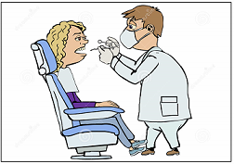

A B C D

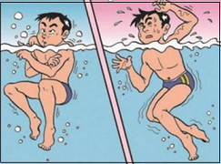  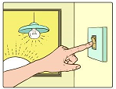 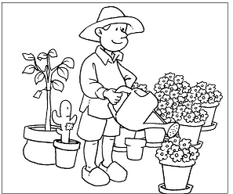

E F G H

1. \_\_\_\_\_\_ 2. \_\_\_\_\_\_ 3. \_\_\_\_\_\_ 4. \_\_\_\_\_\_ 5. \_\_\_\_\_\_ 6. \_\_\_\_\_\_

**B. Listen to the dialogue and choose the best answer to the question you hear (根据你听到的对话和问题，选出最恰当的答案) (8分)**

7. A) Coffee. B) Tea. C) Juice. D) Water.

8. A) By car. B) By plane. C) By bus. D) By ship.

9. A) 10 Yuan. B) 9 Yuan. C) 90 Yuan. D) 100 Yuan.

10. A) In the library. B) In the department store.

C) In the classroom. D) In the restaurant.

11. A) This Wednesday. B) This Saturday.

C) Next Monday. D) Next Sunday.

12. A) Because Tom is ill at home. B) Because Tom didn’t call back.

C) Because Tom didn’t go to school. D) Because Tom didn’t do his homework.

13. A) The hotel is really great. B) The hotel offers good service.

C) The service in the hotel is really poor. D) Customers can’t get anything from the hotel.

14. A) He got injured. B) He visited Japan.

C) He sold plane tickets. D) He wrote a book about Japan.

**C. Listen to the passage and tell whether the following statements are true or false (判断下列句子是否符合你听到的短文内容，符合的用“T”表示，不符合的用“F”表示) (6分)**

15. Jack booked into a hotel in New York on his business trip.

16. He was not satisfied with the food served in the hotel at all.

17. When he returned to the hotel on the second day, he found his room empty.

18. Jack asked for the hotel service of packing his suitcase because he was leaving.

19. Jack was very angry when he found everything packed in the suitcase was in a mess.

20. Jack asked to see the manager most probably to complain about the service in the hotel.

**D. Listen to the passage and complete the following sentences (听短文，完成下列内容。每空格限填一词) (10分)**

21. On a Christmas Eve the Hardens got a special call which lasted only \_\_\_\_\_\_ \_\_\_\_\_\_.

22. The Hardens were \_\_\_\_\_\_ \_\_\_\_\_\_, so they started a special telephone service.

23. Runaway children can call “Alive and Well” and leave \_\_\_\_\_\_ \_\_\_\_\_\_ for their parents.

24. With the answering machines, nobody can speak to the child or make him \_\_\_\_\_\_ \_\_\_\_\_\_.

25. The Hardens \_\_\_\_\_\_ \_\_\_\_\_\_ the children’s words and connect the given addresses.

**Fifteen**

**I. Listening Comprehension (听力理解): (共30分)**

**A. Listen and choose the right picture (根据你听到的内容，选出相应的图片): （6分）**

|  |  |  |  |
| --- | --- | --- | --- |
| C:\Users\ZY\Pictures\balloons.jpgballoonsA | C:\Users\ZY\Pictures\fire smoke.jpgfire smokeB | C:\Users\ZY\Pictures\bird in the cage.jpgbird in the cageC | C:\Users\ZY\Pictures\flood.jpgflood D |
| C:\Users\ZY\Pictures\artist_28.gifartist_28 E | C:\Users\ZY\Pictures\cough.jpgcoughF | C:\Users\ZY\Pictures\dentist.jpgdentist G | C:\Users\ZY\Pictures\climb the fence.jpgclimb the fenceH |

1. \_\_\_\_\_\_\_ 2. \_\_\_\_\_\_ 3. \_\_\_\_\_\_\_\_ 4. \_\_\_\_\_\_\_\_\_ 5. \_\_\_\_\_\_\_\_\_ 6. \_\_\_\_\_\_\_\_\_

**B. Listen to the dialogue and choose the best answer to the question you hear (根据你听到的对话和问题，选出最恰当的答案): (8分)**

7. A) Rainy. B) Snowy. C) Cloudy. D) Clear.

8. A) Science. B) Math. C) P.E. D) Society.

9. A) Cute. B) Popular. C) Friendly. D) Serious.

10. A) $30. B) $21. C) $13. D) $9.

11. A) Teacher and student. B) Doctor and patient.

C) Shop assistant and customer. D) Manager and clerk.

12. A) Bus No. 112. B) Bus No. 153. C) Bus No. 113. D) Bus No. 117.

13. A) Room 102 is not available now. B) John wants to book a room in the hotel.

C) The hotel will get John another room. D) John is complaining about the noise.

14. A) He did some physical activity. B) He did his homework.

C) He listened to a program. D) He studied for the exams.

**C. Listen to the passage and tell whether the following statements are true or false (判断下列**

**句子是否符合你听到的短文内容, 符合的用“T”表示，不符合的用“F”表示): (6分)**

15. Gabriela fell down when she was on her way to the bus stop.

16. Gabriela immediately called an *ambulance* (救护车).

17. It was hard for the nurses to get to Gabriela because so many students were around her.

18. Gabriela’s leg wasn’t broken but it hurt.

19. Gabriela’s classmate drove her home because he lived close to her.

20. The story mainly tells us that one should stay calm when something bad happens.

**D. Listen to the passage and complete the following sentences (听短文，完成下列内容，每空格限填一词): (10分)**

21. Emma’s mom published her first book when she was just \_\_\_\_\_\_\_\_\_ \_\_\_\_\_\_\_\_\_ old.

22. Emma’s dad is a famous \_\_\_\_\_\_\_\_\_\_ \_\_\_\_\_\_\_\_\_\_ and has won many tournaments.

23. Chris’s latest invention can protect your iPod from \_\_\_\_\_\_\_\_\_\_ \_\_\_\_\_\_\_\_\_\_.

24. Emma is \_\_\_\_\_\_\_\_ \_\_\_\_\_\_\_\_ of her school football team.

25. Emma’s parents are \_\_\_\_\_\_\_\_\_\_ \_\_\_\_\_\_\_\_\_\_ her and her brother.