初二年级英语月质量检测试卷 (2017年3月)
（满分100分， 考试时间100分钟）
Part 1 Listening (第一部分 听力) 30%
- Listen and choose the right picture (根据你听到的内容，选出相应的图片): (5%)
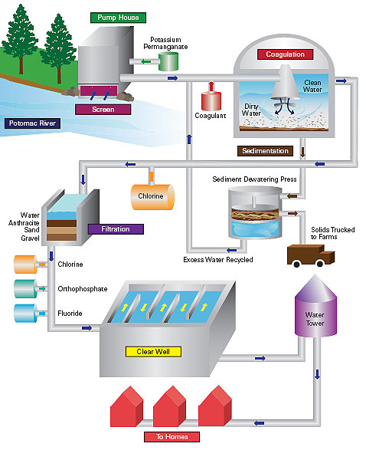

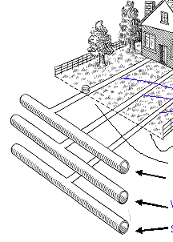

A B C
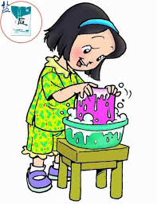


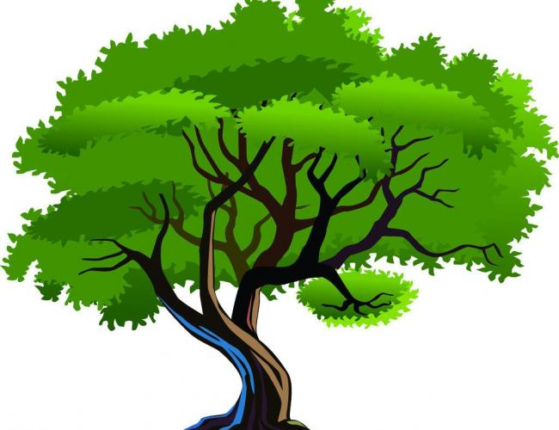

D E F G
1. 2. 3. 4. 5. 6.
II. Listen to the dialogue and choose the best answer to the question you hear (根据你听到的对话和问题，选出最恰当的答案): (10%)
7. A. The pair of black goggles. B. Neither.
C. The pair of brown goggles. D. Either.
8. A. He went to bed too late last night.
B. He feels better.
C. He has little time to have breakfast.
D. He has a stomach ache
9. A. In the street. B. In a flower shop.
C. In a supermarket. D. At a restaurant.
10. A. She stayed at home. B. She went shopping.
C. She went fishing. D. She watched a match.
11. A. At Mike’s home. B. At Rita’s home.
C. On the desk. D. At school.
12. A. 30 years old. B. 35 years old. C. 20 years old. D. 55 years old.
13. A. Fifty-two. B. Twenty. C. Fifty. D. Thirty.
14. A. At a bus stop. B. In the underground.
C. At the railway station. D. At an airport.
15. A. 65758053. B. 65750853. C. 65758035. D. 65750835.
III．Listen to the passage and tell whether the following statements are true or false (判断下列句子是否符合你听到的短文内容, 符合的用“T”表示，不符合的用“F”表示): (5%)
- The sea looks very beautiful when the Sun is shining on it.
- It can be very amazing when there is a strong wind.
- The first thing about the sea to remember is that the sea is very big.
- There is more sea than land on the Earth.
- The highest mountain in the world is about 9 kilometres high.
IV. Listen to the dialogue and fill in the blanks (听短文信息完成空格, 每格限填一词): (10%)
- Yesterday afternoon, Mr. Smith _______ _______ for three hours in his friend’s house.
- It was getting dark, so he left there in a hurry and ______ _____ a car.
- ‘Come here! What a fool!’Mr. Smith _______ ______ it.
- But the dog still _______ ______.
- He was in the ________ _______ ![来源:学§科§网Z§X§X§K]
Part 2 Vocabulary and Grammar ( 第二部分 词汇与语法) 36%
I. Choose the best answer (选择最恰当的答案)：(14%)
( ) 1. Trees are very important because they can make streets _____ beautiful and ____ noisy.
A. less, less B. more, more C. less, more D. more, less
( ) 2. I would like to thank you ______ what you have done for me.
A. to B. on C. for D. with
( ) 3. We are all _______ in the story told by him.
A. interested B. interest C. interesting D. interests
( ) 4. _________ food is there in the fridge?
A. How much B. How many C. How D. How nice
( ) 5. What do you mean by ______ that?
A. say B. to say C. said D. saying
( ) 6. Remember _____ smoke in public places.
A. to B. to not C. not D. not to
( ) 7. We communicate _______ each other by E-mail.
A. to B. for C. about D. with
( ) 8. Have you finished your _______ homework?
A. chemical B. chemistry C. chemical’s D. chemistry’s
( ) 9. Little Tom kept crying ________his mother came back.
A. before B. after C. until D. when
( ) 10. I think friendship is very valuable. The underlined part means _________.
A. beautiful B. useful C. important D. precious
( ) 11. What he said sounds very ______.
A. excited B. well C. interesting D. wonderfully [来源:学。科。网Z。X。X。K]
( ) 12. Please turn down the TV. Grandma __________.
A. sleeps B. is sleeping C. asleep D. sleepy
( )13. Trees release oxygen into the air and clean the air. The underlined part means _________.
A let out B take away C bring in D put up
( )14. The trees can protect themselves by _______ a chemical that makes their
leaves _____ nasty.
A.produce…taste B.producing…tasting
C.produce…tastes D.producing…taste
II. Complete the following passage with the words or the phrases in the box. Each word or phrase can only be used once (完成下列短文，用A, B, C, D, E或F等表示,每空格限填一词，每词或词组只能填一次)： (5%)
A) keep B) however C) have
D) more E) less F) never
It is not always easy to follow a doctor’s advice and stay in bed, especially if the sun is shining or there are things that ____1____ to be done. The pressures of a job or career will often ____2____a sick person working long after he or she should have gone to bed. Somehow people tend to believe that the work will _____3____be delayed.
Following the doctor’s orders, _____ 4_____, is just as important as getting to work on time. It is important for the protection of your health. Even if you are feeling better, and even if you feel that you are strong enough to go back to work, you may still be sick enough to infect others, especially when you have virus. Also, of course, going back too early could cause a relapse, and this means that you might miss _____5____work.
III. Use the right forms of the given words （用所给单词的适当形式填空）： (7%)
- After dinner, Tommy sat __________ in the sofa, reading his favorite book. (comfortable)
- The oxygen in the bottle can keep the pilot _______ if something dangerous happens. (live)
- The shop assistant gave the customer a clear _________, so the customer wasn’t angry any more. (explain)
- There are many kinds of ________ on the earth nowadays. (pollute)
- We sat waiting _________ for the movie to start. (patient)
- Floods and earthquakes are _______ disasters. (nature)
- I tried every _________ (treat) the doctor suggested.
IV. Rewrite the sentences（按要求改写句子）：(10%)
- The students had a good rest during the lunch time yesterday. (改为否定句)
The students___________ ___________a good rest during the lunch time yesterday.
- John could hardly believe the news. (改为反义疑问句)
John could hardly believe the news, __________ __________?
- They sell newspapers. They sell books, too. (合并为一句)
They sell books __________ __________ as newspapers.
4. The girl was too young to drive a car. (保持句意相同)[来源:学&科&网Z&X&X&K]
The girl was ______ young that she ______ drive a car.
5. I, pure, enjoy, suppose, you, air, breathing (连词成句)
Part 3 Reading and Writing ( 第三部分 阅读和写话) 34%
I. Choose the best answer（根据短文内容，选择最恰当的答案）: (5%)
Many people have said that you can experience all four seasons in a single day in Britain. I finally got it recently.
It was a Saturday morning and raining lightly. Mom and I were going to the cinema. But the rain didn’t put us off; we’ve had far worse than that!
After the film was over, we could see from the cinema window that the rain was pouring down (瓢泼大雨). But when we reached the exit, the weather was completely normal. There was no rain, just wind and bright sunshine. It was amazing.
Since the weather was looking good, we decided to go to the Botanic Garden in the afternoon. However, on the way there, there was another shower—this time of snow. I was excited about the snow; Mom was busy trying to get me into my raincoat. Then, dramatically, the snow stopped. We were startled. And guess what? The same thing happened four more times that afternoon. [来源:学科网ZXXK]
If you think that was the end, think again. The next day, on Sunday, when I pulled back the curtains, the world was covered in a blanket of snow. I quickly got dressed and ran out of the house. A few minutes later, I’d made a big snowman in the back garden. The snow was already up to my heels and I didn’t think it would stop the whole day.
But a little later it did stop. That was at 11 in the morning; by 4 pm all the snow had disappeared. The sun had come out again, shining brightly as “normal”!
1. ______ experienced all four seasons in a single day in Britain recently.
A. Many people except the writer. B. The writer and his mom.
C. The writer alone. D. The writer and his sister.
2. ______ on Saturday morning.
A. They saw a film at the cinema B. They visited the Botanic Garden
C. The rain stopped them from visiting the Botanic Garden
D. The rain stopped them from seeing a film
3. The underlined word in the sentence ‘We were startled.’ in paragraph 4 means ______.
A. really happy B. greatly surprised C. rather excited D) a little upset
4. It snowed ______ that Saturday afternoon.
A. twice B. once C. four times D. five times
5. Through the passage, the writer mainly wants to tell us ______.
A. you can go to the Botanic Garden on a sunny day
B. he liked the snow very much like other children
C. people will experience changeable weather in a single day in Britain
D. a heavy snow will be melted within 5 hours
II. Choose the words or expressions and complete the passage（选择最恰当的单词或词语完成短文）:（6%）
Farley worked for the Canadian government. One day, he was __1__ to learn more about wolves. Do wolves kill lots of caribou (big animals)? Do they kill people?
They gave him lots of food and clothes and guns. Then they put him on a plane and took him to __2__. The plane put him down and went away. There were no houses or people in this place. But there were lots of animals -- and lots of wolves.
People tell terrible stories about wolves. They say wolves like to kill and eat people. Farley remembered these stories, and he was __3__. He had his gun with him all the time.
Then one day, he saw a group of wolves. There was a mother wolf with four baby wolves. A father wolf and another young wolf lived with them.
Farley watched these wolves every day. The mother was a very __4__ mother. She gave milk to her babies. She gave them lessons about life. They learned how to get food. The father wolf got food for the mother. The young wolf played with the children. They were a nice, happy family --- a wolf family! Farley did not need his gun any more. In a short time, he got on well with the wolf family. Farley watched them for five months. He learned many new things about wolves. He learned that many stories about the wolves were __5__.
Wolves do not eat people, and they do not eat many large animals, and also learned bad things about men. It was men who killed many caribou and wolves.
Later, Farley wrote a book about wolves. He wanted people to __6__ them and not to kill them.
1. A. seen B. told C. heard D. found
2. A. a small town B. a big city C. a far place D. a lonely village
3. A. afraid B. happy C. angry D. tired
4. A. bad B. good C. hungry D. thirsty
5. A. not good B. not true C. not easy D. not clear
6. A. realize B. have C. teach D. understand
III. Read the passage and fill in the blanks with proper words（在短文的空格内填入适当的词，使其内容通顺，每空格限填一词，首字母已给）：（7分）
Yin Zixi, a 12-year-old boy form No. 159 Middle School in Beijing, started to w___1___ glasses at the age of nine. His parents think he read too many cartoons in bed.
In Yin’s class, more than 20 children out of 46 are short-sighted. They are part of the growing number of kids with eye p___2___.
A new Education Ministry(教育部) survey s___3___ over 55 per cent of junior school students in China are short-sighted. Too much TV, l___4___ exercise and bad reading habits are the top causes. More Chinese teenagers wear glasses than any other country in the world after Japan.
An eye expert at Peking University’s medical school advises students to:
1. Do m___5___ outdoor activities such as basketball and cycling.
2. Keep a distance while r___6___ or watching.
3. Do eye exercises d___7___ your school breaks.
IV. Answer the questions（根据短文内容回答下列问题）：（6分）
Yesterday the police and more than 20 volunteers started to search for the two missing teenagers, Vicky Gray and Tom Hunter, and their guide, Gavin Jones. The police said that they had disappeared during an adventure tour of Cape York Peninsula.
This was the second day of the search and it was getting dark. The police were now very worried about the safety of the missing people.
The police said that the search had covered a wide area, but the rainforest was thick and their work was made harder by the recent rain. Later on Chief Inspector Roger Fleet said, “The travelers had a radio with them. If they had been in trouble, they would have called us.”
The travelers left Cooktown very early on Saturday morning in a Toyota car. They took a small dirt road that runs down to the Daintree River, a dangerous river full of crocodiles. Chief Inspector Roger Fleet said the tourists wouldn’t have got into trouble if they had stayed on the main road.
A photo of Vicky and Tom was found by a policeman under the “Be Careful about Crocodiles” sign near the river. Why was the photo left behind? This is just one of the unanswered questions. Other questions are: Why was the Toyota parked and locked at the edge of the rainforest? The police said that the travelers had left a map of the area behind. Why? Why had someone drawn a cross on the point where the car is? Is this a sign? What does it mean? If anyone can give information or has seen these young people, contact the local police in Cooktown.
1. How many people disappeared during the adventure tour of Cape York Peninsula?
2. What made the search of the missing people even harder?
3. How did the travelers leave Cooktown for the adventure tour on Saturday morning?
4. Which wasn’t found by the police, a touring map, the travellers’ photo or the travellers’ radio?
5. The article doesn’t tell people why a cross was drawn, does it?
6. What does the article ask people to do?[来源:学+科+网]
V. Writing（作文）：（共10%）
Write at least 60 words about the topic “Trees”.（以“树木”为题写一篇不少于60个词的短文，标点符号不占格。）
（注意：短文中不得出现考生的姓名、校名及其他相关信息，否则不予评分。）
Use the following points as a guide.（短文须包含下列要点）
  - What can trees do?
  - What should we do to trees?

学校：______________ 班级：__________ 学号：_________ 姓名：__________成绩：
………密◎……………………………………封◎……………………………………◎线………………………………………

初二年级英语月考答题卷 (2017 年3月)
Part I Listening 30%
I. Listen to the sentence and choose the suitable picture: (5%)
1. _______ 2. _______ 3. _______ 4. _______ 5. _______ 6. _______
II. Listen to the dialogue and choose the best answer to the question you hear. (10%)
7. _______ 8. _______ 9. _______ 10. _______
11. _______ 12. _______ 13. _______ 14. _______ 15. _______
III. Listen to the passage and tell whether the following statements are true or false. (5%)
16. _______ 17. _______ 18. _______ 19. _______ 20. _______
IV. Listen to the dialogue and fill in the blanks. (10%)
21. ____________ ____________ 22. ____________ __________
23. ____________ ____________ 24. ____________ ____________
25. ____________ ____________
Part II Vocabulary and Grammar 36%
I. Choose the best answer: (14%)
1. _______ 2. _______ 3. _______ 4. _______5. ______ 6. _______ 7. _______ 8. _______ 9. _______ 10. ______ 11. ______12. _______ 13. ______ 14. _______
II. Complete the following passage with the words or the phrases in the box. Each word or phrase can only be used once： (5%)
1. _________ 2. _________ 3. _________ 4. _________5. _______
III. Complete the sentences with the given words in their proper forms. (7%)
- ___________ 2. ____________ 3. ____________ 4. ____________
5. ____________6. _____________ 7. _____________
IV. Rewrite the sentences as required: (10%)
1. ___________ ___________ 2. ___________ ___________
3. ___________ ___________ 4. ___________ ___________
5. ______________________________________________________
Part III Reading and Writing 34%
I. Read and choose: (5%)
1. _______ 2. _______ 3. _______ 4. _______ 5. _______
II. Choose the words or expressions and complete the passage: (6%)
1. _______ 2. _______ 3. _______ 4. _______ 5. _______ 6. ________
III. Complete the passage with proper words: (7%)
1. w____________2. p_________ 3. s_________ 4. l_________
5. m_________ 6. r_________ 7. d_________
IV. Read and answer: (6%)
- ________________________________________________________
- ________________________________________________________
- ________________________________________________________
- ________________________________________________________
- ________________________________________________________
- ________________________________________________________
V. Writing: (10%)
Write at least 60 words about the topic “Trees”.（以“树木”为题写一篇不少于60个词的短文，标点符号不占格。）
Use the following points as a guide.（短文须包含下列要点）
- What can trees do?
- What should we do to trees?
Trees
________ ________ ________ ________ ________ ________ ________ ________

________ ________ ________ ________ ________ ________ ________ ________

________ ________ ________ ________ ________ ________ ________ ________

________ ________ ________ ________ ________ ________ ________ ________

________ ________ ________ ________ ________ ________ ________ ________

________ ________ ________ ________ ________ ________ ________ ________

________ ________ ________ ________ ________ ________ ________ ________

________ ________ ________ ________60 ________ ________ ________ _______

________ ________ ________ ________ ________ ________ ________ ________

________ ________ ________ ________ ________ ________ ________ ________
上南南校初二年级英语月质量检测听力材料 (2017年3月)
- Listen and choose the right picture (根据你听到的内容，选出相应的图片): (5%)
- Reading school newspaper is my hobby.
- Don’t wash everything under the running water.
- Add some salt to make your clothes clean and colorful.
- Water was pouring into the washbasin and vanishing down the drain.
- Water is cleaned up in the treatment works.
- Trees take harmful gases and release Oxygen.
- II. Listen to the dialogue and choose the best answer to the question you hear (根据你听到的对话和问题，选出最恰当的答案): (10%)
7.W:Can I help you?
M:Yes,I’d like to buy a pair of goggles. Can you show me one?
W:Sure.What about this black one?
M:Well, it isn’t as nice as that brown one. But that brown one is too expensive for me to buy.
Q: Which pair of goggles will the man probably buy?
8. W: What’s wrong with you? You look very pale.
M: I feel sick. Last night I stayed up too late and get up early this morning. I hardly had any time to have breakfast, so I have had a stomach ache.
W: You’d better see the doctor.
M: Yes, I will. Thank you.
Q: What’s wrong with the man?
9.W:Excuse me. I’m looking for a bunch of bananas.
M:Sorry. There aren’t any more bananas. We’ve sold out all of them.
Q:Where does the conversation probably take place?
10.W:I went to watch an exciting match instead of staying at home yesterday afternoon. What about you?
M:My friend asked me to go fishing with him. But I went shopping with my wife.
Q:What did the woman do yesterday afternoon?
11.W:May I use your dictionary, Mike?
M: Sorry. It was on the desk. But I have just lent it to Rita. She has gone back home.
Q:Where is the dictionary?
12. W: How long have you been away from your hometown?
M: For thirty-five years. I have been away from there since I was twenty.
Q: How old is the man?
13.w:Let me introduce my class to you. What do you want to know about?3
M:How many students are there in your class?
W:There are fifty. Two-fifths of the students are boys.
Q:How many girls are there in the class?
14.M:I remember seeing you somewhere, perhaps at the airport or at the railway station.4
W:You helped me with my bags in the underground and then you took me to the bus stop.
Q: Where did they first meet?
15.M:You’ve got your telephone now, haven’t you?
W:Yes,I have.
M:what’s your telephone number?
W:It’s 65750853.what’s yours?
M:Mine is 65758053.
Q:what is the man’s telephone number?
III．Listen to the passage and tell whether the following statements are true or false (判断下列句子是否符合你听到的短文内容, 符合的用“T”表示，不符合的用“F”表示): (5%)
What do you know about the sea? We know that it looks very beautiful when the Sun is shining on it. We also know that it can be very terrible when there is a strong wind. What other things do we know about it?
The first thing to remember is that the sea is very big. Look at the map of the world.There is more sea than land. The sea covers about three quarters of the world.
Some parts of the sea are very shallow. But some parts are very deep. The sea near Japan is nearly 11 kilometes deep. The highest mountain in the world is about 9 kilometres high.
IV. Listen to the dialogue and fill in the blanks (听短文信息完成空格, 每格限填一词): (10%)
Mr. Smith is an old man. He lives alone. He has a dog and a small car. He likes playing cards. Yesterday afternoon,he played cards for three hours in his friend’s house. It was getting dark, so he left there in a hurry and jumped into a car. His dog followed him, but it didn’t jump into the same car. It jumped into another one. “Come here! What a fool!” Mr. Smith shouted at it. But the dog still stayed there. Mr. Smith wanted to start his car, but the key didn’t turn. Then he looked at the car again. It was not his. He was in the wrong car! And the dog was in the right one. Mr. Smith laughed.

