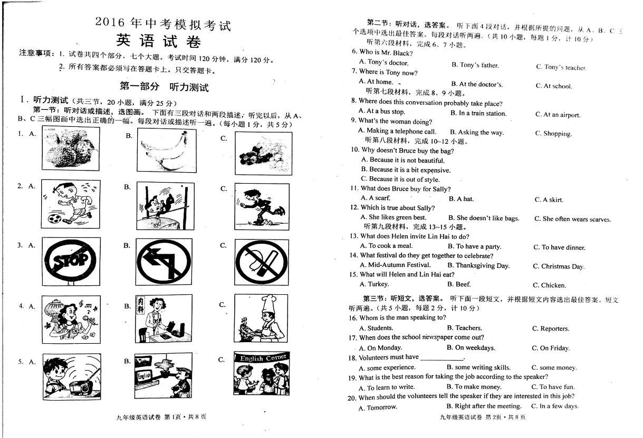
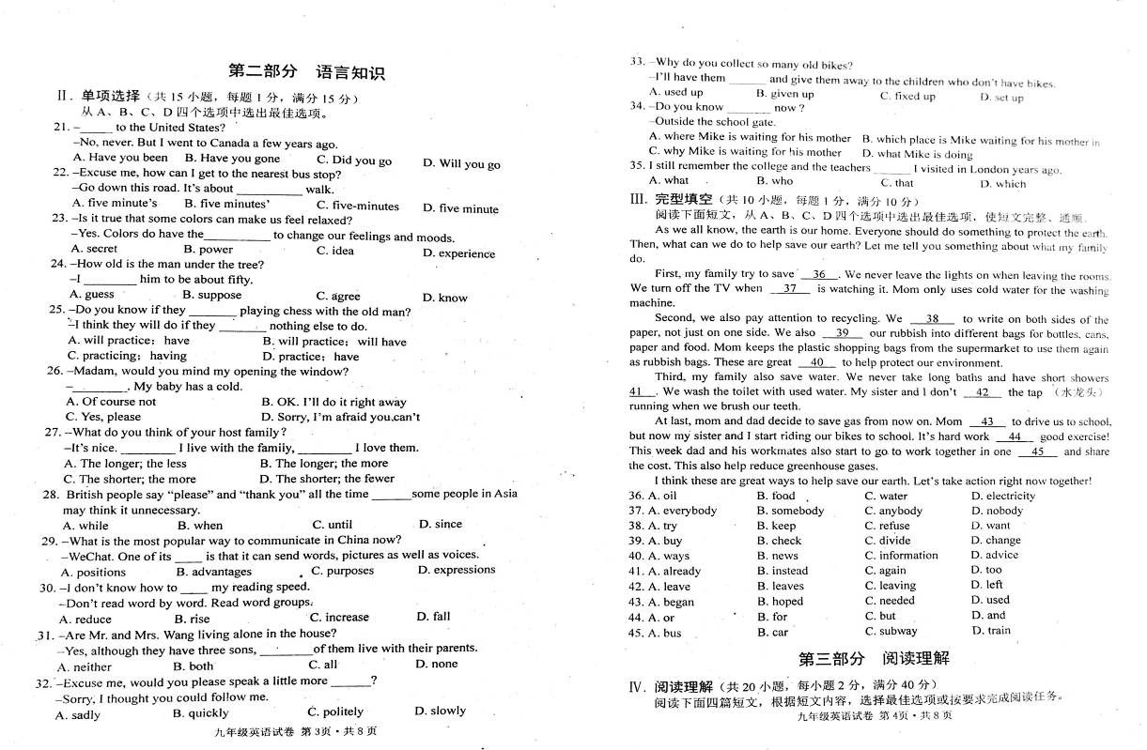
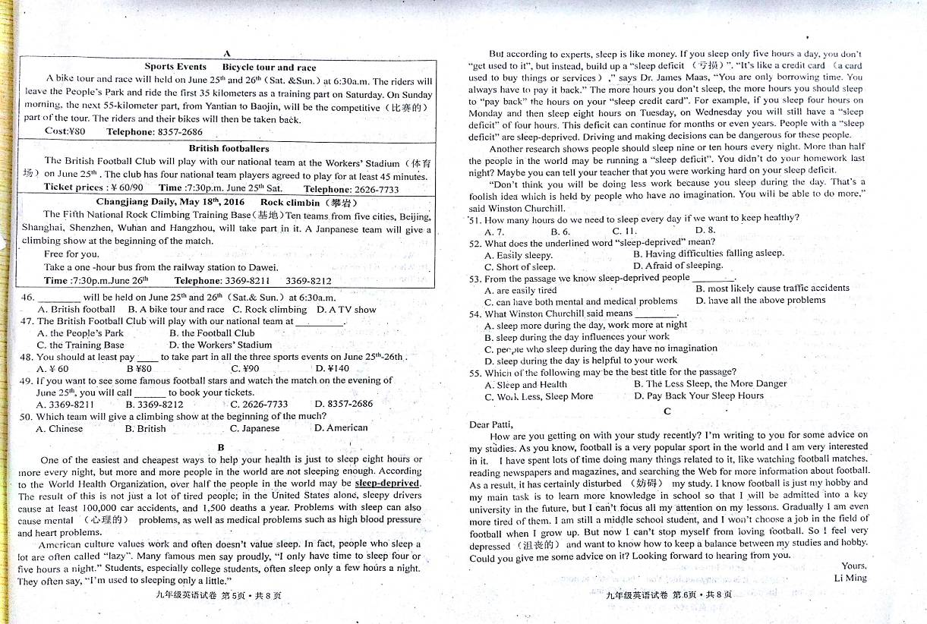
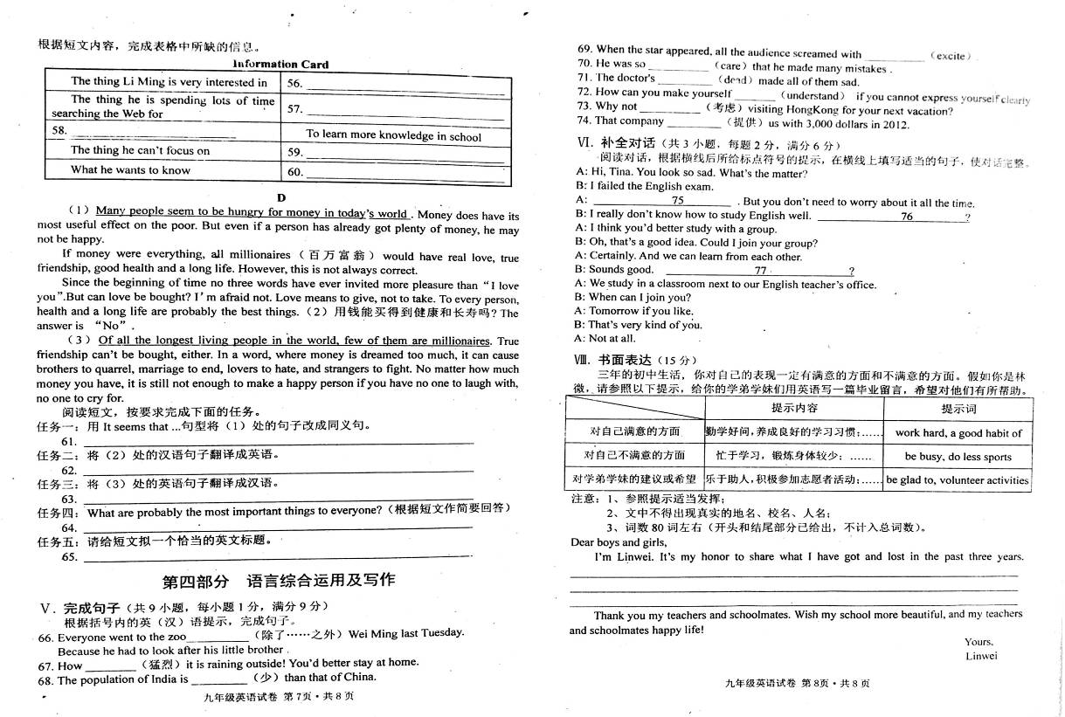

2016年中考模拟考试英语参考答案

1—5 AABBC 6一l0 CBABB 11一15 CACBA 16—20 ABBCB
21—25 ABBBA 26—30 DBABC 3l一35 DDCAC 36—40 DDACA
41—45BADCB 46—50 BDDCC 51一55DCDDA
56．Football 57．More information about football 58．His main task[来源:学科网ZXXK][来源:学,科,网]
59．His lessons 60．How to keep a balance between his studies and hobby
（56-60为阅读理解C篇考查内容，根据16年市中考说明，该题为非选择题，故信息填表
格的可能性较大。常见形式：1 句中填词或短语 2 填相关信息使A, B,栏构成一完整句
3 完成A栏简问或B栏简答 4 在A栏或B栏中填词或填名词性短语……当然还有混合形式填的。我想强调的是：一定注意所填词的适当形式及大小写问题。如本卷此题属上述4形式，观察表中“已知部分”，所填答案首字母应大写较完美。小写建议扣半分。下面其它主观题有的答案也不唯一，希望老师们阅前看卷，酌情处理。仅供参考与提醒。）
61. It seems that many people are hungry for money in today’s world.
(It seems that a lot of people want money very much now.)
62. Can health and a long life be bought with money?
63. 在世界上所有的长寿人群中,百万富翁很少。
64. Health and a long life
65. Is Money Everything?（答案不唯一）
66.except 67. heavily 68.smaller 69.excitement 70.careless 71.death
72.understood 73.consider 74.provided
75. I’m sorry to hear that./ Sorry to hear that.[来源:学+科+网]
76. What should I do? 77. Where do you study?
书面表达 One possible version:
Dear boys and girls,
It’s my honor to share what I have got and lost in the past three years. I am hard-working and have made great progress. I have developed many good habits of learning. I did well in the exams. However, I have problems, too. I spent more time online and I have become quite weak in my eyesight. What’s more, it’s also a pity that I did less sports because of hard work.
In the future I hope you should be glad to help others if someone is in trouble. I also hope you all can take an active part in some volunteer activities, such as being a volunteer in protecting the environment, in helping old people and so on.[来源:学*科*网Z*X*X*K]
Thank you my teachers and schoolmates. Wish my school more beautiful, and my teachers and schoolmates happy life!
Yours,[来源:Zxxk.Com]
Linwei
书面表达评分标准：
一档：（13－15）：1. 所写内容符合提示的文字信息，层次清楚，有创意；
2. 句子结构灵活、正确通顺，或只有个别小错；字数合乎要求；
3. 单词拼写错误不超过3个。
二档：（10－12）：1. 所写内容与所提示的语言信息相符，层次较清楚；
2. 句子正确，表达较通顺；字数合乎要求；
3. 表达错误较少，单词拼写错误不超过5个。
三档：（6－9）： 1. 所写内容与提示的信息基本相符；
2. 少数句子表达错误，但尚可读懂；
3. 单词拼写错误不超过7个。
四档：（0－5）： 1. 所写内容与所提示的信息多数不符；
2. 只有少数句子表达正确；
3. 拼写错误在10个以上。

新课标第一网系列资料 www.xkb1.com 新课标第一网不用注册，免费下载！

