浦东新区第四教育2014学年第二学期期中质量测试

初一年级英语试卷
（测试时间：75分钟，满分：100分）
考生注意：本卷有8大题，共88小题。试题均采用连续编号，所有答案务必按照规定在答题纸上完成，做在试卷上不给分。
Part 1 Listening （第一部分 听力 共25分）
I. Listening Comprehension. (听力理解)
A. Listen to the sentence and choose the right picture. (听句子，选出与内容符合的图片，用A、B、C、D、E、F等表示) (5分)

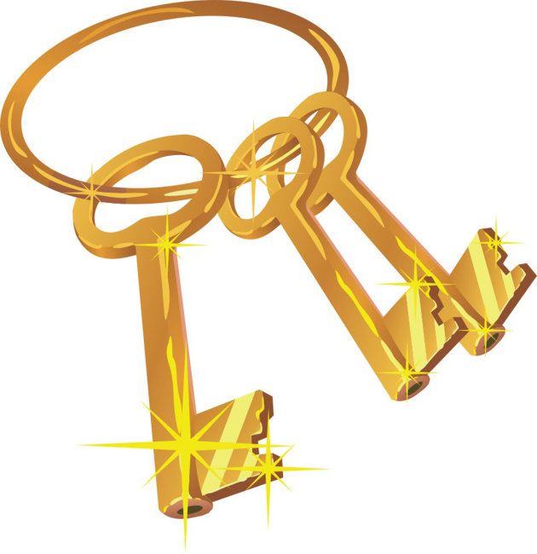
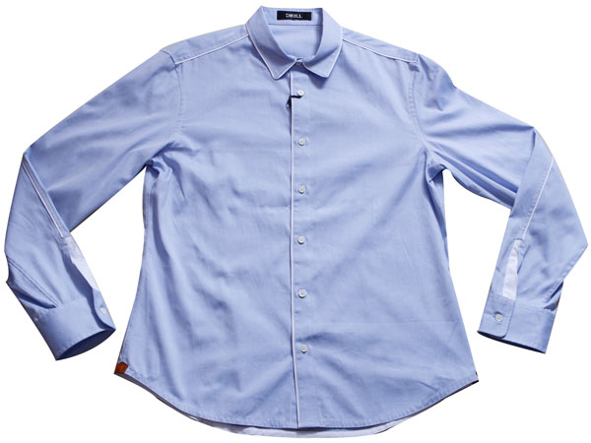

（A） （B） （C）
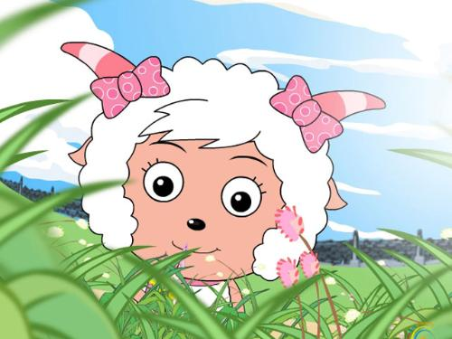
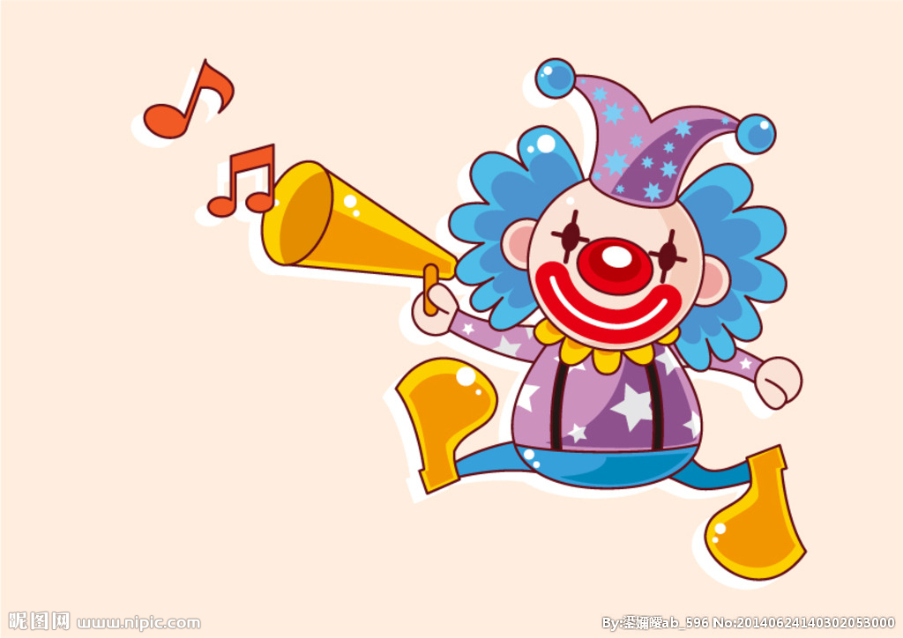
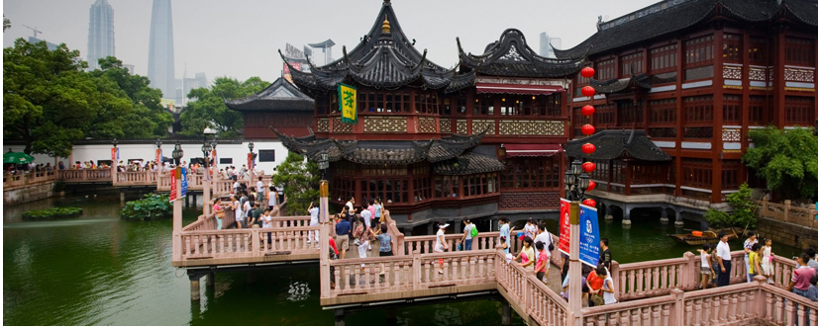

（D） （E） （F）
B. Listen to the dialogue and choose the best answer to the question you hear. (根据你所听到的对话和问题，选出最恰当的答案，用A、B、C、D等表示) (8分)
6. A. Water. B. Tea. C. Coffee. D. Coke.
7. A. A doctor. B. An actor. C. An architect. D. A scientist.
8. A. By bus. B. On foot. C. By underground. D. By taxi.
9. A. Jack. B. Kate. C. Jay. D. Kitty.
10. A. 30 dollars. B. 15 dollars. C. 35 dollars. D. 45 dollars.
11. A. Twice. B. Once. C. Never. D. Three times.
12. A. The blue one. B. The green one. C. The yellow one. D. None of the three.
13. A. Because he was too tired to get up early. B. Because the bus was late.
C. Because his watch was slow. D. Because the meeting started early.
C. Listen to the passage and tell whether the following statements are true or false. (根据你所听到的短文内容判断下列句子是否正确，符合的用“T”表示，不符合的用“F”表示) (6分)

14. One day Mr. white and his daughter wanted to go shopping in the city centre.
15. They didn’t know where the biggest shop is, so they asked friends for help.
16. They went along a street to the north of the hotel.
17. The bus carried them to the end of the wide street.
18. A lot of people came in and went out from a supermarket.
19. They were happy to visit the museum.
D. Listen to the passage and complete the following sentences. (听短文，完成下列句子，每空格限填一词) (6分)
20. Mr. Hunter is busy all the time and __________ has to work at weekends.
21. His wife is a nurse in a hospital and likes to __________ things tidy and clean.
22. One __________, Mr. Hunter went to work. Mrs. Hunter was at home.
23. Just then there was a knock __________ the door.
24. She looked around and found the house was not as clean as __________.
25. Sally asked, ‘Why don’t you wear your __________ today?’
Part 2 Vocabulary and Grammar（第二部分 词汇和语法 共40分）
II. Look at the phonetic symbol and fill in the blanks. (看音标写单词) (5分)
26. She has been an engineer for __________ a few years. [kwaɪt]
27. It is not __________ that many tourists come to Shanghai for shopping. [səˈpraɪzɪŋ]
28. The __________ of Swan Lake is 80 minutes. [dju`reɪʃn]
29. These jeans are too short for me. My size is __________. [`mi:diəm]
30. ‘You don’t ________ much money, I can give you some gold coins’, said the Fairy. [ɜ:n]
III. Choose the best answer (选择最恰当的答案) (15分)
31. Betty’s mother works in ________ international school.
A. a B. an C. the D. /
32. Helen has been a teacher ________ fifteen years.
A. in B. since C. for D. with
33. Paris is one of ________ in the world
A. the largest city B. the large city C. the largest cities D. the large cities
34. Mother was very happy because Ann made ________ mistakes in the exam.
A. few B. a few C. little D. a little
35. Those girls sing and dance ________.
A. good B. beautiful C. lovely D. wonderfully
36. The person who flies a plane is a(an) ________.
A. cook B. pilot C. postman D. fisherman
37. A tiger is ________ the king of the animals.
A. known as B. famous for C. afraid of D. full of
38. I always read the contents page before I decide ________ a book.
A. buy B. buying C. to buy D. buys
39. If you ________ busy next week, I will go to Century Park with you.
A. are B. aren’t C. will be D. won’t be

40. There ________ a swimming center and some markets in the new estate.
A. is B. are C. have D. has
41. --- I would like to have a cup of coffee with milk.
--- ________.
A. Neither did I B. Neither would I C. So did I D. So would I
42. How are you ________ your homework?
A. getting on B. get with C. getting on with D. get on with
43. ________ Simon gets a lot of pocket money, he never wastes it.
A. When B. Because C. If D. Although
44. We are going to ________ a reading competition during the English Festival in our school.
A. take part in B. join C. attend D. take place
45. --- I wish you happiness forever.
--- ________.
A. Not at all B. I agree with you C. Yes, I do D. Thank you
IV. Complete the following passage with the words or expressions in the box. Each can only be used once. (将下列单词或词组填入空格，每空格限填一词，每词只能填一次，用A、B、C、D、E、F等表示) (5分)
A. close B. carefully C. guide D. sad E. kindness F. grew up
There is a fable(寓言) about a poor girl. She had no family and no one to love her. One day, she felt very ____46____ and lonely, she was walking through a forest when she noticed a small butterfly. It was caught in a web. The young girl ____47____ set the butterfly free from the web, the little butterfly didn’t fly away, it changed into a beautiful fairy. The young girl couldn’t believe her eyes.
‘For your wonderful ____48____,’ the good fairy said to the girl, ‘I want to give you a wish.’ ‘I want to be happy!’ said the girl. The fairy said, ‘Very well.’ She walked ___ 49____ to the girl and whispered (低语) in her ear, ‘Everyone, old or young, rich or poor, has need of you.’ Then the good fairy suddenly disappeared.
As the little girl ____50____, there was no one else as happy as she. She helped a lot of people.
V. Complete the sentences with the given words in their proper forms. (用括号内所给单词的适当形式完成句子，每空格限填一词) (5分)
51. This is my __________ visit to Tokyo. (one)
52. When the police came, the hero had already caught the __________. (rob)
53. We can read __________ books in the library. (difference)
54. Tom and Alice lived __________ together in their old house. (happy)
55. Let’s have a __________ about our plan. (discuss)
VI. Rewrite the following sentences as required. (根据要求改写句子，每空格限填一词) (10分)
56. Kitty had sushi for lunch at school yesterday. (改为否定句)
Kitty ________ ________ sushi for lunch at school yesterday.
57. I have already seen the film Country Road. (改一般疑问句)
________ you ever ________ the film Country Road？
58. A watch is used to tell the time. (保持句意基本不变)
A watch is used ________ ________ the time.
59. Mrs. Wang needs some eggs to make the cake. (对划线部分提问)
________ ________ Mrs. Wang need to make the cake?
60. The foreigners can go to the Great Wall in Beijing.（对划线部分提问）
________ ________ the foreigners go in Beijing?
Part 3 Reading and Writing ( 第三部分 阅读和写话 共35分)
VII. Reading comprehension. (阅读理解)
A. True or False. (判断下列句子是否符合短文内容，符合的用“T”表示，不符合的用“F”表示)（5分）
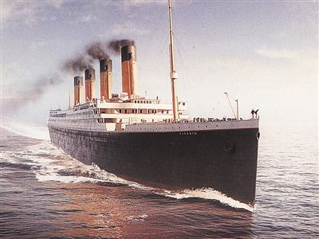
Have you ever seen the film Titanic? “Titanic” was one of the largest and finest ships in 1912. It hit an iceberg on its first sailing from England to America and sank(沉没) very soon, leaving a love story to the people. Do you know what an iceberg is?
The earth is round, like a ball. The top of the earth is the north. The bottom of the earth is the south. At the top and the bottom of the earth, there is no sunshine for some months. It is very cold there. Sometimes there is ice everywhere. Large pieces of ice fall into the sea. They don’t go to the bottom of the sea. They float near the top of the water. We call these large pieces of ice “iceberg”. Some icebergs are bigger than a tall building. Icebergs are dangerous for ships. Sometimes a ship hits an iceberg. Then the ship sinks.
You can make a small iceberg. Put a piece of ice in a glass of water. Look at it. The ice does not sink.
61. “Titanic” was the largest and finest ships in 1912.
62. “Titanic” hit an iceberg, when it sailed from England to America and sank very soon.
63. There is no sunshine for the whole year at the top and the bottom of the earth.
64. Some icebergs are bigger than a tall building, and they are dangerous for the ships.
65. Put a piece of ice in a glass of water, it will sink.
B. Choose the best answer. (根据短文内容，选择最恰当的答案，用A、B、C、D等表示)(5分)
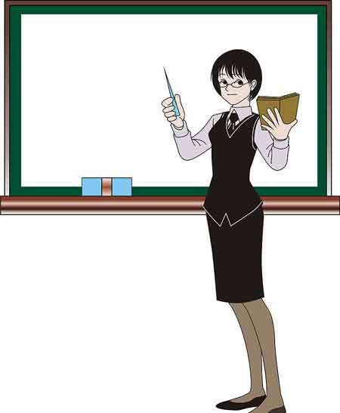
As a volunteer teacher, I traveled a long way to a small village school in Longzhou, Guangxi. On my way there, I thought about the village, the school, and the children there. However, I felt sad when I arrived there. It wasn't what I expected. It didn't look like a school at all! The school had only three rooms, one for Grades 1, 2 and 3, and another one for Grades 4, 5 and 6. There was a third one for me. The children welcomed me warmly on my first day. They asked me a lot of questions, and I told them stories about myself and my life in Shanghai.
The next day, I gave them a test to find out their level. Though the test was very easy, over half of the students failed it, yet they all wanted to learn new things. I knew they needed me. I was busy preparing lessons, reading test papers every night. I enjoyed teaching these lovely and hardworking children, and I could see that they were making progress with my help. I have also learned a lot from them. I understand their lives better, and we are now good friends.
I have worked in Longzhou for a year now. I’m very happy, and the experience has been very useful for me. I love the small village school and the children. In fact, I would like to continue working here.
66. From the first paragraph, we know the school is very _________.
A. beautiful B. big C. interesting D. small
67. There are _________ grades in the school.

A. 6 B. 4 C. 3 D. 5
68. The writer came from _________.
A. Longzhou. B. Guangxi. C. Shanghai. D. Beijing.
69. The writer thinks working in the school is____________.
A. very interesting. B. very useful. C. very careful. D. very exciting.
70. According to the passage, the writer _________.
A. was sorry for the poor school B. worked hard to teach the children
C. didn't want to work in the school D. left the school in a short time
C. Choose the words or expressions and complete the passage. (选择最恰当的单词或词语完成短文，用A、B、C、D等表示) (6分)
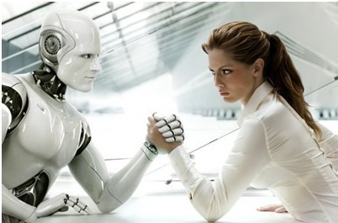
Life in the year 3044 is very different from life in the 21st century. We still do many of the things you did, but we do them ____71___. For example, we now have e-friends to help us. An e-friend is a machine that looks just____72____a human being. It can walk and talk and can do almost everything we human beings do. My e-friend is a lot like me and we have____73____fun together. She helps me with my homework and we often go swimming. She is programmed to take care of me if anything ____74____, so I always feel safe when we are together. She can also send me messages, just like old-fashioned e-mail, and I can download(下载) information from her memory. It’s ____75____to have an e-friend – I am never lonely and I always have someone to talk with.
I would like to tell you more about life in the year 3044, but I have to send my e-friend to clean up my room. Maybe____76____I will be able to travel back in time and visit you.
71. A. different B. difference C. differently D. differences
72. A. like B. for C. at D. up
73. A. many B. no C. little D. much
74. A. helps B. happens C. needs D. agrees
75. A. sad B. great C. afraid D. stupid
76. A. one day B. in one day C. after one day D. with one day
D. Read the passage and fill in the blanks with proper words. (在短文的空格内填入适当的词，使其内容通顺，每空格限填一词，首字母已给) (6分)
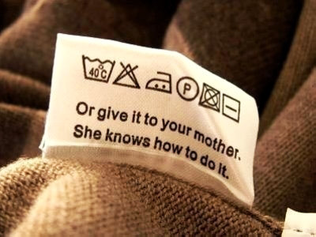
When you want to go shopping, decide how much money you can pay for new clothes. Think about the kind of clothes you really n____77____. Then look for those clothes on sale. There are labels (标签) inside all new clothes. The labels tell you h____78____ to take care of your clothes. The label for a shirt may tell you to wash it in warm water. A sweater label may tell you to wash by washing in cold water. The label on a coat may say "dry clean only". Washing may ruin (损坏) this coat. If you do as the d____79____ on the label, you can keep your clothes looking their best. Many clothes today must be dry-cleaned. Dry cleaning is e____80____. When buying new clothes, check to see if they will need to be dry-cleaned. You will save money if you buy clothes that can be washed. You can save money if you buy clothes that are well made. Well-made clothes last longer. They look good even after they have been washed many times. Clothes that cost m____81____ money are not always better made. They do not always fit better. S____82____ less expensive clothes look and fit better than more expensive clothes.
E. Read the passage and answer the questions. (根据短文内容回答下列问题) (5分)
The four children, Kitty, Ben, Lucy and Simon decide to see a film in the evening. They are reading a film guide in the newspaper to choose one. Read the guide.
The strangest Fairy Tale
What may happen when Snow White meets Cinderella? What will Little Red Riding Hood say to the Little Mermaid? Coming soon on 14June at Gold Star Cinema.
We are Robots
The film is set in 2065. A family finds out that their relatives and friends have all turned into robots. The family tries to leave the city, but one day the son is missing… Coming soon on 14 June at New World Cinema.
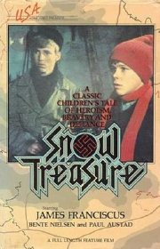
The Boy Next Door
Julia and Eddie were best friends when they were six. They lost contact(联系) when Eddie moved to another country. Twenty years later Julia meets her new neighbour who is also her old friend. Watch out for the romantic story in July at Sunny Cinema.
Finding Lost Treasure(珍宝)
This exciting story is about two students who find a strange map in the school library. They show the map to their teacher. Soon, they discover the map shows the way to a land full of treasure. Coming soon on 21 June at Silver Moon Cinema.
83. Where are the students reading the film guide?
______________________________________.
84. Alan likes jokes, which film will he probably want to see?
______________________________________.
85. David wants to see We are Robots, which cinema should he go to?
______________________________________.
86. In the introduction of Finding Lost Treasure(珍宝), what does the underlined word ‘they’ refer to?
______________________________________.
87. Which film would you like to see? Why?
______________________________________.
VIII. Writing. (作文)
88. Write a passage of at least 50 words on the topic “A model student”. (以“模范生”为题写一篇不少于50字的短文， 标点符号不占格) (8分)
Use the following points as a reference.（以下内容仅供参考）
- How is a model student?
- Who is the model student in your class?
- What can you learn from him/her?

