黄浦区2015年九年级学业考试模拟考
英语试卷
（满分150分，考试时间100分钟）
考生注意：本卷有7大题，共94小题。试题都采用连续编号，所有答案务必按照规定在答题卷上完成，做在试卷上不给分。
Part 1 Listening (第一部分 听力)
I. Listening Comprehension (听力理解) (共30分)

A. Listen and choose the right picture (根据你听到的内容，选出相应的图片): (6分)
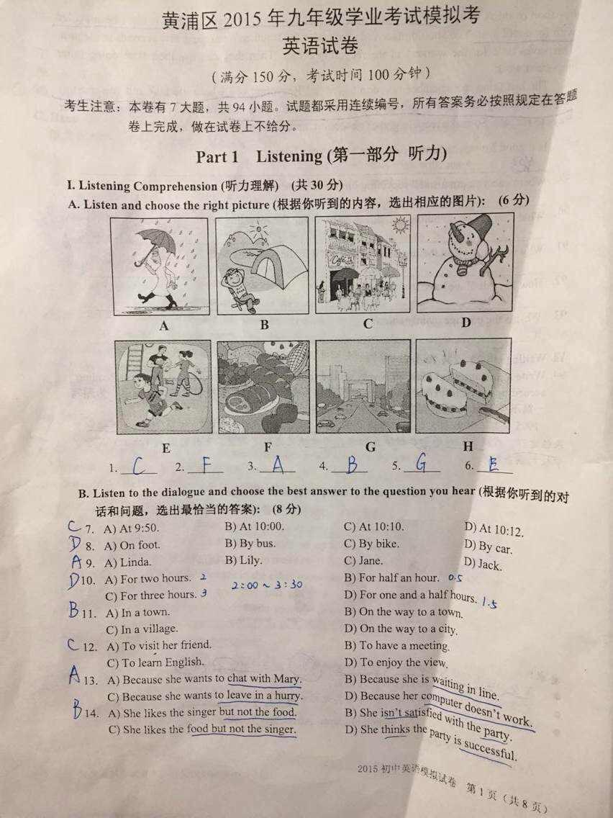

1. ______ 2. ______ 3. ______ 4. ______ 5. ______ 6. ______

B. Listen to the dialogue and choose the best answer to the question you hear (根据你听到的对话和问题，选出最恰当的答案): (8分)
7. A) At 9 :50. B) At 10:00. C) At 10:10. D) At 10:12 Seven.
8. A) On foot. B) By bus. C) By bike. D) By car.
9. A) Linda. B) Lily. C) Jane. D) Jack.
10. A) For two hours. B) For half an hour.
C) For three hours. D) For one and a half hours.
11. A) In a town. B) On the way to a town.
C) In a village. D) On the way to a city.
12. A) To visit her friend. B) To have a meeting. [来源:学科网ZXXK]
C) To learn English. D) To enjoy the view.
13. A) Because she wants to chat with Mary. B) Because she is waiting in line.
C) Because she wants to leave in a hurry. D) Because her computer doesn’t work.
14. A) She likes the singer but not the food. B) She isn’t satisfied with the party.
C) She likes the food but not the singer. D) She thinks the party is successful.

C. Listen to the passage and tell whether the following statements are true or false (判断下列句子是否符合你听到的内容, 符合的用“T”表示，不符合的用“F”表示): (6分)
15. Bianca was born in September, 1994 and there are three children in her family.
16. When Bianca was three years old, she became interested in singing and dancing.
17. Bianca won national dance contests first, and then sang her first song in church.
18. Bianca entered a national talent show and won second place at the age of eight.
19. After Bianca won America’s Got Talent(美国达人), her first CD came out in 2008.
20. Bianca thinks the key to success is to believe in yourself and try to realize your dream.
D. Listen to the passage and complete the following sentences (听短文，完成下列内容，每空格限填一词): (10分)
21. Chinese people look on Spring Festival as their ________ ________.
22. It is a festival ________ ________ to get together during that time.
23. It is my favorite because in those days my life was________ ________.
24. When Spring Festival came, I could have ________ ________ food to eat.
25. I could receive much New Year’s ________ ________ on that day.
Part 2 Phonetics, Grammar and Vocabulary[来源:Zxxk.Com]
(第二部分 语音、语法和词汇)
Ⅱ. Choose the best answer (选择最恰当的答案): (共20分)
26. Which of the following word matches the sound /peə/
A) pain B) pair C) pale D) pearl
27. It is a good habit to go to ______bed early and get up early.
A) a B)an C) the D) /
28. The lovely girl is from Class Six. ______name is Alice.
A) She B)Hers C) Her D) Herself
29. If you read a lot, your life will be full ______pleasure.
A) of B)with C)by D) for
30. We have to go shopping today. There is ______juice left in the fridge.
A) few B) a few C) little D) a little
31. Taiwan became one of ______places for tourists during this winter holiday.
A) popular B) more popular C) most popular D) the most popular[来源:学科网]
32. Why not ask others for help when you can't finish ______it by yourself?
A) to write B) writing C) write D) wrote
33. Mum asked us ______off all the lights when we left the house.
A) to turn B) turn C) turning D) turned[来源:学*科*网]
34. The music in the supermarket sounded so _____that I wanted to leave at once.
A) clearly B) loudly C) sadly D) noisy
35.______I see your ID card, sir? We have to check your information.
A) Must B) Should C) May D) Need
36. Keep quiet, please. Someone _______to a concert inside now.
A) is listening B) has listened C) was listening D) listened
37. My sister _______to a birthday party in a new dress last night.
A) goes B) went C) will go D) had gone
38. Charles said that he ______tennis with John this Friday afternoon.
A) plays B) is playing C) will play D) would play
39. The post is free, _______there's no need for you to buy a stamp.
A) for B) but C) so D) or
40. You will be late for the train _______you don't hurry up now.
A) when B) if C) because D) unless
41. Kate has little bread for breakfast every morning, _______?
A) has she B) hasn't she C) does she D) doesn't she
42. -_______do you need to feed your baby?
- Once every three or four hours, at least.
A) How far B) How soon C) How long D) How often
43. Neither Alice nor I _______from Canada. We are both from China.
A) am B) is C) are D) be
44. — Would you please help me to take the clothes downstairs, Tom? -_______.
A) Never mind. B) No problem. C) That's right. D) Let's go.
45. - Hello! May I speak to Diana, please? -_______I'll go and get her.
A) Hold on, please. B) I don't think s C) Hurry up, please. D) Speaking.
Ⅲ. Complete the following passage with the words or phrases in the box. Each can only be used once (将下列单词或词组填入空格。每空格限填一词，每词只能填一次): (共8分)

A. choice B. themselves C. easily
D. pretty E. trouble
Are you the only child in your family? If so, you are the most important person in your parents' hearts. They are the closest people to you in the world. But nowadays many teenagers like you have __46__ communicating with their parents. They always complain that their parents say too much instead of listening to what they're thinking. When they do something wrong, getting away from parents seems to be the only __47__. In fact, what your parents do just shows love for you. They love you more than they love __48__. Whenever you need help, they are always there standing by you. Try to put yourself into their shoes, and you'll understand them __49__.
A. hobbies B. enough C. easily
D. pretty E. trouble
Many people think that if more time is spent, more work will be done. So students have to spend the whole day doing homework except during the three meals. It is not __50__ to see students lost in a sea of homework both at school and at home.
Modern students usually have many __51__. They love music, sports, reading and watching TV. A two-day weekend __52__ them time to do what they like, but there’s much homework to do, so they usually don’t want to do it until Sunday night. In such a short time, students may finish it carelessly. The badly done weekend homework makes teachers angry.
Things always get worse without the right ideas. Too much homework makes students lose interested in learning. A horse runs faster after a rest, but for students only rest is not __53__. We should manage this situation. We should give students more time to relax.
Ⅳ. Complete the sentences with the given words in their proper forms（用括号中所给单词的适当形式完成下列句子，每空格限填一词): (共8分)
54. Lily and Lucy wanted to be top___________ when they were little girls . (dancer)
55. Joe broke his leg on the ___________ day of the holiday and couldn’t walk. (five)
56. Julie was ___________bored doing exercises while Christine was out all day. (real)
57. Bill has a very ___________ mobile phone and he can do many things with it. (power)
58. A lot of people are willing to take in and raise ___________cats and dogs. (home)
59. Mr. Smith is still very ___________ although he is already in his seventies. (act)
60. The book collects the ___________ and thoughts of many people in our school. (wise)
61. Joanna stopped , took a deep ___________ and went on climbing the mountain. (breathe)

V. Rewrite the following sentences as required（根据所给要求，改写下列句子。62-67题，每空格限填一词): (共14分)
62. Kitty work up as usual at half past six this morning. (改为一般疑问句)
_________ Kitty _________ up as usual at half past six this morning?
63. My pen friend has sent me a very beautiful birthday card．(改为感叹句)
_________ _________ beautiful birthday card my pen friend has sent me!
64. There was heavy snow and windy weather this winter in Boston．(对划线部分提问)
_________ and _________ was there heavy snow and windy weather?
65. My brother Frank receives a letter from his family every Christmas. (保持句意基本不变)
My brother is Frank_________ _________ his family every Christmas.
66. Miss Green is so buys that she can't go for a holiday this summer. (改为简单句)
Miss Green is _________ busy _________ go for a holiday this summer.
67. People will build a lot of new houses in the south of America. (改为被动语态)
A lot of new houses will _________ _________ in the south of America.
68. live, it, to, exciting, on a small farm, for Tony, is (连词成句)
_________________________________________________________________________.

Part 3 Reading and Writing (第三部分 读写)
Ⅵ. Reading comprehension (阅读理解) (共50分)
A. Choose the best answer（根据短文内容，选择最恰当的答案): (12分)
In summer everybody needs to be careful with the sun. Do you know how to spend time in the sun without burning or damaging your skin? Read the ten rules below. Some of them are RIGHT and the others are WRONG.
SUMMER SKIN CARE
—RIGHT OR WRONG?
• Always wear a baseball cap. It protects you from the sun and looks cool, too.
WRONG You need to wear a hat, but choose your hat carefully. Baseball caps protect your eyes, but they don't protect your ears or your neck. Use a proper sun hat.
• Use sun cream. You need to put it on at least twenty minutes before you go out.
RIGHT Sun cream starts to work twenty minutes after you put it on.
• Put sun cream around your eyes and on your eyelids to protect them from the sun.
WRONG Sun cream hurts the eyes. Wear sunglasses instead.
• You only need a little sun cream. Too much sun cream is bad for your skin.
WRONG You need to use a lot of sun cream. The sun makes your skin dry. Sun cream moisturizes(滋润) and protects it.
• Put more sun cream on every two hours.
RIGHT You need to put sun cream on often, especially when you're swimming.
• You need to use sun cream even on a cloudy day in summer.
RIGHT The sun can damage your skin even on a cloudy day.
• On a hot sunny day, wear light-coloured clothes - white or yellow are best.
• On a hot sunny day, wear light-coloured clothes -white or yellow are best.
WRONG Light-colored clothes don't protect you from the sun. The best solution is to wear dark-coloured clothes.
• You need to spend time in the sun for healthy skin.
RIGHT You need to spend time in the sun to get enough vitamin D for healthy skin and bones(骨头), but don't forget to use sun cream. Without sun cream, you have a bigger risk(danger) of skin cancer(癌症).
• You need to spend a lot of money to get a good sun cream.
WRONG There are many different kinds of sun cream. Find the one that is best for you Expensive ones are not always better than cheap ones. Use a sun cream labeled(标明) SPF30+ and it should give you the same protection as one that is more expensive.
• In summer, people with dark skin can also get burnt.
RIGHT People with fair skin and blonde or red hair need to be extra careful and use a high factor sun cream. People with fair skin do need to protect their skin from the sun, too.
59. What is the best to wear to protect your skin from the sun?
A) A baseball hat and light-coloured clothes. B) A sun hat and light-coloured clothes.
C) A baseball hat and dark-coloured clothes. D) A sun hat and dark-coloured clothes.
70. Where shouldn't you put sun cream on your body?
A) On your ears and neck. B) On dry skin.
C) Around your eyes and eyelids. D) On darker skin.
71. What is the right way to use sun cream?
A) Use a little and often. B) Use a lot every two hours.
C) Use a lot twice a day. D) Use a little every two hours.
72. Why is it important to spend time in the sun?
A) You can drink more water. B) It's a chance to wear cool sunglasses.
C) It improves dark dry skin. D) It helps keep your skin and bones healthy.
73. Which of the following is true about sun cream?
A) Sun cream reduces the risk of skin cancer. B) Black people don't need sun cream.
C) Sun cream starts to work immediately. D) Sun cream is usually very expensive.
74. What is the purpose of the above passage?
A) To make people buy sun cream.
B) To tell the importance of healthy skin.
C) To give people advice on summer skin care.
D) To show people how to dress properly in summer.
B. Choose the words or expressions and complete the passage（选择最恰当的单词或词语完成短文): (12分)
Start Today
"What can you do when you have done nothing but mess up(搞糟) your whole life long?"
These were the words 1 heard when I turned on the TV the other day. They were coming from one of the talk shows that are so popular on TV these days. I started to turn the channel but the words I had heard made me __75__ for a moment. I looked at the speaker of them. He couldn't have been more than 18 years old, but already he was writing off(认为…已失败) his life as a useless waste.
I wanted to shout at him, "You're not __76__ yet!"
It is so sad that so many people cannot get rid of their pasts and live in the present. There are so many people like that talk show guest. There are people still in their teen years thinking that their lives are over. There are people in their twenties who already think they have __77__ the boat to success and happiness. There are people in their thirties and forties who sit around complaining that life has passed them by. I want to shout to them all, "Wake up! You're still alive! What have you done today?" If you want a happy life, you can't just think about your past mistakes. If you want joy and love in your life, you have to choose them today. God gives us a new __78__ at life every time we wake up in the morning. It is up to us to catch it.
Today can be the __79__ of a new life for each of us. We can choose joy right now. We can share love today. We can live with hope starting at this moment. It doesn't matter how hard our past has been. Our present can be full of joy and our future can be full of happiness. It doesn't matter whether we are eight __80__ eighty - we can still make our lives wonderful. Life isn't over until your last heartbeat. Start today, then, to make your heart beat with joy love and light.
75. A) go B) stop C) move D) talk
76. A) wrong B) alone C) dead D) ready
77. A) lost B) caught C) taken D) missed
78. A) chance B) joke C) gift D) right
79. A) end B) goal C) form D) beginning
80. A) to B) and C) or D) between
C. Read the passage and fill in the blanks with proper words（在短文的空格内填入适当的词，使其内容通顺，每空格限填一词，首字母已给) : (14分)
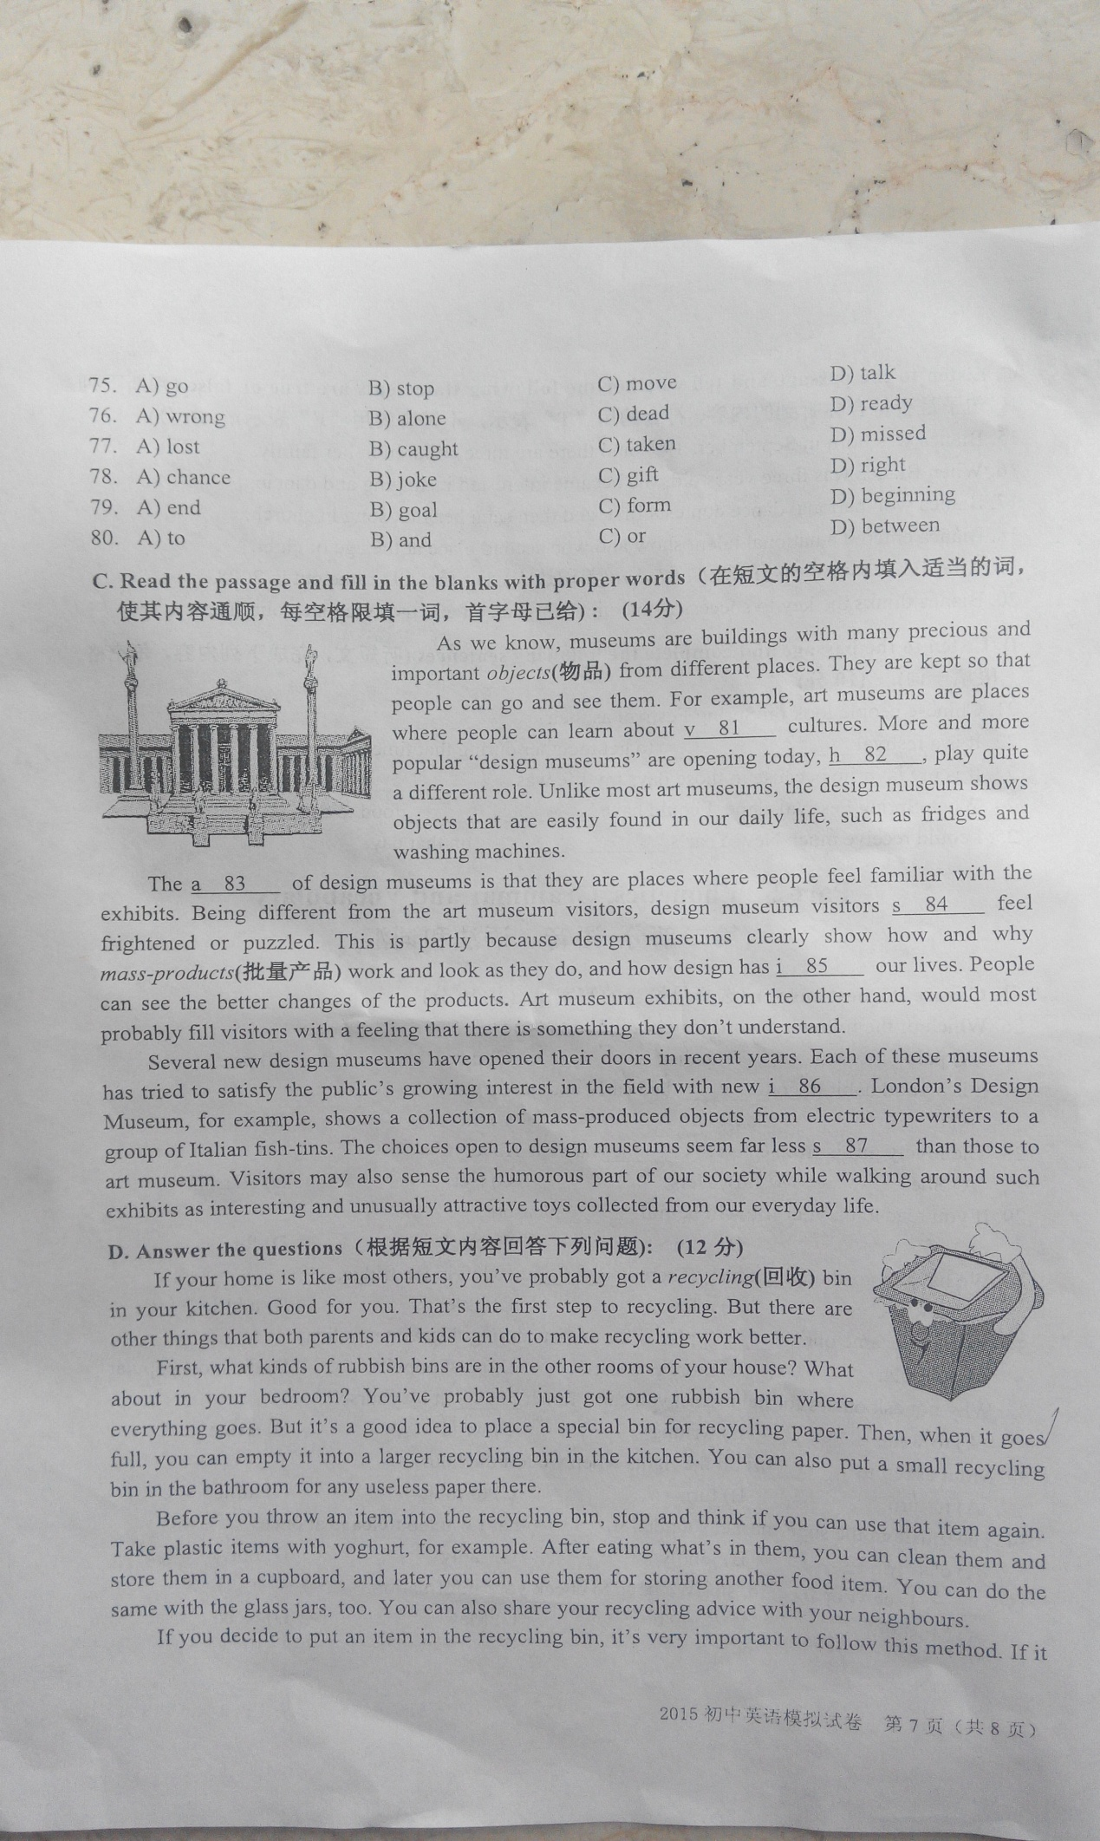
As we know, museums are buildings with many precious and important objects(物品) from different places. They are kept so that people can go and see them. For example, art museums are places where people can learn about v 81 cultures. More and more popular "design museums" are opening today, h 82 , play quite a different role. Unlike most art museums, the design museum shows objects that are easily found in our daily life, such as fridges and washing machines. The a 83 of design museums is that they are places where people feel familiar with the exhibits. Being different from the art museum visitors, design museum visitors s 84____ feel frightened or puzzled. This is partly because design museums clearly show how and why mass-products(批量产品) work and look as they do, and how design has i 85 our lives. People can see the better changes of the products. Art museum exhibits, on the other hand, would most probably fill visitors with a feeling that there is something they don't understand.
Several new design museums have opened their doors in recent years. Each of these museums has tried to satisfy the public's growing interest in the field with new i 86 . London's Design Museum, for example, shows a collection of mass-produced objects from electric typewriters to a group of Italian fish-tins. The choices open to design museums seem far less s 87 than those to art museum. Visitors may also sense the humorous part of our society while walking around such exhibits as interesting and unusually attractive toys collected from our everyday life.
D. Answer the questions（根据短文内容回答下列问题): (12分)
If your home is like most others, you've probably got a recycling (回收) bin in your kitchen. Good for you. That's the first step to recycling. But there are other things that both parents and kids can do to make recycling work better.
First, what kinds of rubbish bins are in the other rooms of your house? What about in your bedroom? You've probably just got one rubbish bin where everything goes. Bui it's a good idea to place a special bin for recycling paper. Then when it goes full, you can empty it into a larger recycling bin in the kitchen. You can also put a small recycling bin in the bathroom for any useless paper there.
Before you throw an item into the recycling bin, stop and think if you can use that item again. Take plastic items with yoghurt, for example. After eating what's in them, you can clean them and store them in a cupboard, and later you can use them for storing another food item. You can do the same with the glass jars, too. You can also share your recycling advice with your neighbours.
If you decide to put an item in the recycling bin, it's very important to follow this method. If it has food or drink m it, you must clean it before you put it in the recycling bin. It can't be recycled with food still in it. You should place the item under the running water for a few seconds to clean it. This saves time for the workers in the recycling center. Then they can use their time doing more important work.
The last thing to remember is - don't give up! Recycling is a whole life task and you mustn't just do recycling for a month and then return to your old habits. You can also continue to find other ways to recycle. So make recycling your new habit, and get others involved as well!
88. Is it good for you to have a recycling bin in your kitchen?
_______________________________________________________________.
89. Where can you put a small recycling bin for any useless paper?
_______________________________________________________________.
90. What should you do before you throw an item into the recycling bin?
_______________________________________________________________.
91. Why must you clean the item before you put it in the recycling bin?
_______________________________________________________________.
92. How long shall we have the habit of recycling?
_______________________________________________________________.
93. What is the passage mainly about?
It_______________________________________________________________.
Ⅶ. Writing (作文) (共20分)
94. Write a passage of at least 60 words on the topic “Our School Students ‘After-class Reading’” according to the information given. ( 阅读以下信息，并以“我校学生的课外阅读”为题写一篇不少于60个词的短文，标点符号不占格。)
1995年联合国科教文组织宣布每年的4月23日为“世界读书日”。在第20个世界读书日来临之际，我校分别对四个年级学生的课外阅读情况进行了调查，下面的图表（chart）显示了学校的调查结果。
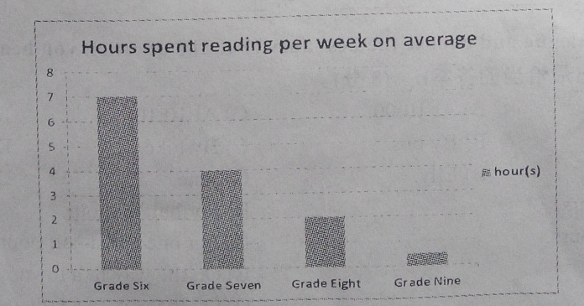
要求：
- 简要描述图中的信息，分析产生这种结果的原因，提出你的额想法和建议；[来源:学|科|网Z|X|X|K]
- 文章的题目和开头已给出，不计入词数；
- 短文中不得出现考生的姓名、校名及其他相关信息，否则不予评分。

Our School Students’ After-class Reading
As is shown in the chart,...

