2014年辽宁高考英语试题解析
阅读理解（A）
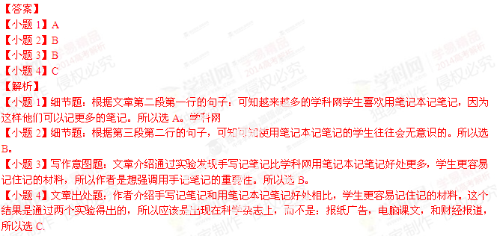
阅读理解（B）
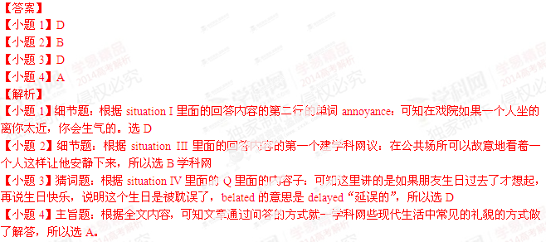
阅读理解（C）
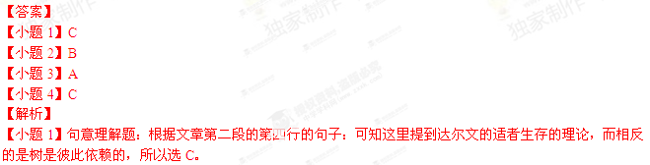【小题2】细节题：根据文章第四段的第三行和第四行的句子：可学科网知mother trees之所以重要是因为它们将营养传给小树，选B
【小题3】猜词题：it出现在文章最后一段：实际上it指代的是第四段提到的内容，人们砍倒快死的mothertrees是不知道树的社会的依存关系，可知it指的是“树的社会”是怎么运作的，所以选A
【小题4】标题确定题：根据全文内容，可知文章介绍树和树之间不是你死我活的竞争关系，它们之间是相互依赖的，快要死的树会将自己的营养传给小树让它们更好的成长，所以选C。

阅读理解（D）
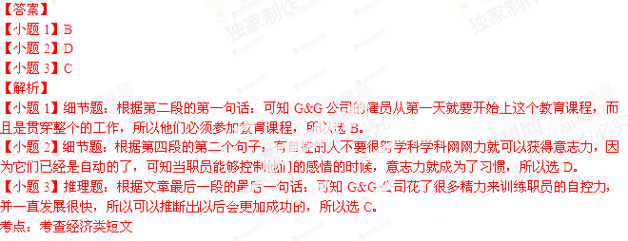
信息匹配
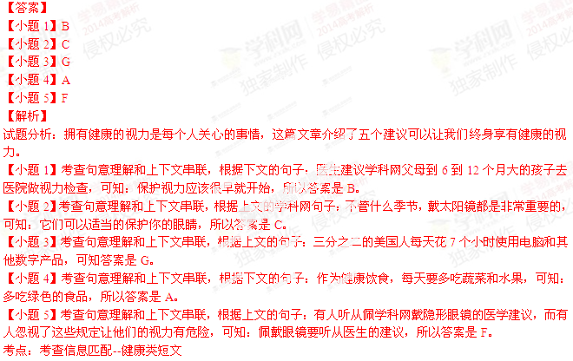[来源:Z_xx_k.Com]
完型填空
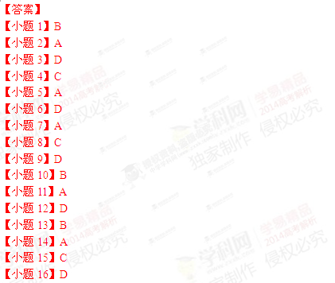
【小题17】B[来源:Zxxk.Com]
【小题18】A
【小题19】D
【小题20】C
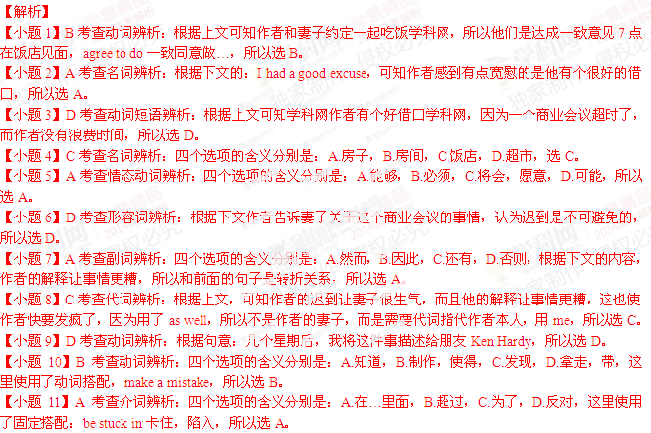 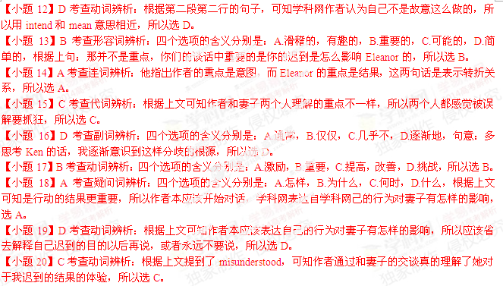语法填空
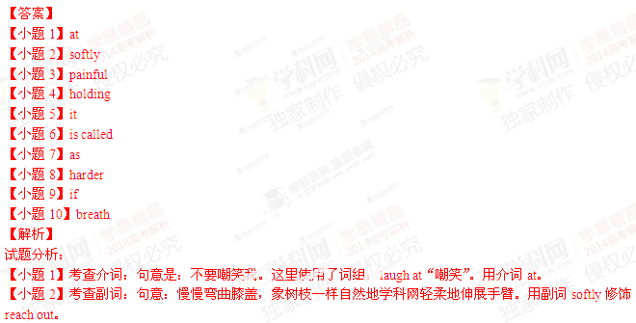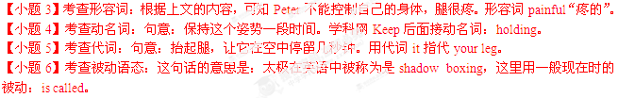 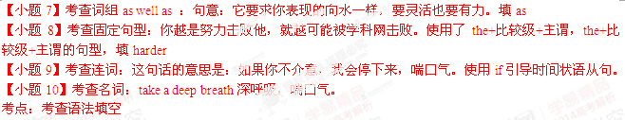短文改错
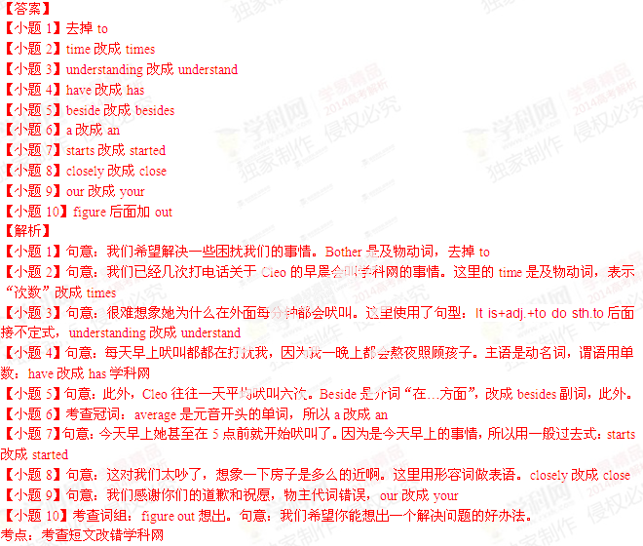书面表达
【答案】[来源:学#科#网]
Notice
An exciting event “Innovations on Campus” is around the corner. Every one of you is expected to be part of the event which encourages creative minds and gives full play to your DIY skills.
Note that your innovations must be school things. Along with your wonderful innovation, you need to hand in a report, explaining how the idea occurs to you and what materials you use.
All the collections will be on show from June 16 to 18 in the gym. Looking forward to the prize-giving ceremony? Sure! It’ll be held from 15:00 to 17:00 on June 18. So don’t miss the chance of being the winner. Your contribution will certainly make the event a huge success. For any questions. Call Li Hua at 44876655.
Come on, everybody! It’s your show time.
Student Union[来源:学#科#网]
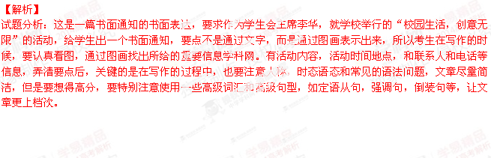[来源:Z。xx。k.Com]
