2014年全国普通高等学校招生统一考试
上海 英语试卷
第I卷 （共103分）
I. Listening Comprehension
Section A
Directions: In Section A, you will hear ten short conversations between two speakers. At the end of each conversation, a question will be asked about what was said. The conversations and the questions will be spoken only once. After you hear a conversation and the question about it, read the four possible answers on your paper, and decide which one is the best answer to the question you have heard.
1. A. policewoman. B. A judge. C. A reporter. D. A waitress.
2. A. Confident. B. Puzzled. C. Satisfied. D. Worried.
3. A. At a restaurant. B. At a car rental agency.
C. In a bank. D. In a driving school.
4. A. A disaster. B. A new roof. C. A performance. D. A TV station.
5. A. Catch the train. B. Meet Jane.
C. Get some stationery. D. Clean the backyard.
6. A. Ask for something cheaper. B. Buy the vase she really likes.
C. Protect herself from being hurt. D. Bargain with the shop assistant.
7. A. Use a computer in the lab. B. Take a chemistry course.
C. Help him revise his report. D. Gel her computer repaired.
8. A. Amused. B. Embarrassed. C. Shocked. D. Sympathetic.
9. A. She doesn't plan to continue studying next year.
B. She has already told the man about her plan.
C. She isn’t planning to leave her university.
D. She recently visited a different university.
10. A. It spoke highly of the mayor. B. It misinterpreted the mayor’s speech.
C. It made the mayor’s view clearer. D. It earned the mayor’s speech accurately.
Section B
Directions: In Section B, you will hear two short passages, and you will be asked three questions on each of the passages. The passages will be read twice, but the questions will be spoken only once. When you hear a question, read the four possible answers on your paper and decide which one would be the best answer to the question you have heard.
Questions 11 through 13 are based on the following passage.
11. A. 70 B. 20 C. 25. D. 75
12. A. The houses there can't be B. It is a place for work and holiday.
C. he cabins and facilities D. It is run by the residents themselves.
13. A. A skiing B. A special community
C. A splendid mountain D. A successful businesswoman
Questions 14 through 16 are based on the following news.
14. A. Those who often sent text messages. B. Those who suffered from heart disease.
C. Those who did no physical exercise. D. whose who were unmarried
15. A. They responded more slowly than usual. B. They sent more messages.
C. They typed 10 percent faster on average. D. They edited more passages.
16. A. Why chemical therapy works.
B. Why marriage helps fight cant
C. How unmarried people survive
D. How cancer is detected after marriage.
Section C
Directions: In Section C, you will hear two longer conversations. The conversations will be read twice. After you hear each conversation, you are required to fill in the numbered blanks with the information you have heard. Write your answers on your answer sheet.
Blanks 17 through 20 are based on the following conversation.
Complete the form. Write ONE WORD for each answer.

Travelers’ Survey Sheet
Travel purpose: for a(n) 17 in London
Comments on the airport environment / facilities:
Likes: • 18
• 19 walkways
Dislikes: • 20 shops
• small trolleys

Blanks 21 through 24 are based on the following conversation.
Complete the form. Write NO MORE THAN THREE WORDS for each answer.
What is critical thinking in reading? | Assessing the writer’s ideas and thinking about the 21 of what the writer is saying.
What is the first step in reading an academic text critically? | Finding out the argument and the writer's main line of 22 .
What may serve as the evidence? | 23 , survey results, examples, etc.
What is the key to critical thinking? | To read actively and 24 .

II. Grammar and vocabulary
Section A
Directions: After reading the passages below, fill in the blanks to make the passages coherent and grammatically correct. For the blanks with a given word, fill in each blank with the proper form of the given word; for the other blanks, use one word that best fits each blank.
(A)
My Stay in New York
After graduation from university, I had been unable to secure a permanent job in my small town. So I decided to leave home for New York, (25)______I might have a better chance to find a good job. (26) ______ (earn) some money to pay the daily expenses, I started work in a local café as a waiter. I believe that (27) ______ ______ ______ I was offered a good position, I would resign at once.
Over time, the high cost of living became a little burden on my already (28) ______ (exhaust) shoulder. On the other hand, my search for a respectable job had not met with much success. As I had studied literature at university, I found it quite difficult to secure a suitable job in big companies. Mother had just said that (29) ______ I want to have a better career advancement, I had to find work in the city. Perhaps (30) ______my mother had told me was deeply rooted in my mind. I just did as she had expected.
Soon I had lived in the city for over six months but I still did not like it. Apparently, I had difficulty (31) ______ (adapt) myself to life in the city, let alone finding a job to my delight. After nine months of frustration, I eventually decided to go back to my small town. Not until I returned (32) ______I realize that a quiet town life was the best for me.
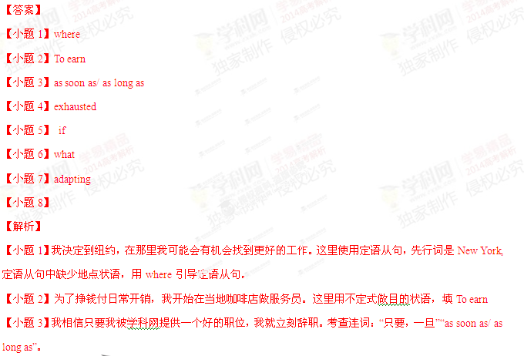【小题4】过了一段时间，高生活成本在我已经疲惫的肩膀成了一个负担。考查形容词“疲惫的”：exhausted
【小题5】 妈妈说过，如果我想有个更好的事业的进步，我就得到城市里面找工作。这里需要连词“如果”：if
【小题6】妈妈说的话深深的扎根到我的思想中了。What引导的是主语从句。
【小题7】很显然我适应城市的生活有困难。这里使用了have difficulty in doing sth，所以填动名词：adapting
【小题8】直到我回来我才发现安静的小镇生活对我才是最好的。Not until放在句学科网首，后面的主句要倒装。用助动词did提到主语前面。
考点：考查故事类短文
(B)
The giant vending machine (自动售货机) is a new village shop
Villagers have long been used to facing a drive when they run out of basic supplies. However, help is now nearer at hand in form of the country’s first automatic push-button shop. Now residents in the Derbyshire Village of Clifton can buy groceries around the clock after the huge vending was installed outside a pub in the village this week.
Peter Fox, who is (33)______electrical engineer, spent two and a half years working on the project. The machine (34)______ (equip) with securing cameras and alarms and looks like a mini shop with a brick front, a grey roof and a display window.
Mr. Fox said he hoped his invention, (35)______ is set to be installed in other villages in the area over the coming months, will mark a return to convenience shopping for rural communities.
He said:“ I had this idea a few years ago but I couldn’t find a manufacture who could deliver what I wanted, so I did it by (36)______. The result is what amounts to huge outdoor vending machine. Yet I think the term “automatic shop” is far (37)______ (appropriate)
In recent years, the commercial pressure from supermarket chains (38)______ force village shops across the country to close. In 2010, it was estimated that about 400 village shops closed, (39)______ (urge) the local government to give financial support to struggling shops or set-up new communities stores.
Hundreds of communities have since stepped in and opened up their won volunteer-run shops, but Mr. Fox hopes his new invention will offer a solution (40)______these villages without a local shop.
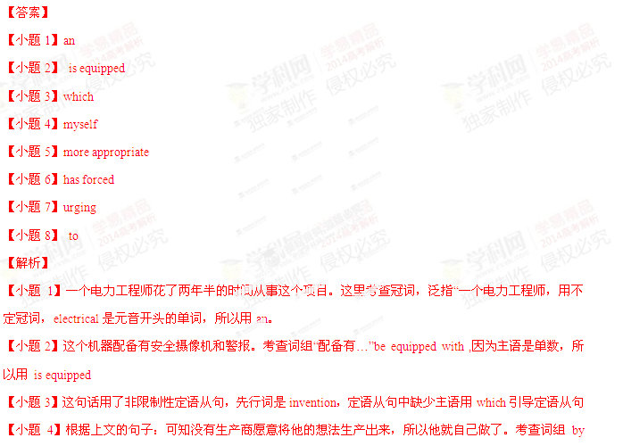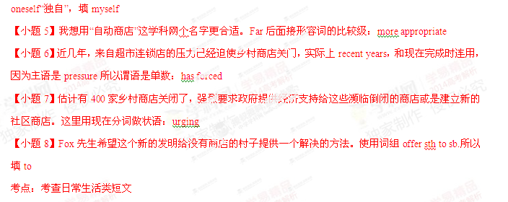Section B
Directions: Complete the following passage by using the words in the box. Each word can only be used once. Note that there is one word more than you need.

A. alert B. classify C. commit D. delicately E. gentle F. impose
G. labels H. moderation I. relieve J. signals K. simply
Let's say you've decided you want to eat more healthfully. However, you don't have time to carefully plan menus for meals or read food __41__ at the supermarket. Since you really__42__ yourself to a healthier lifestyle, a little help would come in handy, wouldn't it? This is where a "choice architect" can help__43__some of the burden of doing it all yourself. Choice architects are people who organize the contexts in which customers make decisions. For example, the person who decides the layout of your local supermarket-including which shelf the peanut butter goes on, and how the oranges are piled up—is a choice architect.
Governments don't have to__44__healthier lifestyles through laws for example, smoking bans. Rather, if given an environment created by a choice architect-one that encourages us to choose what is best-we will do the right things. In other words, there will be designs that gently push customers toward making healthier choices, without removing freedom of choice. This idea combines freedom to choose with__45__hints from choice architects, who aim to help people live longer, healthier, and happier lives.
The British and Swedish governments have introduced a so-called "traffic light system" to __46__foods as healthy or unhealthy. This means that customers can see at a glance how much fat, sugar, and salt each product contains__47__by looking at the lights on the package. A green light __48__that the amounts of the three nutrients are healthy; yellow indicates that the customer should be__49__; and red means that the food is high in at least one of the three nutrients and should be eaten in __50__. The customer is given important health information, but is still free to decide what to choose.
【小题8】绿色的灯表示这三种营养的含量是健康的。这里需要动词“发信号，表示”signal，所以选J
【小题9】黄灯表示消费者应该警觉了。这里使用形容词“警觉的“alert”，所以选A
【小题10】红灯表示这些食物至少有一种营养是含量很高的，所以应该被适当的食用。考查名词“适度”moderation，所以选H
考点：考查健康类短文
III. Reading Comprehension
Section A
Directions: For each blank in the following passage there are four words or phrases marked A, B, C and D. Fill in each blank with the word or phrase that best fits the context.

Research has shown that two-thirds of human conversation is taken up not with discussion of the cultural or political problems of the day, not heated debates about films we've just watched or books we've just finished reading, but plain and simple __51__.
Language is our greatest treasure as a species, and what do we __52__ do with it? We gossip. About others' behaviour and private lives, such as who's doing what with whom, who's in and who's out-and why; how to deal with difficult __53__ situations involving children, lovers, and colleagues.
So why are we keen on gossiping? Are we just natural __54__, of both time and words? Or do we talk a lot about nothing in particular simply to avoid facing up to the really important issues of life? It's not the case according to Professor Robin Dunbar. In fact, in his latest book, Grooming, Gossip and the Evolution of Language, the psychologist says gossip is one of these really__55__issues.
Dunbar __56__ the traditional view that language was developed by the men at the early stage of social development in order to organize their manly hunting activities more effectively, or even to promote the exchange of poetic stories about their origins and the supernatural. Instead he suggests that language evolved among women. We don't spend two-thirds of our time gossiping just because we can talk, argues Dunbar—__57__, he goes on to say, language evolved specifically to allow us to gossip.
Dunbar arrived at his cheery theory by studying the __58__ of the higher primates（灵长类动物）like monkeys. By means of grooming--cleaning the fur by brushing it, monkeys form groups with other individuals on whom they can rely for support in the event of some kind of conflict within the group or__59__ from outside it.
As we human beings evolve from a particular branch of the primate family, Dunbar __60__ that at one time in our history we did much the same. Grouping together made sense because the bigger the group, the greater the __61__ it provided; on the other hand, the bigger the group, the greater the stresses of living close to others. Grooming helped to __62__ the pressure and calm everybody down.
But as the groups got bigger and bigger, the amount of time spent in grooming activities also had to be __63__ to maintain its effectiveness. Clearly, a more __64__ kind of grooming was needed, and thus language evolved as a kind of vocal（有声的）grooming which allowed humans to develop relationship with ever-larger groups by exchanging information over a wider network of individuals than would be possible by one-to-one __65__ contact.
【小题1】 A. claim B. description C. gossip D. language
【小题2】A. occasionally B. habitually C. independently D. originally
【小题3】 A. social B. political C. historical D. cultural
【小题4】 A. admirers B. masters C. users D. wasters
【小题5】 A. vital B. sensitive C. ideal D. difficult
【小题6】A. confirms B. rejects C. outlines D. broadens
【小题7】A. for instance B. in addition C. on the contrary D. as a result
【小题8】A. motivation B. appearance C. emotion D. behaviour
【小题9】A. attack B. contact C. inspection D. assistance
【小题10】A. recalls B. denies C. concludes D. confesses
【小题11】A. prospect B. responsibility C. leadership D. protection
【小题12】A. measure B. show C. maintain D. ease
【小题13】A. saved B. extended C. consumed D. gained
【小题14】A. common B. efficient C. scientific D. Thoughtful
【小题15】A. indirect B. daily C. physical D. secret
【答案】
【小题1】C
【小题2】B
【小题3】A
【小题4】D
【小题5】A
【小题6】B
【小题7】C
【小题8】D
【小题9】A
【小题10】C
【小题11】D
【小题12】D
【小题13】B
【小题14】B
【小题15】C
【解析】
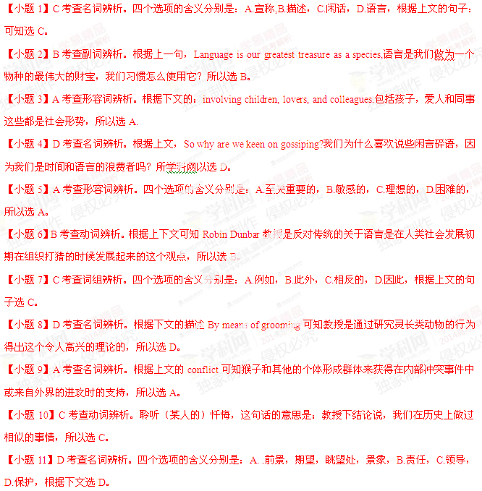【小题12】D考查动词辨析。根据上文：on the other hand, the bigger the group, the greater the stresses of living 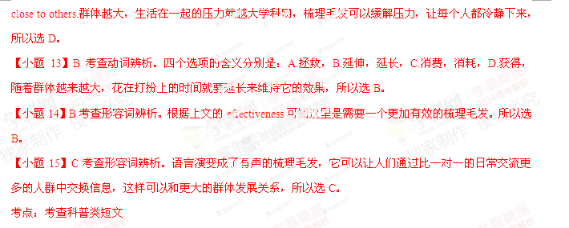Section B
Directions: Read the following three passages. Each passage is followed by several questions or unfinished statements. For each of them there are four choices marked A, B, C and D. Choose the one that fits best according to the information given in the passage you have just read.

(A)
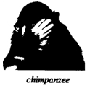
Most people agree that honesty is a good thing. But does Mother Nature agree? Animals can't talk, but can they lie in other ways? Can they lie with their bodies and behavior? Animal experts may not call it lying, but they do agree that many animals, from birds to chimpanzees, behave dishonestly to fool other animals. Why? Dishonesty often helps them survive.
Many kinds of birds are very successful at fooling other animals. For example, a bird called the plover sometimes pretends to be hurt in order to protect its young. When a predator（猎食动物）gets close to its nest, the plover leads the predator away from the nest. How? It pretends to have a broken wing. The predator follows the "hurt" adult, leaving the baby birds safe in the nest.
Another kind of bird, the scrub jay, buries its food so it always has something to eat. Scrub jays are also thieves. They watch where others bury their food and steal it. But clever scrub jays seem to know when a thief is watching them. So they go back later, unbury the food, and bury it again somewhere else.
Birds called cuckoos have found a way to have babies without doing much work. How? They don't make nests. Instead, they get into other birds' nests secretly. Then they lay their eggs and fly away. When the baby birds come out, their adoptive parents feed them.
Chimpanzees, or chimps, can also be sneaky. After a fight, the losing chimp will give its hand to the other. When the winning chimp puts out its hand, too, the chimps are friendly again. But an animal expert once saw a losing chimp take the winner's hand and start fighting again.
Chimps are sneaky in other ways, too. When chimps find food that they love, such as bananas, it is natural for them to cry out. Then other chimps come running. But some clever chimps learn to cry very softly when they find food. That way, other chimps don't hear them, and they don't need to share their food.
As children, many of us learn the saying "You can't fool Mother Nature." But maybe you can't trust her, either.
【小题1】A plover protects its young from a predator by______.
A. getting closer to its young B. driving away the adult predator
C. leaving its young in another nest D. pretending to be injured
【小题2】By "Chimpanzees, or chimps, can also be sneaky" (paragraph 5), the author means______.
A. chimps are ready to attack others B. chimps are sometimes dishonest
C. chimps are jealous of the winners D. chimps can be selfish too
【小题3】Which of the following is true according to the passage?
A. Some chimps lower their cry to keep food away from others.
B. The losing chimp won the fight by taking the winner's hand.
C. Cuckoos fool their adoptive parents by making no nests.
D. Some clever scrub jays often steal their food back.

【小题4】Which of the following might be the best title of the passage?
A. Do animals lie? B. Does Mother Nature fool animals?
C. How do animals learn to lie? D. How does honesty help animals survive?
【答案】
【小题1】D
【小题2】B
【小题3】A
【小题4】A
【解析】
【小题1】细节题：根据第二段的第二句话：a bird called the plover sometimes pretends to be hurt in order to 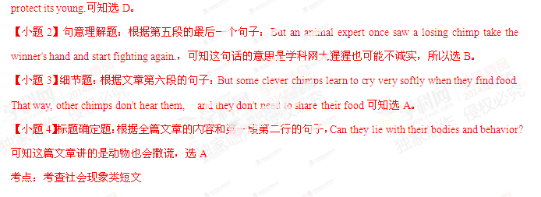 (B)


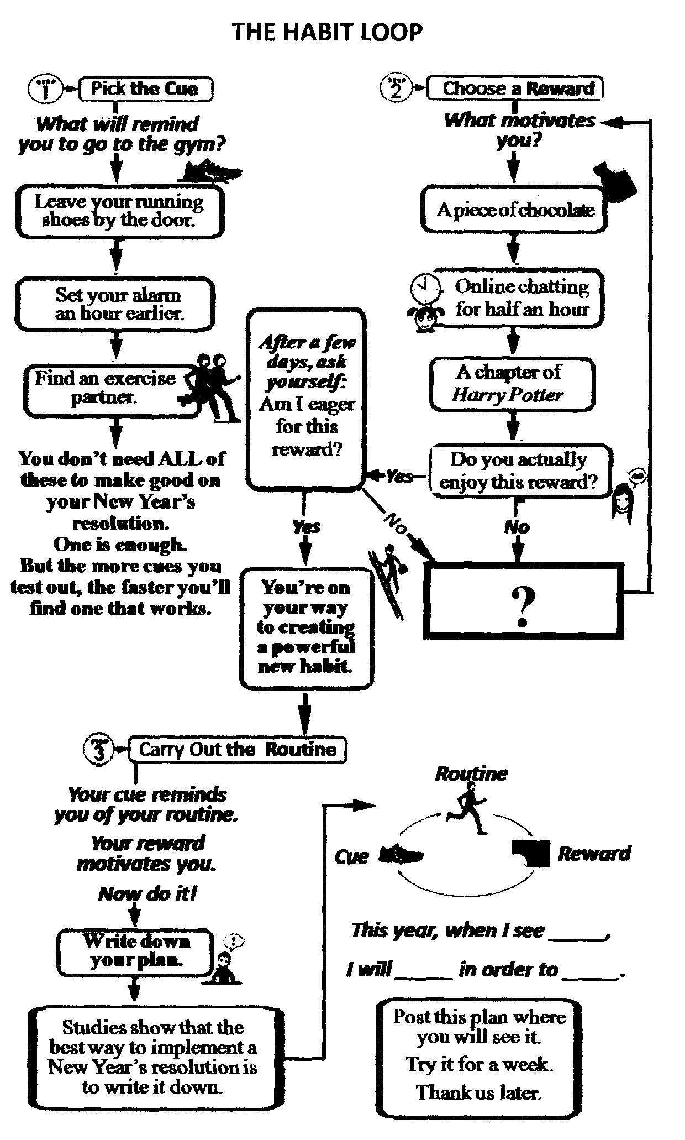
Let's say you want to hit the gym more regularly this year. How do you make that happen? Consider putting the habit loop to use.
Here's how it works:
A habit is a 3-step process. First, there's a cue, something that tells your brain to operate automatically. Then there's a routine. And finally, a reward, which helps your brain learn to desire the behavior. It's what you can use to create-or break-habits of your own.
Here's how to apply it:
Choose a cue, like leaving your running shoes by the door, then pick. a reward-say, a piece of chocolate when you get home from the gym. That way, the cue and the reward become interconnected. Finally, when you see the shoes, your brain will start longing for the reward, which will make it easier to work out day after day. The best part? In a couple of weeks, you won't need the chocolate at all. Your brain will come to see the workout itself as the reward. Which is the whole point, right?
【小题1】Which of the following best fits in the box with a “?” in THE HABIT LOOP?
A. Pick a new cue. B. Form a new habit.
C. Choose a new reward. D. Design a new resolution.
【小题2】According to THE HABIT LOOP, you can stick to your plan most effectively by______.
A. changing the routine B. trying it for a week
C. adjusting your goal D. writing it down
【小题3】. What's the purpose of putting the habit loop to use?
A. To test out different kinds of cues.
B. To do something as a habit even without rewards.
C. To work out the best New Year's resolution.
D. To motivate yourself with satisfactory rewards.
【小题4】 “This year when I see the Harry Potter poster, I will read 30 pages of an English novel or an English newspaper in order to watch TV for half an hour." What is the cue in this resolution?
A. The Harry Potter poster.
B. Reading 30 pages of an English novel.
C. An English newspaper.
D. Watching TV for half an hour.
【答案】
【小题1】C
【小题2】D
【小题3】B
【小题4】A
【解析】
【小题1】推理题：根据文章图表里面内容的句子：可知如果对这个奖励不满意，可以选择一个新的奖励，Choose a new reward最适合The Habit Loop里面的有问号的方框，所以选C。
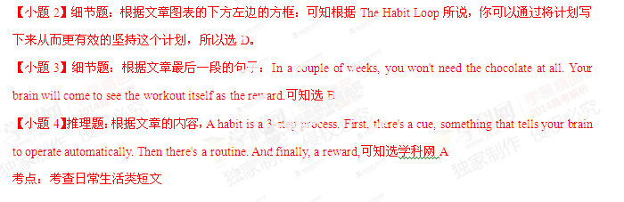 (C)
If you could be anybody in the world, who would it be? Your neighbour or a super star? A few people have experienced what it might be like to step into the skin of another person, thanks to an unusual virtual reality（虚拟现实）device. Rikke Wahl, an actress, model and artist, was one of the participants in a body swapping experiment at the Be Another lab, a project developed by a group of artists based in Barcelona. She swapped with her partner, an actor, using a machine called The Machine to Be Another and temporarily became a man. "As I looked down, I saw my whole body as a man, dressed in my partner's pants," she said. "That's the picture I remember best."
The set-up is relatively simple. Both users wear a virtual reality headset with a camera on the top. The video from each camera is sent to the other person, so what you see is the exact view of your partner. If she moves her arm, you see it. If you move your arm, she sees it.
To get used to seeing another person's body without actually having control of it, participants start by raising their arms and legs very slowly, so that the other can follow along. Eventually, this kind of slow synchronised（同步的）movement becomes comfortable, and participants really start to feel as though they are living in another person's body.
Using such technology promises to alter people's behaviour afterwards-potentially for the better. Studies have shown that virtual reality can be effective in fighting racism-the bias（偏见）that humans have against those who don't look or sound like them. Researchers at the University of Barcelona gave people a questionnaire called the Implicit Association Test, which measures the strength of people's associations between, for instance, black people and adjectives such as good, bad, athletic or awkward. Then they asked them to control the body of a dark skinned digital character using virtual reality glasses, before taking the test again. This time, the participants' bias scores were lower. The idea is that once you've "put yourself in another's shoes" you're less likely to think ill of them, because your brain has internalised the feeling of being that person.
The creators of The Machine to Be Another hope to achieve a similar result. "At the end of body swapping, people feel like holding each other in their arms," says Arthur Pointeau, a programmer with the project. "It's a really nice way to have this kind of experience. I would really, really recommend it to everyone."
【小题1】The word "swapping" (paragraph 1) is closest in meaning to______.
A. building B. exchanging C. controlling D. transplanting
【小题2】 We can infer from the experiment at the Be Another lab that______.
A. our feelings are related to our bodily experience
B. we can learn to take control of other people's bodies
C. participants will live more passionately after the experiment
D. The Machine to Be Another can help people change their sexes
【小题3】 In the Implicit Association Test, before the participants used virtual reality glasses to control a dark skinned digital character, ______.
A. they fought strongly against racism
B. they scored lower on the test for racism
C. they changed their behaviour dramatically
D. they were more biased against those unlike them
【小题4】 It can be concluded from the passage that______.
A. technology helps people realize their dreams
B. our biases could be eliminated through experiments
C. virtual reality helps promote understanding among people
D. our points of view about others need changing constantly
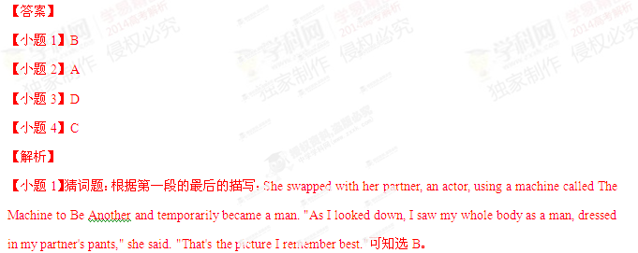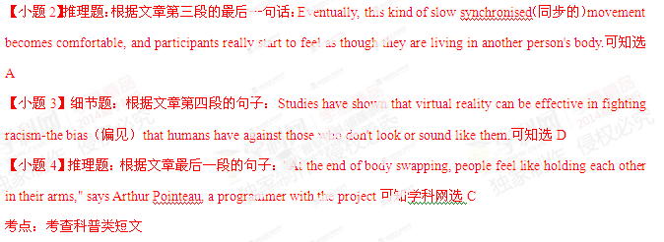Section C
Directions: Read the passage carefully. Then answer the questions or complete the statements in the fewest possible words.

More and more corporations are taking an interest in corporate social responsibility (CSR). CSR is made up of three broad layers. The most basic is traditional corporate charity work. Companies typically spend about 1% of pre-tax profits on worthy projects. But many feel that simply writing cheques to charities is no longer enough. In some companies, shareholders want to know that their money is being put to good use, and employees want to be actively involved in good works.
Money alone is not the answer when companies come under attack for their behavior. Hence the second layer of CSR, which is a branch of risk management. Starting in the 1980s, with environmental disasters such as the explosion at Bhopal and the Exxon Valdez oil spill, industry after industry has suffered blows to its reputation.
So, companies often responded by trying to manage the risks. They talk to non-governmental organisations (NGOs) and to governments, create codes of conduct（行为准则) and devote themselves to more transparency（透明）in their operations. Increasingly, too. they, along with their competitors, set common rules to spread risks.
All this is largely defensive, but there are also opportunities for those that get ahead of the game. The emphasis on opportunity is the third layer of CSR: the idea that it can help to create value. If approached in a strategic way, CSR could become part of a company's competitive advantage. That is just the sort of thing chief executives like to hear. The idea of "doing well by doing good" has become popular.
Nevertheless, the business of trying to be good is bringing difficult questions to executives. Can you measure CSR performance? Should you be cooperating with NGOs and you’re your competitors? Is there any really competitive advantage to be had from a green strategy?
Corporate social responsibility is now seen as a mainstream. Big companies want to tell the world about their good citizenship with their devotion to social responsibilities. Done badly, CSR is often just window-dressing and can be positively harmful. Done well, though, it is not some separate activity that companies do on the side, a corner of corporate life reserved for virtue（美德）：it is just good business.
(Note: Answer the questions or complete the statements in NO MORE THAN TEN WORDS)
【小题1】Both _________ in some companies find it no longer enough to simply donate money to charities.
【小题2】Give one example of the defensive measures of risk management according to the passage.
【小题3】With the emphasis on opportunity, the third layer of CSR is meant to_________.
【小题4】According to the passage, "good business" (paragraph 6) means that corporations ________ while making profits.
【答案】
【小题1】Shareholders and employees
【小题2】Companies talk to non-government organizations(NGOs) and to governments./Companies create codes of conduct. /Companies devote themselves to more transparency in their operations./Companies set common rules with their competitors to spread risks.
【小题3】Create value
【小题4】 take social responsibilities
【解析】
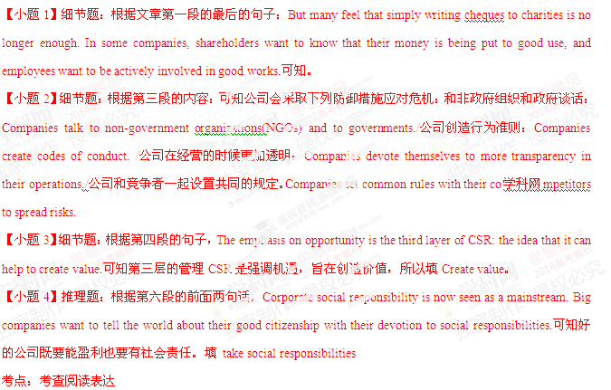第II卷（共47分）
I. Translation
Directions: Translate the following sentences into English, using the words given in the brackets.

【小题1】我习惯睡前听点轻音乐。(accustomed)
【小题2】将来过怎样的生活取决于你自己。(be up to)
【小题3】没有什么比获准参加太空旅行项目更令人兴奋的了。(than)
【小题4】家长嘱咐孩子别在河边嬉戏，以免遭遇不测。(for fear)
【小题5】虽然现代社会物资丰富，给予消费者更多的选择，但也使不少人变成购物狂。(turn)
【答案】
【小题1】I’m accustomed to listening to some light music before sleep.
【小题2】It’s up to you what kind of life will lead in the future.
【小题3】There is nothing more exciting than being allowed to take part in the space travel programme.
【小题4】Parents ask their kids not to play by the river for fear that something terrible might happen.
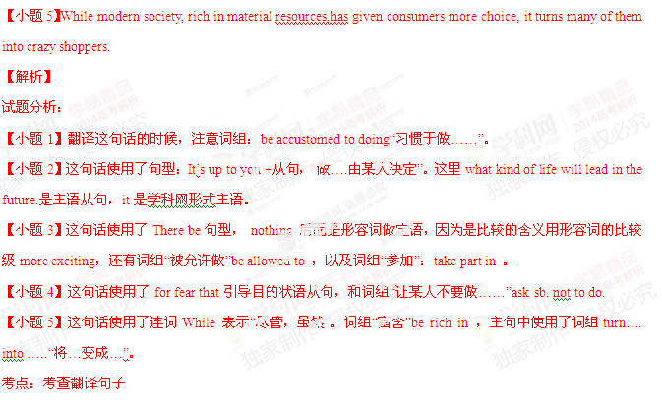II. Guided Writing
Directions: Write an English composition in 120-150 words according to the instructions given below in Chinese.

学校英语报正在酝酿改版，拟从现有的三个栏目（健康、娱乐、文化）中去除一个，并从三个备选栏目（时尚、职业规划、读者反馈）中挑选一个纳入该报。假设你是该校学生程飞，给校报编辑写一封电子邮件，表达你的观点。邮件须包括以下内容：
1. 你建议去除的栏目及去除的理由；
2. 你建议增加的栏目及增加的理由。
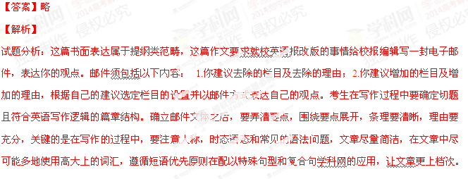考点：考查提纲类书面表达
