2006年上海市初中毕业生统一学业考试
英语试卷
（满分150分，考试时间100分钟）
Part 1 Listening (第一部分 听力)
Ⅰ. Listen and choose the right picture (根据你听到的内容，选出相应的图片): (共6分)
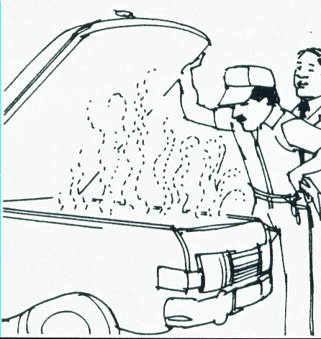
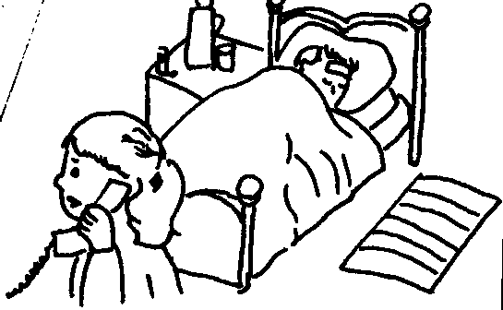
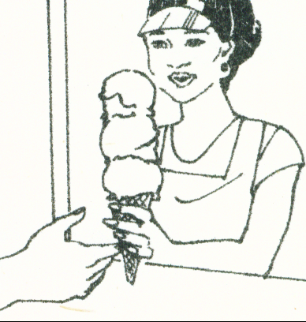

A B C
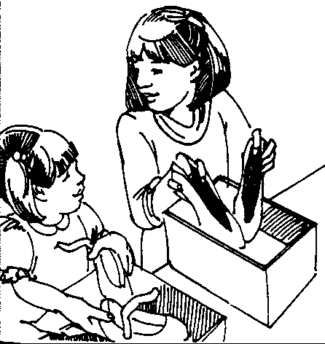
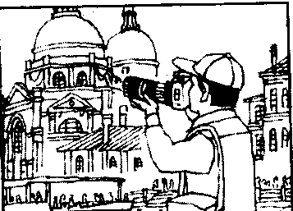
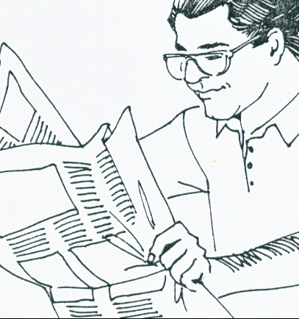
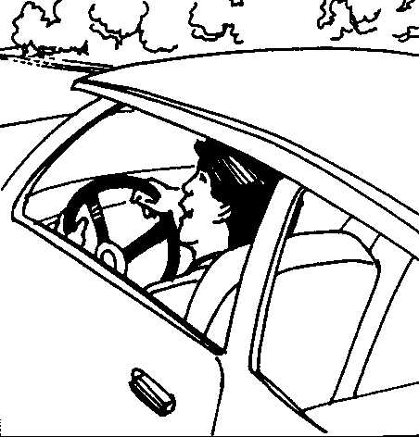

D E F G
1. ______ 2. ______ 3. ______ 4. ______ 5. ______ 6. ______
Ⅱ. Listen to the dialogue and choose the best answer to the question you hear (根据你听到的对话和问题，选出最恰当的答案): (共10分)
7. A) Jack. B) Linda. C) Mr White. D) Miss Green.
8. A) The fish. B) The soup. C) The meat. D) The chicken wings.
9. A) 6:00. B) 6:30. C) 5:30. D) 5:00.
10. A) A pilot. B) An engineer. C) A fireman. D) An astronaut.
11. A) Sunny. B) Rainy. C) Windy. D) Cloudy.
12. A) On Tuesday. B) On Friday. C) On Saturday. D) On Sunday.
13. A) Do their homework. B) Watch the football match.
C) Go to the cinema. D) Watch the movie on TV.
14. A) In England. B) In America. C) In New Zealand. D) In China.
15. A) In a restaurant. B) In a shop. C) In a school. D) In a library.
16. A) They are having a meeting. B) They are fishing.
C) They are making a phone call. D) They are talking about the time.
Ⅲ. Listen to the passage and tell whether the following statements are true or false (判断下列句子是否符合你听到的短文内容, 符合的用“T”表示，不符合的用“F”表示):
(共7分)
17. Sandy went to visit his cousin in London with his brother.
18. They took a train and arrived at 6 o’clock in the morning.
19. Sandy often played tennis and was very good at it.
20. Sandy’s brother bought some new clothes in Oxford Street.
21. They had dinner in a nice restaurant on Saturday evening.
22. Sandy and his brother stayed in London until Sunday.
23. Sandy enjoyed his trip to London very much.
Ⅳ. Listen to the dialogue and complete the table (听对话，完成下列表格): (共7分)
Presents on Father’s Day

Date | the third Sunday in (24)
From whom | Rose  a (25) and a card | Mike  a （29）
Presents |   Size:  Colour:  Price:  (26)  (27)  $ (28) |   Ingredients (配料):  flour butter  sugar (30)

Part 2 Vocabulary and Grammar (第二部分 词汇和语法)
Ⅴ. Choose the best answer (选择最恰当的答案): (共20分)
31. The old lady teaches children to play ______ piano at a weekend school.
A) a B) an C) the D) /
32. It’s getting warmer and warmer ______ spring, and plants start growing.
A) to B) in C) of D) for
33. Taiwan is ______ island of China. I hope to visit it soon.
A) big B) bigger C) biggest D) the biggest
34. It’s time for sports. Let’s ______ bowling, shall we?
A) go B) to go C) going D) goes
35. Millions of Shanghai citizens are learning to ______ English for the 2010 World Expo.
A) tell B) speak C) say D) talk
36. Zhang Yining is ______ favourite table tennis player.
A) I B) me C) my D) mine
37. Teenagers are very fond ______ cartoons.
A) in B) among C) with D) of
38. A good friend always gives you a helping hand ______ you’re in trouble.
A) when B) before C) until D) though
39. My mother ______ make rice dumplings. She’ll teach me how to do it.
A) must B) need C) should D) can
40. The 2007 Special Olympic Games ______ in Shanghai.
A) will hold B) will be held C) were held D) held
41. Mr Smith is quite busy today. He has ______ meetings to attend.
A) little B) a little C) few D) a few
42. The lake looks ______ in the moonlight. I often take a walk around it.
A) wonderfully B) famous C) beautiful D) well
43. Jenny ______ with a Chinese family for two years. Now she’s used to the life in China.
A) stays B) would stay C) is staying D) has stayed
44. The Russian President paid his first visit to Shaolin Temple last March. He had ______ been there before.
A) never B) often C) usually D) always
45. To ______ his sick mother, David goes to the hospital after work every day.
A) take charge of B) take hold of C) take care of D) take the place of
46. Obey the traffic rules and learn to protect yourself. ______ is more important than life.
A) Nothing B) Something C) Everything D) Anything
47. Most people ______ when the big earthquake (地震) took place in that area.
A) are sleeping B) were sleeping C) slept D) sleep
48. ______ exciting event the 2006 World Cup is!
A) What an B) What a C) What D) How
49. Our class teacher asked the monitor ______.
A) why didn’t Bill come to school B) why doesn’t Bill come to school
C) why Bill didn’t come to school D) why Bill doesn’t come to school
50. – Sorry, Tommy. I’ve lost your book.
– ______ I’ve got another copy.
A) You’re welcome. B) That’s all right.
C) I hope so. D) Of course not.
Ⅵ. Complete the sentences with the given words in their proper forms（用括号中所给单词 的适当形式完成下列句子): (共8分)
51. I received some Christmas ___________ from my pen pals. (card)
52. The young man works as a ___________ in a five-star hotel. (wait)
53. The children were ___________ excited when they saw the two pandas, Tuantuan and Yuanyuan. (real)
54. To be lovely Shanghainese, we should be helpful and ___________ to others. (friend)
55. Our new flat is on the ___________ floor, and we have a good view of the park. (ten)
56. It is ___________ to improve our English without enough practice. (possible)
57. The situation in that country is ___________. You’d better not go there. (danger)
58. It is ___________ of Peter to pay so much money for clothes. (fool)
Ⅶ. Choose the word or expression which is closest in meaning to the underlined part in each sentence（选择与下列各句中划线部分内容意思相近的单词或短语，用A、B、C、D 等表示): (共8分)
A) want to know B) was over C) again and again
D) started E) Almost F) here and there
G) Not more than H) at some future time I) solve

59. The mother thanked the policeman over and over for finding her lost child.
60. The old town looks like a garden. We can see trees and flowers everywhere.
61. I wonder how many new light railways will be open to traffic in Shanghai by 2010.
62. Keep trying, and you will work out the difficult problem.
63. The scientists set out for the South Pole last month.
64. When the summer camp came to an end, the students felt sorry to say goodbye to each other.
65. – Excuse me, how many books can I borrow at a time?
– At most four.
66. China will set up her own space station sooner or later.
Ⅷ. Rewrite the following sentences as required（根据所给要求，改写下列句子。每空格限填一词): (共10分)
67. Sam wants to look for a job in London after he graduates from university. (改为否定句)
Sam _________ _________ to look for a job in London after he graduates from university.
68. Tom didn’t take part in the after-school activity yesterday. (改为反意疑问句)
Tom didn’t take part in the after-school activity yesterday, _________ _________?
69. The students’ projects will be on show in three days. (对划线部分提问)
_________ _________ will the students’ projects be on show?
70. Can you tell me when I should water the flowers? (改为简单句)
Can you tell me _________ _________ water the flowers?
71. Laura spent one week finishing reading the book Harry Potter. (保持句意基本不变)
It _________ Laura one week _________ finish reading the book Harry Potter.
Part 3 Reading and Writing (第三部分 阅读和写话)
Ⅸ. Reading comprehension (阅读理解): (共36分)
(A)
Complete the following dialogue with proper sentences in the box (选出适当的句子完成下列对话): ( 6分)
- Are you going to go with anyone?
- Yes, I’ve decided on one thing.
- So, when are you leaving?
- How long will you be away?
- I will probably not.
- No, I haven’t.
- That sounds like fun.

A: Have you made any holiday plans?
B: 72 I am going to go camping.
A: That’s great! 73
B: For a week. I only have a five-day holiday.
A: 74
B: I’ll probably leave around the end of May.
A: And where are you going to go?
B: I haven’t thought about that yet. Perhaps I will go to one of the national parks.
A: National parks? 75
B: Yeah. I will go hiking and do some fishing there.
A: Are you going to buy a tent?
B: I am not sure. 76 It’s too expensive.
A: 77
B: No. I need some time alone. I’m going to travel by myself.
( B )
It seems that everybody tells lies（谎言）— well, not big lies, but what we call “white lies”. Telling white lies isn’t that bad. Most of the time, people do it because they want to protect a friendship. Some studies show that the average person lies about seven times a day. The only real questions are about when we lie and who we tell lies to. A recent study found that people often say something different from the facts. Here are some ways they do it.
- Lying to hide something:
People often lie because they want to hide something from someone. For example, a son doesn’t tell his parents that he’s dating (约会) a girl because he doesn’t think they will like her. So he says he’s going out with the boys.
- Giving false excuses:
Sometimes people lie because they don’t want to do something. For example, someone invites you to a party. You think it will be boring, so you say you’re busy.
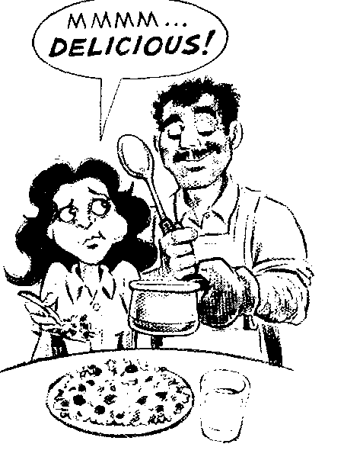
- Lying to make someone feel good:
Often we say something different from the facts to make someone feel good. For example, your friend cooks dinner for you, but it tastes terrible. Do you say so? No! You probably say, “Mmm, this is delicious!”
- Lying to hide bad news:
Sometimes we don’t want to tell someone bad news. For example, you have just had a very bad day at work, but you don’t feel like talking about it. So if someone asks you about your day, you just say all was fine.
True or False（判断下列句子是否符合短文内容，符合的用“T”表示，不符合的用“F”表示): ( 6分)
78. White lies are usually big lies.
79. People tell white lies in different ways.
80. Young people may tell white lies to hide something from their parents.
81. People sometimes tell white lies to refuse invitations politely.
82. When you taste something terrible, you may tell a white lie to make the host happy.
83. From the passage we learn that white lies are harmful to friendship.
( C )
For 99% of human history, people took their food from the world around them. They ate all that they could find, and then moved on. Then about 10,000 years ago, or for 1% of human history, people learned to farm the land.
The kind of food we eat depends on which part of the world we live in, or which part of our country we live in. For example, in the south of China they eat rice, but in the north they eat noodles. In European countries near the sea, people eat a lot of fishes. In central (中部) Europe, away from the sea, people don’t eat so much fish, they eat more meat. In Germany and Poland there are hundreds of different kinds of sausages.
In North America, Australia, and Europe, people eat with knives and forks. In China, people eat with chopsticks. In parts of India and the Middle East people use their fingers and bread to pick up food.
Nowadays it is possible to transport (运输) food easily from one part of the world to the other. We can eat what we like, when we like, at any time of the year. In Britain, bananas come from Africa; rice comes from India or the USA; strawberries come from Chile or Spain. Food is very big business. But people in poor countries are still hungry, and people in rich countries eat too much.
Choose the best answer（根据短文内容，选择最恰当的答案): ( 12分)
84. 10,000 years ago, people .
A) learned to farm the land B) cooked different kinds of food
C) couldn’t find food around them D) transported food from one country to another
85. In central Europe, away from the sea, people eat .
A) more noodles B) much fish
C) more meat D) much rice
86. In North America, Australia, and Europe, people .
A) eat with chopsticks B) eat with knives and forks
C) use their fingers to pick up food D) use bread to pick up food
87. have many kinds of sausages.
A) Chile and Spain B) America and Australia
C) China and Japan D) Germany and Poland
88. Which of the following sentences is NOT true?
A) What we eat depends on where we live.
B) Poor countries are still having food problems.
C) Rich countries don’t need food from other countries.
D) Nowadays we can eat what we like at any time of the year.
89. Which is the best title of this passage?
A) Ways to Find Food B) Food Around the World
C) Food Choices D) World Food Problems
( D )
Julia Hill, an American woman, was born in 1974. She was 23 years old when she discovered that a company wanted to cut down part of a forest in California. In the forest there were lots of redwood trees. One of the trees was 70 metres tall and 1,000 years old.
Julia wasn’t happy about this. She traveled to California and climbed up the tree. “If I sit in the tree,” she said, “the company can’t cut it down.” At the beginning, Julia planned to stay in the tree for two weeks. She lived in a small tree-house and her friends were very helpful — they cooked food for her every day. She used her mobile phone to talk to her family and to news reporters. She stayed in the tree day and night.
Environmental organizations supported her, but other people weren’t on her side and they tried to stop her. The company used a helicopter that stayed near her tree-house for a long time. The helicopter was very noisy and there was a lot of wind. Julia didn’t like it, but she stayed in the tree.
In the end, she was successful. The company agreed not to cut down the redwood. Finally, after two years and eight days in the tree, Julia Hill climbed down and walked on the ground again. She and her friends were very happy.
Answer the questions（根据短文内容回答下列问题): ( 12分)
90. What nationality is Julia Hill?

91. How tall and how old was the tree Julia Hill stayed in?
The tree was tall and old.
92. How did she keep in touch with others while staying high up in the tree?
She kept in touch with others .
93. When did she climb down the tree?
After the company .
94. How long did Julia Hill stay in the tree?
For .
95. Why did Julia Hill stay in the tree?
She wanted to .
Ⅹ. Cloze test (完形填空):（共24分）
A. Choose the words or expressions and complete the passage（选择最恰当的单词或词语 完成短文):（8分）
In 1999, a television company in Britain made a very popular programme called The 1900 House. They changed an ordinary house in a street in London so it was 96 a house from the year 1900. For example, it had no electricity, just gas for the lights and the kitchen. The toilet was outside in the garden, and all the furniture was from 1900 or before.
Then they found a family — the Browns — to live in the house for three months. 97 people in the family lived in the house: Paul and Joyce Brown, their daughters, Kathryn, Ruth and Hilary and their son, Joe. For three months, while they were living in the house, they had to wear Victorian (维多利亚时代的) clothes and live like people 98 . For example, they didn’t wash their hair with shampoo but with something else like lemon. They didn’t have a washing machine so they had to wash their clothes by hand, and they had to use the toilet outside in the garden. But the family didn’t have to go shopping. 99 , the TV company did all their shopping for them. There were 100 inside the house to make videos of the family’s everyday life, and the Browns talked on television about their experiences. Here are some of the things that Hilary said later about her time in the house:
“Some things were 101 — we had to find things to do in the evenings, because there was no television or computer, and we all had to work hard to clean the house and to cook our food. Since there weren’t enough rooms, my sister and I had to 102 a bedroom and a bed. It was fun — and we didn’t have to go to school every day, that was nice. But I don’t want to do it
103 . I think I’d like to live in the future, not the past!”
96. A) different from B) larger than C) the same as D) as convenient as
97. A) Six B) Five C) Four D) Three
98. A) in the future B) at that time C) not long ago D) of modern times
99. A) In addition B) However C) Later on D) Instead
100.A) radios B) cameras C) TV sets D) telephones
101.A) comfortable B) unlucky C) difficult D) exciting
102.A) build B) decorate C) buy D) share
103.A) again B) either C) at least D) at all
B. Read the passage and fill in the blanks with proper words（在短文的空格内填入适当的词，使其内容通顺，每空格限填一词，首字母已给):（16分）
When the London Underground goes on strike (罢工), my journey to work can be terrible. I remember a strike which happened a few years a 104 — the station near my house was closed and I had to use another station and take a different train. This a 105 about an hour to my journey, so I wasn’t very happy.
E 106 went wrong at the station. People were late and they were panicking (惊恐)! By the time I got on the train, I was feeling upset and sorry for myself. Then I saw this man. There was something about him — he had such a familiar f 107 . A few minutes later, I realized that he was Jack, a friend from my school days in Scotland. At the same time he a 108 realized who I was. Then we started talking about school days and the people we both used to k 109 . I was even more surprised when the train came into my station and he started to get off too! I asked him w 110 he was going and he said he was going to work. He told me he worked in Fitzroy Street. You see, I work in Fitzroy Street, too. It’s a small w 111 ! It was such an amazing coincidence!
Ⅺ. Writing (写话): (共14分)
112. Write a passage of at least 60 words on the topic “I Have a Dream”. ( 以“我有一个梦想”为题写一篇不少于60个词的短文，标点符号不占格。)
（ 注意：短文中不得出现考生的姓名、校名及其他相关信息，否则不予评分。）
Sentence patterns for reference （以下句型仅供参考）
- My dream is to be… / to do… / to go…
- I enjoy / like / prefer…
- To make my dream come true, I…
- If my dream comes true, …
Ⅰ. 1. Mr. Green usually reads newspapers before breakfast.
2. Betty and her mother want to buy some new shoes.
3. Hello, Miss Grey, Tim is ill and he can’t go to school today.
4. The tourist is taking photos in this beautiful city.
5. Cathy bought herself a big ice cream on her way home.
6. Something is wrong with my car. Can you help me?
Ⅱ. 7. W: Hi, Jack.
M: Hi, Linda. I’d like you to meet our new teacher, Mr. White.
Q: Who is the new teacher?
8. M: Wow, the fish is so delicious and the soup tastes nice, too.
W: I like the chicken wings best.
Q: What is the girl’s favourite dish?
9. W: Hurry. George ill be here any minute.
M: Oh, he said he’d come around six o’clock. It’s only five thirty now.
Q: What time is it now?
10. W: What does your father do, Mike?
M: He is an engineer.
W: What would you like to be in the future?
M: Well, a pilot or an astronaut.
Q: What does Mike’s father do?
11. M: I’m so glad it’s sunny today. The rain has finally stopped.
W: I hope it will be fine tomorrow, too. We are going for an outing.
M: The weather report says it’s going to be windy tomorrow.
Q: What’s the weather like today?
12. M: Are you in the dancing club, Mary?
W: Yes.
M: How often do you practice there?
W: Twice a week. We meet on Tuesday and Friday afternoons, but we’ll take part in a competition this Saturday.
Q: When will the competition take place?
13. M: There, I’ve finally done my homework.
W: Good, want to watch TV with me?
M: Of course. There is a football match now.
W: But a great movie on CCTV Six will begin soon. Let’s watch it together.
M: Oh, all right.
Q: What are they going to do?
14. M: Where are you from, Nancy?
W: I’m from England. I went to study in America when I was sixteen years old.
M: Do you still live in America?
W: No, I live in New Zealand with my husband now, and we hope to start our business in China soon.
Q: Where does Nancy live now?
15. W: Hi, remember me?
M: Sure, you bought a pair of jeans from me yesterday.
W: Yes, but they are too big for my daughter. Can I exchange them?
M: No problem.
Q: Where does this dialogue probably take place?
16. W: Hello, may I speak to Frank?
M: Speaking, who is that?
W: This is Kitty.
M: Hi, Kitty. What’s up?
W: Would you like to go fishing with us tomorrow?
M: Go fishing? Great! What time?
Q: What are they doing now?
Ⅲ. Hi, my name is Sandy. My brother and I have just been to my cousin’s house in London. We went there by train on Friday morning, and arrived at six in the afternoon. My aunt and uncle cooked a big dinner for us, and then we all went to play tennis. It was my first time, so I wasn’t very good at it and I didn’t win, but it was great fun. On Saturday we went shopping in Oxford Street. I bought some new summer clothes and my brother bought a computer game. In the evening, we all went to a nice restaurant. I had a pizza and it was very delicious. We came back home on Sunday but I wanted to stay in London. What a wonderful weekend I have had!
Ⅳ. It’s the third Sunday in June. Mike and his sister Rose are talking in the sitting room.
W: Mike, what’s the date today?
M: It’s June the 18th.
W: What’s special about it?
M: Special?
W: It’s Father’s Day. It’s a day to show love and thanks to fathers.
M: Oh, yes, then how shall we celebrate the special day?
W: Well. I have bought a shirt and a card for dad.
M: A shirt? What size?
W: Size large.
M: What colour?
W: Red.
M: Wonderful!
W: It’s dad’s favourite colour.
M: How much did it cost?
W: Twenty dollars.
M: That’s a nice present. Er, what shall I do for dad?
W: Why not make a cake?
W: Good idea! Do we have some flour, butter, sugar and eggs?
W: I think we’ve got everything.
M: Cool! I’ll get started right now.
2006年上海市初中毕业生统一学业考试
英语答案
第一部分 听力
Ⅰ. 1. F 2. D 3. B 4. E 5. C 6. A
Ⅱ. 7. C 8. D 9. C 10.B 11.A 12.C 13.D 14.C 15.B 16.C
Ⅲ. 17.T 18.F 19.F 20.F 21.T 22.T 23.T
Ⅳ. 24. June 25. shirt 26. L./Large 27. red 28. 20/twenty 29. cake 30. egg(s)

第二部分 词汇和语法
Ⅴ. 31.C 32.B 33.D 34.A 35.B 36.C 37.D 38.A 39.D 40.B
41.D 42.C 43.D 44.A 45.C 46.A 47.B 48.A 49.C 50.B
Ⅵ. 51.cards 52.waiter 53.really 54.friendly 55.tenth 56.impossible
57.dangerous 58.foolish
Ⅶ. 59.C 60.F 61.A 62.I 63.D 64.B 65.G 66.H
Ⅷ. 67.doesn’t want 68.did he 69.How soon 70.when to 71. took to

第三部分 阅读和写作
Ⅸ. A) 72.B 73.D 74.C 75.G 76.E 77.A
B) 78.F 79.T 80.T 81.T 82.T 83.F
C) 84.A 85.C 86.B 87.D 88.C 89.B
D) 90. American / She is from America.
91.70 meters, 1000 years
92.by mobile phone / by using a mobile phone / using a mobile phone
93.agreed not to cut down the red wood / tree(s)
94.two years and eight days
95.protect the tree(s) / the environment / the forest / stop the company from
Ⅹ. A) 96.C 97.A 98.B 99.D 100.B 101.C 102.D 103.A
B) 104.ago 105.added 106.Everything / Everyone 107.face / figure
108.also 109.know 110.where 111.world
Ⅺ. 略

