

作文

**宝山区初三英语第一学期期末质量抽查试卷**

**99. April 23 is World Reading Day. Write a short passage of at least 60 words to call on your classmates to get into good habits of reading and read more good books. (4月23日是“世界读书日”,请你写一篇短文，呼吁全班同学以实际行动迎接“世界读书日”的到来，为创建“书香校园”，多读书、读好书，养成课外读书的好习惯。字数不少于60个，标点符号不占格。要求内容切题，意思连贯.)**

**( 注意：短文中不得出现考生的姓名、校名及其它相关信息，否则不予评分. )**

**Use the following points as a guide. （短文须包含下列要点）:**

1. What do the students who are not interested in study usually do in their spare time?

2.What are the advantages of reading?

3.What are your suggestions?

**长宁区初三英语第一学期期末质量抽查试卷**

99**. Write a passage of at least 60 words on the topic “Happiness is for everyone”. ( 以“幸福/快乐属于每个人”为题写一篇不少于60个词的短文，标点符号不占格。)**

**（ 注意：短文中不得出现考生的姓名、校名及其他相关信息，否则不予评分。）**

**For reference:**

Do you feel happy in your life?

What / Who usually brings happiness to you?

What can you do to make yourself or others happy?

**崇明县初三英语第一学期期末质量抽查试卷**

**99. Write at least 60 words about the topic “Something I want to do during the winter holiday”. （以“寒假中我想做的一件事”为题写一篇不少于60个词的短文，标点符号不占格。）**

**Use the following points as a reference. （以下问题仅供参考）**

* What is the thing that you want to do during the winter holiday?
* Why do you want to do it?
* How are you going to do it?

（注意：短文中不得出现任何人名、校名及其它相关信息，否则不予评分。

**奉贤区初三英语第一学期期末质量抽查试卷**

**99.** Write a letter in at least 60 words according to the given situation (根据所给情景写一封不少于60词的信)

Suppose you are Sara, you want to enter your ideal school –Flower Senior High School. Please write a letter to recommend yourself. You can introduce your hobbies, personalities, studies, advantages and so on.( 假设你是Sara, 你想进入你心仪的花儿高级中学,请为自己写封自荐信。你可以介绍你的兴趣爱好、个性特长、学业情况、优点等等。**注意：1. 开头、结尾已给出，不计入总词数 2. 短文中不得出现考生的姓名、校名及其他相关信息，否则不予评分**)

Dear sir,

I’m writing to recommend（推荐） myself to you.

_______ _______ _______ _______ _______ _______ _______ _______ _______ _______

_______ _______ _______ _______ _______ _______ _______ _______ _______ _______

_______ _______ _______ _______ _______ _______ _______ _______ _______ _______

_______ _______ _______ _______ _______ _______ _______ _______ _______ _______

_______ _______ _______ _______ _______ _______ _______ _______ _______ _______

_______ _______ _______ _______ _______ _______ _______ _______ _______ _______

_______ _______ _______ _______ _______ _______ _______ _______ _______ _______

_______ _______ _______ _______ _______ _______ _______ _______ _______ _______

_______ _______ _______ _______ _______ _______ _______ _______ _______ _______

_______ _______ _______ _______ _______ _______ _______ _______ _______ _______

I’m eager to enter this school. I strongly believe that I’m the person you are looking for.

Sincerely,

Sara

**虹口区初三英语第一学期期末质量抽查试卷**

99**. Write a passage in at least 60 words on the topic “Practising the long jump”. ( 以 “ 跳远”为题写一篇不少于60个词的短文，标点符号不占格。)**

**（ 注意：短文中不得出现考生的姓名、校名及其他相关信息，否则不予评分。）**

|  |  |  |
| --- | --- | --- |
| When | a PE lesson; this afternoon | |
| Where | playground | |
| What | learn the long jump | |
| Who | Teacher | tell …about…;show students …; |
| I | follow…; nervous; fail; at last…jump over 3 meters |
| My feeling | ... | |

**黄浦区初三英语第一学期期末质量抽查试卷**

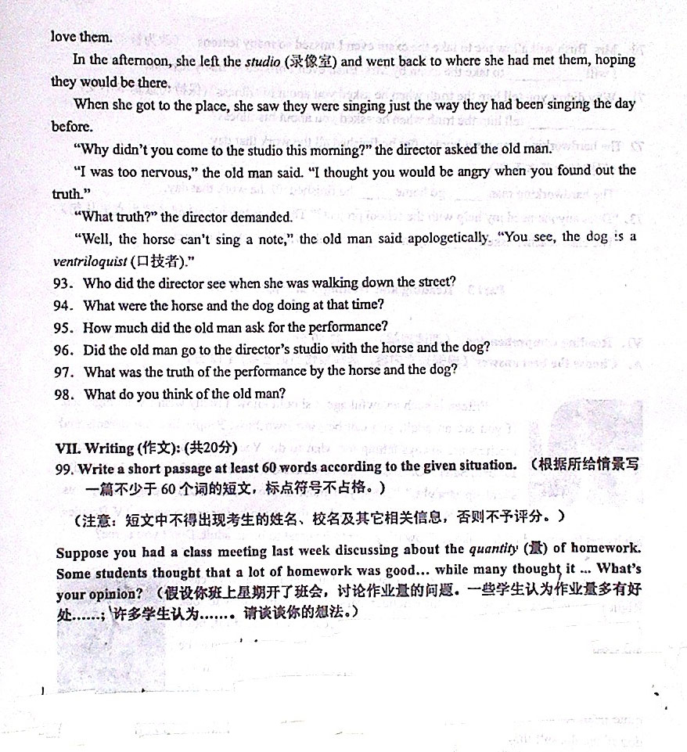

**嘉定区初三英语第一学期期末质量抽查试卷**

**99. Write at least 60 words about the topic “My view on owning a car”. （以“我对买车的看法”为题写一篇不少于60个词的短文，标点符号不占格。)**

**（注意：短文中不得出现考生的姓名、校名及其它相关信息，否则不予评分。）**

**Use the following points as a reference. （以下问题仅供参考）**

* Does your family own a car?
* Are you for or against owning a car? Why? (Give at least two reasons)

**（注意：短文中不得出现任何人名、校名及其它相关信息，否则不予评分。）**

**金山区初三英语第一学期期末质量抽查试卷**

**99. Write at least 60 words about the topic “Obeying traffic rules ” (以“遵守交通规则”为题，写一篇不少于60词的短文，标点符号不计入在内。)**

**Use the following points as reference. (以下问题请参考使用。)**

1. Is it important to obey traffic rules? （2分）
2. Why should we obey traffic rules? (Give at least two reasons.) （2分）
3. What can people / we students do? (Give at least two ways.) （4分）

参考词汇：pedestrian(行人), keep right （靠右）zebra crossing(斑马线) pavement(人行道)

思考角度：行人，驾驶员

**（注意：短文中不得出现任何人名、校名及其它相关信息，否则不予评分。）**

**静安区(青浦区)初三英语第一学期期末质量抽查试卷**

**99. Write a short passage of at least 60 words according to the situation given below（根据所给情景，以“Jenny, a good writer around me!” 为题写一篇不少于60个词的短文，标点符号不占格。)**

**（注意：文中不得出现考生的姓名、校名及其它相关信息，否则不予评分。）**

**Situation:**

Jenny loves writing and often writes short passages for our school newspaper. You interviewed her last week. Please tell us how Jenny becomes a good writer.

You have got some information on: (以下信息仅供参考)

|  |
| --- |
| 1. Her hobby 2. Her parents’ job 3. An award in writing in 2010  4. Extra work for the school newspaper 5. Her ambition |

1. 内容8， 语言8， 组织结构4.

2. 分档：A:20-18 B:17.5-13.5 C: 13-8.5 D: 8-4.5 E: 0-4

3. 标准：A: 思路清晰、内容充实、结构严密。 B: 审题略偏，但观点较清晰。

C: 审题较偏，常套文章。语法错误也较多。

D: 审题不清、无中心、词不达意、错误很多、字数也不够。

**闵行区初三英语第一学期期末质量抽查试卷**

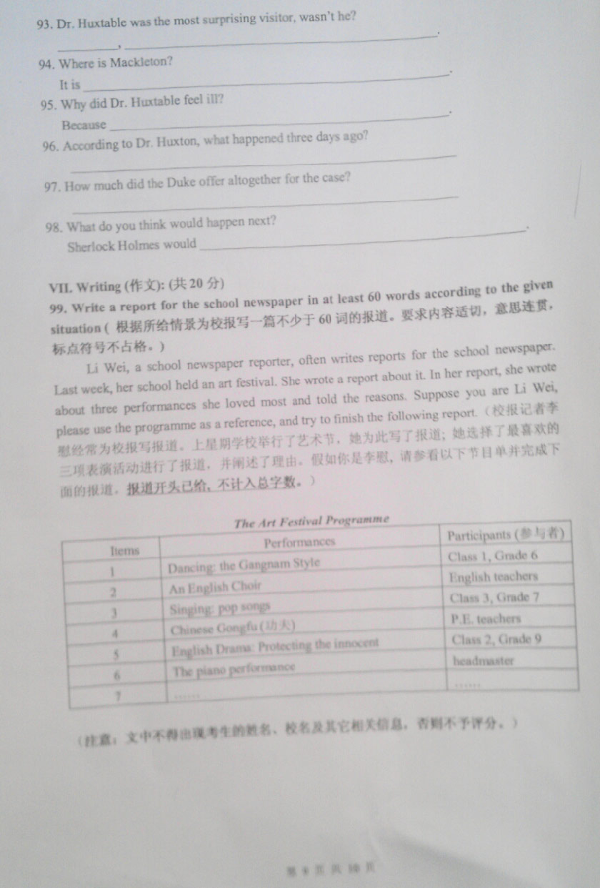

**浦东新区初三英语第一学期期末质量抽查试卷**

99. Suppose you’re a member of your school “Friends of the Earth” Club. Please make a proposal to call on your schoolmates to live a low carbon life. The following questions are for your reference: Why should we have a low carbon life ? How can we do that ? **You should write at least 60 words**.

假设你是校"地球之友"俱乐部成员, 请写一份至少60 字的“倡议书”,呼吁同学们低炭生活。以

下问题仅供参考:为什么我们要低炭生活？如何做到低炭生活？

（注意：文．中．不．得．出．现．任．何．姓．名．、．校．名．及．其．它．相．关．信．息．，．否．则．不．予．评．分．。）

**1**）每篇作文**2** 人批改分数相差超过**4** 分（含**4** 分），要求第三人批阅

**2**）参考评分标准分为**4** 档：

**1**档 **16-20**分：内容很切题、充实，意思连贯、逻辑性强，表达准确、清楚、完整，

无或少见语法错误；字数符合要求

**2**档 **11-15**分：内容切题、充实，意思比较连贯，逻辑性较强，表达比较准确、

清楚、完整，字数符合要求

**3**档 **6-10** 分：内容基本切题，意思基本连贯，表达基本清楚完整，字数符合要求

**4**档 **0-5**分： 文不对题，表达不清，但能写一些句子、词汇等

3）参考给分标准**:**

内容8 分：紧扣主题，围绕该主题要求的几个方面展开

语言8 分：大小写、标点符号、单词拼写、词法、句法正确，字数符合要求

结构4 分：内容充实，不写废话； 上下文连贯、用语规范、表达准确、无或少见

语法错误； 词汇和句型句式运用恰当， 多见好句型和习惯表达用语

通篇句型、句式单一，词汇贫乏，即使无语法错误，组织结构分要酌情扣分

**4**）错误扣分标准：

标点符号、大小写错误：每2 处扣0.5 分，此项错误扣分总数不超过1 分

拼写：每个错误扣0.5 分，同一错误不重复扣分

词数：每少5 个词扣0.5 分，依次类推

语法错误：每个错误扣0.5 分，同一错误不重复扣分

**普陀区初三英语第一学期期末质量抽查试卷**

99. Write a composition in at least 60 words according to the given situation (根据所给情景写一篇不少于60词的短文)

Suppose you’re going to have a class meeting. Everyone will talk about whether he/she would like to go to a boarding high school. Please write a composition about your opinion and give your reason(s). （假如你们即将召开一次班会，每个人将谈谈他/她是否想上寄宿制高中，请就这个主题写出你的想法和理由。）

（注意：文中不得出现任何姓名、校名及其它相关信息，否则不予评分。）

**松江区初三英语第一学期期末质量抽查试卷**

**99.** Write at least 60 words according to the given situation (根据所给情景写一篇不少于60词的短文，标点符号不占格。)

**（注意：文中不得出现任何姓名、校名及其它相关信息，否则不予评分。）**

每个人都有自己的梦想，都在为自己的梦想努力学习、奋斗、拼搏。你呢？当然也不例外。但是我们应该怎样学习呢？应该怎样用实际行动实现自己的梦想呢？

**徐汇区初三英语第一学期期末质量抽查试卷**

**99.** Eric Schmidt, Google chairman, made a speech at Boston University and gave some meaningful advice to the students, asking them to stay away from electronic devices and to have more time to talk face-to-face with their friends and parents.

Eric Schmidt谷歌公司主席在波士顿大学的演讲中建议学生不要沉迷于电子设备而要留出更多时间和朋友家长面对面交流。 请你就Eric Schmidt的建议结合你或者你身边同学朋友的实际情况谈谈你的看法。

**Write at least 60 words to describe what you know and think about Eric Schmidt’s advice.**

**（注意：短文中不得出现任何人名、校名及其它相关信息，否则不予评分。）**

Suggested questions:

1. Do you or your friends spend much time on electronic devices, such as …?

2. What do you think of his advice? Do you agree or disagree?

**杨浦区初三英语第一学期期末质量抽查试卷**

99**. Write a passage of at least 60 words on the topic “One stormy night”. ( 以“一个风雨交加的夜晚”为题写一篇不少于60个词的短文，标点符号不占格。)**

**（ 注意：短文中不得出现考生的姓名、校名及其他相关信息，否则不予评分。）**

**Use the following points as a guide. （短文必须包含下列要点）**

1. What happened during the big storm? Was there any damage?
2. Where were you and what were you doing when the storm hit the city?
3. How did you feel about the night?

**You can begin like this:**

There was a big storm last night. **____________ ____________ ___________ ___________ ____________ ____________ ____________ ____________ ___________ ___________**

**闸北区初三英语第一学期期末质量抽查试卷**

