阅读选择



**宝山区初三英语第一学期期末质量抽查试卷**

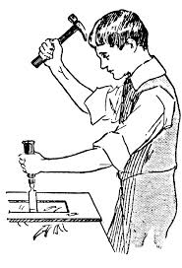Jim was a young man in his early twenties who was studying to be a carpenter(木匠). He was a good worker, honest and worthy of trust, so his boss was pleased with him. As he was such a likable man and easy to deal with, he was popular with his workmates, too. They also made fun of him a great deal but he never got angry with them and would only laugh.

But Jim’s one great shortcoming(缺点) was that he could never tell a lie, no matter how hard he tried, not even a little one. In fact, he was so honest and shy that he would blush(脸红) even when he was telling the truth. He used to stand in front of the mirror and practise lying while looking himself in the eyes at the same time. But as soon as he saw his face starting to go red he had to look away.

One morning, however, he didn’t like going to work because he had been to a party the night before and it hadn’t ended till the early hours of the morning. And then the first time in his life he decided to take the day off. He rang his boss, pretending to be a woman. He spoke in a high voice. “ Hello,” he said timidly. “I’m afraid Jim can’t come to work today. He isn’t feeling very well.” Poor Jim was thankful that his boss couldn’t see him just at that moment because his hands were trembling(发抖) and his face was bright red.

“Thank you for letting me know,” said Mr. Woods, his boss, and then just as he was about to hang up, he said, “ Just a moment, madam, who’s speaking.”

“Oh!” Jim stammered(口吃), and going all out for making a voice（尽量装出…的嗓音）like a woman, he cried in a loud voice: “This is my landlady speaking!”

1. Jim was ________________________.

A) mid-aged B) a teenager C) over 25 D) between 20--25

75. He was a _________________________ .

A) skillful worker B) skillful carpenter

C) researcher studying how to be a carpenter D) being- trained carpenter

76. His boss was ________ with him.

A) displeased B) not pleased C) satisfied D) unsatisfied

77. His workmates used to __________________ .

A) cheat him B) play with him C) play jokes on him D) beat him

78. Telling lies always made him _____________.

A) go blue B) go white C) go red D) feel hot

79. At the end of the story poor Jim let the cat ________________ .

A) out of the bag B) out of the house C) into the bag D) into the house

74. D 75. D 76. C 77. C 78.C 79.A

**长宁区初三英语第一学期期末质量抽查试卷**

James shook his money box again. Nothing! He carefully counted the coins that lay on the bed. $24.17 was all that he had. The bicycle he wanted was at least $90! How was he going to get the end of the money?

He knew that his friends all had bicycles. It was hard to hang around(闲逛) with people when you were the only one without wheels. He thought about what he could do. It was no use asking his parents, for he knew they had no money to save.

There was only one way to get money, and that was to earn it. He would have to find a job. But who would hire him and what could he do? He decided to ask Mr. Clay for advice, who usually had opinions on most things.

“Well, you can start right here,” said Mr. Clay. “My windows need cleaning and my car needs washing.”

That was the beginning of James’ part-time job. For three months he worked every day after finishing his homework. He was amazed by the variety of jobs that people found for him to do. He took dogs and babies for walks, cleared out cupboards, and mended books. He lost count of the number of cars he washed and windows he cleaned, but the money increased and he knew that he would soon have enough for the bicycle he was eager to have.

The day finally came when James counted his money and found $94.32. He wasted no time and went down to the shop to pick up the bicycle he wanted. He rode proudly home, looking forward to showing his new bicycle to his friends. It had been hard working for the money, but James knew that he valued his bicycle far more since he had bought it with his own money.

1. James in the passage was probably ________.
2. a cleaner B. a worker C. a student D. a teacher
3. The only way for James to earn money was to ________.
   1. find a part-time job B. borrow some from his parents

C. ask Mr. Clay for help D. study very hard

76. Which of the following is NOT mentioned in the passage?

A. He mended books. B. He cleared out cupboards.

C. He washed dogs. D. He cleaned windows.

77. The underline phrase “lost count of” in paragraph 5 means ________.

A. remembered B. forgot C. added D. reduced

78. James valued his bicycle very much because ________.

A. it was very expensive B. it was bought with his own money

C. he was too poor to have one D. his friends all had bicycles.

79. What’s the best title of this passage?

A. Too poor to have a bicycle. B. A part-time job.

C. How to get a bicycle. D. James’ new bicycle.

74.C 75. A 76. C 77. B 78. B 79. D

**崇明县初三英语第一学期期末质量抽查试卷**

What was school like in ancient times? In Greece, 2,500 years ago, students used to get up at dawn to go to school. Classes began very early and ended when it was dark. Students didn’t rest on the weekends. They had classes seven days a week, so they didn’t have much time for anything else. In Athens, only the sons of rich people went to school, and they started school around the age of seven. After they learned to read and write, they used to study Greek poems and historical works. Music was very important, and physical training was also important. Teachers used to hit students who didn’t pay attention or were lazy. Girls stayed at home with their mothers and learned how to do housework in the home.

In ancient Rome, boys and girls from wealthy families received a *bilingual* (双语) education. They had to study Greek and Latin. Students usually had classes outside, if the weather was good, or in the teacher’s house. Young students sat on the floor. Older students used to sit on benches, higher up. That’s how “high school” got its name.

Education was very important to the ancient Aztecs of Mexico. Boys and girls used to attend school, but they were kept in different classes. They learned Aztec history, myths, and rituals, but they *memorized* (记住) everything because there weren’t any textbooks. The boys received intensive military training, and the girls learned how to manage the home and the family. There were two kinds of schools: one for children of rich families and another for children of ordinary families.

74. We know from the first paragraph that in ancient Greece.

A) classes began very late B) students went to school very late

C) classes ended very early D) students had to study at the weekends

75. What was school like in ancient Athens?

A) The students didn’t study Greek poems.

B) There were no girl students at schools.

C) There were no music lessons at schools.

D) The students started school at the age of ten.

76. The students didn’t learn how at schools in ancient Athens.

A) to read B) to write C) to enjoy music D) to do housework

77. The second paragraph tells us that .

A) older students used to sit on benches

B) only young students had classes outside

C) only boys received a bilingual education

D) girls didn’t have to study Greek and Latin

78. Which of the following is **NOT** true according to the third paragraph?

A) Boys and girls were kept in different classes at schools.

B) Students learned Aztec history, myths, and rituals at school.

C) Boys and girls both received intensive military training.

D) Students had to have good memory because they had no textbooks.

79. Which of the following might be the best title for this passage?

A) Schools in Ancient Times B) Greek Poems and Music

C) Bilingual Education in Rome D) Schools in Ancient Mexico

74D 75B 76D 77A 78C 79A

**奉贤区初三英语第一学期期末质量抽查试卷**

Andrew Engel was puzzled. He was sitting in class, but had no idea what the other students were talking about. He had done his homework, paid attention to lectures, and taken notes, but nothing was familiar. “Everyone is so much cleverer than I am,” he thought. It was a strange feeling, as he was always a good student in high school.

He felt even more puzzled a few days later. He got lost on his way to his favourite cinema. What’s worse, he began having trouble finding the right words when speaking. He asked, “What’s for dinner, Mom?” after he had just eaten. Poor Andrew, he was only 15!

His parents were worried and took Andrew to see a doctor. A brain scan（扫描）made it clear: Andrew had a malignant brain tumor(恶性脑肿瘤) . It was pressing on the part of the brain that makes new memory. He should be operated on as soon as possible. Andrew was ***scared***!

Doctors removed the tumor, but Andrew’s memory was still poor. He was told he would probably never go back to school. Andrew was eager to enter a university, but it seemed that his dream wouldn’t come true.

“Even though they told me this, I knew I wanted to go back to school,” Andrew said. “I wanted to get my memory back.”

Andrew began by auditing(旁听) an English class at a nearby school. In class, he took notes carefully and read his notes several times a day, then typed them again and again. He studied twelve hours a day, seven days a week. He worked ten times harder than other students. In 2007, at age 29, he graduated from a local university. Six months later, Andrew found a job.

74. At first, Andrew Engel felt puzzled ________.

A). at home B). in class C). in a hospital D). in his favourite cinema

75. Andrew’s strange behavior(行为) including all the following ***except***_________.

A) having no idea what the other students were talking about

B) getting lost on his way to his favourite cinema

C) having trouble finding the right words when speaking

D) not knowing who he was

76. The underlined word "**scared**" in the third paragraph means “ __________”.

A）very frightened B）very excited

C）very surprised D）very happy

77. The tumor in Andrew’s brain __________.

A) didn’t damage his memory

B) didn’t have to be removed

C) caused his forgetfulness

D) is still in his brain

78. Andrew studied very hard at the nearby school because ___________.

A) he wanted to realize his dream

B) he liked to stay with other students

C) he wanted to forget his illness

D) his parents wanted him to do so

79. Which of the following is ***the best title*** of the article?

A) A man with an amazing brain

B）An unusual story of memory lost and found

C）How to improve your memory D）Never lose your memory

74. B 75.D 76. A 77. C 78.A 79. B

**虹口区初三英语第一学期期末质量抽查试卷**

News of an air crash in the north of England has just been received. The plane, which was on a charter（包机）flight from London to Carlisle, was carrying a party of businessmen on their way to a trade fair. It seems likely that the plane ran into a heavy fog as it neared Carlisle and had to circle for twenty minutes. Everything seemed to be going well. The pilot was in constant radio communication with Grand Control, when the engines suddenly went wrong and all ***contact*** was lost. The plane crashed on the site of the Roman camp at Hadrian’s Hill, a place well known to archaeologists(考古学家）and tourists.

So far few details have been reported, but it is feared that at least twenty people lost their lives, among them the pilot, who was killed at once. The local ambulance and firemen were on the scene within minutes of the crash, but additional help had to be rushed from other areas.

Mr. Lesilie Collins told our reporter, “We passengers noticed the engines were making a funny noise. Of course we couldn’t see anything because of the fog, but the pilot said there was nothing to worry about. The next thing we knew, the engines went dead. There was a rushing noise and a kind of flash— and after that I don’t remember any more.’”

Collins is now in hospital, being treated for his injuries. We will bring you further news of the crash as we receive it. In the meantime relatives are asked to ring 02-3457211 for information.

( )74. Why did the party of businessmen fly to Carlisle?

1. For sightseeing. B) For a camp. C) For information. D) For a trade fair.

( )75. When the plane neared Carlisle it __________.

1. had instructions to land immediately B) was unable to hear Ground Control

C) had to wait for instructions to land D) had to turn back

( )76. The underlined word “contact” probably means _________.

A) 联系 B) 影响 C) 手机信号 D) 电

( )77. From the information in the text, it seems that the plane crashed at ______.

A)a local scenic spot B) a place of historical interest

C) an archaeological museum D) a training camp

( )78. The news report tells us that when the crash happened __________.

A) the local ambulance and firemen immediately came to the rescue

1. all the passengers were killed
2. additional help was unnecessary
3. help was long delayed

( )79. From what Collins said, it appears that he _________.

1. remembered everything that happened
2. had an incomplete picture of what had happened
3. remembered speaking to the pilot

D) heard and saw nothing at all

74. D 75. C 76. A 77. B 78. A 79. B

**黄浦区初三英语第一学期期末质量抽查试卷**

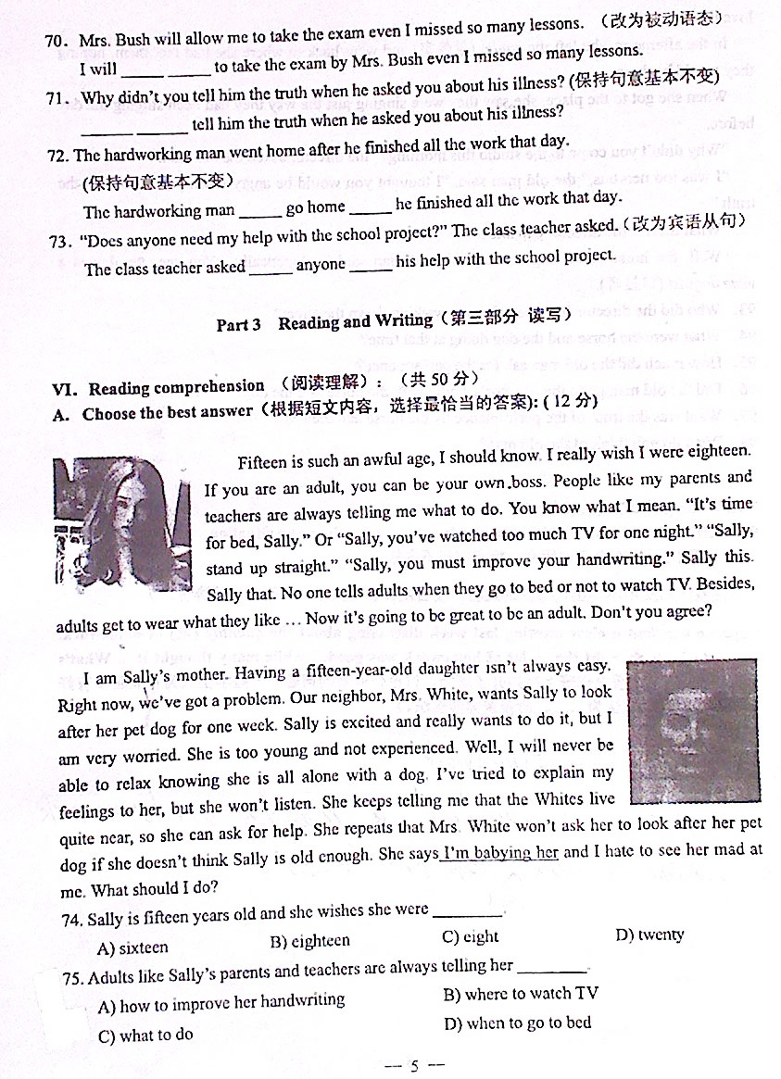

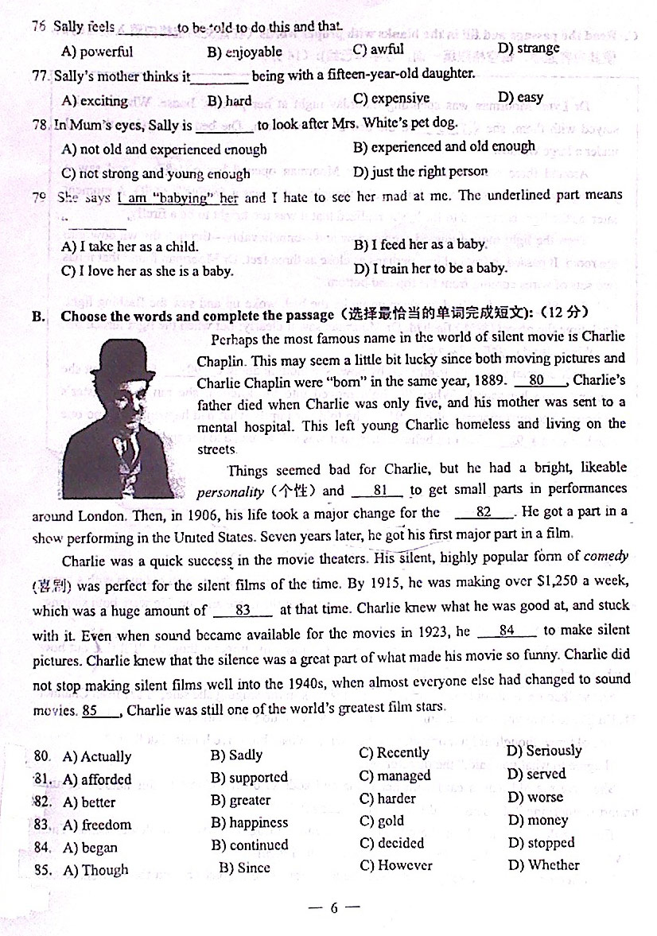

BCCBAA

**嘉定区初三英语第一学期期末质量抽查试卷**

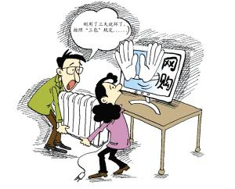Shopping used to mean actually going to shops, but nowadays, you can shop without even leaving your house. Just sit in front of your computer, click your mouse and your things will be sent to your house in a couple of days.

November 11th is a big day for people who like shopping online. On that day last year, many online stores offered a big discount and free delivery service. The biggest online shopping sites in China, Taobao.com. and Tmall.com., sold things worth 19.1 billion yuan in total.

“Goods online are often much cheaper. It also saves me a lot of time. And we often have more goods on many online stores than in shopping malls,” Wang Xin, an online shopping lover in Beijing, said to China Daily. She stayed up very late for a lot of cheap goods online. She spent several thousand on what she bought that day.

Another big advantage of online shopping is that it helps people get things from different cities, even different countries, *with ease* (轻松地). “I like eating duck neck very much and I often buy it on Taobao from shops in Wuhan. It’s much more delicious than what our *local* (当地的) stores sell, but cheaper,” said Zang Xin, a girl in Yangzhou.

While enjoying online shopping, many people also have worries, especially for middle school student buyers. Young students are easily attracted by advertisements on the Internet and buy things they don’t need.

“Middle school students should pay more attention to their study. Searching for things wastes their time,” said Jing Chunling, an education expert. “In addition, online shop owners have no idea of the ages of their buyers. Anyone can easily buy things that they want to. Some of goods are even bad for young students such as cigarettes and wine.”

( ) 74. Nowadays many people like shopping online instead of _________.

A. clicking their mouses B. paying money

C. sitting in front of their computers D. going to shops

( ) 75. Taobao.com and Tmall.com are the biggest _________ in China.

A. online shopping sites B. traditional shops

C. companies D. sellers

( ) 76. According to the article, which of the following is **not** an advantage of shopping

online?

A. It can save people time and money.

B. Online stores have better quality goods.

C. People can buy things from different places.

D. Online stores may have more kinds of goods.

( ) 77. People worry about students shopping online because students _________.

A. are easily attracted to buy useless things

B. may depend too much on online shopping

C. haven’t met the online store owners

D. may buy nothing with a lot of money

( ) 78. _________ persons are *mentioned* (提到) in this passage.

A. Two B. Three

C. Four D. Five

( ) 79. The article is mainly about _________.

A. how to buy good products online.

B. how to find good online stores.

C. advantages and disadvantages of online shopping.

D. dangers of shopping online for students.

74. D 75. A 76. B 77. A 78. B 79. C

**金山区初三英语第一学期期末质量抽查试卷**

Most people have dogs as pets. But do you know that dogs can also do different jobs?

On September 11, 2001, terrorists attacked the US and nearly 3,000 people died. At that time over 300 dogs were there to help to find and save people. They are working dogs.

The US army began to use dogs during World War I. Now, about 2,700 dogs are working in Afghanistan and Iraq, according to Discovery News. These four-legged soldiers use their powerful sense of smell to find bombs (炸弹), drugs (毒品) and enemies.

Dogs are “man’s best friend”. They can help us work better.

The most common jobs for working dogs are in search and rescue. They can find lost people or bodies after a big disaster or in the wild.

Guide dogs can help blind people walk safely. These dogs can understand some words. Guide dogs are popular in the US and Japan. Many guide dogs visited China during the 2008 Olympic Games.

There are also dogs working with doctors. They can help autistic (自闭症的) children. These children sometimes don’t talk and like to do the same things again and again. A study from Canada in 2010 showed that dogs could make autistic children feel relaxed and safe.

***Herding dogs*** are important to sheep owners. They keep the sheep safe. They are common in Australia, New Zealand and some parts of China. Nowadays, many people have them as pets.

So dogs are not only our pets but also our workmates now.

74. Working dogs in Afghanistan and Iraq help to _____________.

A) keep people safe B) find and save people

C) find bombs, drugs and enemies D) keep the environment clean

75. The most common jobs for working dogs are in .

A) helping blind people walk safely B) search and rescue

C) helping autistic children D) keeping sheep safe

76. Guide dogs are popular in _____________.

A) China and Japan B) Canada and the USA

C) Australia and the USA D) the USA and Japan

77. A lot of guide dogs came to China in _____________.

A) 2001 B) 2700 C) 2008 D) 2010

78. The underlined word “***herding dogs*** ” means .

A) 狩猎犬 B) 牧羊犬 C) 警犬 D) 玩具犬

79. The best title for this passage is .

A) Four-legged soldiers B) Guide dogs are popular

C) Dogs are our pets D) People and dogs make a great team

74. C 75. B 76. D 77. C 78. B 79. D

**静安区(青浦区)初三英语第一学期期末质量抽查试卷**

Do you have a mobile phone? Do you send text messages to your friends and family?

Text messaging or ‘texting’ is becoming very popular. But, scientists have discovered that texting can give us problems with our hands. Be careful! Too much texting can cause *swelling* (**肿胀**) in our thumbs and wrists. Our thumbs are not made for pushing small buttons, over and over. Scientists call this problem RSI.

We spoke to a doctor called Harriet Wilson, who treats many patients with RSI. She said we needed to see how much time we were spending in typing text messages. If we are spending more than 10-15 minutes **at once**, we could have problems in the future.

We also talked with Dr Harjeet Deepa who treats RSI patients. He told us that the youngest patient she had treated was a five-year-old girl. She wasn’t doing well at school, so her parents took her for treatment. It was found that she had such bad RSI in her hands, she couldn’t hold a pencil.

As mobile phones develop, they are getting smaller with buttons closer together. Texting with a smaller phone is worse than using a larger phone with bigger buttons. Using a computer keyboard and playing video games can also cause the same problem. So, more and more people could find themselves with RSI.

Many university students and teenagers have RSI, as they do not know the *risks* (**冒险**) of spending so much time using computers, video games and mobile phones. If we don’t do something about this, too many young people could grow up in terrible pain.

74. What causes the problem RSI?

A) More people have mobile phones. B) Texting is becoming very popular.

C) People type too many text messages. D) Our thumbs were made for pushing buttons.

75. _______ were interviewed about the problem RSI in this passage.

A) The writer and a little girl B) Harriet Wilson and Harjeet Deepa

C) Three scientists D) Four doctors

76. The underlined part “**at once**” in the third paragraph means “________”.

A) right away B) at one time

C) finally D) immediately

77. The little girl who Dr. Harjeet Deepa treated couldn’t hold a pencil because ________.

A) she didn’t go to school B) she was only five years old

C) she had no thumbs at all D) she suffered a lot from RSI

78. You can probably read this passage in a ________.

A) comic strip B) story book

C) science book D) detective story

79. From the passage we know _________.

A) it is better to use a larger phone with bigger buttons

B) it is worse to spend less time typing the text messages

C) using the computer keyboard will never cause the problem RSI

D) university students who have RSI know it’s dangerous to do too much texting.

74. C 75. B 76. B 77. D 78. C 79. A

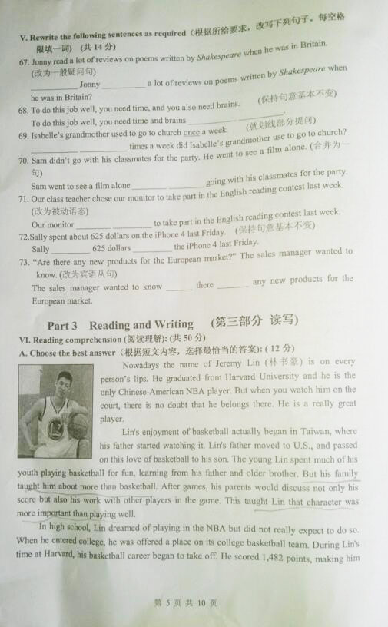**闵行区初三英语第一学期期末质量抽查试卷**

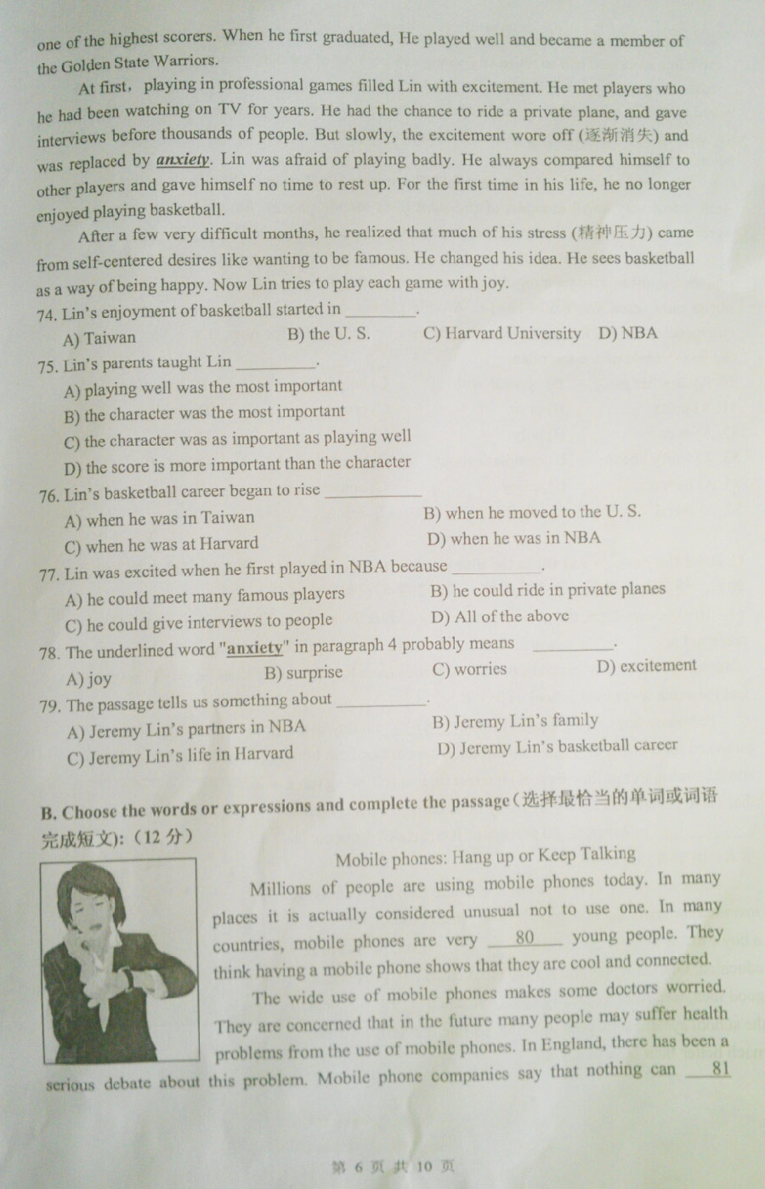

74-79 ABCDCD

**浦东新区初三英语第一学期期末质量抽查试卷**

What do you do if you don't get into your first choice of university? That's the question that faces thousands of students in Britain every year.

Many students turn to Clearing, an education agency that helps find university places for students at the last moment. If students don't have enough marks to get into their first choice of universities, Clearing tells them about places available at other universities, though they might have to study another subject.

But this year has seen a record number of students who want to study in universities. This means that there's been a fiecer competition for university places than usual. Education officials say six students competed for one place. It’s said almost 190,000 students still don't have a place in a university. That's a rise of over 46,000 students from last year.

Faced with these numbers, some students are going to be disappointed, others might be thinking of an interesting choice: studying abroad. The University of Nottingham, for example, is offering places in Ningbo, near Shanghai.

Because of the problems with university entrance, the UK's Higher Education Minister, David Willetts, encourages students to study at home or to learn one kind of skills, such as cooking, hairdressing

and so on . But some people say that rising university costs, less hope to find jobs in the future, and a drop in *graduate recruitment*（大学招生）mean it's the worst time to be a university student in the UK.

74. Thousands of _________ students don’t know what to do if they can’t enter their first choice of

universities.

A) American B) Chinese C) Brazilian D) British

75. What does the underlined "place " mean? It means ______.

A) room B) playground C) chance D) location

76. What suggestion does David Willetts give to help solve the problems in university entrance?

A) To study abroad. B) To turn to Clearing.

C) To study at home. D) To turn to parents.

77. What is NOT the reason that makes it the worst time to be a university student in the UK?

A) British economic *crisis* **(**危机**).** B) Rising University costs.

C) A drop in graduate recruitment. D) less hope to find jobs in the future.

78. Which of the following statements is NOT true ?

A) 190,000 students still don’t have a place in a university.

B) Students in UK compete for places in universities.

C) Students can study in Ningbo if they can't afford expenses in the University of Nottingham.

D) Studying abroad may be another chance for those who don’t have enough marks to get into their

first choice of university.

79. Which of the following can be the best title of the passage?

A) Clearing, the key to university. B) University Disappointment.

C) Graduate recruitment. D) Studying abroad.

D C C A C B

**普陀区初三英语第一学期期末质量抽查试卷**

If you want to find out a piece of information about anything, the best place to search for it is Wikipedia. This online encyclopedia is written by thousands of people around the world. Anyone can add or change the information if he or she finds it not correct or not well written. In this way, people who know a lot about a certain subject can write about it even if they are not university professors.

What is more, Wikipedia includes articles written in about 253 languages. This fact makes it one of the few websites (网站) on the Internet that are truly international. It was started in 2001 by Larry Sanger and Jimmy Wales, as a free online English-language encyclopedia project. By April 2008, over 10 million articles had been put on Wikipedia. A quarter of the articles are in English. Wikipedia is also a place where people can find the latest news.

However, Wikipedia has its own problems. There have been many complaints that some of the information on Wikipedia is not accurate and some important subjects are not included. This has *led to* arguments between the writers of the articles. The people running Wikipedia say that the accuracy of the information is improving and that it is one of the top 20 visited websites on the Internet.

So, if you are looking for some information, why not try Wikipedia?

74. Wikepedia is .

A) a computer game B) an online magazine

C) a free university D) a website encyclopedia

75. People who write on Wikepedia .

A) know much about a certain subject B) likes writing different stories

C) should be university professors D) are usually famous scientists

76. Wikipedia is truly international because .

A) everything is written in English B) the articles are in about 253 languages

C) there are over 10 million articles D) each writer can write in various languages

77. People didn’t see Wikepedia on the Internet until .

A) 1998 B) 2001 C) 2008 D) 2011

78. Besides information about different subjects, people can also on Widipedia.

A) watch interesting movies B) send e-mails to friends

C) read about the latest news D) play exciting games

79. The underlined part in Paragraph 3 probably means .

A) caused B) stopped C) become D) reported

74. D 75. A 76. B 77. B 78. C 79. A

**松江区初三英语第一学期期末质量抽查试卷**

They crossed in front of me as I was driving out of the store parking lot. I would be delayed for a whole ten seconds. However, I realized that it was an elderly couple. No more anger.

The man leaned on his wife who walked in front of him. He not only used her for support but it was obvious that he was blind. She was his eyes as well. The two of them worked as one --- each needing the other to *function(起作用)* in this fast-changing world.

That little example of true strength that day changed my whole personal perception of life. Suddenly I wasn’t so mad about having to work a few extra hours on Saturday. I had my strength, and I was still relatively young.

That picture of those two elderly people walking with *dignity(尊严、自尊)* and strength stayed with me the entire week. My life wasn’t so bad after all. I had my health and a good job. My wife always gave me good advice whenever I needed it. I started to think --- not only was I lucky to have it all, but so was that wonderful old couple, who, despite the trials and sufferings of a long life, still had the love and support of each other to carry them through this world.

There are so many people out there just like that couple. My wife and I sometimes picture ourselves in our old age, walking arm-in-arm into the sunset. That image always gives us a warm feeling of comfort. Just remember, none of us would be here if it wasn’t for our elders. We should spend an extra minute to listen and learn when it comes to helping our elder friends. They need it.

74. What was the writer’s first *reaction(反应)* when he was stopped by the old couple?

A) He got angry at being delayed. B) He didn’t mind at all.

C) He showed great pity for the couple. D) He waited patiently.

75. After meeting the old couple, the writer thought ________.

A) they lived a happier life than he B) they should be respected because of their love

C) they didn’t live a life without hardships D) they lived happily by walking together

76. The underlined word “perception” in Paragraph 3 probably means “________”.

A) strength B) method

C) picture D) understanding

77. From the fourth paragraph, we can learn that ________.

A) the writer once decided to change his job

B) the writer’s wife gave him lots of support

C) old people are more likely to get impatient with others

D) it is a bad thing to live a long life full of hardships

78. The writer wants to tell us in the last paragraph that ________.

A) everyone should live with dignity and strength

B) old people can teach us many important lessons

C) we should be patient when dealing with old people

D) happiness comes from walking arm-in-arm

79. What do we know about the writer according to the passage?

A) He and his wife are in their old age. B) He has a good but busy job.

C) His life is very bad actually. D) He and his wife often walk arm-in-arm.

74. A 75. B 76. D 77. B 78. C 79. B

**徐汇区初三英语第一学期期末质量抽查试卷**

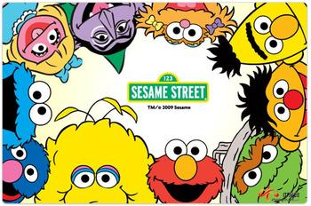More than forty years ago, a group of artists gathered to develop a television program. They planned to make a television show that would teach young children about subjects like reading and math in a fun way.

*Sesame Street* was first shown on TV on November 10th, 1969. It was produced by a group called The Children’s Television Workshop, and today it was called The Sesame Workshop. The show combines animation (动画), music, large puppets (布偶) and human actors to create funny and creative lessons. Some of the most famous characters on the show are Big Bird, Cookie Monster, Oscar the Grouch, and Bert and Ernie. Puppet maker Jim Henson created these lovely characters.

Research is an important part of what made *Sesame Street* special. The show’s creators studied children very carefully to understand how to best keep them having fun and learning. When the show was first introduced to children, some of its creators were not sure whether it would last one season. But forty years later, *Sesame Street* is the longest running children’s television program in the United States.

As part of its fortieth anniversary (周年纪念日), *Sesame Street* had a special guest on its show. First Lady Michelle Obama showed a group of children and Big Bird how to plant. She explained that the seeds would grow into vegetables, which are healthy and good to eat. She also had a message to the parents who watch the show with their children. She said parents can help their children do things to have healthy lives, like getting enough exercise.

74. *Sesame Street* is a program shown ________.

A) in the cinema B) on the radio C) on TV D) on the Internet

75. The characters in the program were created by ________.

A) The Sesame Workshop B) Jim Henson

C) Big Bird D) Michelle Obama

76. *Sesame Street* was produced mainly________.

A) to make money

B) to introduce the United States

C) to teach parents

D) to help children learn

77. On the program’s fortieth anniversary, First Lady tried to help parents learn ________.

A) how to grow and eat vegetables correctly

B) to watch the show with their children

C) to teach children to do enough exercise

D) the importance of a healthy life for their children

78. Children may find the lessons taught by *Sesame Street* very ________.

A) funny B) difficult C) strange D) useless

79. *Sesame Street* is a successful children’s program because ________.

A) it was developed by a group of artist

B) it is the longest running children’s program

C) it has invited many famous actors and actresses

D) it knows very well what children really want

CBDDAD

**杨浦区初三英语第一学期期末质量抽查试卷**

Daniel Olin was 11 years old when his parents moved to Canada. He liked his new school and made friends there, but then things at home started to change. His mum and dad began to argue and the arguments got worse and worse until one day, Daniel's mum left. With his father working long hours, Daniel felt very lonely and very unhappy. He wanted to escape, to run away. And that's what he did.

Very early one terribly cold morning when the snow was deep on the ground, he packed a bag with some clothes, some chocolate and a map of Canada and set off to a forest. He ran and ran until he could hardly breathe. His feet were heavy with the snow but he still walked on through deep snow, not even watching where he was going.

Then, **disaster** struck. A rock hidden by the deep snow caught his feet and Daniel fell to the ground. He had broken the bone. He was very cold and was starting to feel tired, but he knew that if he fell asleep in the snow, he would certainly die from the cold.

A tree shook ahead. From within the *branches*(树枝), a pair of yellow eyes watched Daniel. The puma had been following him. A puma is a large wild cat with claws that could tear Daniel into pieces. But instead of moving in for the kill, the puma walked up to Daniel and lay across his chest, arms and legs. Daniel was too frightened to move, but soon the warmth of the animal reached Daniel and he began to feel better. From time to time, the puma pressed his *muzzle* (口鼻) against Daniel and rocked his head gently. Clearly, the puma knew that Daniel must not fall asleep. This animal should have been a real danger to Daniel and yet the boy began to feel safe.

They remained like that for several hours until Daniel and the puma heard voices. The *rescue* (援救) team had found them.

74. Daniel ran away from home because ______.

A) he had a big argument with his father B) he wanted to learn to be independent

C) he didn’t get enough care from his parents D) his parents were always arguing at home

75. What was the ‘disaster’?

A) Daniel lost his way in the forest. B) The heavy snow blocked the way.

C) Daniel fell down and got hurt. D) A puma wanted to attack Daniel.

76. Why didn’t Daniel notice the rock that caused him to fall?

A) Because it was getting dark. B) Because the rock was hidden by snow.

C) Because he was frightened by a puma. D) Because he was too sad to notice it.

77. Where was the puma when Daniel first saw it?

A) In the tree. B) On the top of a rock.

C) Behind the rock. D) Before a cave.

78. Why did the puma press its muzzle against Dan and rock his head gently from time to time?

A) To keep Daniel warm. B) To play with Daniel.

C) To kill Daniel. D) To keep Daniel awake.

79. What is the best title for the story?

A) Puma in danger B) A caring puma

C) Rescue of a boy D) A homeless boy

74.C 75.C 76.B 77.A 78.D 79. B

**闸北区初三英语第一学期期末质量抽查试卷**

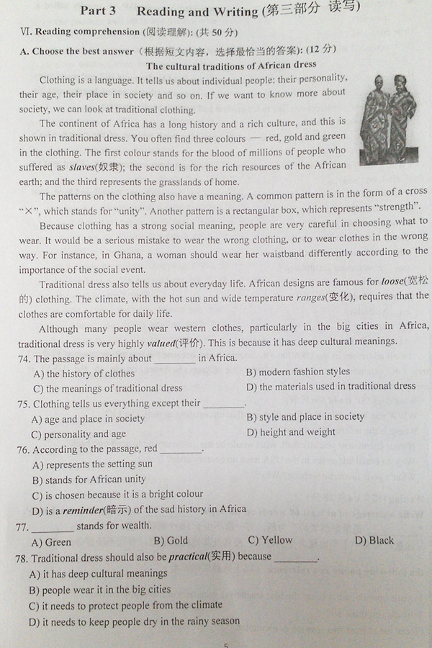

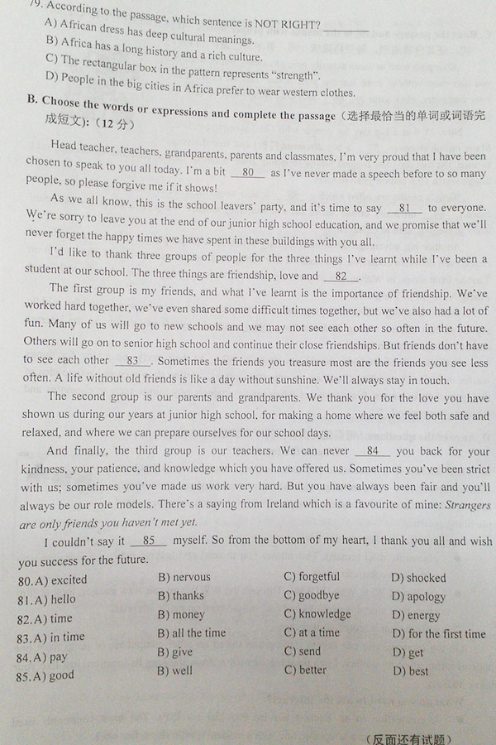

74-79 CDDBCD