

回答问题

**宝山区初三英语第一学期期末质量抽查试卷**

George Washington Carver was a scientist who helped farmers learn how to grow new crops and take better care of the soil. He studied many different plants and crops, but some of his favourites were peanuts, sweet potatoes and pecans（美洲山核桃）.

We don’t know exactly when George Washington Carver was born, but it was probably sometime in the 1860s. His mother was a slave（奴隶） owned by a farmer in Missouri（密苏里州）named Moses Carver. Young George Carver was fascinated by plants and flowers. He tended（照料）his own little garden. People began to see what a gift （天赋）he had for growing things. They called him the “the plant doctor” and asked him to help them grow their gardens better.

George longed to go to school. But in those days most schools only taught white children. So, George had to move to a town eight miles away to attend a school for black children. At that time, some people wrongly believed that a black child should not get any education.

His determination carried him all the way through college. In 1894, George Washington Carver graduated from Iowa State University. Soon he was invited to teach at Tuskegee Institute in Alabama, a college created especially for African-American students. It was just what Carver wanted: a place where he could study plants and agriculture, and help educate other black men and women.

Carver wanted to help farmers in the South. They had been raising cotton for many years，and the crops weren't growing strong and healthy any more. Carver said they needed to improve the soil by growing other crops, like peanuts. People laughed and called peanuts monkey food. Nobody ate peanuts then. One evening a group of important people came to dinner at Tuskegee. George Washington Carver planned the menu. What do you think he served? Peanut soup, peanut bread, creamed peanuts, peanut cookies and peanut ice cream for dessert(甜点)！

In his laboratory Carver learned how peanuts could be used to make shoe polish(鞋油)，ink, oil, shampoo(洗发精), soap(肥皂)，and shaving cream (剃须膏). Altogether, Carver discovered over three hundred ways to use the peanut. People started calling him “the Wizard (奇才）of Tuskegee”.

1. What did George Washington Carver help farmers do?

___________________________________________________________.

1. People don’t know the exact birthday of George Washington Carver, do they?

____________________________________________________________.

1. Why did he study at a school far away?

____________________________________________________________.

1. How could the farmers in the South improve their soil?

____________________________________________________________.

1. How many things could peanuts be used to make in Carver’s laboratory?

____________________________________________________________.

1. Why did Carver serve some important guests with a lot of peanut food?

____________________________________________________________.

93. He helped farmers learn how to grow new crops and take better care of the soil.

94. No, they don’t.

95. Because most schools only taught white children then.

96. They could improve the soil by growing other crops, like peanuts.

97. Peanuts could be used to make six different kinds of things in his laboratory.

98.Because he wanted to let them understand peanut was a kind of useful and important plant.

(Any reasonable answers can be acceptable.)

**长宁区初三英语第一学期期末质量抽查试卷**

HITTING the water with almost superman’s love and strength, Sun Yang has made history after his excellent performance at the London Olympic Games.

The 20-year-old Sun became the first Chinese man to win gold in swimming. He took home four medals in total, two golds, one silver and one bronze.

Sun said his success was down to hard work. For years he has made it a rule to swim 20km every day. “When I trained in Australia, it was winter. Although the weather was cold and I was tired, I started training at 4:30am,” he said. The post-1990 athlete is popular not only because of his victory in London, but also his sportsmanship.

Nicknamed “Sun Mengmeng” online, which in Chinese refers to his innocent appearance and charming personality, Sun has gained more than 10 million followers on Sina Weibo. His first message about his trip back to his hometown, Hangzhou, after the Olympics, received thousands of responses. “The high-speed train on my way home has been blocked for three hours due to Typhoon Haikui,” it said. “Is it possible for me to arrive home tonight?” Some Weibo users even visited his page to give funny replies, such as, “Why not swim home?”

Sun may dream of matching his idol, American Michael Phelps, who has won 22 Olympic medals. But as a third-year student in Zhejiang University, he says he has a long way to go.

“Sun works hard in class. His diligence shows the choices of a new generation of Chinese athletes, who are making more time for their education and not just focusing on sport,” said his professor, Zheng Fang.

93. Is Sun Yang the first Chinese man to win gold in swimming?

____________________________________________________________.

94. Why is Sun Yang, the post-1990 athlete, so popular?

____________________________________________________________.

95. What does Sun Yang’s nickname refer to?

____________________________________________________________.

96. What did Sun’s first message about his trip back to his hometown mean?

____________________________________________________________.

97. Sun Yang thinks it’s easy to match his idol ‘Michael Phelps’, doesn’t he?

____________________________________________________________.

98. Would you like to be a person like Sun Yang? Why?

____________________________________________________________.

93. Yes, he is.

94. Not only because of his victory in London, but also his sportsmanship. /Because of his victory and sportsmanship.

95. His innocent appearance and charming personality.

96. (It meant) he couldn’t go back home (in time)/he wanted to go home very much/he had been blocked by the typhoon. (Any reasonable answers)

97. No, he doesn’t.

98. Yes. Because he is hardworking/successful. (Any possible answers)

**崇明县初三英语第一学期期末质量抽查试卷**

Years ago, I lived in a building in a large city. The building next door was only a few feet away from mine. There was a woman who lived there, whom I had never met , yet I could see her seated by her window each afternoon, sewing or reading.

After several months had gone by, I began to notice that her window was dirty. Everything seen through the dirty window was unclear. I would say to myself, “I wonder why that woman doesn’t wash her window. It really looks terrible.”

One bright morning I decided to clean my flat, including washing the window on the inside.

Late in the afternoon when I finished the cleaning, I sat down by the window with a cup of coffee for a rest. What a surprise! Across the way, the woman sitting by her window was clearly *visible* (看得见的). Her window was clean!

Then I realized that I had been *criticizing* (批评) her dirty window, but all the time I was watching her window through my own dirty window.

That was quite an important lesson for me. How often had I looked at and criticized others through the dirty window of my heart, through my own shortcoming?

Since then, whenever I want to judge someone, I will ask myself first, “Am I looking at him through my own dirty window?”

Then I try to clean the window of my own world so that I may see the world about me more clearly.

93. How far away was the building next door from the writer’s ?

____________________________________________________________.

94. What was the woman doing each afternoon?

____________________________________________________________.

95. Why did the writer think that the woman should wash her window?

____________________________________________________________.

96. When did the writer find that the woman’s window was clean?

____________________________________________________________.

97. The writer learned an important lesson from it, didn’t he ?

____________________________________________________________.

98. What can you learn from this story?

____________________________________________________________.

1. Only a few feet away.
2. (She was) sewing or reading.
3. Because everything seen through the dirty (the woman’s )window was unclear./ Because the writer thought the woman’s window was dirty.
4. After he finished cleaning (his window) one afternoon.
5. Yes, he did.
6. Any reasonable answers will be accepted. ( We should clean the window of our own world so that we may see the world around us more clearly./ Don’t look at anyone or anything through my own dirty window. …)

**奉贤区初三英语第一学期期末质量抽查试卷**

**How to be a good detective**

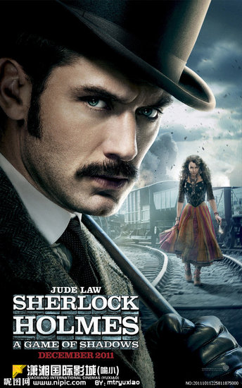Have you seen the Hollywood movie *Sherlock Holmes*? Holmes is a character created by British writer Sir Arthur Conan Doyle. His books were so popular that Holmes soon became “the most famous detective in the world”. What do you need to be a good detective? The movie *Sherlock Holmes* will show you.

In this movie, this great detective faces a dangerous man, Lord Blackwood. Together with his best friend Dr Watson, Holmes stops Blackwood’s plan to control the world with black “magic”.

Most of us are not as intelligent as Holmes. But we can also work out mysteries on our own. All we have to do is to follow some simple rules.

|  |
| --- |
| ***Rule No. 1: Justice (正义) is most important.***  No matter how smart he or she is, the most important quality for a detective is being good. In the movie, Lord Blackwood and Sherlock Holmes are both very intelligent. The difference is that Lord Blackwood is a bad man and he does bad things. Holmes can beat him on the side of justice. |
| ***Rule No. 2 Have sharp eyes***  Every bad man tries to cover up what he did. But not all things can be covered up easily. A good detective can discover clues hidden at crime scenes with sharp eyes. For example, Holmes can simply look at a man’s footprints and quickly find out his personal information like age and habits. |
| ***Rule No. 3: A good assistant is a great help.***  Even though Holmes has knowledge about many subjects , such as chemistry, botany(植物学) and anatomy, he still needs Dr Watson’s help to fight with him. We should also have someone to help you, especially if you don’t know as much as Holmes. |
| ***Rule No. 4: Logic (逻辑) is the key.***  A good detective never jumps to conclusions. When all the necessary clues are put together, you’d better think carefully. If you can’t work it out, don’t be afraid. Just take a deep breath and concentrate on thinking. Logic can help you discover missing clues. |

93. Who created “the most famous detective in the world”-Sherlock Holmes?

__________________________________________________________________________

94. What’s Lord Blackwood’s plan in the movie?

His plan ____________________________________________________________________

95. Being intelligent is the most important quality for a detective, isn’t it?

_______________, ___________________________________________________________

96. How can Holmes find out a man’s personal information like age and habits?

By _________________________________________________________________________

97. Does a good detective need much knowledge or a good assistant?

___________________________________________________________________________

98. What do you think a good detective needs?

A good detective needs_________________________because__________________________

93: (British writer) Sir Arthur Conan Doyle.

94: is to control the world with black “magic”.

95: No, it isn’t.

96. (simply) looking at his footprints/(sharp eyes)

97. Both

98. (possible answer: eg. sharp eyes, he must discover clues hidden at crime scenes with them(可以用文章中的内容，也可以是自己的想法，只要言之有理，语法正确都可以视为正确答案。)

**虹口区初三英语第一学期期末质量抽查试卷**

Have you ever heard the story of the four-minute mile? Many years ago, people believed that it was impossible for a human being to run a mile in less than four minutes until Roger Banister proved it wrong in 1954.

What happens if you put an animal in a pond? Any animal, big or small, will swim its way through. What happens when someone, who does not know how to swim, falls in deep waters? They drown. If an animal who hasn’t learned swimming could escape by swimming, why not you? Because you believe you will drown while the animal does not.

Have you ever wondered why the letters are organized in a particular order on your keyboard? You might have thought it is to increase the typing speed. Most people never question it. But the fact is that this system was developed to reduce the typing speed at a time when typewriter parts would jam if the operator typed too fast.

These three cases show the power of our beliefs(信念）. There is no other more powerful directing force in human behavior than belief. Your beliefs have the power to create and to destroy. A belief delivers a direct command to your nervous system.

I used a snake to show my students in India how unrealistic some of their beliefs are. They thought snakes were slippery, slimy( 粘糊糊的) and poisonous. After doing an exercise for changing beliefs, they handled my snake and found it to be dry and clean. They also remembered that only three types of poisonous snakes exist in India.

Did this story end the way you thought? Review your beliefs now and find out which ones you need to change.

93. Who first ran a mile in less than four minutes?

_________________________________________________________________.

94. If we put an animal in a pond, what will happen?

_________________________________________________________________.

95. Why are the letters organized in such a particular order on your keyboard?

They are organized in such a particular order _____________________________.

96. According to the passage, does your belief have a great effect on your behavior?

____, _____________________________________________________________.

97. What does the writer’s experiment show?

It shows ____________________________________________________________.

98. What does the writer think of beliefs?

They_______________________________________________________________.

93. Roger Banister

94. It will escape by swimming./It will swim its way through.

95. They are organized in such a particular order on our keyboard to reduce the typing speed. 96. Yes, it does.

97. It shows that snakes are dry and clean./It shows how unrealistic some of their beliefs are.

98. They are very powerful but people should not always believe in themselves.

**黄浦区初三英语第一学期期末质量抽查试卷**

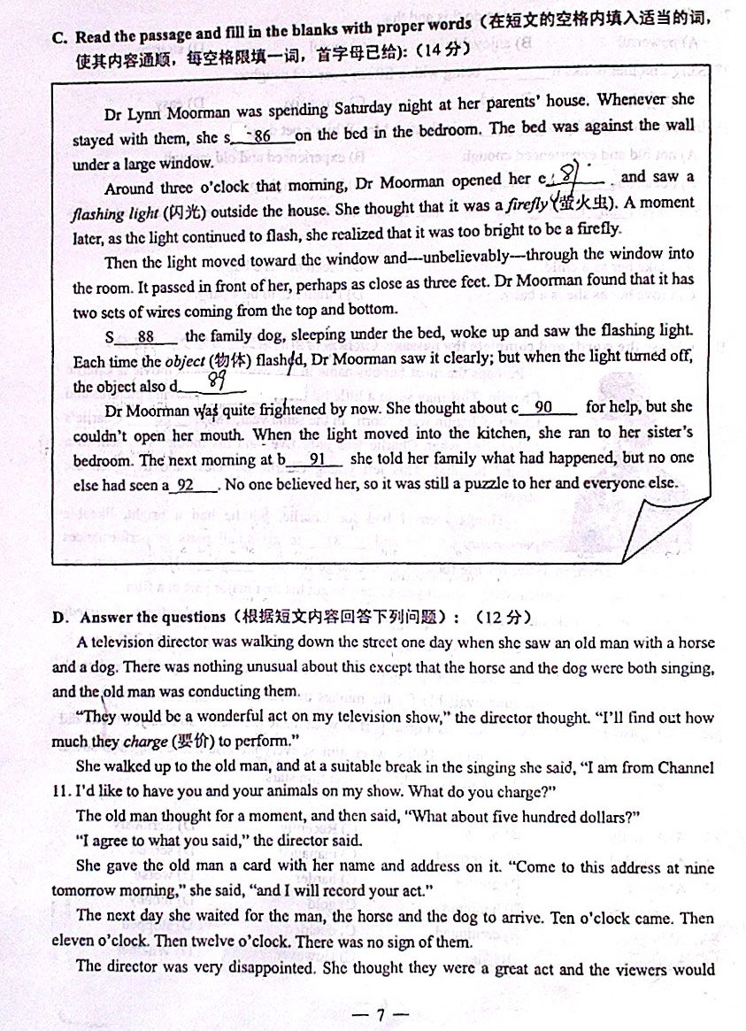

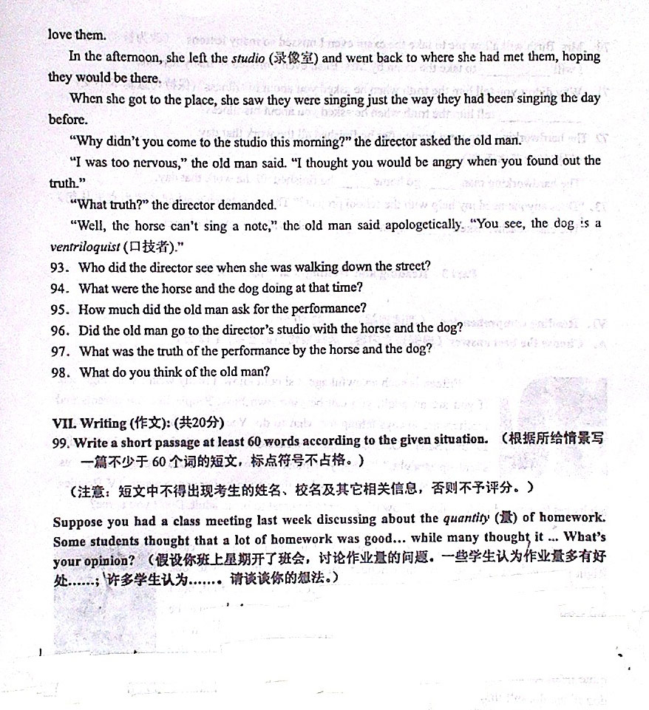

93. She saw an old man with a horse and a dog

94. They were singing.

95. 500 dollars

96. No, he didn’t

97. The horse couldn’t sing a note and the dog was a ventriloquist.\Neither the hose nor the dog could sing.

98. I think the old man was honest because he finally told the truth. (Any reasonable answer is acceptable)

**嘉定区初三英语第一学期期末质量抽查试卷**

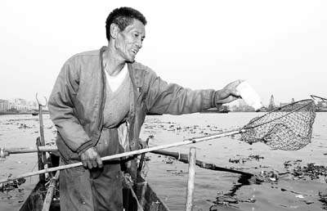The Board Meeting had come to an end. Bob started to stand up and *jostled* (挤，撞) the table, spilling his coffee over his notes. “How *embarrassing* (令人尴尬的)! I am getting so clumsy in my old age.”

Everyone had a good laugh, and soon we were all telling stories of our most embarrassing moments. It came around to Frank who sat quietly listening to the others. Someone said, “Come on, Frank. Tell us your most embarrassing moment.”

Frank began, “I grew up in San Pedro. My Dad was a fisherman, and he loved the sea. He had his own boat, and he caught fish on the sea to make a living. But it was very hard. He worked hard and would stay out until he caught enough fish to feed the family. Not just enough for our family, but also for his Mom and Dad.” He looked at us and said, “I wish you could have met my Dad. He was a big man, and he was strong from pulling the nets and fighting the seas for his catch. When you got close to him, you could smell the ocean.”

Frank’s voice dropped a bit. “When the weather was bad he would drive me to school. He would pull me right up in front, and it seemed like everybody would be standing around and watching. Then he would *lean over* (俯身) and give me a big kiss on the cheek and tell me to be a good boy. It was so embarrassing for me. Here I was twelve years old, and my Dad would lean over and kiss me good-bye!”

　　He paused and then went on, “I remember the day I thought I was too old for a good-bye kiss. When we got to the school and came to a stop, he had his usual big smile. He started to lean toward me, but I put my hand up and said, ‘No, Dad.’ It was the first time I had ever talked to him that way, and he had this surprised look on his face.

I said, ‘Dad, I'm too old for a good-bye kiss. I'm too old for any kind of kiss.’ My Dad looked at me for the longest time, and his eyes started to tear up. I had never seen him cry. He turned and looked at the windshield. ‘You’re right,’ he said. ‘You are a big boy…a man. I won't kiss you anymore.’”

For the moment, Frank got a funny look on his face, and the tears began to well up in his eyes. “It wasn’t long after that when my Dad went to sea and never came back.”

I looked at Frank and saw that tears were running down his cheeks. Frank spoke again. “Guys, you don't know what I would give to have my Dad give me just one more kiss on the cheek… to feel his rough old face… to smell the ocean on him… to feel his arm around my neck. I wish I had been a man then. If I had been a man, I would never have told my Dad I was too old for a good-bye kiss.”

93. What was everyone telling about on that day?

Everyone was telling about ____________________________________.

94. How did Frank’s father make a living?

By ___________________________________________.

95. When would Frank’s father drive him to school?

____________________________________________.

96. Why didn’t Frank want his father to kiss him good-bye?

Because he thought _____________________________.

97. Frank had never seen his father ever since then, had he?

____________, he ___________.

98. What was Frank’s feeling when he told the story?

______________________________________.

93. his/ her most embarrassing moment

94. catching fish on the sea.

95. When the weather was bad.

96. it was embarrassing (for a 12-year-old boy to get a good-bye kiss from his father)

97. No, he hadn’t.

98. He regretted what he had done. / He missed his father. / He realized that his father

loved him./ He thought he shouldn’t say that to his father …

**金山区初三英语第一学期期末质量抽查试卷**

Rising temperatures

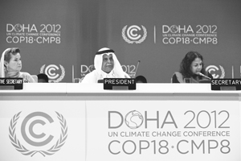If the temperature rises by 5 degrees tomorrow, you will probably take off just one coat. But such a change in the average world temperature would be a serious problem. Many animals and plants would not be able to deal with these changes, and would die.

The UNEP(联合国环境规划署) released the Report 2012 on November 21, 2012. It says that if we don’t take action now, the world temperature will have risen by 3 to 5 degrees by the end of this century.

The report was written by 55 scientists from 20 countries. Scientists have set a goal for greenhouse gases sending out to limit the world temperature rise to only 2 degrees this century. But according to the report, people have already let out 14 percent more greenhouse gases than they should have done.

A large rise in temperatures could be terrible for us and for many other living things on Earth. Sea levels will rise because higher temperatures will cause melting ice flow into the sea. Large coastal (沿海的) cities in countries such as the Netherlands and Bangladesh could be flooded.

Some plants such as corn and sugarcane (甘蔗) will not grow well in higher temperatures. Some countries, such as Brazil and parts of Africa, will not have enough food. The change may cause less rain and even make some places very dry.

On November 26, people from around 200 nations and regions gathered again in Doha (多哈) for the annual UN climate talks. “Climate change is coming to all human beings and effective actions need to be taken to deal with it,” president of the conference said at the opening ceremony.

93. What will you probably do if the temperature rises by 5 degrees tomorrow?

I will probably .

94. When was the Report 2012 released by the UNEP?

It was released .

95. The report was written by 20 scientists, wasn’t it?

, .

96. Why did people from around 200 nations and regions gather again in Doha?

They gathered there to .

97. What needs to be taken to deal with the climate change?

need to be taken to deal with the climate change .

98. Do you think the problem of climate change is serious? What should you do?

.

93. I will probably take off just one coat .

94. It was released on November/Nov. 21, 2012. .

95. No, it wasn’t.

96. They gathered there to have/hold/attend the annual UN climate talks.

They gathered there to discuss /talk about the climate .

97. Effective actions need to be taken to deal with the climate change .

98. I think it is serious and I should try to go to school on foot or ride to school. /use cloth

bags instead of plastic bags.… Yes, I think so./Yes, it is serious and I should….

**静安区(青浦区)初三英语第一学期期末质量抽查试卷**

Every month, junior high schools in China choose one hero of the month. This person is a hero because he or she has done something to help protect animals in danger. Huang Jing decided to write a letter to the President of China.

|  |
| --- |
| Dear Mr. President,  I have been doing a project at school recently about animals in danger. I think the situation all over the world is really awful. I am writing to you to suggest what China should do to help protect animals more.  I know that there are nearly 2,000 nature *reserves* (**保护区**) in China, which is good. I live in Beijing and there are about 30 reserves outside the city. We visited one of them last month to see for ourselves.  I feel so sorry for the giant panda. It’s one of the most popular animals in the world and a real symbol of China. We learned that pandas mainly live on bamboo, and that a panda can eat half its body weight of bamboo in 24 hours! That’s a lot of bamboo. I think we should try to do more to stop cutting down their forests. Pandas are already a rare animal and it would be so sad if they became *extinct* (**灭绝**) forever.  The other animal we should try to protect more is the Chinese *alligator* (**扬子鳄**). These creatures live in some parts of eastern China. These beautiful animals live in freshwater rivers and lakes but the water in some places isn’t clean enough for them to live in. It’s really dirty in fact. The government should stop factories polluting the lakes and rivers.  http://t2.baidu.com/it/u=47260961,146067326&fm=23&gp=0.jpghttp://t2.baidu.com/it/u=812527423,3358184625&fm=52&gp=0.jpg If we protect these beautiful animals in China, more people may wish to visit China to see them. They could be an important tourist attraction. It would be good if more people came to visit our beautiful country, especially to see the quieter areas in the country. Now most visitors just see the cities.  I hope you will encourage more people to think about such an important subject.  Sincerely yours,  Huang Jing |

93. What’s Huang Jing’s project at school about?

It’s about __________________________.

94. What animals did Huang Jing talk about in his letter?

__________________________.

95. How much bamboo can a panda eat in 24 hours?

__________________________.

96. Why is the water in some places too dirty for alligators to live in?

__________________________.

97. According to Huang Jing, how could animals become an important tourist attraction?

__________________________.

98. If you are a hero of the month like Huang Jing, what else will you possibly do to help protect the animals in danger?

__________________________.

93. animals in danger. / protecting animals in danger.

94. The giant panda and the Chinese alligator. 95. Half its body weight.

96. Because factories pollute the lakes and rivers.

97. By encouraging more people to think about the animals in danger.

By encouraging more people to protect the animals in danger / these beautiful animals.

98. Any reasonable answers are accepted.

**闵行区初三英语第一学期期末质量抽查试卷**

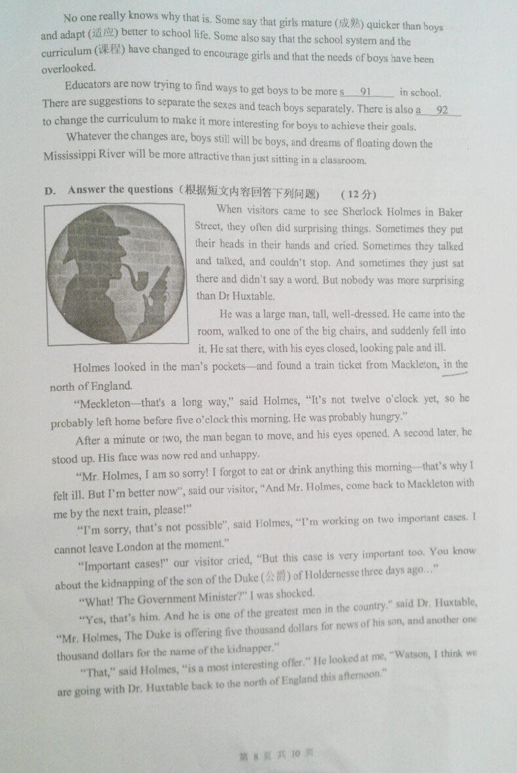

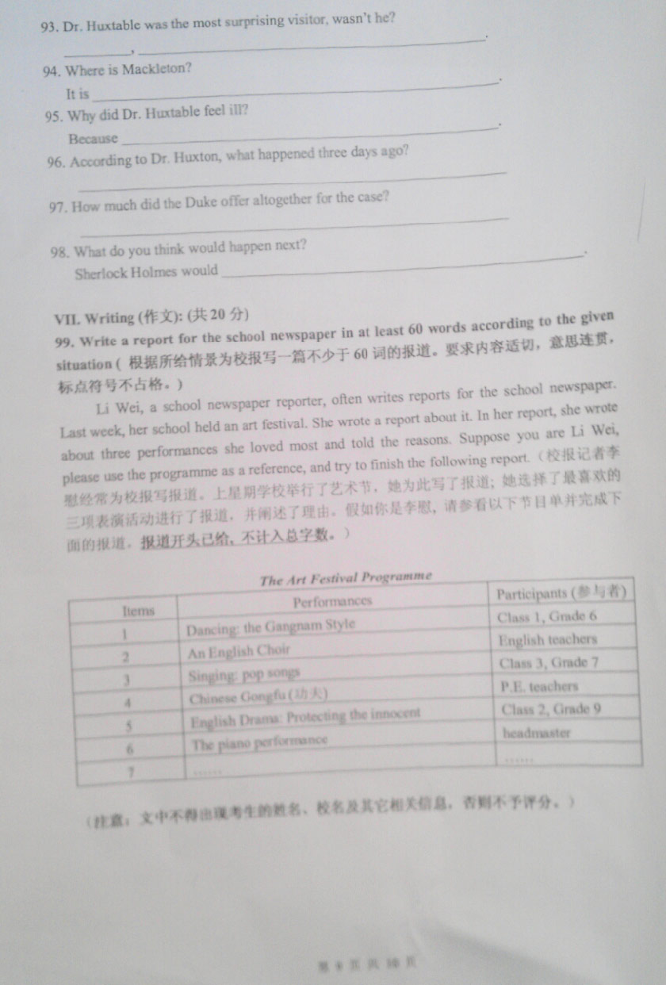

93. Yes, he was

94. In the north of England

95. he forgot to eat or drink anything.\he didn’t eat or drink anything

96. The son of the Duke of Holdernesse was kidnapped.\ Someone kidnapped the son of the Duke of Holdernesse.

97. Six thousand dollars.

98. (Sherlock Holmes would) go to Meckleton with Dr. Huxtable.\ (Sherlock Homes would) work on the case. ………

**浦东新区初三英语第一学期期末质量抽查试卷**

Mo Yan, the winner of the Twenty-Twelve Nobel Prize for Literature, is extremely popular nowadays. The Chinese writer is good at combining *folk* **(**民间**)** stories, history and modern events in his writings. When Mo Yan learned he had won the award, he was “shocked and frightened”, as he told reporters in front of the TV screen. He received his Nobel diploma, a medal and more than one million dollars prize money at a ceremony in Stockholm in December 2012.

Mo Yan is a leading author of modern Chinese novels. He is fifty-seven, and his real name is Guan Moye. Mo Yan means “Don’t Speak.” The writer said he chose the name to remember to stop his tongue from getting himself in trouble. Mo Yan began his career as a writer in the reform and opening up period, and he published dozens of short stories and novels in Chinese. His first novel was “Falling Rain on a Spring Night”, published in 1981.

Mo Yan used to write from memories of his youth. He also set many of his story scenes in the area where he was born – Shandong Province in northeastern China. Mister Mo’s book “*Red Sorghum* **(**红高粱**)**,” is an example. It is about the *extreme violence* **(**极端暴力**)** in rural eastern China in the nineteen twenties and nineteen thirties. The story describes the violent culture of that time, Japanese cruety and the terrible life of farm workers. “Red Sorghum” was later made into a movie. Mo Yan’s other important works include, “Big Breasts and Wide Hips,” “Republic of Wine” and “Life and Death Are Wearing Me Out.” Several of his novels were translated into English by Howard Goldblatt, professor of East Asian languages and literatures at the University of Notre Dame.

China is celebrating the success of this native son. Minutes after the award was announced, millions of Chinese expressed pleasure and pride for Mo Yan on social media websites.

93. What award has Mo Yan won?

____________________________________________________________.

94. Was Mo Yan shocked or frightened when he heard the exciting news?

____________________________________________________________.

95. Why did Mo Yan choose “Mo Yan” as his pen name?

____________________________________________________________.

96. Which novel was made into a film according to the passage?

____________________________________________________________.

97. Who translated Mo Yan’s novels into English?

____________________________________________________________.

98. How do you feel about Mo Yan’s success?

____________________________________________________________.

93. The Twenty-Twelve Nobel Prize for Literature.

94. Both./ He was surprised and frightened.

95.（ Because he wanted ）To remember to stop his tongue from getting himself in trouble.

96. “Red Sorghum”.

97. Howard Goldblatt.

98. Any reasonable answer is OK. (e.g.: I think he is hardworking./Full of wisdom./ He enjoys… )

**普陀区初三英语第一学期期末质量抽查试卷**

One of my earliest and most unforgettable experiences was the day my father took me to see my first football match. I was nine years old and crazy about football. All my friends at schools had been to see their favourite teams but I had never been to see a *live* (现场的) game.

“You’re not old enough,” my father said when I asked him to take me. But all my friends had gone. In the playground we talked about our favourite players and discussed how well we thought they would do on Saturday. I knew everything about them, but I had never actually seen them play.

Then one cold and bright winter morning my father told me to get dressed in warm clothes and hat and to get ready to go out later in the morning. “Where are we going, Dad?” I asked. “You’ll see”, is all he replied.

We drove in the car for hours, it seemed. I did not know where we were going and I finally fell asleep in the car. The next thing I knew my father was shaking me awake and telling me to get out. I found myself outside a tall round building and from behind wall I could hear a huge noise.

We walked around the corner and I saw the largest number of people I had ever seen, all pushing their way through huge iron gates into the building—a football stadium.

“Here we are,” said Dad cheerfully.

“Where are we, Dad?” I asked. “This is the home of the Chester City football team,” Dad answered. “I first came here when I was a young boy to see this team. I thought you would like to see them too.”

The next two hours passed like a dream. I watched the players kick and shoot the ball, and I shouted and cheered along with the other people near me. When one of the Chester players kicked a goal, we all cheered. That was the only score of the game. Our team had won.

I was so excited that on Monday morning at school I couldn’t stop telling everyone what had happened. It was an unforgettable experience. And even today I am still the fan of Chester City Football Club!

93. The writer had an unforgettable experience at the age of nine, didn’t he?

____________________________________________________________.

94. What did the writer look forward to at that time?

____________________________________________________________.

95. Where did the writer and his father go one winter morning?

____________________________________________________________.

96. Did they go there by bus or by car?

____________________________________________________________.

97. Which team won the game that day?

____________________________________________________________.

98. How did the writer show his excitement about his experience?

____________________________________________________________.

93. Yes, he did.

94. (He looked forward to) seeing a live football game.

95. (They went) to a football stadium/to the home of Chester City football team.

96. By car.

97. Chester City football team.

98. He kept telling everyone what had happened./By telling everyone what had happened.

**松江区初三英语第一学期期末质量抽查试卷**

Pictures are falling off the walls. Lights are waving. Bed is shaking. Everything is moving. What’s going on? It’s an earthquake.

Earthquakes are horrible *disasters(灾难)* and some of them are destructive. The top layer of the earth is made up of huge pieces of rock. They move past each other all the time along *fault lines(裂纹线)*. But sometimes two pieces get stuck together. When they finally move away from each other, they move suddenly. And this makes the land above them shake. This is the most common cause of earthquakes.

During a small earthquake, you will feel a little shaking. But during a strong one, you will be thrown about. A strong earthquake is very horrible. Cracks will appear on the ground and windows and doors will break. Buildings will even fall down. So watch out! If an earthquake happens at sea, it can make big waves called “tsunamis”(海啸). When these waves reach land, they can destroy villages.

Earthquakes are measured on a scale of 0-9. It is called the Richter scale. A size 9 earthquake is the strongest and most dangerous. Since 1900, more than two million people have died in earthquakes. In 1976, a size 7.8 earthquake hit Tangshan, China. It killed more than 240,000 people!

Many earthquakes happened in China, so it is important for us to know what to do when an earthquake hits. Here are some tips on how to stay safe in an earthquake.

**Indoors**

* Hide under a desk or bed. Stay away from windows and anything that could fall on you.
* Do not get into a lift during an earthquake! When an earthquake has ended, stay under the desk until it is really safe to get up.
* Open a window and get out of the building quickly if the gas line in your house is broken.

**Outdoors**

* Move away from buildings and street lights.
* Do not run outside if you are in a shop and far from the door.
* Make sure you wear shoes after an earthquake. There may be broken glass on the ground.

93. What will happen when an earthquake happens at sea?

____________________________________________________________.

94. How are earthquakes measured?

____________________________________________________________.

95. Where should we hide when an earthquake happens if we are at home?

____________________________________________________________.

96. We don’t need to wear shoes after an earthquake, do we?

____________________________________________________________.

97. Why should we move away from buildings and street lights when an earthquake happens?

____________________________________________________________.

98. According to the passage, what is the common cause of an earthquake?

____________________________________________________________.

93. It can make big waves called “tsunamis”./It can make tsunamis.

94. Earthquakes are measured on a scale of 0-9.

95. We should hide under a desk or bed.

96. Yes, we do.

97. Because something will fall on us.

98. The cause is that huge pieces of rock move away suddenly.

**徐汇区初三英语第一学期期末质量抽查试卷**

When Paul was a boy growing up in Utah, he happened to live near a copper smelter(炼铜厂), and the chemicals coming out of the smelter made a beautiful forest become a wasteland. One day a young visitor looked at this wasteland and called it an awful area. Paul got so angry when he heard these words. From then on, something happened inside him.

Years later Paul was back to the hometown and he went to the smelter office. He asked if they had any plans or if they would let him try to bring the trees back. The answer from that big industry was “No.”

Paul then went to college to study the science of plants. Unfortunately, his teachers said there weren't any birds or *squirrels(松鼠)* to spread the seeds. It would be a waste of his life to try to do it. Everyone knew that, he was told. Even if he was knowledgeable as he had expected, nobody accepted his idea.

Paul later got married and had some kids. But he didn’t give up. And then one night he did what he could with what he had. Under the cover of darkness, he went secretly into the wasteland and started planting.

And every week, he made his secret journey into the wasteland and planted trees and grass. Slowly rabbits appeared. Later, as there was *pressure*(压力) to clean up the environment, the company actually invited Paul to do what he was already doing. Now the place is fourteen thousand acres of trees and grass, and Paul has received almost every environmental award Utah has. It took him until his hair turned grey, but he managed to keep that impossible promise he made to himself as a child.

93. What did the copper smelter do to Paul’s hometown?

_____________________________________________________________________.

94. Did the copper smelter agree to let Paul bring trees back at first?

_________, ___________________________________________________________.

95. Why did most people think it would be a waste of time to change that area?

_____________________________________________________________________.

96. What did he decide to do one night?

_____________________________________________________________________.

97. How long did it take Paul to realize his dream?

_____________________________________________________________________.

98. What can we learn from Paul’s story?

_____________________________________________________________________.

93. It made a beautiful forest become a wasteland.

94. No, it didn’t.

95. Because there weren’t any birds or squirrel to spread seeds. / Seeds can not grow in the wasteland.

96. He decided to go into the wasteland secretly and started planting. / He decided to start planting secretly in the wasteland. / He decided to grow trees secretly by himself.

97. Until his hair turned grey. / Until he became old. / Almost all his life.

98. You will succeed if you stick to your dream. / Any other possible answers.

**杨浦区初三英语第一学期期末质量抽查试卷**

In a comfortable room in East London, a group of teenagers and older women are looking at brightly coloured paintings with chatting and laughing. They are taking part in a four-month art project started by the charity, Magic Me, which was set up in 1989 to solve generational problems and bring the local community closer by organizing creative projects.

Anisa Islam, a quiet 15-year-old student, loves taking part in the meetings, which she says have given her a safe place to talk about difficult *emotions* (情感). Besides this, there is much-needed useful *guidance* (指导) that only older women can give. She said, "I am closest to Winnie. She gives me a lot of advice on exams, telling me not to worry about them too much. Before, I was really shy and I couldn’t speak up, but now I join in and am confident."

Her head teacher, Vanessa Ogden, agrees that Magic Me, which has worked with the school on eight such projects, has had a great effect on the girls taking part. "Every year, many students improve their confidence and ability to think about their lives. They love meeting women with life experiences, and begin to understand how they can change their own lives. They regard them as role models," said Miss Ogden.

Davies, a charming older woman, says such projects are good for both older and younger people. "I think there should be a Magic Me in every area. We were like strangers at first, but by the end of the project we are like a family. We look forward to seeing the girls and they look forward to seeing us. They make me feel young again."

93. **When** and **where** was *Magic Me* set up?

It was set up _________________________.

94. What does *Magic Me* do to bring the local community closer?

It _____________________________ to bring the local community closer.

95. Anisa used to be shy, didn’t she?

__________, ____________________________.

96. How can the older women help the girls in the charity?

By ______________________ and ________________________.

97. What does Vanessa Ogden think of *Magic Me*?

She thinks *Magic Me* _______________________________.

98. Why do you think the older women like *Magic Me*?

Because being with the girls ________________________________.

93. It was set up in London in 1989.

94. It organizes creative projects.

95. Yes, she did.

96. By giving them advice and useful guidance/ sharing life experiences.

97. She thinks *Magic Me* has had a great effect on the girls taking part.

98. Because being with the girls makes them feel young again.

**闸北区初三英语第一学期期末质量抽查试卷**

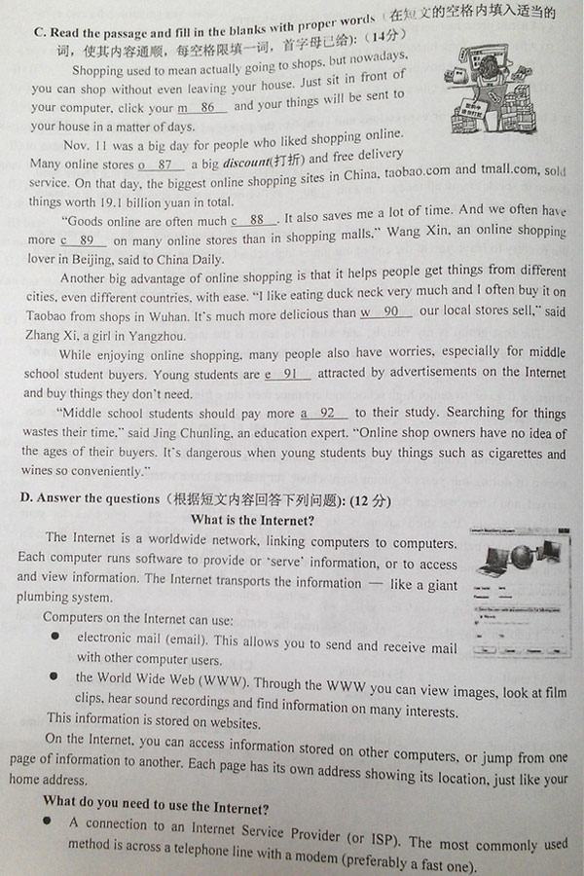

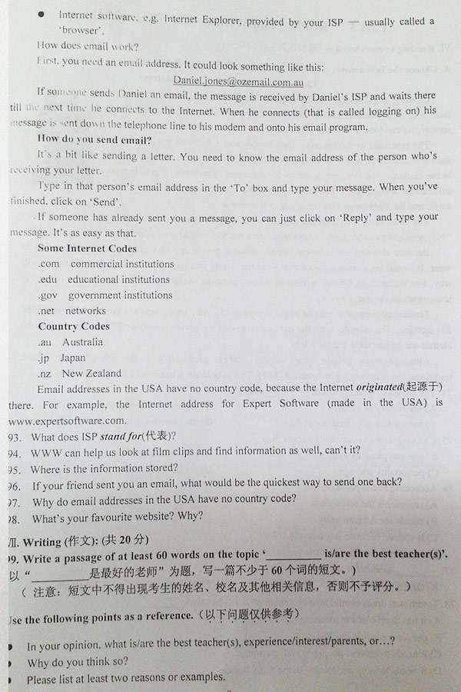

93. It stands for Internet Service Provider. 94. Yes, it can

95. It is stored on websites. 96. Just click on ‘Reply’ and type your message.

97. Because the Internet originated there. 98. Any reasonable answer is acceptable.