$\begin{aligned}\text{定理}1\text{：若直线}l\text{不经过}Δ\text{ABC}\text{的顶点，并且与}Δ\text{ABC}\text{的三边}\text{BC}、\text{CA}、\text{AB}\text{或它们} \\ \text{的延长线分别交于}P、Q、R\text{，则} \\ \frac{\text{BP}}{\text{PC}}⋅\frac{\text{CQ}}{\text{QA}}⋅\frac{\text{AR}}{\text{RB}}=1\end{aligned}$平面几何的几个重要的定理
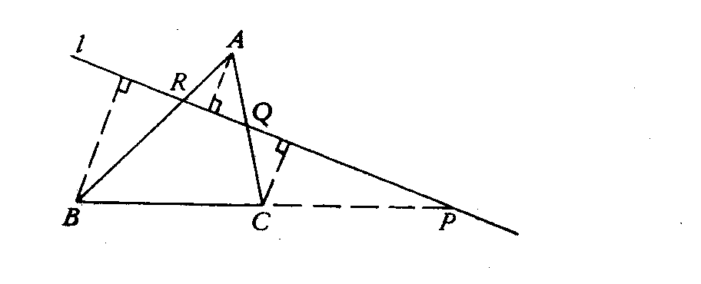
一、梅涅劳斯定理：
$$\begin{aligned}\text{证：设}h_{A}、h_{B}、h_{C}\text{分别是}A、B、C\text{到直线} \\ l\text{的垂线的长度，则：} \\ \frac{\text{BP}}{\text{PC}}⋅\frac{\text{CQ}}{\text{QA}}⋅\frac{\text{AR}}{\text{RB}}=\frac{h_{B}}{h_{C}}⋅\frac{h_{C}}{h_{A}}⋅\frac{h_{A}}{h_{B}}=1\end{aligned}$$
注：此定理常运用求证三角形相似的过程中的
线段成比例的条件；
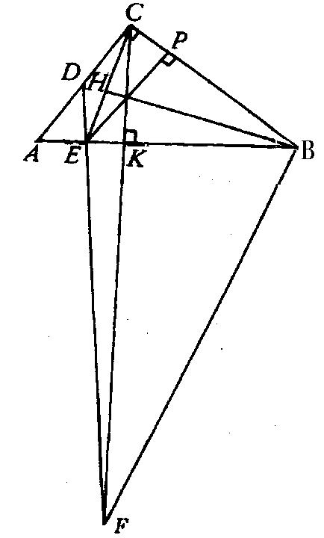
$\begin{aligned}例1\text{：若直角}Δ\text{ABC}\text{中，}\text{CK}\text{是斜边上的高，}\text{CE}是∠\text{ACK}\text{的平分线，}E点 \\ 在\text{AK}\text{上，}D是\text{AC}\text{的中点，}F是\text{DE}与\text{CK}\text{的交点，证明：}\text{BF}\text{//}\text{CE}。\end{aligned}$
$\begin{aligned}\text{证：}∵在Δ\text{EBC}\text{中，作}∠B\text{的平分线}\text{BH} \\ \text{则：}∠\text{EBC}\text{=∠}\text{ACK} \\ ∠\text{HBC}\text{=∠}\text{ACE} \\ ∠\text{HBC}\text{+∠}\text{HCB}\text{=∠}\text{ACE}\text{+∠}\text{HCB}=\text{90}° \\ \text{即：} \text{BH}⊥\text{CE} \\ ∴Δ\text{EBC}\text{为等腰三角形} \\ 作\text{BC}\text{上的高}\text{EP}\text{，则：}\text{CK}=\text{EP} \\ \text{对于}Δ\text{ACK}\text{和三点}D、E、F\text{依梅涅劳斯定理有：} \\ \frac{\text{CD}}{\text{DA}}⋅\frac{\text{AE}}{\text{EK}}⋅\frac{\text{KF}}{\text{FC}}=1 \\ \text{于是}\frac{\text{KF}}{\text{FC}}＝\frac{\text{EK}}{\text{AE}}=\frac{\text{CK}}{\text{AC}}=\frac{\text{EP}}{\text{AC}}=\frac{\text{BP}}{\text{BC}}=\frac{\text{BK}}{\text{BE}} \\ \text{即：}\frac{\text{KF}}{\text{FC}}＝\frac{\text{BK}}{\text{BE}} \\ \text{依分比定理有：}\frac{\text{KF}}{\text{KC}}＝\frac{\text{BK}}{\text{KE}} \\ ∴Δ\text{FKB}≃Δ\text{CKE} \\ ∴\text{BF}\text{//}\text{CE}\end{aligned}$

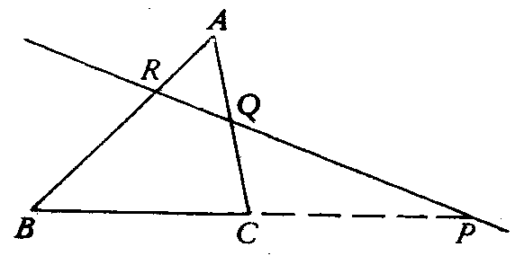
$\begin{aligned}\text{证：设直线}\text{PQ}\text{与直线}\text{AB}\text{交于}R^{'}\text{，于是由定理}1\text{得：} \\ \frac{\text{BP}}{\text{PC}}⋅\frac{\text{CQ}}{\text{QA}}⋅\frac{{\text{AR}}^{'}}{R^{'}B}=1 \\ 又∵\frac{\text{BP}}{\text{PC}}⋅\frac{\text{CQ}}{\text{QA}}⋅\frac{\text{AR}}{\text{RB}}=1\text{，则：}\frac{{\text{AR}}^{'}}{R^{'}B}＝\frac{\text{AR}}{\text{RB}} \\ \text{由于在同一直线上的}P、Q、R^{'}\text{三点中，位于}Δ\text{ABC}\text{边上的点的个数也为}0或2， \\ \text{因此}{R与R}^{'}\text{或者同在}\text{AB}\text{线段上，或者同在}\text{AB}\text{的延长线上；} \\ {若R与R}^{'}\text{同在}\text{AB}\text{线段上，则}{R与R}^{'}\text{必定重合，不然的话，设}\text{AR}>{\text{AR}}^{'}, \\ \text{这时}\text{AB}−\text{AR}<\text{AB}−{\text{AR}}^{'},即\text{BR}<{\text{BR}}^{'},\text{于是可得}\frac{\text{AR}}{\text{BR}}>\frac{{\text{AR}}^{'}}{{\text{BR}}^{'}} \\ \text{这与}\frac{\text{AR}}{\text{BR}}＝\frac{{\text{AR}}^{'}}{{\text{BR}}^{'}} \text{矛盾} \\ \text{类似地可证得当}{R与R}^{'}\text{同在}\text{AB}\text{的延长线上时，}{R与R}^{'}\text{也重合} \\ \text{综上可得：}P、Q、R\text{三点共线；}\end{aligned}$$\begin{aligned}\text{定理}2\text{：设}P、Q、R\text{分别是}Δ\text{ABC}\text{的三边}\text{BC}、\text{CA}、\text{AB}\text{上或它们的延长线上的三点，并且} \\ P、Q、R\text{三点中，位于}Δ\text{ABC}\text{边上的点的个数为}0或2\text{，这时若}\frac{\text{BP}}{\text{PC}}⋅\frac{\text{CQ}}{\text{QA}}⋅\frac{\text{AR}}{\text{RB}}=1， \\ \text{求证：}P、Q、R\text{三点共线；}\end{aligned}$$$\begin{aligned}\text{【练习}1\text{】从点}K\text{引四条直线，另两条直线分别交这四条直线于}A、B、C、D \\ {和A}_{1}、B_{1}、C_{1}、D_{1}\text{，试证：}\frac{\text{AC}}{\text{BC}}:\frac{\text{AD}}{\text{BD}}=\frac{A_{1}C_{1}}{B_{1}C_{1}}:\frac{A_{1}D_{1}}{B_{1}D_{1}}\end{aligned}$$
注：此定理常用于证明三点共线的问题，且常需要多次使用 再相乘；

$\begin{aligned}\text{证：易得：}\frac{{\text{BA}}_{1}}{{\text{CA}}_{1}}=−\frac{\text{BP}⋅\text{cos}∠\text{PBC}}{\text{CP}⋅\text{cos}∠\text{PCB}}, \\ \frac{{\text{CB}}_{1}}{{\text{AB}}_{1}}=−\frac{\text{CP}⋅\text{cos}∠\text{PCA}}{\text{AP}⋅\text{cos}∠\text{PAC}} \\ \frac{{\text{AC}}_{1}}{{\text{BC}}_{1}}=−\frac{\text{AP}⋅\text{cos}∠\text{PAB}}{\text{PB}⋅\text{cos}∠\text{PBA}} \\ \text{将上面三条式子相乘，} \\ 且∵∠\text{PAC}\text{=∠}\text{PBC},∠\text{PAB}\text{=∠}\text{PCB},∠\text{PCA}\text{+∠}\text{PBA}=\text{180}° \\ \text{可得}\frac{{\text{BA}}_{1}}{{\text{CA}}_{1}}⋅\frac{{\text{CB}}_{1}}{{\text{AB}}_{1}}⋅\frac{{\text{AC}}_{1}}{{\text{BC}}_{1}}＝1 ， \\ \text{依梅涅劳斯定理可知}A_{1}、B_{1}、C_{1}\text{三点共线；}\end{aligned}$$$\begin{aligned}例2\text{.}点P\text{位于}Δ\text{ABC}\text{的外接圆上；}A_{1}、B_{1}、C_{1}\text{是从点}P向\text{BC}、\text{CA}、\text{AB}\text{引的垂线的垂足，} \\ \text{证明点}A_{1}、B_{1}、C_{1}\text{共线；}\end{aligned}$$
C
B
A

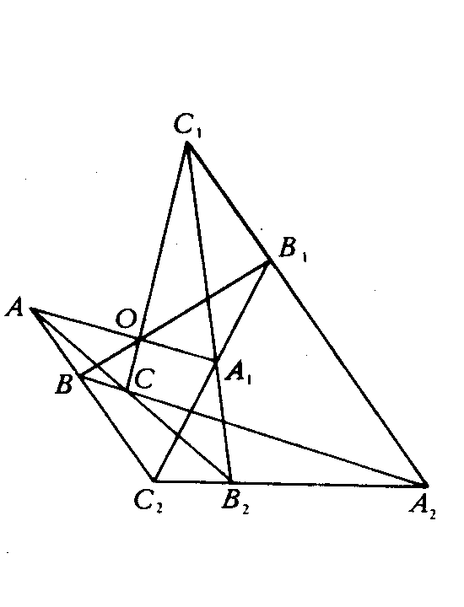
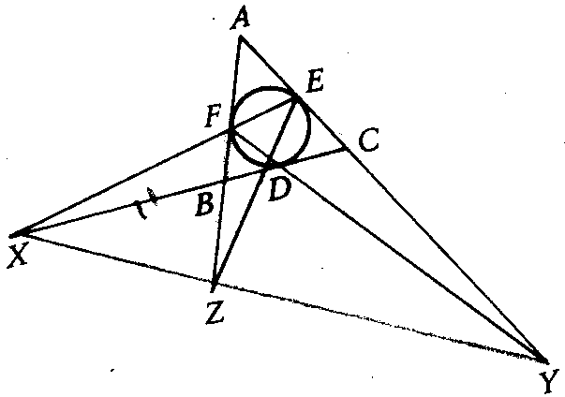
$\begin{aligned}\text{【练习}2\text{】设不等腰}Δ\text{ABC}\text{的内切圆在三边}\text{BC}、\text{CA}、 \\ \text{AB}\text{上的切点分别为}D、E、F\text{，则}\text{EF}与\text{BC}， \\ \text{FD}与\text{CA}，\text{DE}与\text{AB}\text{的交点}X、Y、Z\text{在同一条} \\ \text{直线上；}\end{aligned}$$\begin{aligned}\text{【练习}3\text{】已知直线}{\text{AA}}_{1}，{\text{BB}}_{1}，{\text{CC}}_{1}\text{相交于}O\text{，直线}\text{AB}和 \\ A_{1}B_{1}\text{的交点为}C_{2}\text{，直线}\text{BC}{与B}_{1}C_{1}\text{的交点是}A_{2}\text{，直} \\ 线\text{AC}{与A}_{1}C_{1}\text{的交点是}B_{2}\text{，试证：}A_{2}、B_{2}、C_{2}\text{三点共线；}\end{aligned}$$\begin{aligned}\text{练习}2\text{的证明} \\ \text{证：}Δ\text{ABC}\text{被直线}\text{XFE}\text{所截，由定理}1\text{可得：}\frac{\text{BX}}{\text{XC}}⋅\frac{\text{CE}}{\text{EA}}⋅\frac{\text{AF}}{\text{FB}}=1 \\ 又∵\text{AE}=\text{AF} \text{代人上式可得：}\frac{\text{BX}}{\text{XC}}＝\frac{\text{FB}}{\text{CE}} \\ \text{同理可得：}\frac{\text{CY}}{\text{YA}}＝\frac{\text{DC}}{\text{AF}} \frac{\text{AZ}}{\text{ZB}}＝\frac{\text{EA}}{\text{BD}} \\ \text{将上面三条式子相乘可得：}\frac{\text{BX}}{\text{XC}}⋅\frac{\text{CY}}{\text{YA}}⋅\frac{\text{AZ}}{\text{ZB}}=1 \\ 又∵X、Y、Z\text{都不在}Δ\text{ABC}\text{的边上，由定理}2\text{可得}X、Y、Z\text{三点共线}\end{aligned}$

$\begin{aligned}\text{【练习}4\text{】在一条直线上取点}E、C、A\text{，在另一条上取点}B、F、D\text{，记直线}\text{AB}和\text{ED}， \\ \text{CD}和\text{AF}，\text{CD}和\text{AF}，\text{EF}和\text{BC}\text{的交点依次为}L、M、N\text{，证明：}L、M、N\text{共线}\end{aligned}$
$\begin{aligned}\text{练习}1\text{的证明} \\ \text{证：若}\text{AD}\text{//}A_{1}D_{1}\text{，结论显然成立；} \\ 若\text{AD}{与A}_{1}D_{1}\text{相交与点}L\text{，则把梅涅劳斯定理分别用于}{ΔA}_{1}\text{AL}{和ΔB}_{1}\text{BL}\text{可得：} \\ \frac{\text{AD}}{\text{LD}}⋅\frac{{\text{LD}}_{1}}{A_{1}D_{1}}⋅\frac{A_{1}K}{\text{AK}}=1 \frac{\text{LC}}{\text{AC}}⋅\frac{\text{AK}}{A_{1}K}⋅\frac{A_{1}C_{1}}{{\text{LC}}_{1}}=1 \frac{\text{BC}}{\text{LC}}⋅\frac{{\text{LC}}_{1}}{B_{1}C_{1}}⋅\frac{B_{1}K}{\text{BK}}=1 \\ \frac{\text{LD}}{\text{BD}}⋅\frac{\text{BK}}{B_{1}K}⋅\frac{B_{1}D_{1}}{{\text{LD}}_{1}}=1 \\ \text{将上面四条式子相乘可得：}\frac{\text{AD}}{\text{AC}}⋅\frac{\text{BC}}{\text{BD}}⋅\frac{A_{1}C_{1}}{A_{1}D_{1}}⋅\frac{B_{1}D_{1}}{B_{1}C_{1}}=1 \\ \text{即：}\frac{\text{AC}}{\text{BC}}:\frac{\text{AD}}{\text{BD}}=\frac{A_{1}C_{1}}{B_{1}C_{1}}:\frac{A_{1}D_{1}}{B_{1}D_{1}}\end{aligned}$
$\begin{aligned}\text{练习}3\text{的证明} \\ \text{证：设}A_{2}、B_{2}、C_{2}\text{分别是直线}\text{BC}{和B}_{1}C_{1}，\text{AC}{和A}_{1}C_{1}，\text{AB}{和A}_{1}B_{1}\text{的交点，} \\ \text{对所得的三角形和在它们边上的点：}\text{OAB}和(A_{1}，B_{1},C_{2}),\text{OBC}和(B_{1}， \\ C_{1},A_{2}),\text{OAC}和(A_{1}，C_{1},B_{2})\text{应用梅涅劳斯定理有：} \\ \frac{{\text{AA}}_{1}}{{\text{OA}}_{1}}⋅\frac{{\text{OB}}_{1}}{{\text{BB}}_{1}}⋅\frac{{\text{BC}}_{2}}{{\text{AC}}_{2}}=1 \frac{{\text{OC}}_{1}}{{\text{CC}}_{1}}⋅\frac{{\text{BB}}_{1}}{{\text{OB}}_{1}}⋅\frac{{\text{CA}}_{2}}{{\text{BA}}_{2}}=1 \frac{{\text{OA}}_{1}}{{\text{AA}}_{1}}⋅\frac{{\text{CC}}_{1}}{{\text{OC}}_{1}}⋅\frac{{\text{AB}}_{2}}{{\text{CB}}_{2}}=1 \\ \text{将上面的三条式子相乘可得：}\frac{{\text{BC}}_{2}}{{\text{AC}}_{2}}⋅\frac{{\text{AB}}_{2}}{{\text{CB}}_{2}}⋅\frac{{\text{CA}}_{2}}{{\text{BA}}_{2}}=1 \\ \text{由梅涅劳斯定理可知}A_{2},B_{2},C_{2}\text{共线}\end{aligned}$

$\begin{aligned}\text{练习}4\text{的证明} \\ \text{证：记直线}\text{EF}和\text{CD}，\text{EF}和\text{AB}，\text{AB}和\text{CD}\text{的交点分别为}U、V、W\text{，对}Δ\text{UVW}\text{，应用梅} \\ \text{涅劳斯定理于五组三元点}(L,D,E),(A,M,F),(B,C,N),(A,C,E),(B,D,F)\text{，则有} \\ \frac{\text{UE}}{\text{VE}}⋅\frac{\text{VL}}{\text{WL}}⋅\frac{\text{WD}}{\text{UD}}=1 \frac{\text{VA}}{\text{WA}}⋅\frac{\text{UF}}{\text{VF}}⋅\frac{\text{WM}}{\text{YM}}=1 \frac{\text{UN}}{\text{VN}}⋅\frac{\text{WC}}{\text{UC}}⋅\frac{\text{VB}}{\text{WB}}=1 \\ \frac{\text{WA}}{\text{VA}}⋅\frac{\text{UC}}{\text{WC}}⋅\frac{\text{VE}}{\text{UE}}=1 \frac{\text{WB}}{\text{VB}}⋅\frac{\text{UD}}{\text{WD}}⋅\frac{\text{VF}}{\text{UF}}=1 \\ \text{将上面五条式子相乘可得：}\frac{\text{VL}}{\text{WL}}⋅\frac{\text{WM}}{\text{UM}}⋅\frac{\text{UN}}{\text{VN}}=1, ∴点L,M,N\text{共线}\end{aligned}$

